IMPROVING STUDENTS’ SPEAKING SKILLS THROUGH TED YOUTUBE CHANNEL AT SMA SWASTA

AL-WASHLIYAH 1 MEDAN

A Thesis

BY

ARYANTI HANIFAH
NPM : 191224030

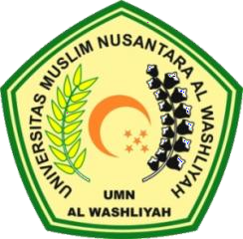

ENGLISH EDUCATION DEPARTEMENT
FACULTY OF TEACHER TRAINING AND EDUCATION
UNIVERSITAS MUSLIM NUSANTARA AL WASHLIYAH
MEDAN

2023

