ACKNOWLEDGEMENTS

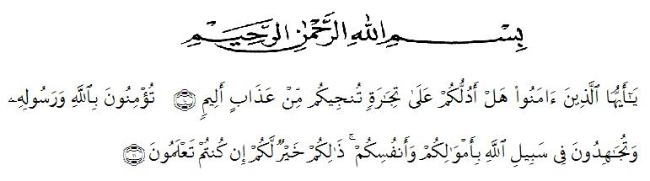

Artinya : “Hai orang-orang yang beriman, sukakah kamu aku tunjukkan suatu

perniagaan yang dapat menyelamat kamu dari azab yang pedih?¹⁰.
(Yaitu)kamuberimankepada Allah SWT dan Rasul-Nya dan berjihad di
jalan Allah dengan harta dan jiwamu. Itulah yang lebih baik bagimu
jika kamu mengetahuinya¹¹.Qs (As-Shaff 10 : 11)
Assalamualaikum wr.wb
Alham dulilah, firstly all praises belong to Allah SWT who had bestowed mercy,health, blessing, knowledge to the researcher, because of His blessings the researcher can complete this research. In accomplishing this thesis, the researcher got advice, suggestions, criticism, support for the researcher and guidance from many people. Therefore, the researcher would like to extend her sincere and an appropriate moment for her deepest gratitude for.
- Mr. Dr. KRT. Hardi Mulyono K. Surbakti, as the Rector of UMN Al-Washliyah Medan, who has given the researcher the opportunity to study at the institution he leads
- Mr. Drs. Samsul Bahri, M.Pd. as the Dean of FKIP UMN Al Washliyah who has given this research permission.
- Mrs. Zulfitri, S.S., M.A, as the leader of English Department of UMN Al-Washliyah Medan, which has provide invaluable guidance and sistance for researcher.
- Mr. Teguh Satria Amin, M.Hum as adviser who has provided suggestions, comments, and criticisms that are very supportive in completing this thesis.
- All of lecturers in the English Department of FKIP UMN Al Washliyah Medan for their kindness and valuable suggestions to enrich the researcher’s knowledge.
- Mrs. Ir. Hj. Nursiah Abe as the headmaster of SMA Swasta Al-Washliyah 1 Medan and all the teachers for facilities and who has allowed her to conduct research at the school she is leading and assist her in conducting research.
- Ms. Wariyati, S.Pd., M.Hum., M.Pd who has given a bunch of reliance, guidance, supports, motivation, criticism, suggestions and who always gives corrections to the researcher, and to Mr. Prof. Dr. Ahmad Laut Hasibuan S.Pd., M.Pd who heard the researcher complaint in order to finish this thesis.
- Thank you to special beloved parents of the researcher Mr. Karsim bin Abdul Karim and Mrs. Rustini for the support and who always love the researcher unconditionally. The important thing is facilitate the researcher to finished the study.
- To her beloved sister Rizky Ayu Sekarini, A.Md who have provide supports researchers to finished study, and to my little nephew Rafifah Zalfa Manurung who always make the researcher happy when have the bad days while doing the thesis.
- Thank you to researcher friends, Indah Ayu Tarigan, Utari Nur Jannah who always help the researcher when the researcher ask and need help about how to finished thesis.

Researcher realized that this thesis is far from perfection. All constructive criticisim and suggestion are indispensable for the perfect of this thesis, with the hope that this thesis will be useful for everyone. Aamiin.

Medan, Agustus 2023
Researcher

Aryanti Hanifah

