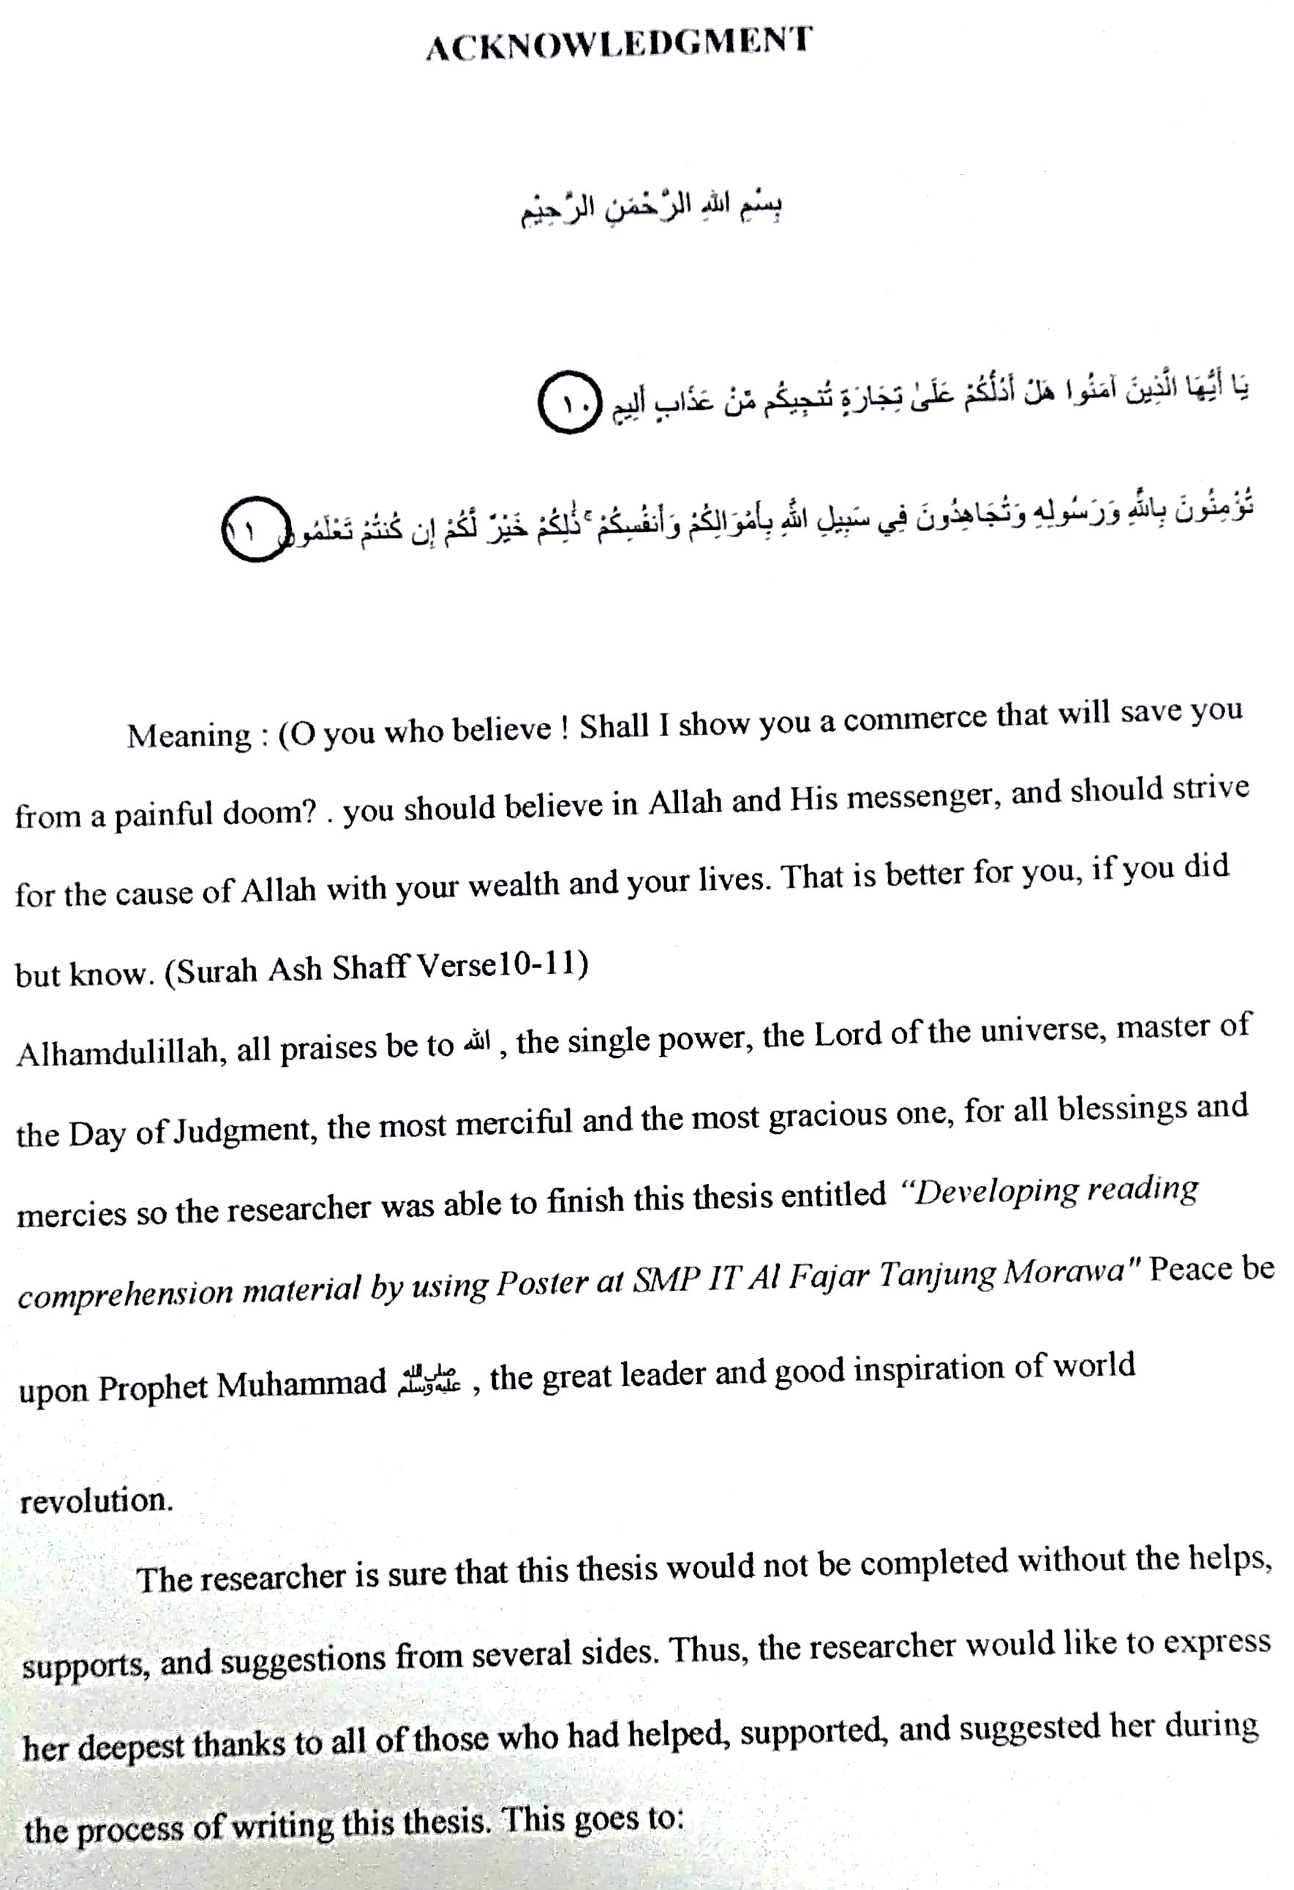

- Dr.KRT. Hardi Mulyono K. Surbakti, as Rector of UMN Al Washliyah, who has given facilities to his during study at the University.
- Sutikno, S.Pd, M.Pd, Ph.D as Dean of FKIP UMN Al Washliyah Medan and his staffs for guidance during the study.
- Asnawi, S.Pd., M. Hum, as the head of English Department who has given a lot of valuable suggestions, comments, and criticism for completing this research.
- Prof.Dr. Ahmad Laut Hasibuan. M.Pd, as the adviser, who has given her a lot of valuable suggestions, comments and criticism for completing this research.
- Fitriah Lubis, as HeadMaster SMP IT AL-FAJAR TANJUNG MORAWA
- Sutaryo Tomik (Husband), Irdha Diah Utami (Child), Indri Dwi Nurhayati (Child), Fitriah Lubis My family, who always give motivation and support.
- Ridarni Yanti, Salfiani, as a friend who always accompanies and supports the researcher so that he is able to write a thesis.
The researcher realizes that this thesis is still far from being perfect. The researcher hopes that this thesis is useful for the researcher in particular and readers in general.

Medan,
The researcher

( Tina )

