ABSTRAK

PENGEMBANGAN KETERAMPILAN MENULIS SISWA MELALUI
MODEL BLENDED LEARNING DI STKIP USMAN SAFRI KUTACANE TAHUN PELAJARAN 2022/2023

OLEH :

ISNAINI RAMADANIAH

NPM. 217215019

Tujuan dari penelitian ini adalah untuk mengembangkan keterampilan menulis siswa melalui model pembelajaran campuran. Populasi penelitian adalah mahasiswa STKIP Usman Safri Kutacane. Sampelnya adalah semester dua yang terdiri dari 12 siswa. Jenis penelitian yang digunakan adalah Research and Experimental Development (R&D), model Flipped Classroom digunakan dalam penelitian ini. yang dilakukan dengan memberikan dua tes yaitu pre-test dan post-test. Pre-test diberikan sebelum melaksanakan penulisan esai deskriptif sedangkan post-test diberikan setelah pelaksanaan penulisan esai deskriptif. Penelitian ini dilakukan dengan menggunakan metode kualitatif dan kuantitatif. Instrumen pengumpulan datanya adalah tes menulis esai. Data dianalisis dengan menggunakan uji T. Setelah pengumpulan data dilakukan dengan menggunakan tes, diperoleh rata-rata pre-test sebesar 61,67 dan post-test sebesar 76,67. Terdapat peningkatan sebesar 15% dari nilai pre-test. Jadi, penulis menyimpulkan bahwa ada peningkatan keterampilan menulis siswa melalui model pembelajaran campuran. Hal ini juga dapat dibuktikan dengan membandingkan hasil t observasi (5,169) dengan t tabel (4,318) untuk alpha = 0,1%. Artinya hipotesis diterima.

Kata Kunci : blended learning, keterampilan menulis, model flippedclassroom

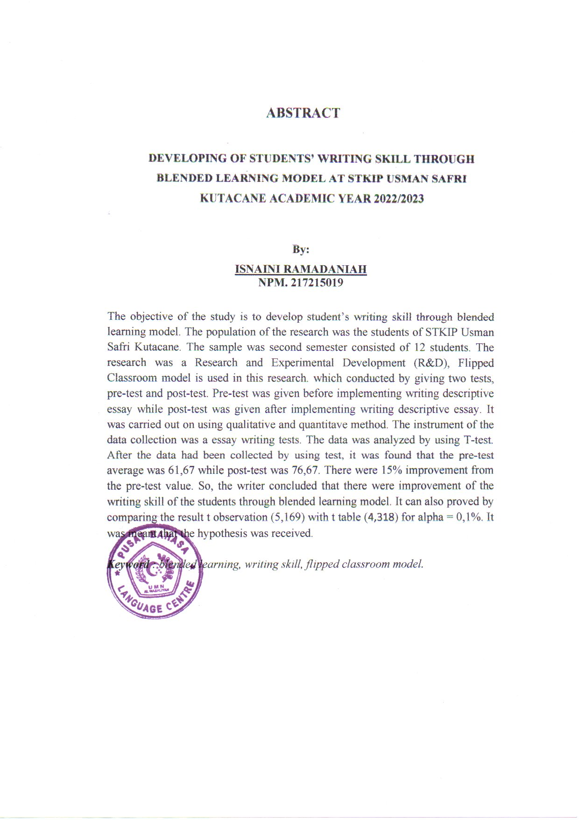

POSTGRADUATE PROGRAM
ENGLISH EDUCATION DEPARTMENT
UNIVERSITAS MUSLIM NUSANTARA AL WASHLIYAH MEDAN

LETTER OF APPROVAL THESIS

NAME : Isnaini Ramadaniah
NPM : 217215019
DEPARTMENT : English Language Education
QUALIFICATIONS : Strata Dua (S-2)
TITTLE : Developing Of Students’ Writing Skill Through Blended Learning Model At STKIP Usman Safri Kutacane Academic Year 2022/2023

Approved by:
Adviser,

Harianto II,S.S., M.S.Ph.D
NIDN. 0128118203

The Thesis was examined :
Judicium :

Examination Comitte

Chairman Secretary

Dr. KRT. H. Hardi Mulyono K. Surbakti Sutikno, S.Pd.,M.Pd., Ph.D
NIDN. 0111116303 NIDN. 0110098104

DEVELOPING OF STUDENTS’ WRITING SKILL THROUGH BLENDED LEARNING MODEL AT STKIP USMAN SAFRI KUTACANE ACADEMIC YEAR 2022/2023

THESIS

By:

ISNAINI RAMADANIAH
NPM. 217215019

POSTGRADUATE PROGRAM
UNIVERSITAS MUSLIM NUSANTARA AL WASHLIYAH
MEDAN
2023
DEVELOPING OF STUDENTS’ WRITING SKILL THROUGH BLENDED LEARNING MODEL AT STKIP USMAN SAFRI KUTACANE ACADEMIC YEAR 2022/2023

THESIS

To Obtain a Master Degree in English Education (M.Pd.)
In the Postgraduate Master Program in English Language Education (S2)
Universitas Muslim Nusantara Al-Washliyah

By

ISNAINI RAMADANIAH
NPM. 217215019

POSTGRADUATE PROGRAM
UNIVERSITAS MUSLIM NUSANTARA AL WASHLIYAH
MEDAN
2023
STATEMENT LETTER

The undersigned below:
Name : Isnaini Ramadaniah
NPM : 217215019
Place/date of birth : Kutacane, 27 February 1995
Study program : Magister Pendidikan Bahasa Inggris
Alamat Address : JL. Terminal Terpadu , Kutarih, kec, Babussalam, kab, Aceh Tenggara, Kutacane, 24664
\No HP/ Telp No HP/ Telp : 085360415005
Thesis Title : Developing Of Students’ Writing Skill Through Blended Learning Model At STKIP Usman Safri Kutacane Academic Year 2022/2023

Hereby certify that:
- This thesis is original and has never been submitted to obtain an academic degree (Master of English Education, S-2), either at UMN Al-Washliyah or at other universities.
- My thesis is purely my own ideas, formulations, research and thoughts, without the help of other parties, except for directions from the Advisory Team.
- In this thesis there are no works or opinions of other people that have been written or published unless explicitly stated as a reference in the manuscript by mentioning the name of the author and listed in the bibliography.
- If one of the points above is violated by me, then I am willing to accept Academic Sanctions in the form of revocation of the academic degree that I have obtained because of my thesis, as well as other sanctions in accordance with the norms in force in Higher Education.

Thus, I actually made this statement in a conscious state, and can be used as needed.
Medan, 28 June 2023
I stated,

Isnaini Ramadaniah

ACKNOWLEDGEMENTS
In the name of Allah, The most gracious, the most merciful. Allah praises be to Allah the beneficience and the merciful who has give me healty and opportunity to finish this thesis with the title Development Of Student’s Writing Skill Blended Learning Model At STKIP Usman Safri Kutacane Academi Year 2022/2023. Piece be salutation be upon to great prophet Muhammad who has brough islam guided human good lif and faith.
The aim of finishing writing this thesis is one of the duties and obligations of every student,especially the Teaching and Education Faculty of the Universitas Muslim Nusantara Al Washliyah Medan and as a condition for obtaining a Postgraduate of Education (M.Pd) degree.
The process finishing this thesisinvolved some contricuting person. Therefore, the researcher would like to say thank for them, and they are:
- Dr. KRT. H.Hardi Mulyono Surbakti, SE., MAP as the Rector of the Universitas Muslim Nusantara Al Washliyah in Medan.
- Sutikno, S.Pd.,M.Pd., Ph.D. As Director of Postgraduate University Muslim Nusantara Al Washliyah Medan, which has given permission sothe author can complete studies at the Muslim University Postgraduate Program Archipelago Al Washliyah Medan.
- Harianto II,S.S., M.S., Ph.D the adviser who gave the command, critic and suggestion toward the researcher in finishing the proposal.
- Dr. H. Asnawi, M.Hum. the head of the English Education Department of postgraduate program of Muslim Nusantara University Al Washliyah Medan.
- The head of English Education Study Programand all the teacher for the facilities given to her in conducting this research.
- All lecturers and administrative staffs as well as librarians in the programPostgraduate at the Muslim Nusantara University Al Washliyah Medan, which ishas directly or
indirectly provided assistance to the author in finish writing a thesis.
- Especially for my beloved parents, Sinarati and Sabiran Skd who have inspired me and offered the prayer. Until the end of his life, his services will always be remembered
- For my beloved husband, Muhammad Azri Mahdi, SE and my beloved children, Rahmad Abqory Aulia Nazril and Muhammad Alfarizqi Faeyza and Aisyah Humairah (Almh) who have given support and the sincere encouragement to the author to finish her study in the postgraduate program. The author hope that the knowledge will be useful to the family.
Finally, the researcher realized that this thesis was far from being perfect. Therefore, constructive suggestion was needed for the researcher to continue the reasearch.

Medan, 28 June 2023
The researcher,

Isnaini Ramadaniah

