DEVELOPING OF STUDENTS’ WRITING SKILL THROUGH BLENDED LEARNING MODEL AT STKIP USMAN SAFRI KUTACANE ACADEMIC YEAR 2022/2023

THESIS
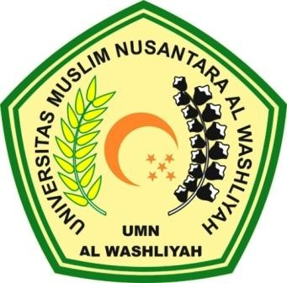

By:

ISNAINI RAMADANIAH
NPM. 217215019

POSTGRADUATE PROGRAM
UNIVERSITAS MUSLIM NUSANTARA AL WASHLIYAH
MEDAN
2023
DEVELOPING OF STUDENTS’ WRITING SKILL THROUGH BLENDED LEARNING MODEL AT STKIP USMAN SAFRI KUTACANE ACADEMIC YEAR 2022/2023

THESIS

To Obtain a Master Degree in English Education (M.Pd.)
In the Postgraduate Master Program in English Language Education (S2)
Universitas Muslim Nusantara Al-Washliyah

By

ISNAINI RAMADANIAH
NPM. 217215019

POSTGRADUATE PROGRAM
UNIVERSITAS MUSLIM NUSANTARA AL WASHLIYAH
MEDAN
2023

