**ACKNOWLEDGEMENT**

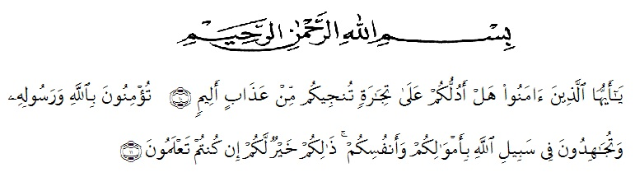

Artinya : “ Wahai orang-orang yang beriman! MaukahkamuAkutunjukkansuatuperdagangan yang dapatmenyelamatkankamudariazab yang pedih? (10) (yaitu) kamuberimankepada Allah danRasul-Nyadanberjihad di jalan Allah denganhartadanjiwamu. Itulah yang lebihbaikbagimu, jikakamumengetahui.(11)” (QS. As Shaff : 10-11)

Alhamdulillahirabbil’alamin, the researcher express her higest to Allah SubhanahuWaTa’ala for blessing, opportunity, love, health, and mercy to complete the research. In arranging this research, a lot of people have provided motivation, advice, and support for the researcher. In this valuable chance, the researcher intended to express her gratitude and appreciation to all

1. Dr. KRT HARDI MULYONO K.SURBAKTI as a Rector of University Muslim Nusantara Al-Washliyah Medan.
2. Drs. SamsulBahri, M.Si as a dekan of FKIP University Muslim Nusantara Al-Washliyah Medan.
3. Zulfitri, S.S., MA as a Head of English Language Education Department of University Muslim Nusantara Al-Washliyah Medan.
4. Zulfitri, S.S, MA as a consultant who has the researcher supervision, advice, and guidance from very early stage of this research.
5. NurafniSiregar, S.Pd.,M.Humas a first examiner lecturer who has provided direction to the researcher since the beginning of this research.
6. Prof Dr. H. Ahmad LautHasibuan, M.Pd as a second examiner lecturer who has provided direction to the researcher since the beginning of the research.
7. Askardin, S.Pdi as the headmaster of SMA NEGERI 4 SEMBILAN who has allowed researchers to conduct research at the school.
8. DewiNirmalaS.Pd as an English teacher atSMA NEGERI 4 SIMEULUE BARAT SEMBILAN.
9. Class X 1 students who has helped and collaborated in this research.
10. My beloved parents (Ali FikriAndJusma) who always supported the researcher to finish this research.
11. My sister and beloved brother (LiliIdahSufrah T Bahruman Ali And T Raja Dinata Ali ) who always entertain and motivation for the researcher to finish this research.
12. My Friends YudiFahmiYessyNisa And RiriKuntari who always supported the researcher in finishing this research and always give a solution when there was a problem, Cut MutiaDewiDeira who always help the researcher kindly in drafting proposal. .
13. My friends in college students class 8H English Department in academic 2020-2021 who always have researcher a lot motivation, suggestion, and advice.
14. The entire of University Muslim Nusantara Al-Washliyah who have provided guidance and knowledge to the researcher.

This research is far from perfect, but hopefully it is expected that it will be usefull not only for researcher, but also for the readers, thank you.

Medan, Oktober 2023

**Yusfita Ali**