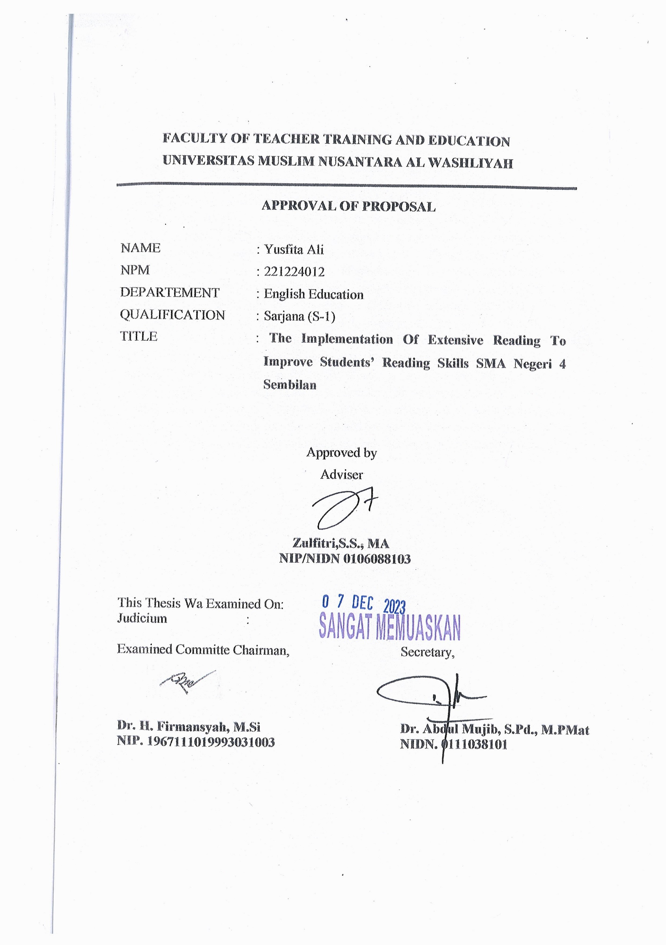**FACULTY OF TEACHER TRAINING AND EDUCATION**

**UNIVERSITAS MUSLIM NUSANTARA AL WASHLIYAH**

**APPROVAL OF PROPOSAL**

NAME : Yusfita Ali

NPM : 221224012

DEPARTEMENT : English Education

QUALIFICATION : Sarjana (S-1)

TITLE : **The Implementation of Extensive Reading aproach to Improve Students’ Reading Skills SMA Negeri 4 Sembilan**

Approved by

Adviser

**Zulfitri,S.S., MA**

**NIP/NIDN 0106088103**

This Thesis Wa Examined On:

Judicium :

Examined Committe Chairman, Secretary,

**Dr,KRT. HardiMulyonoK.Surbakti** **Dr. SamsulBahri, M.Si**

**NIDN 0111116303 NIDN 0017036702**