THE DEVELOPMENT OF READING COMPREHENSION MATERIAL BASED ON VOCABULARY COLLECTION STRATEGY AT SMAN 13 MEDAN IN
ACADEMIC YEAR 2022/2023

Submitted to Obtain a Master Degree in English Education (M.Pd.)
In the Postgraduate Master Program in English Language
Education (S2) Universitas Muslim
Nusantara Al-Washliyah

By
AFFAN LUBIS
Registration Number: 217215015

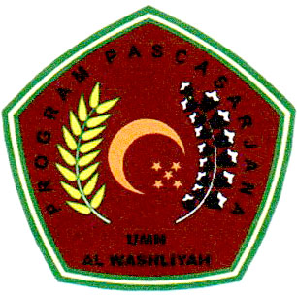

ENGLISH EDUCATION DEPARTMENT
POSTGRADUATE PROGRAM
UNIVERSITAS MUSLIM NUSANTARA AL WASHLIYAH
2023

