**PENGEMBANGAN MEDIA PAPAN *DAILY NUMBER* PADA PEMBELAJARAN**

**MATEMATIKA MATERI PENJUMLAHAN DAN**

**PENGURANGAN KELAS II SD**

**ABSTRAK**

**JULIANI BR SEMBIRING**

**NPM : 191434204**

Penelitian ini merupakan jenis penelitian pengembangan (Research and Development) dengan menggunakan model ADDIE yaitu analisis (Analysis), desain (Design), pengembangan (Development), implementasi (Implementation), dan evaluasi (Evaluation). Tetapi peneliti hanya sampai pengembangan saja. Subjek dalam penelitian ini adalah media papan daily number, guru kelas II SD, validasi ahli media, ahli materi dan objek pada penelitian ini adalah media papan daily number pada pembelajaran matematika materi penjumlahan dan pengurangan yaitu siswa kelas II SD. Data kuantitatif di peroleh dari rumus yang digunakan untuk mengetahui kelayakan media dan materi. Data yang diperoleh sebagai acuan untuk melakukan revisi pada produk yang dikembangkan.Berdasarkan perhitungan di atas maka hasil penilaian dari ahli materi keseluruhan mencapai instrument yang digunakan untuk mengumpulkan data adalah angket kuisioner. Hasil validasi media papan daily daily number pada pembelajaran matematika materi penjumlahan dan pengurangan adalah validasi ahli media memperoleh 92% dengan kriteria sangat layak digunakan dan layak untuk dikembangkan dalam pembelajaran matematika materi penjumlahan dan pengurangan dengan sangat layak, validasi ahli materi memperoleh skor 80% dengan kriteria layak digunakan, tanggapan guru memperoleh skor 67% dengan kriteria layak digunakan dan validasi guru kelas memperoleh skor 100% dengan kriteria sangat layak. Berdasarkan data yang diperoleh dapat disimpulkan bahwa media papan daily number sangat layak digunakan di sekolah dasar.

Kata kunci : media pembelajaran, penjumlahan dan pengurangan

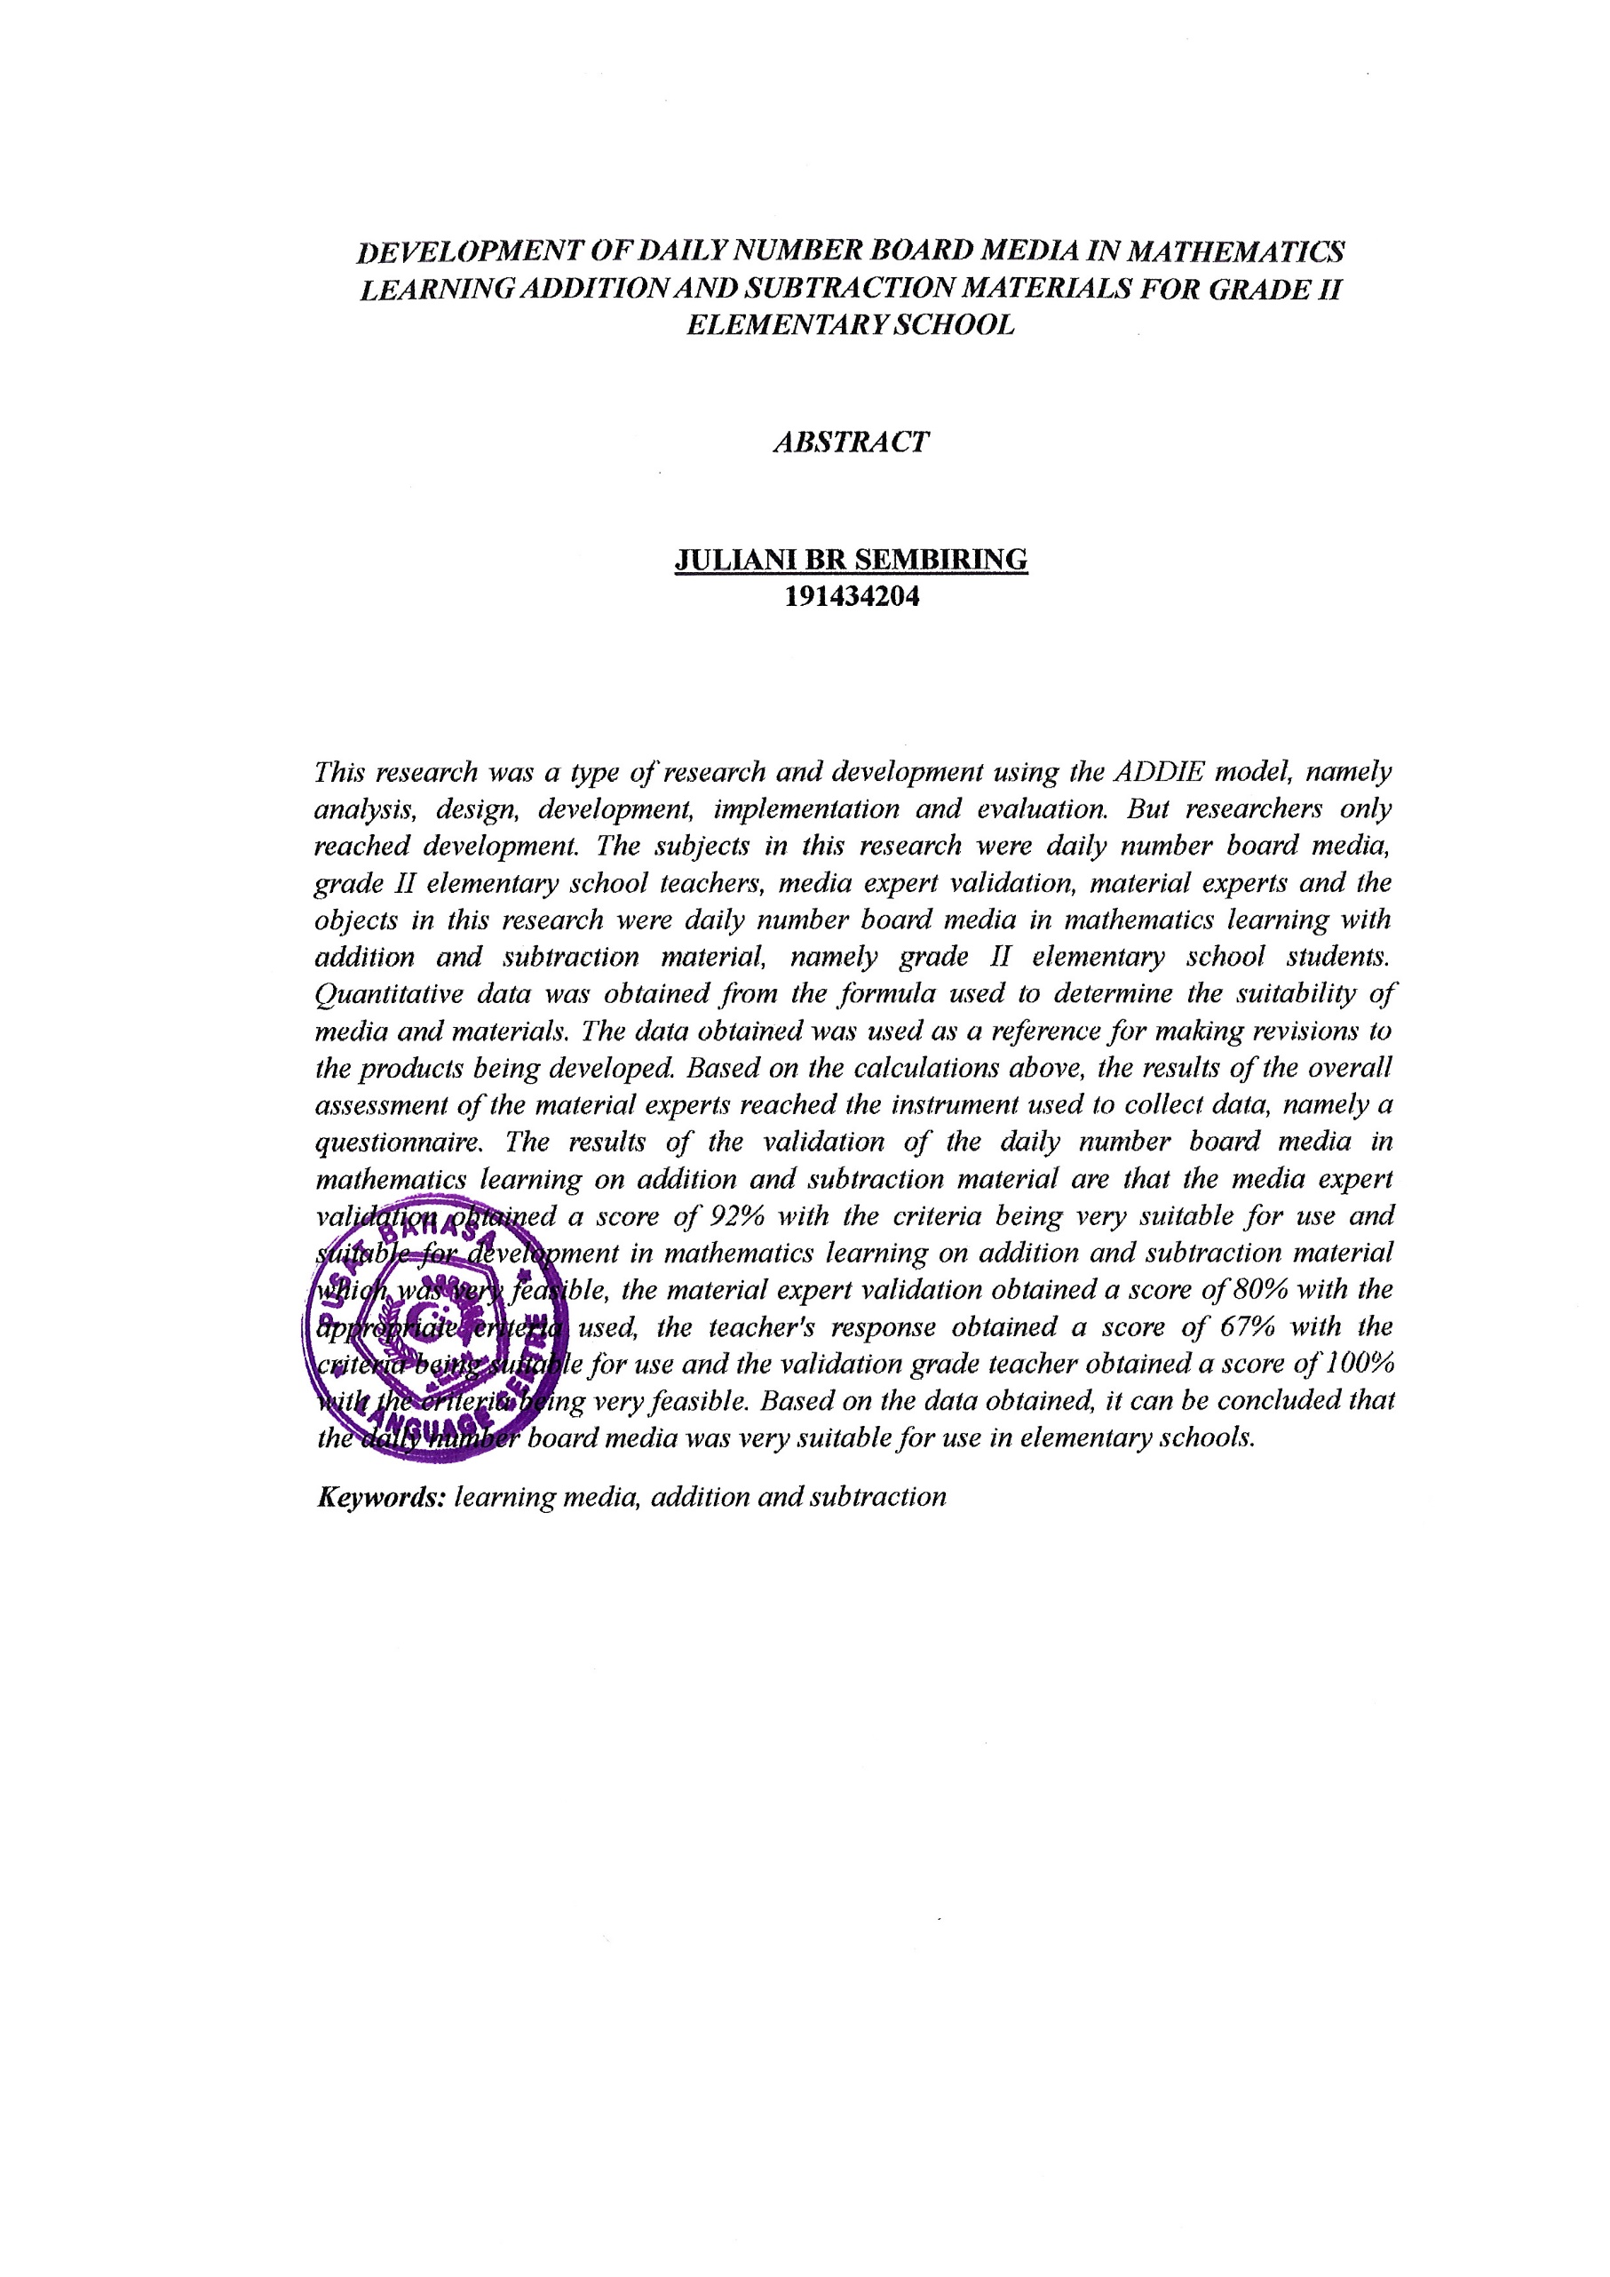

***EVELOPMENT OF DAILY NUMBER BOARD MEDIA IN MATHEMATICS LEARNING ADDITION AND SUBTRACTION MATERIALS FOR GRADE II   
ELEMENTARY SCHOOL***

***ABSTRACT***

**JULIANI BR SEMBIRING  
191434204**

*This research was a type of research and development using the ADDIE model, namely analysis, design, development, implementation and evaluation. But researchers only reached development. The subjects in this research were daily number board media, grade II elementary school teachers, media expert validation, material experts and the objects in this research were daily number board media in mathematics learning with addition and subtraction material, namely grade II elementary school students. Quantitative data was obtained from the formula used to determine the suitability of media and materials. The data obtained was used as a reference for making revisions to the products being developed. Based on the calculations above, the results of the overall assessment of the material experts reached the instrument used to collect data, namely a questionnaire. The results of the validation of the daily number board media in mathematics learning on addition and subtraction material are that the media expert validation obtained a score of 92% with the criteria being very suitable for use and suitable for development in mathematics learning on addition and subtraction material which was very feasible, the material expert validation obtained a score of 80% with the appropriate criteria used, the teacher's response obtained a score of 67% with the criteria being suitable for use and the validation grade teacher obtained a score of 100% with the criteria being very feasible. Based on the data obtained, it can be concluded that the daily number board media was very suitable for use in elementary schools.*

***Keywords:*** *learning media, addition and subtraction*