# ACKNOWLEDGEMENTS

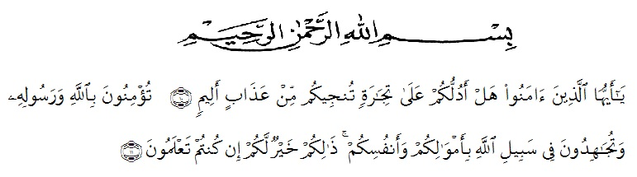

Artinya: “*Hai orang-orang yang beriman, sukakah kamu Aku tunjukkan suatu* *perniagaan yang dapat menyelamatkan kamu dari azab yang pedih?* (Yaitu) *kamu beriman kepada Allah dan Rasul-Nya dan berjihad di jalan* *Allah dengan harta dan jiwamu. Itulah yang lebih baik bagimu jika kamu* *mengetahuinya”.* (As-Saff 10-11).

Assalamualaikum Warahmatullahi Wabarakatuh

Alhamdulillah, all praises belong to Allah STW who had bestowed mercy, chance and knowledge to the Researcher. Secondly, peace and salutation always be given prophet Muhammad SAW who has guided us from the darkness to the lightness. therefore the Researcher can finish this graduating paper as one of the requiretment for Sarjana English Department of Education Faculty of Universitas Muslim Nusantara AL- Washliyah. However, this success would not be achieved without those supports, guidance, advice, help and encouragement from individual and institution, and the writer somehow realize that an appropriate moment for her deepest gratitude for:

1. My beloved parents, Mr Syahrul and Mrs Ramini who always love the researcher unconditionally, support, facilitate the researcher to finished study. My parents don’t have a college degree, but my college degree is still lower than their education.
2. My Beloved Previlage brother, Habib Abdullah. Maybe he is not like orther children, but he is one of the people who makes reseacher enthusiastic to continue living every day.
3. Mr. Dr. KRT. Hardi Mulyono K. Surbakti as a Rector of the Universitas Muslim Nusantara Al Washliyah who has given the researcher the opportunity to study at the institution he leads.
4. Mr. Drs. Samsul Bahri, M.Si as the Dean of FKIP UMN Al Washliyah who has given this research permission.
5. Mrs. Zulfitri S.S.,M.A the head of English Language Education Department which has provide invaluable guidance and ssistance for researcher.
6. Mr. Dr. Azhary Tambusai, M.A as adviser who has given a bunch of reliance, guidance, supports, suggestions and corrections in order to finish this thesis from the very start to the last.
7. All of the lectures in FKIP UMN Al Washliyah for the precious knowledge sharing, and giving wonderful study experiences which had built who the researcher is now.
8. Mrs. Retnawati, S.Pd, as the head of MTs. As-Sakinah Tanah Raja and teacher adviser. For researcher, who has allowed her to conduct research at the school he is leading and assist her in conducting research.
9. To beloved friends, Faridz Fauzan, Karimuddin, Andrian, Akrima, Sekar Sari, Rika Nurwayuni, Armita Sari, Rindi Rantika. Thank you for always

beside her and help her for sharing information and supports researcher to finished study.

1. To All of her friends in English Department Class H 2017 who had given her a lot of life experiences in this college life even they are conscious or uninconscious.
2. The comrades in KAMMI UMN AW, it has become a space for growth and improvement from researcher. Researcher’s wish, We are can regroup in heaven.
3. To beloved sister in Halaqoh Zahratul Jannah, Tia Khairun Nisa, Siska Erika, Ika Safitri, Dea Puspita, Nur Aripa, Nazmi Dalimunthe, Afriana Lestari, Della Ananda and Nurul Aisyah. Thank you for always supports researcher to finished study.
4. For everyone whom she has not mention yet, thank you very much for all your support.

Researcher realized that this thesis is far from perfect. All constructive criticisim and suggestions are indispensable for the perfection of this thesis, with the hope that this thesis will be useful for everyone. Aamiin.

Medan, Dec 2021

Researcher

**Ummul Khair**