IMPROVING STUDENTS’ ABILITY IN WRITING SHORT STORY BY USING CONTEXTUAL TEACHING AND LEARNING (CTL) METHOD AT GRADE VIII
MTs AS-SAKINAH TANAH RAJA
ACADEMIC YEAR 2021/2022

A Thesis

By

UMMUL KHAIR
NPM: 171224097

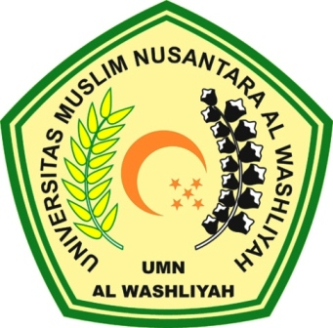

ENGLISH EDUCATION DEPARTMENT
FACULTY OF TEACHER TRAINING AND EDUCATION
UNIVERSITAS MUSLIM NUSANTARA AL WASHLIYAH
MEDAN
2021
IMPROVING STUDENTS’ ABILITY IN WRITING SHORT STORY BY USING CONTEXTUAL TEACHING AND LEARNING (CTL) METHOD AT GRADE VIII
MTs AS-SAKINAH TANAH RAJA
ACADEMIC YEAR 2021/2022

A Thesis

Submitted to the Department of English Language Education in Partial Fulfillment of the Requirements for the Degree of Sarjana Pendidikan

by
UMMUL KHAIR
NPM: 171224097

ENGLISH EDUCATION DEPARTMENT
FACULTY OF TEACHER TRAINING AND EDUCATION
UNIVERSITAS MUSLIM NUSANTARA AL WASHLIYAH
MEDAN
2021
