AUDIO LINGUAL METHOD AND USING ANIMATION VIDEO ON THE STUDENTS’ ACHIEVEMENT IN SPEAKING SKILL AT SMPS PRAYATNA MEDAN

A THESIS

Submitted to the Department of English Language Education in Partial Fulfillment of the Requirements for the Degree of
Sarjana Pendidikan

by

ULFA DEKA
Regristration Number: 191224023

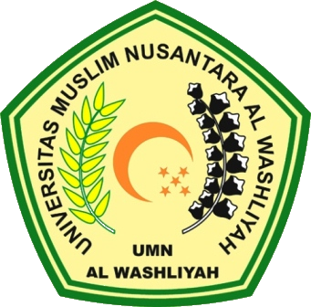

ENGLISH EDUCATION DEPARTMENT
FACULTY TEACHERS TRAINING AND EDUCATION
UNIVERSITAS MUSLIM NUSANTARA AL WASHLIYAH MEDAN
2023

