ACKNOWLEDGEMENT

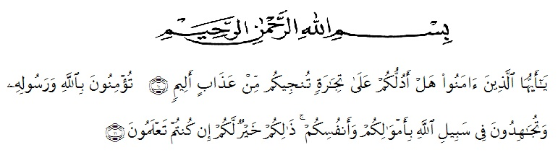

Meaning:
“Hai orang-orang yang beriman, sukakah kamu aku tunjukkan suatu perniagaan yang dapat menyelamat kamu dari azab yang pedih?¹⁰.
(yaitu kamu beriman kepada Allah SWT dan Rasul-Nya dan berjihad di jalan Allah dengan harta dan jiwamu. Itulah yang lebih baik bagimu jika kamu mengetahuinya¹¹.Qs (As-Shaff 10 : 11)
Alhamdulillahirabbil’alamin. First and foremost, the researcher would praise and thanks to Allah SWT, because of His blessings the researcher can complete this research. Secondly, sholawat and salam always be given to our prophet Nabi Muhammad SAW who has guided us from darkness to brightness. The researcher got suggestions, criticism and guidance from many people. Therefore, the researcher would like to extend her sincere and special thanks to:
- Dr. H. Firmansyah, M.Si. The Rector of UMN Al-Washliyah Medan,
- Dr. Abdul Mujib, S.Pd., M.PMat. The Dekan of the Faculty of Teachers’ Training and Education of Muslim Nusantara University,
- Zulfitri, S.S., M.A, as the leader of English Department of UMN Al-Washliyah Medan who has given knowledge and information.
- Rini Fadhillah Putri, S.Pd., M.Hum, as the first consultant, who has given correction, suggestion, support, criticism for completing her research.
- Dr. Asnawi, M.Hum., the Examiner 1 who has provided critiscm and direction.
- Drs. M.Khalid, M.Hum,. the Examiner 2 who has provided critiscm and direction.
- All lectures of the English Department of FKIP UMN Al-Washliyah Medan who have taught her.
- All of academic administration staff of Universitas Muslim Nusantara Al-Washliyah Medan.
- Supardi, S.Pd as The Headmaster of SMPS Prayatna Medan for given permission to conduct the research.
- Mam Tuti Mudrikah H and Madam as English subject teacher at SMPS Prayatna Medan who has helped the research process.
- The researcher’s beloved late father Alm. Mujito, thank you throughout his life for giving advice and motivation, "keep your enthusiasm even though my father is no longer in this world", Those words stick in researcher mind to this day.
- The researcher’s beloved Mom Zahrin Br, Ujung, thank you for supporting, mentally strengthening, and funding researchers all this time.
- The researcher’s beloved bestie in Riau Blackaren, Safitri, Lisa Amelia, Andini Miranda, Thank you guys for supporting, and comforting when researcher sad, and always being there for me.
- All of classmate of English Department class 8A Kyut gurl, who always support, motivation, help and our together and all beautiful memories.

The researcher realized that this thesis is still far for being perfect. Therefore, the researcher hopes constructive critics and suggestion will be highly appreciated much. May Allah SWT always give guidance and blessing to us. Amiin Ya Rabbal Alaamiin.
Medan, Oktober 2023
The researcher

Ulfa Deka

