UJI AKTIVITAS ANTIBAKTERI SABUN TRANSPARAN PUTIK SAFFON (Crocus sativus L) TERHADAP BAKTERI Staphylococcus aureus

EMMY WIWIANDINI
NPM. 182114090

ABSTRAK

Sabun transparan merupakan variasi sabun padat batang yang tidak hanya berfungsi untuk membersihkan kotoran, namun memiliki fungsi scrubbing. sabun padat transparan merupakan salah satu inovasi sabun yang menjadi sabun menarik. Saffron juga memiliki sifat antibakteri. Memiliki senyawa flavonoid, tanin dan saponin. Flavonoid merupakan senyawa yang dapat memiliki efek anti inflamasi, antikanker dan antioksidan, karena dapat menghambat pembentukan radikal bebas. Telah digunakan secara tradisional untuk mengobati berbagai penyakit termasuk depresi, penyakit kardiovaskular, gangguan menstruasi, asama, insomnia, penyakit pencernaan, nyeri tulang dan beberapa penyakit lainnya.
Sari putik Saffron dibuat dengan cara dilarutkan menggunakan aquades bebas CO₂. Skrining fitokimia dilakukan terhadap sari putik saffron. Sari putik saffron dibuat dalam berbagai formula Sabun yaitu formula I, formula II dan formula III. Kontrol positif yang digunakan adalah antibiotik kloramfenikol dan kontrol negatif adalah DMSO. Ada beberapa pengujian yang dilakukan pada sari Putik Saffron selain skrining fitokimia yaitu pengujian antibakteri pada sabun transparan dengan sari putik Saffron sebagai bahan tambahan sabun.
Hasil skrining fitokimia menunjukkan bahwa senyawa putik saffron (Crocus sativus L) mengandung senyawa metabolit sekunder yaitu : flavonoid, alkaloid, tanin, saponin. Dan untuk hasil penelitian aktivitas antibakteri juga menunjukkan bahwa sari putik Saffron terhadap sabun transparan dapat dijadikan sebagai bahan tambahan sabun, hasil antibakteri, memiliki daya hambat yang kuat pada nilai rata-rata formula III yaitu 20,5 dan formula II yaitu 18,4 mm dan formula I 16,1 mm, terhadap bakteri Staphylococcus aureus.

Kata Kunci : Putik Saffron (Crocus sativus L), Sabun Transparan, Skrining fitokimia, aktivitas Antibakteri, Staphylococcus aureus.

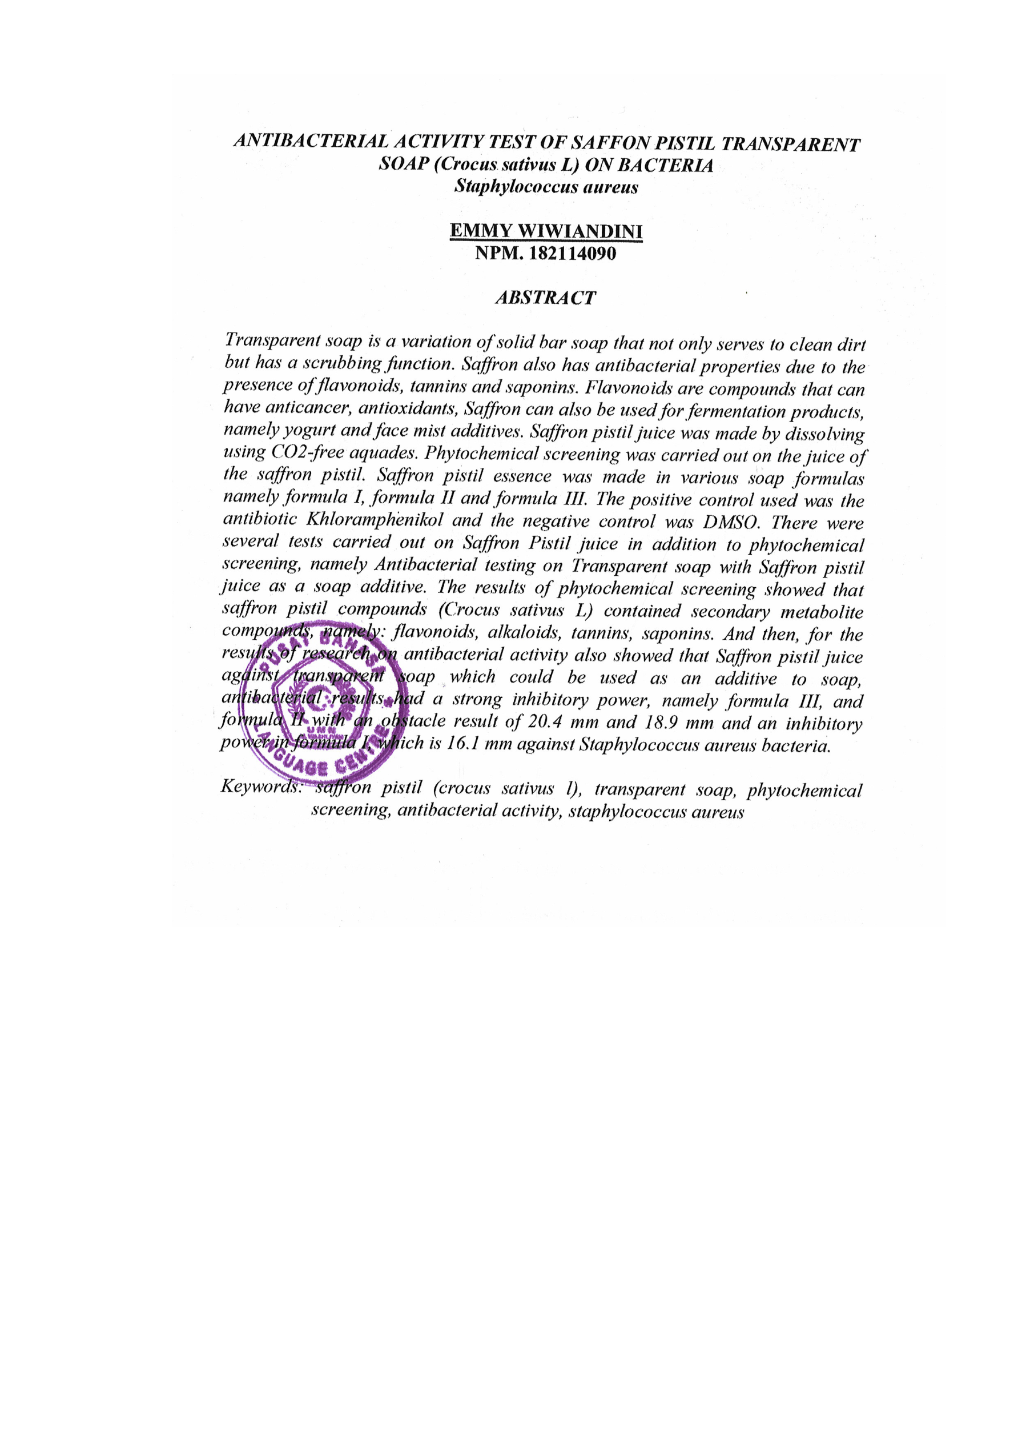
UJI AKTIVITAS ANTIBAKTERI SABUN TRANSPARAN PUTIK SAFFON (Crocus sativus L) TERHADAP BAKTERI Staphylococcus aureus

EMMY WIWIANDINI
NPM. 182114090

ABSTRACT

Transparent soap is a variation of solid bar soap that not only functions to clean dirt but also has a scrubbing function. Transparent solid soap is one of the soap innovations that has become an attractive soap. Saffron also has antibacterial properties due to the presence of flavonoids, tannins and saponins. Flavonoids are compounds that can have anti-inflammatory, anticancer and antioxidant effects, because they can inhibit the formation of free radicals. It has been used traditionally to treat various ailments including depression, cardiovascular disease, menstrual disorders, asthma, insomnia, digestive ailments, bone pain and several other ailments.
Saffron pistil juice is made by dissolving in CO₂-free distilled water. Phytochemical screening was carried out on saffron pistil extract. Saffron pistil juice is made in various soap formulas, namely formula I, formula II and formula III. The positive control used was chloramphenicol antibiotic and the negative control was DMSO. There were several tests carried out on Saffron pistil extract in addition to phytochemical screening, namely antibacterial testing on transparent soap with Saffron pistil extract as a soap additive.
The results of phytochemical screening showed that the pistil of saffron (Crocus sativus L) contained secondary metabolites, namely: flavonoids, alkaloids, tannins, and saponins. And for the results of the antibacterial activity research also showed that the Saffron pistil extract against transparent soap which can be used as a soap additive, the antibacterial results had a strong inhibition at the average value of formula III which was 20.5 and formula II was 18.4 mm and formula I 16.1 mm, against Staphylococcus aureus bacteria.

Keywords: Saffron (Crocus sativus L) pistil, Transparent Soap, Phytochemical Screening, Antibacterial activity, Staphylococcus aureus.

