ACKNOWLEDGEMENT
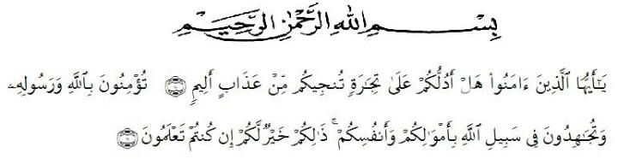
Artinya: “ Hai orang-orang yang beriman, maukah kamu aku tunjukkan suatu perniagaan yang dapat menyelamatkanmu dari azab yang pedih? (10). (yaitu) kamu beriman kepada Allah dan Rasul-nya dan berjihad di jalan Allah dengan harta dan jiwamu. Itulah yang lebih baik bagimu, jika kamu mengetahuinya. (11)”.
The author give thanks to Allah Subhanahu wa taala, for all the graces and blessings that provide health and wisdom to the author that this study can be completed properly in accordance with the planned time. Shalawat and Salam to our beloved Prophet Muhammad SAW, the greatest man ever who teaches us the kindness and good life in order to ben the good Muslim. We hope his salutation in future day. This thesis entitled “EFL Students Motivation on Learning English With Authentic Video Project in Academic Year 2020-2021” can be completed in order to fulfill one of the requirements in completing education at the Department of English Education Faculty of the Teacher Training and Education, the University of Muslim Nusantara Al Washliyah Medan.

In the process of finishing this thesis, the author has been given many supports and valuable knowledge from many people. Therefore, the reseaecher would like to express her great appreciation and thanks:
- Dr. KRT. Hardi Mulyono K. Surbakti, as the Rector of Universitas Muslim Nusantara Al Washliyah Medan.
- Dr. Samsul Bahri, M. Si, as the Dean of FKIP of Universitas Muslim Nusantara Al WAshliyah Medan.
- Dra. Hj. Nurjannah, M. Si, as Plt. of the Head of English Education Department in Universitas Muslim Nusantara Al Wasliyah Medan.
- Zulfitri, S.S., M.A, as the Head of the English Education Department of Universitas Muslim Nusantara Al Washliyah Medan.
- Nazriani Lubis, S.Pd., M.Hum, as the consultant who gives the command, critics and suggestion to the researcher in finishing the proposal.
- All of the lecturer of the English Education Department of Universitas Muslim Nusantara Al Washliyah Medan.
- All of the Academic Administration Staff of Universitas Muslim Nusantara Al Washliyah Medan.
- Campus Univesitas Muslim Nusantara and all of administration staff who have given permission for the place to carry out research
- The researcher would like to thank you the resource persons for their contribution during research.
- Her beloved parents, Ibu Siti Zainab and Bapak Musriadi, and all her family. I would like to thank you, how lucky I am for being your little girl. And also my little brother Azlam, who have given the greatest love, prayer, kindness, and everything to support.
- For all her lovely friends, Adisty, Sahrul, Glis, kak Cici, Ija, Icak, Vira, Ika, Maudy, who always support. Thanks for your love.
- For my boyfriend Canserio, thank you so much for your time and support.
- All her friends in her life, thank you so much for your wonderful times. The researcher knows that this paper needs to be revised in order to get good result. The researcher also hopes that this paper would be useful for us. Aamiin.

Medan, July 2021
The Author,

Abdi Zihan Nanda
ID. 171224046

