PENGEMBANGAN MEDIA POP-UP BOOK PADA MATA PELAJARAN IPA MATERI DAUR HIDUP HEWAN KELAS IV SEKOLAH DASAR

IKA NUR’AINI BAHAR
NPM. 191434205

ABSTRAK

Tujuan penelitian pengembangan ini adalah untuk mendeskripsikan kelayakan media pop-up book mata pelajaran IPA materi daur hidup hewan kelas IV sekolah dasar dalam meningkatkan hasil belajar siswa. Dengan adanya media ini, diharapkan adanya peningkatan hasil belajar siswa dengan berdasar pada nilai kevalidan, kepraktisan, efektivitas media yang diperoleh selama penelitian. Dalam prosesnya, digunakan ADDIE sebagai tahapan pengembangan yang mana terdiri dari 5 tahap, yakni tahap analisis (analyze), perancangan (design), pengembangan (development), implementasi (implementation), dan evaluasi (evaluation). Subjek dalam penelitian ini, yaitu validator ahli media, validator ahli materi dan validator ahli pembelajaran yang akan menilai kelayakan dari media Pop Up Book yang dikembangkan. Adapun objek dalam penelitian ini, yaitu media Pop Up Book mata pelajaran IPA materi daur hidup hewan di kelas IV yang dikembangkan. hasil penelitian dan pengembangan yang dilakukan oleh peneliti dapat disimpulkan bahwa peneliti dan pengembangan menggunakan tahapan-tahapan dengan model ADDIE dengan demikian peneliti hanya menggunakan 3 tahapan dengan Langkah-langkah analysis (Analisis), Design (Desain), Development (pengembangan) yang telah menghasilkan produk berupa media Pop-Up Book pada tema metamorfosis untuk kelas IV SD Berdasarkan hasil skor dari kelayakan media pembelajaran Pop-Up Book yang sudah divalidasikan oleh ahli media skor 77%, ahli materi skor 94% dan tanggapan guru skor 94% tersebut, maka pengembangan media pembelajaran Pop-Up Book pada tema metamorfosis yang dikembangkan oleh peneliti tersebut masuk dalam kategori Sangat Layak digunakan sebagai media pembelajaran untuk siswa kelas IV SD.

Kata kunci: pop up book, daur hidup hewan, media pembelajaran

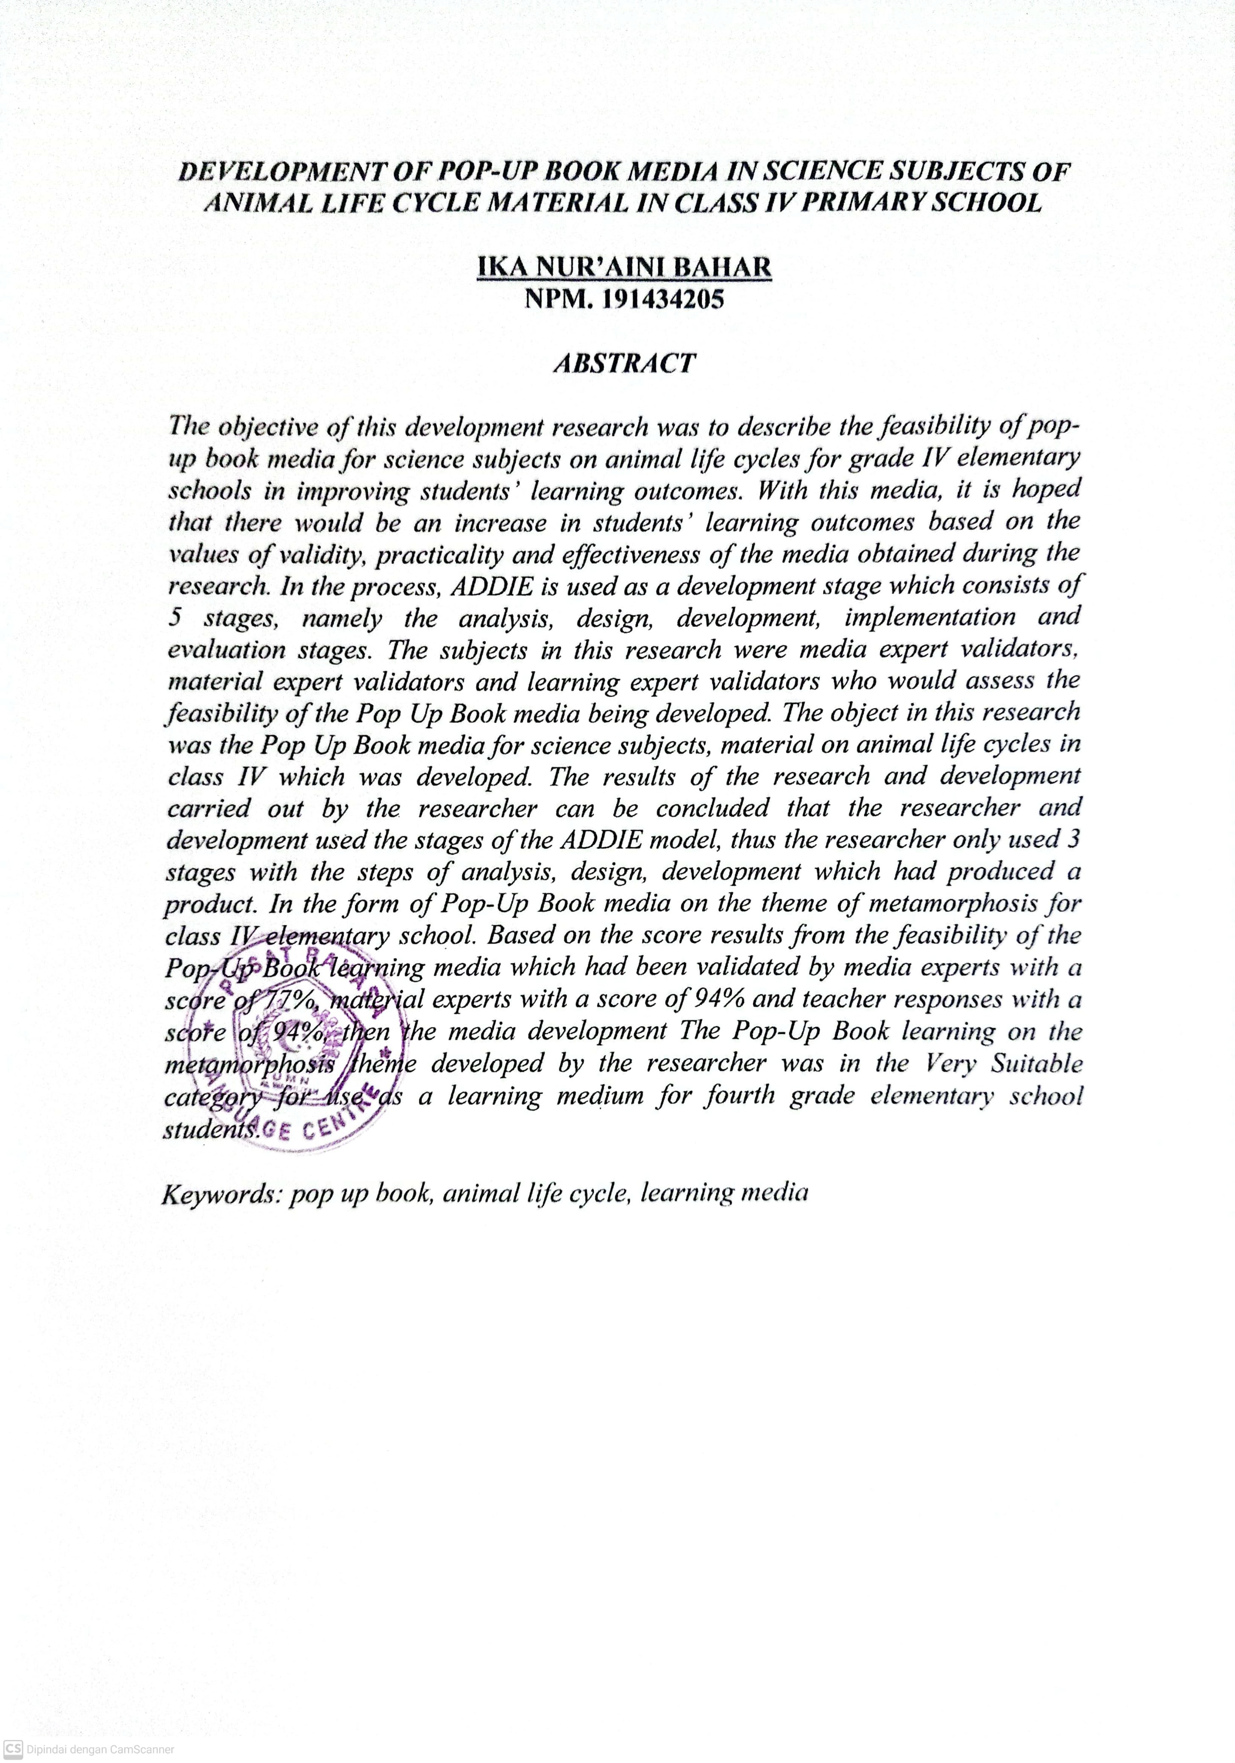
DEVELOPMENT OF POP-UP BOOK MEDIA IN SCIENCE SUBJECTS OF ANIMAL LIFE CYCLE MATERIAL IN CLASS IV PRIMARY SCHOOL

IKA NUR’AINI BAHAR
NPM. 191434205

ABSTRACT

The objective of this development research was to describe the feasibility of pop-up book media for science subjects on animal life cycles for grade IV elementary schools in improving students’ learning outcomes. With this media, it is hoped that there would be an increase in students’ learning outcomes based on the values of validity, practicality and effectiveness of the media obtained during the research. In the process, ADDIE is used as a development stage which consists of 5 stages, namely the analysis, design, development, implementation and evaluation stages. The subjects in this research were media expert validators, material expert validators and learning expert validators who would assess the feasibility of the Pop Up Book media being developed. The object in this research was the Pop Up Book media for science subjects, material on animal life cycles in class IV which was developed. The results of the research and development carried out by the researcher can be concluded that the researcher and development used the stages of the ADDIE model, thus the researcher only used 3 stages with the steps of analysis, design, development which had produced a product. In the form of Pop-Up Book media on the theme of metamorphosis for class IV elementary school. Based on the score results from the feasibility of the Pop-Up Book learning media which had been validated by media experts with a score of 77%, material experts with a score of 94% and teacher responses with a score of 94%, then the media development The Pop-Up Book learning on the metamorphosis theme developed by the researcher was in the Very Suitable category for use as a learning medium for fourth grade elementary school students.

Keywords: pop up book, animal life cycle, learning media

