ACKNOWLEDGEMENT

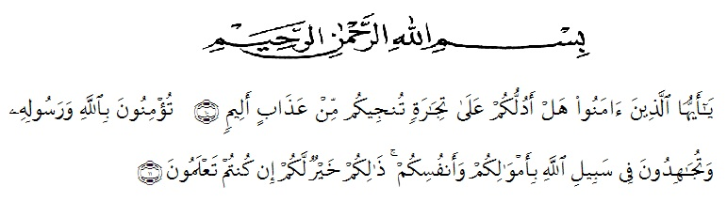

Meaning:
“Hai orang-orang yang beriman, sukakah kamu aku tunjukkan suatu perniagaan yang dapat menyelamat kamu dari azab yang pedih?¹⁰.
(yaitu kamu beriman kepada Allah SWT dan Rasul-Nya dan berjihad di jalan Allah dengan harta dan jiwamu. Itulah yang lebih baik bagimu jika kamu mengetahuinya¹¹.Qs (As-Shaff 10 : 11)
Alhamdulillahirabbil’alamin. First and foremost, the researcher would praise and thanks to Allah SWT, because of His blessings the researcher can complete this research. Secondly, sholawat and salam always be given to our prophet Nabi Muhammad SAW who has guided us from darkness to brightness. The researcher got suggestions, criticism and guidance from many people. Therefore, the researcher would like to extend her sincere and special thanks to:
- Dr. H. Firmansyah, M.Si, as the Rector of UMN Al-Washliyah Medan,
- Dr. Abdul Mujib, S.Pd., M.PMat as the Dean of the Faculty of Teachers’ Training and Education of Muslim Nusantara University,
- Zulfitri, S.S., M.A, as the leader of English Department of UMN Al-Washliyah Medan who has given knowledge and information.
- Dahlia Sirait, S.Pd., M.Hum, as the first consultant, who has given correction, suggestion, support, criticism for completing her research.
- All lectures of the English Department of FKIP UMN Al-Washliyah Medan who have taught her.
- All of academic administration staff of Universitas Muslim Nusantara Al-Washliyah Medan.
- Supardi, S.Pd as The Headmaster of SMPS Prayatna Medan for given permission to conduct the research.
- Mam Tuti Mudrikah H and Madam as English subject teacher at SMPS Prayatna Medan who has helped the research process.
- Ali Mahdar Ritonga, S.Pd.,S.M as brother and teacher at SMPS Prayatna Medan who has a lot in the research.
- The researcher’s beloved parents, Samuddin Pasaribu and Ijah, who always support her financial, moral and for their love, support, praying and everything that will never forgotten.
- The researcher’s beloved brother and sisters, Nurhaidah Pasaribu, Ilham Fahri Pasaribu, Yeni Rahmadani Pasaribu S.E and Andriyani, S.Kom who always support her financial, motivation, praying, and everything.
- The researcher’s uncle and aunt, Hamonangan Pasaribu and Lailatul Khusna Tanjung S.Pd who always support her financial, motivation and praying.
- The researcher’s beloved best friend High School Wulan Aprianty S.E, Wahyu T, Dimas, and Febri, who always remember her in finishing thesis and praying to success her.
- All of classmate of English Department class 8A Kyut gurl Ila Paramida, Susi Melyana, Vica Annisah Gultom, Nabila Albalqis, Ulfa Deka, Siti Ramlah Siregar who always support, motivation, help and our together and all beautiful memories.

The researcher realized that this thesis is still far for being perfect. Therefore, the researcher hopes constructive critics and suggestion will be highly appreciated much. May Allah SWT always give guidance and blessing to us. Amiin Ya Rabbal Alaamiin.
Medan, Agustus 2023
The researcher

Siti Zubaidah Pasaribu

