THE EFFECT OF PLAYING CARD TECHNIQUE TO IMPROVE STUDENTS’ SPEAKING SKILL ON
THE SEVENTH GRADE STUDENTS OF
SMP SWASTA PRAYATNA MEDAN

A SKRIPSI

by
NABILA ALBALQIS
NPM: 191224009

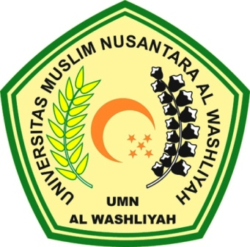

ENGLISH EDUCATION DEPARTMENT
FACULTY OF TEACHER TRAINING AND EDUCATION
UNIVERSITAS MUSLIM NUSANTARA AL-WASHLIYAH
MEDAN
2023

THE EFFECT OF PLAYING CARD TECHNIQUE TO IMPROVE STUDENTS’ SPEAKING SKILL ON
THE SEVENTH GRADE STUDENTS OF
SMP SWASTA PRAYATNA MEDAN

Submitted to the Department of English Language Education in Partial Fulfillment of the Requirements for the Degree of
Sarjana Pendidikan

by
NABILA ALBALQIS
NPM: 191224009

ENGLISH EDUCATION DEPARTMENT
FACULTY OF TEACHER TRAINING AND EDUCATION
UNIVERSITAS MUSLIM NUSANTARA AL-WASHLIYAH
MEDAN
2023

