**DEVELOPING SPEAKING INSTRUCTION THROUGH WHOLE**

**BRAIN TEACHING FOR TENTH GRADER AT SMA**

**SWASTA NUR AZIZI TANJUNG MORAWA  
IN ACADEMIC YEAR 2023/2024**

**THESIS**

**By**

**REVI RESTU AYANDA**

**Registration Number : 217215008**

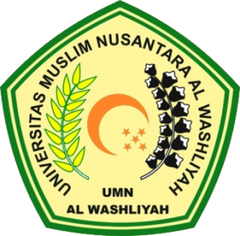

**ENGLISH EDUCATION DEPARTMENT**

**POSTGRADUATE PROGRAM**

**UNIVERSITAS MUSLIM NUSANTARA AL WASHLIYAH**

**2023**

**DEVELOPING SPEAKING INSTRUCTION THROUGH WHOLE**

**BRAIN TEACHING FOR TENTH GRADER AT SMA**

**SWASTA NUR AZIZI TANJUNG MORAWA  
IN ACADEMIC YEAR 2023/2024**

Submitted to Obtain a Master Degree in English Education (M.Pd.)

In the Postgraduate Master Program in English Language Education (S2)

Universitas Muslim Nusantara Al-Washliyah

**By**

**REVI RESTU AYANDA**

**Registration Number : 217215008**



**POSTGRADUATE PROGRAM**

**UNIVERSITAS MUSLIM NUSANTARA AL WASHLIYAH**

**2023**