# ACKNOWLEDGEMENT

First of all, the greatest gratitude to TUHAN YME, the Almighty God for the blessing which has been given to the writer so that she finally completed this proposal in partial fulfillment of the requirements for the degree of *Sarjana Pendidikan* at Faculty of Teachers’ Training and Education, English Education Department of the University of Muslim Nusantara Al Washliyah Medan. This proposal could not have been accomplished without the guidance, suggestions, and comments from several people so that in this opportunity the writer would like to express her deep gratitude to the following people:

1. **Dr. KRT. Hardi Mulyono Surbakti,** the rector of Muslim Nusantara AlWashliyah University.
2. **Drs. Samsul Bahri, M.Si.**, the dean of the Teachers’ Training and Education, Faculty of Muslim Nusantara Al Washliyah University Medan.
3. **Zulfitri, S.S, M.A** the head of English Language Education Department of Muslim Nusantara Al Washliyah University
4. **Yugi Diraga Prawiyata, S.Pd., M.Hum** the Adviser who give the command, critic, suggestion ,and also motivation that always supporting the writer in finishing the script.
5. All of the lectures of the English Education Department of Muslim Nusantara Al Washliyah University Medan.
6. All of the Academic Administration Staffs of Muslim Nusantara Al Washliyah University Medan.
7. All of the Librarians Staffs of Muslim Nusantara Al Washliyah University Medan.
8. **Jhonny and Eneng**, the researcher’s beloved parents who always love, care, pray and give the advices and spirit so that the writer can grow up and can reach this position. Thank you for your struggle that always make me realize that both of you is important for me. Both of you always accompany me if I do this thesis until midnight. I hope both of you always happy whenever and wherever. Also thanks for writer’s beloved brother **Okky,Oktav,Arthur** that always give me suggestion and always support me, always accompany me if I have something that urgent or must be printed at night, I hope you will be success in the future. Thank you for the writer’s big family that can’t be mention one by one, thanks for support, suggestion, like financial and also the motivation that always given to me.
9. **Dheasy,Bella** my bestie Since we were SMA until now thank you for suggest, support, and motivate the writer. To my best friend happy or sad we were together , thanks for the time when the writer feel tired you support soon. Ans also **All my Family and Friends in Pubg (Shinta,Bg Wili,Bg Ray,and Bg daren)** that always give me a happy place that i can deliver my feeling and my condition.
10. **Syarifah Aini Sinaga, Windi Novia Sari Lubis, Intan Pohan** who becomes writer’s friends in sharing about proposal, lessons, experiences, problems or even love.

Finally, the writer realize that this script far from being perfect. Therefore, constructive suggestion is needed for the progress of the next research.

Medan, June 2023

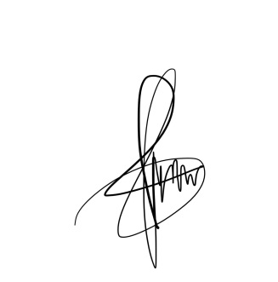The researcher,

**Yehmima Debora Saragih**

**171224109**