**THE EFFECT OF USING INTENSIVE READING STRATEGY ON STUDENTS’ VOCABULARY ACHIEVEMENT AT THE FIRST YEAR STUDENT**

# A THESIS

# BY :

**YEHMIMA DEBORA SARAGIH**

**NPM : 171224109**

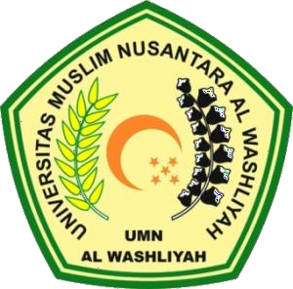

**FACULTY OF TEACHER TRAINING AND EDUCATION UNIVERSITAS MUSLIM NUSANTARA AL-WASHLIYAH MEDAN**

**2022**