# ACKNOWLEDGEMENTS

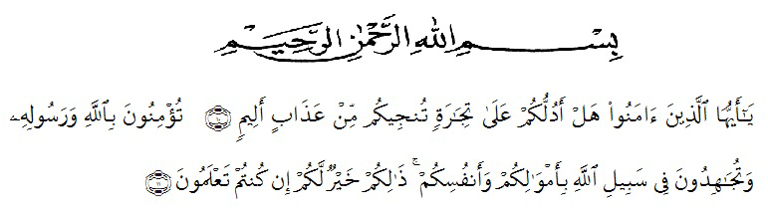

The meaning:

10. O you who believe! Do you want me to show you a trade that can save you from a painful punishment? 11. (That is) you believe in Allah and His Messenger and strive in the way of Allah with your wealth and your soul. That is better for you if you know. (QS. Ash Shaff: 10-11)

First of all, the researcher likes to express her greatest thanks to Allah SWT, for blessing that has been given to her especially health and luck until this thesis could be completed and also *shalawat* and *salam* to our prophet Muhammad SAW who has brought human being from the dark era into bright era.

In the process of completing the thesis, she received suggestions, assistances, criticism and lots of guidance from many people whom she cannot mention one by one, but she would like to thank them. Especially she would like to thank to:

1. Dr. Firmansyah, M.Si. the Rector of Muslim Nusantara Al Washliyah University.
2. Dr. Abdul Mujib, S.Pd., M.Pmat. the Dean of the faculty of Teachers Training and Education of Muslim Nusantara Al Washliyah University.
3. Zulfitri, S.S., M.A., M.Pd. the Head of English Education Department who had provided her time, knowledge, guiding, and suggestion for her.
4. Yulia Sari Harahap, S.Pd., M.Hum. the adviser who had contributed her time, knowledge, guiding, suggestion and comments to help her write the draft of this thesis.
5. Dr. Yulia Arfanti, M.Hum. and Asnawi, S.Pd., M.Hum. the reviewers who had contributed their time, knowledge, guiding, suggestion and comments to help her write the draft this thesis.
6. Fauziah Noor Siregar, S.Pd., M.Si. the headmaster of SMP Negeri 1 Delitua for supporting and assisting her during the research.
7. All lectures at the English Department of FKIP UMN Al Washliyah Medan for their valuable discussion to enrich her knowledge.
8. Her beloved mother, Machraini, M.Pd. for all help, attention, support, hardwork, material support and pray which gave her spirit to finished this thesis.
9. Her beloved late father who has always prayed and worked hard for all of his children to become scholars.
10. Her beloved young sister, Rizki Aulia, who always provided help, support and lent her laptop during the process of completing this thesis and her beloved young brother, Syukri Ramadhan, who always provided support and reminded her to complete this thesis.
11. Her beloved cousins, sister Syafira, sister Halfa Hansyah and her beloved aunty Masniari who always given support, always ask about the progress of this thesis and reminds her to finish this thesis.
12. All of her friends from the Sports Organization of UMN Al Washliyah Medan. Especially, Ira Amalia Harahap, S.Pd., Aswan Simanjuntak, S.Pd., Rizky Ananda Hafit, S.Pd., and Mega Utami Aulia, S.Pd., who have given support, guiding, suggestions and comments to help her finish this thesis.
13. All of her colleagues in 8A of English Department. Especially, sister Indah Ayu Br. Tarigan, S.Pd., Emya Gresta Br. Sembiring, S.Pd., Dilla Anglia, S.Pd., and Brother Iwan Rizky Daulay, S.Pd., who have given support, guiding, gave suggestions and comments to help her finish this thesis.
14. All Grade VIII students of SMP Negeri 1 Delitua who are very enthusiastic in following her directions.

Finally, she realizes that she cannot recompense the contribution of those people mentioned above. She prays upon Allah SWT, may Allah SWT bless them all in hereafter. *Aamiin Ya Rabbal ‘aalamiin.*

Medan, ... June 2023

The Researcher

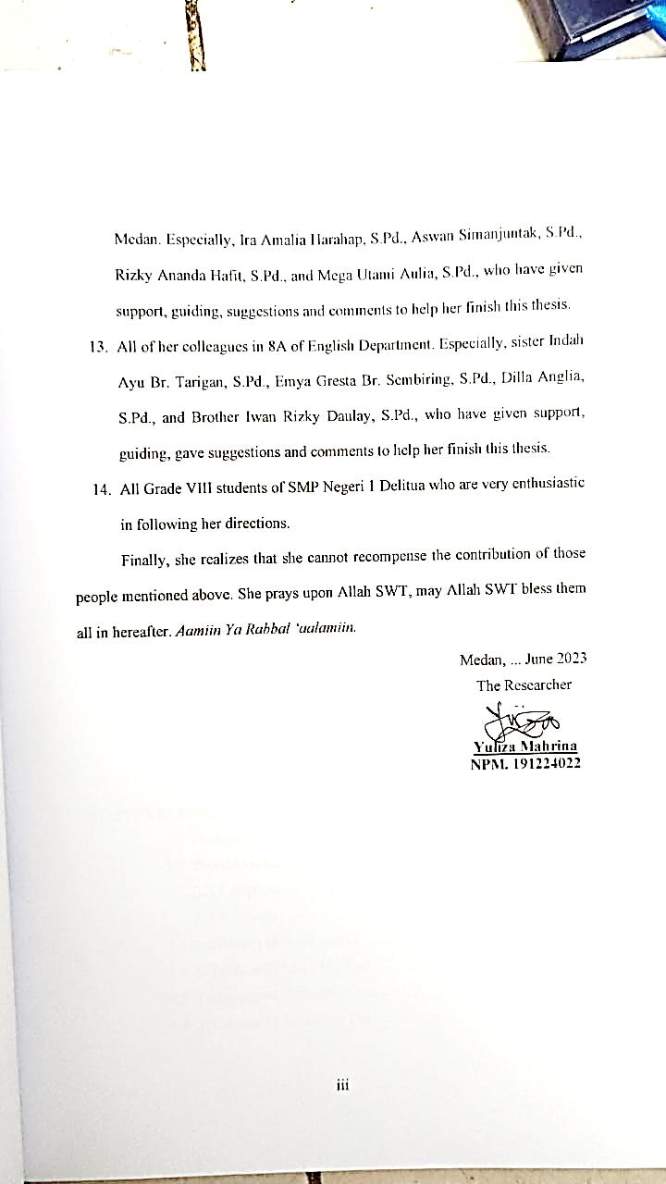

**Yuliza Mahrina**

**NPM. 191224022**