# ACKNOWLEDEGMENT

بِسْــــــــــــــــــمِ اللهِ الرَّحْمَنِ الرَّحِيْمِ

يَا أَيُّهَا الَّذِينَ آمَنُوا هَلْ أَدُلُّكُمْ عَلَىٰ تِجَارَةٍ تُنْجِيكُمْ مِنْ عَذَابٍ أَلِيمٍ (١٠) تُؤْمِنُونَ بِاللَّهِ

وَرَسُولِهِ وَتُجَاهِدُونَ فِي سَبِيلِ اللَّهِ بِأَمْوَالِكُمْ وَأَنْفُسِكُمْ ۚ ذَٰلِكُمْ خَيْرٌ لَكُمْ إِنْ كُنْتُمْ

تَعْلَمُونَ (١١)

# Artinya :

“Hai, orang-orang yang beriman, sukakah kamu aku tunjukkan suatu perniagaan yang dapat menyelamatkanmu dari azab yang pedih?” (Q.S. Ash-shaff:10)

“(yaitu) kamu beriman kepada Allah dan Rasul-Nya dan berjihad di jalan Allah dengan harta dan jiwamu. Itulah yang lebih baik bagimu, jika kamu mengetahui.” (Q.S. Ash-shaff:11)

## Assalamu'alaikum Warahmatullahi Wabarakatuh

*Alhamdulillah*, First of all the researcher would like to praises and thank to ALLAH SWT who has given the grace and guidance to complete this thesis on time. Sholawat and salam be upon to the greatest Prophet Muhammad SAW.

This thesis entitled **“Conceptual Metaphor In The Poetry Collection *Love Letters For The Future You* by Adi K : Cognitive Semantics Study”** was prepared to fulfill one of the requirements to obtain a bachelor's degree in Literature in the English literature study program at the University of Muslim Nusantara Al- Washliyah Medan.

For the first, the researcher expresses the deepest gratitude to her beloved parents and family who have provided support in the form of moral and material as well as prayers that have always flowed during her study.

In addition, the researcher would like to convey the appreciation to the following amazing people, namely:

1. Dr. H. Firmansyah, M.Si, as a Rector of The University of Muslim Nusantara Al-Washliyah Medan.
2. Dewi Nurmala, S.S., M.Hum., as Dean of the Faculty of Letters.
3. Diana Sopha, S.S., M.Hum., as Deputy Dean of the Faculty of Letters.
4. Ayu Melati Ningsih, S.Pd., M.S., as the Head of English Literature Study Program.
5. Rezky Khoirina Tarihoran, S.S., M.A., as the thesis supervisor who has helped provide solutions to every obstacle and has sacrificed her valuable time to guide me in completing this thesis.
6. Dr. Yulia Arfanti, M.Hum., and Ayu Melati Ningsih, S.Pd., M.S., as the examining lecturer who has provided many constructive suggestions and inputs to the researcher.
7. All lecturers in the Faculty of Letters who have taught and inspired me during the study.
8. My beloved family, my younger siblings and my grandmother who have provided a lot of support and assistance to me in completing this thesis, may Allah always protect and bless them.
9. My closest friends Pinka Yani, Almira Devany, Dini Fitriani Nst, Dea Deffiar, and Muftia Zakia Mawaddah as well as friends in the 2020 English Literature class who always accompany and encourage me to complete this thesis.
10. Everyone I met and spent time together that cannot be mentioned one by one in sharing the insights, spirit, knowledge, experiences, and motivations for me.
11. *Last but not least, I wanna thank me, I wanna thank me for believing in me, I wanna thank me for doing all this hard work, I wanna thank me for having no days off. I wanna thank me for never quitting, I wanna thank me for just being me at all times.*

This thesis may be far from perfect, so this thesis requires critiaism and suggestion so that it can be improved and become batter in the future. And lastly, the researcher hope that this thesis can make a positive and educational contribut ion to all its readers.

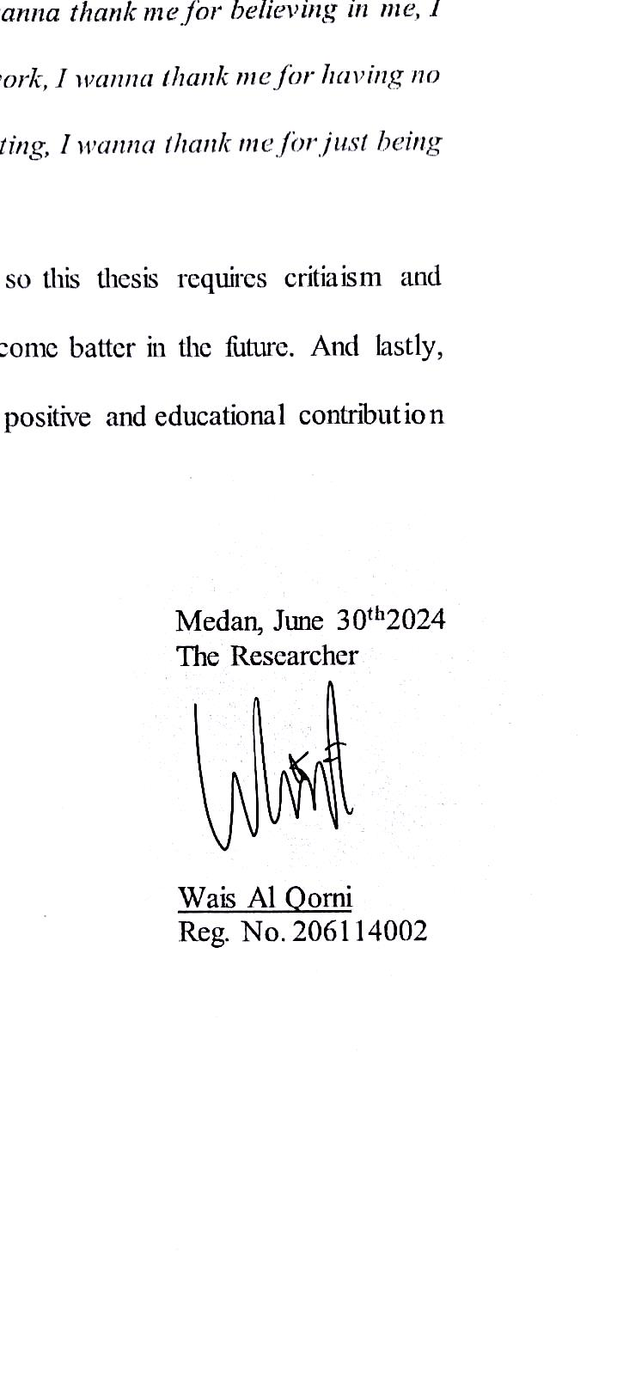Medan, June 30th2024 The Researcher

Wais Al Qorni

Reg. No. 206114002