# ACKNOWLEDGEMENT

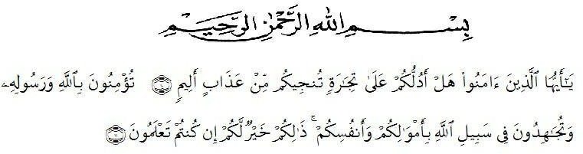

**Artinya:**"Wahai orang-orang yang beriman! Maukah kamu Aku tunjukkan suatu perdagangan yang dapat menyelamatkan kamu dari azab yang pedih? (10) (Yaitu) kamu beriman kepada Allah dan Rasul- Nya dan berjihad di jalan Allah dengan harta dan jiwamu. Itulah yang lebih baik bagi kamu jika kamu mengetahui (11)" (As-Saff ayat 100-11)

All praise is to Allah, the Almighty, the Merciful, for the blessing given to the researcher so that can finish this thesis. Shalawat and Salam are delivered to the prophet Muhammad SAW. Hopefully the researcher will get intercession from him in hereafter later

In this occasion with great humility, the researcher would like to thank you to all of those who have given her help and guidance so that this thesis can be finished on time. Completion of writing of this thesis, the researcher would like to thank to

1. Dr. KRT. Hardi Mulyono K.Surbakti as the Rector of UMN AI Washliyah,
2. Drs. Samsul Bahri, M.Si, as the Dean of FKIP UMN Al Washliyah.
3. Zulfitri, S.S., M.A.,M.Pd, as the Head of the English Education Study Program.
4. Teguh Satria Amin, S.Pd., M.Hum, as the Adviser who has given a lot of valuable suggestions, attention, comments, and critism for completing this research.
5. All lecturers in Teachers' Training and Education Faculty, especially in English Education Study Program, Thanks for the teaching during this time.
6. Nazra Indrawati,SE as the headmaster in SMPS Plus Kasih Ibu Patumbak and all the teachers especially all English teachers as well as the students in the school where the researcher did the research.

ii

