**PENGEMBANGAN MEDIA KARTU KUARTET UNTUK MENINGKATKAN NILAI-NILAI PANCASILA SISWA**

**KELAS III SDN 1304 MOMPANG**

**UMMIYATUL TAZKIA RODINA NASUTION**

**NPM. 201434168**

**ABSTRAK**

Penelitian ini bertujuan untuk mengetahui kelayakan media pembelajaran kuartet pada materi nilai-nilai Pancasila melalui respon siswa, respon guru, dan hasil belajar siswa. Metode penelitian menggunakan metode pengembangan dengan desain ADDIE. Sampel penelitian adalah satu orang ahli media, satu orang ahli materi, dan tiga orang guru. Instrumen pengumpulan data angket ahli materi, angket ahli media, dan angket respon guru. Teknik analisis data adalah deskripsi data dan persentase. Hasil penelitian yang diperoleh sebagai berikut: 1) Pengembangan media pembelajaran kartu kuartet dilakukan berdasarkan analisis permasalahan, analisis, kebutuhan, dan tinjauan terhadap teori yang ada berdasarkan bimbingan dari ahli; 2) Kelayakan media pembelajaran kartu kuartet materi nilai-nilai Pancasila mendapatkan validitas sangat layak dari ahli materi dan ahli media dengan rentang kelayakan 81-100% kategori sangat layak yang mana ahli materi memberikan skor 82,86%, dan ahli media memberikan skor 84,76%; 3) Respon guru SDN 1304 Mompang terhadap media pembelajaran kartu kuartet materi nilai-nilai Pancasila untuk siswa kelas III SD sebesar 82,08% berada pada rentang 81-100% dengan kategori sangat layak. Dapat disimpulkan bahwa media pembelajaran kuartet layak digunakan pada mata pelajaran PKn materi nilai-nilai Pancasila.

**Kata kunci:** Media kuartet, nilai pancasila, ahli media, materi, respon guru

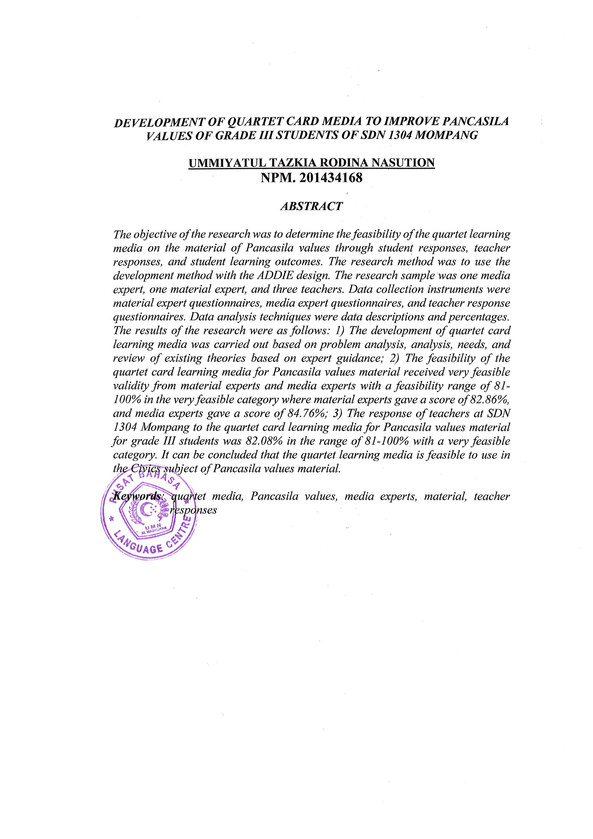***DEVELOPMENT OF QUARTET CARD MEDIA TO IMPROVE PANCASILA VALUES OF GRADE III STUDENTS OF SDN 1304 MOMPANG***

**UMMIYATUL TAZKIA RODINA NASUTION**

**NPM. 201434168**

***ABSTRACT***

*The objective of the research was to determine the feasibility of the quartet learning media on the material of Pancasila values ​​through student responses, teacher responses, and student learning outcomes. The research method was to use the development method with the ADDIE design. The research sample was one media expert, one material expert, and three teachers. Data collection instruments were material expert questionnaires, media expert questionnaires, and teacher response questionnaires. Data analysis techniques were data descriptions and percentages. The results of the research were as follows: 1) The development of quartet card learning media was carried out based on problem analysis, analysis, needs, and review of existing theories based on expert guidance; 2) The feasibility of the quartet card learning media for Pancasila values ​​material received very feasible validity from material experts and media experts with a feasibility range of 81-100% in the very feasible category where material experts gave a score of 82.86%, and media experts gave a score of 84.76%; 3) The response of teachers at SDN 1304 Mompang to the quartet card learning media for Pancasila values ​​material for grade III students was 82.08% in the range of 81-100% with a very feasible category. It can be concluded that the quartet learning media is feasible to use in the Civics subject of Pancasila values ​​material.*

***Keywords****: quartet media, Pancasila values, media experts, material, teacher responses*