# ABSTRACT

***THE EFFECT OF PROJECT-BASED LEARNING STRATEGIES AND CONVENTIONAL STRATEGIES, AND STUDENTS' INTEREST IN READING ON THE ABILITY TO WRITE SHORT RELIGIOUS STORIES AMONG SEVENTH-GRADE STUDENTS***

# AT SMP NEGERI 1 DELI TUA ACADEMIC YEAR 2023-2024

ETI SUKOWATI NPM 227015001

# ABSTRACT

The objectives of this research were: (1) to describe the differences in the results of writing short religious stories between students taught using project-based learning strategies and those taught using conventional strategies; (2) to describe the differences in the results of writing short religious stories between students with high and low interest in reading short stories; and (3) to describe the interaction between project- based learning strategies and interest in reading short stories on the ability to write short religious stories among seventh-grade students at SMP Negeri 1 Deli Tua for the 2023- 2024 academic year. The population for this research comprised all seventh-grade students at SMP Negeri 1 Deli Tua for the 2023-2024 academic year, totaling 160 students. The sample included two classes: VII-1 as the experimental group and VII-2 as the control group. Instruments used included questionnaires and writing tests. The results showed that the mean score for writing short religious stories was 83.19 in the experimental class compared to 72.22 in the control class; the mean interest score was

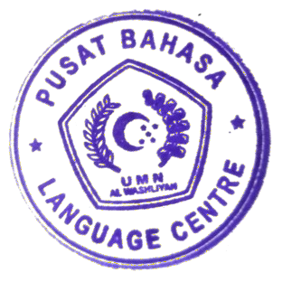88.11 in the experimental class compared to 58.44 in the control class. The research concluded that there were differences in the results of writing short religious stories between students taught with project-based learning strategies and those taught with conventional strategies, with a mean difference of 83.1; there was a difference in writing results between students with high and low interest in reading short stories, with a mean difference of 88.11, reflecting the interaction between project-based learning strategies and reading interest in enhancing the ability to write short religious stories.

**Keywords:** project-based learning strategies, writing ability, short stories.

i

i