**ABSTRAK**

**PENGEMBANGAN MEDIA PEMBELAJARAN BERBANTUAN APLIKASI *MACROMEDIAFLASH* BERBASIS *PROBLEM BASED LEARNING* PADA PEMBELAJARAN MATEMATIKA PECAHAN KELAS IV SD**

**ERNA SARI RAMBE NPM : 201434200**

Penelitian ini bertujuan untuk mengembangkan media pembelajaran berbantuan

Aplikasi *Macromedia Flash* berbasis *Problem Based Learning* pada pembelajaran matematika pecahan dan mengetahui kelayakan media. Penelitian ini merupakan jenis penelitian pengembangan (*Research and Development*) dengan menggunakan model ADDIE. Penelitian dilakukan dengan lima tahapan desain yaitu 1) *Analysis*;

*2)Design*; *3) Development*; *4)Implementation; 5)Evaluation.* Subjek dalam penelitian ini adalah 1 validator ahli media dan 1 validator ahli materi. Instrument yang digunakan untuk mengumpulkan data adalah kuesioner. Teknik analisis data yang digunakan dalam penelitian ini adalah deskriptif kualitatif. Berdasarkan kelayakan media dari masukan para ahli materi yaitu dosen, ahli media yaitu dosen. Mencapai 83% degan kategori sangat layak, ahli materi (dosen), mencapai 87,2% Jika presentase yang dicapai 80% sampai 100% maka media pembelajaran berbantuan *Macromedia Flash* berbasis *Problem Based Learning* dikategorikan sangat layak. Jika pesrsentase 80% sampai 100% maka materi pembelajaran dikatakan sangat layak. Dari data hasil validasi, pengembangan media pembelajaran berbantuan *Macromedia Flash* berbasis *Problem Based Learning* pada pembelajaran matematika pecahan yang dikembangkan oleh peneliti dinyatakan sangat layak untuk digunakan sebagai media pembelajaran dalam proses pembelajaran.

***Kata Kunci: Media Pembelajaran, Macromedia Flash ,Matematika Pecahan***

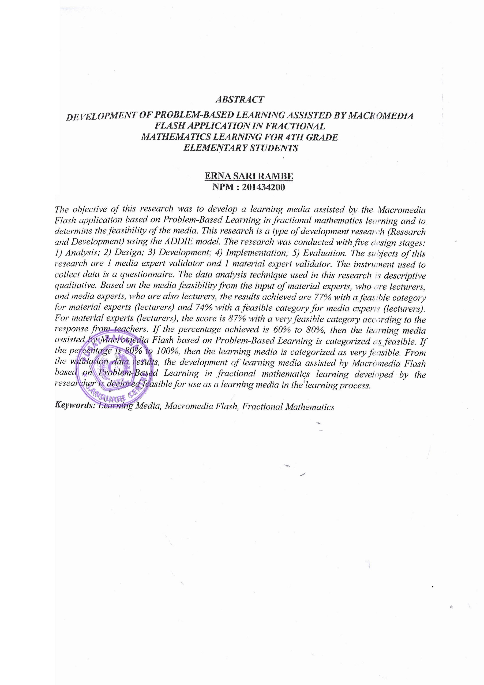

**ABSTRACT**

**DEVELOPMENT OF LEARNING MEDIA ASSISTED WITH THE MACROMEDIAFLASH APPLICATION BASED ON PROBLEM BASED LEARNING IN LEARNING FRACTION MATHEMATICS IN CLASS IV SD**

**ERNA SARI RAMBE**

**201434200**

This research aims to develop assisted learning media the macromedia flash application is based on Problem Based Learning in learning mathematics

fractions and determining the suitability of the media. This research is a type of research and development using the ADDIE model. The research was carried out in five design stages, namely 1) Analysis; 2) Design; 3) Development; 4) Implementation; 5) Evaluation. The subjects in this research were 1 media expert validator and 1 material expert validator. The instrument used to collect data was a questionnaire. The data analysis techniques used in this research are qualitative descriptive. Based on the suitability of the media from input from material experts, namely lecturers, media experts, namely lecturers. Reaching 77% in the appropriate category, media experts (lecturers), reaching 74% in the appropriate category, material experts (lecturers), reaching 87% in the very appropriate response category (teachers). If the percentage achieved is 60% to 80% then learning media assisted by Macromedia Flash based on Problem Based Learning is categorized as feasible. If the percentage is 80% to 100% then learning is said to be very feasible. From the validation data, the development of learning media assisted by Macromedia Flash based on Problem Based Learning in learning mathematics fractions developed by researchers was declared suitable for use as learning media in the learning process.

***Keywords****: Learning Media, Macromedia Flash, Fraction Mathematics*