Lampiran 1

No. Responden :

KUESIONER PENELITIAN
- UMUM
Yth Bpk/Ibu Responden
Dengan hormat,
Pernyataan dalam kuesioner ini adalah sebagai data untuk penyusunan skripsi dengan judul “Pengaruh Harga, Kepuasan dan Kepercayaan Terhadap Loyalitas Pelanggan Kartu Simpati (Studi Kasus Kelurahan Tegal Sari Mandala II Kecamatan Medan Denai)”. Saya mengharapkan kesediaan Bapak/Ibu untuk menjawab dengan baik. Terimakasih atas kerja samanya.

- IDENTITAS RESPONDEN
- Nama :
- Usia : tahun (> 17 Thn)
- Jenis Kelamin : □ Laki – laki □ Perempuan
- Lama Pemakaian Kartu Simpati : □ 1 tahun
□ Lebih dari 1 tahun
- Alternatif kartu Seluler lain yang digunakan :
□ Tri “3” □Axis
□ XL □ Indosat
□ Smartfren
- Isilah kuesioner berikut ini dengan tanda checklist (√) pada kolom yang tersedia. Adapun keterangan tanda dalam kolom adalah :
- Sangat Setuju (SS)
- Setuju (S)
- Kurang Setuju (KS)
- Tidak Setuju (TS)
- Sangat Tidak Setuju (STS)

HARGA (X₁)
No. | Pernyataan | SS | S | KS | TS | STS
1. | Harga kartu Simpati sangat terjangkau sesuai dengan kemampuan saya
2. | Harga yang ditawarkan kartu Simpati sesuai dengan kualitas yang baik
3. | Harga kartu simpati dapat bersaing secara kuat dengan harga kartu lainnya seperti kecepatan jaringannya
4. | Kartu Simpati memiliki berbagai promosi potongan harga yang ditawarkan (paket data, kuota, pulsa pra bayar, dll)
5. | Harga kartu Simpati sesuai dengan manfaat yang saya terima

KEPUASAN (X₂)
No. | Pernyataan | SS | S | KS | TS | STS
1. | Kartu Simpati sesuai dengan harapan saya
2. | Kartu Simpati memiliki kinerja yang baik dan dapat mengakses data di wilayah terpencil
3. | Layanan yang diberikan kartu Simpati lebih baik dari kartu pra bayar lainnya
4. | Melakukan Pembelian kembali terhadap layanan pra bayar (pengisian pulsa, paket data internet) dari kartu simpati
5. | Merekomendasikan kepada orang lain untuk membeli kartu simpati

KEPERCAYAAN (X₂)
No. | Pernyataan | SS | S | KS | TS | STS
1. | Kartu Simpati berasal dari perusahaan yang memiliki reputasi tinggi
2. | Kartu Simpati dapat diandalkan dan memenuhi keinginan
3. | Kartu Simpati tidak akan melakukan kecurangan dan akan memenuhi janji nya
4. | Kartu Simpati menyediakan layanan pra bayar yang konsisten dalam mempertahankan kualitasnya
5. | Kartu Simpati memberikan kualitas layanan yang terbaik diantara kartu pra bayar lainnya
6. | Kartu Simpati memberikan kualitas layanan yang terbaik diantara kartu lainnya.

LOYALITAS PELANGGAN (Y)
No. | Pernyataan | SS | S | KS | TS | STS
1. | Saya selalu membeli kembali setiap kali menggunakan layanan pra bayar (pengisian pulsa, paket data internet) dari kartu Simpati
2. | Saya setia menggunakan kartu Simpati dan tidak akan memakai kartu lain selain kartu Simpati
3. | Saya akan merekomendasikan positif kartu Simpati kepada orang lain
4. | Saya tidak keberatan dengan membayar lebih untuk menggunakan kartu Simpati yang memiliki kualitas yang baik
5. | Saya akan menceritakan pengalaman baik saya selama menggunakan kartu Simpati kepada orang lain
6. | Saya bersedia menjadi pelanggan kartu Simpati meskipun ada kartu pra bayar lain yang menawarkan harga yang lebih murah

Lampiran 2

Tabulasi Data Uji Validitas Dan Reliabilitas Variabel Harga
No | X1.1 | X1.2 | X1.3 | X1.4 | X1.5 | X1.TTL
1 | 5 | 4 | 4 | 5 | 5 | 23
2 | 4 | 4 | 3 | 4 | 4 | 19
3 | 5 | 3 | 4 | 5 | 3 | 20
4 | 4 | 4 | 5 | 4 | 4 | 21
5 | 4 | 4 | 4 | 4 | 4 | 20
6 | 4 | 4 | 5 | 4 | 4 | 21
7 | 5 | 5 | 5 | 5 | 5 | 25
8 | 4 | 5 | 4 | 4 | 5 | 22
9 | 3 | 4 | 5 | 3 | 4 | 19
10 | 3 | 5 | 4 | 3 | 5 | 20
11 | 2 | 4 | 3 | 2 | 4 | 15
12 | 3 | 3 | 4 | 3 | 3 | 16
13 | 5 | 4 | 4 | 5 | 4 | 22
14 | 4 | 4 | 3 | 4 | 4 | 19
15 | 5 | 3 | 3 | 5 | 3 | 19
16 | 5 | 2 | 3 | 5 | 2 | 17
17 | 4 | 3 | 5 | 4 | 3 | 19
18 | 4 | 4 | 4 | 4 | 3 | 19
19 | 5 | 4 | 5 | 5 | 4 | 23
20 | 4 | 4 | 4 | 4 | 4 | 20
21 | 4 | 3 | 4 | 4 | 3 | 18
22 | 4 | 4 | 4 | 4 | 4 | 20
23 | 5 | 4 | 5 | 5 | 4 | 23
24 | 5 | 5 | 5 | 5 | 5 | 25
25 | 4 | 4 | 4 | 4 | 4 | 20
26 | 5 | 5 | 5 | 5 | 5 | 25
27 | 4 | 4 | 4 | 4 | 4 | 20
28 | 3 | 5 | 4 | 3 | 5 | 20
29 | 4 | 4 | 4 | 4 | 4 | 20
30 | 4 | 4 | 5 | 4 | 4 | 21

Tabulasi Data Uji Validitas Dan Reliabilitas Variabel Kepuasan
No | X2.1 | X2.2 | X2.3 | X2.4 | X2.5 | X2.TTL
1 | 3 | 4 | 4 | 4 | 4 | 19
2 | 3 | 3 | 4 | 3 | 4 | 17
3 | 4 | 4 | 3 | 4 | 3 | 18
4 | 5 | 4 | 4 | 4 | 4 | 21
5 | 4 | 4 | 4 | 4 | 4 | 20
6 | 5 | 5 | 4 | 5 | 4 | 23
7 | 4 | 5 | 5 | 5 | 5 | 24
8 | 4 | 4 | 5 | 4 | 5 | 22
9 | 5 | 5 | 4 | 5 | 4 | 23
10 | 4 | 4 | 5 | 4 | 5 | 22
11 | 3 | 3 | 4 | 3 | 4 | 17
12 | 4 | 4 | 3 | 4 | 3 | 18
13 | 4 | 4 | 4 | 4 | 4 | 20
14 | 3 | 3 | 4 | 3 | 4 | 17
15 | 3 | 2 | 3 | 2 | 3 | 13
16 | 3 | 3 | 2 | 3 | 2 | 13
17 | 4 | 2 | 5 | 2 | 5 | 18
18 | 4 | 5 | 4 | 5 | 4 | 22
19 | 5 | 5 | 4 | 5 | 4 | 23
20 | 4 | 4 | 4 | 4 | 4 | 20
21 | 3 | 4 | 5 | 4 | 5 | 21
22 | 4 | 5 | 4 | 5 | 4 | 22
23 | 5 | 5 | 5 | 5 | 5 | 25
24 | 5 | 4 | 5 | 4 | 5 | 23
25 | 4 | 5 | 4 | 5 | 4 | 22
26 | 5 | 4 | 5 | 4 | 5 | 23
27 | 3 | 4 | 4 | 4 | 4 | 19
28 | 4 | 4 | 5 | 4 | 5 | 22
29 | 3 | 5 | 4 | 5 | 4 | 21
30 | 5 | 4 | 5 | 4 | 5 | 23

Tabulasi Data Uji Validitas Dan Reliabilitas Variabel Kepercayaan

No | X3.1 | X3.2 | X3.3 | X3.4 | X3.5 | X3.6 | X3.TTL
1 | 3 | 4 | 3 | 4 | 4 | 4 | 22
2 | 4 | 4 | 3 | 3 | 4 | 3 | 21
3 | 3 | 3 | 4 | 4 | 3 | 4 | 21
4 | 5 | 4 | 5 | 4 | 4 | 4 | 26
5 | 4 | 4 | 4 | 4 | 4 | 4 | 24
6 | 5 | 4 | 5 | 5 | 4 | 5 | 28
7 | 4 | 5 | 4 | 5 | 5 | 5 | 28
8 | 4 | 5 | 4 | 4 | 5 | 4 | 26
9 | 5 | 4 | 5 | 5 | 4 | 5 | 28
10 | 3 | 5 | 4 | 4 | 5 | 4 | 25
11 | 3 | 4 | 3 | 3 | 4 | 3 | 20
12 | 4 | 3 | 4 | 4 | 3 | 4 | 22
13 | 4 | 4 | 4 | 4 | 4 | 4 | 24
14 | 3 | 4 | 3 | 3 | 4 | 3 | 20
15 | 3 | 3 | 3 | 2 | 3 | 2 | 16
16 | 4 | 2 | 3 | 3 | 2 | 3 | 17
17 | 3 | 5 | 4 | 2 | 5 | 2 | 21
18 | 4 | 4 | 4 | 5 | 4 | 5 | 26
19 | 4 | 4 | 5 | 5 | 4 | 5 | 27
20 | 4 | 4 | 4 | 4 | 4 | 4 | 24
21 | 3 | 5 | 3 | 4 | 5 | 4 | 24
22 | 4 | 4 | 4 | 5 | 4 | 5 | 26
23 | 5 | 5 | 5 | 5 | 5 | 5 | 30
24 | 5 | 5 | 5 | 4 | 5 | 4 | 28
25 | 4 | 4 | 4 | 5 | 4 | 5 | 26
26 | 4 | 5 | 5 | 4 | 5 | 4 | 27
27 | 3 | 4 | 3 | 4 | 4 | 4 | 22
28 | 4 | 5 | 4 | 4 | 5 | 4 | 26
29 | 3 | 4 | 3 | 5 | 4 | 5 | 24
30 | 3 | 5 | 5 | 4 | 5 | 4 | 26

Tabulasi Data Uji Validitas Dan Reliabilitas Variabel Loyalitas Pelanggan

No | Y.1 | Y.2 | Y.3 | Y.4 | Y.5 | Y.6 | Y.TTL
1 | 4 | 5 | 4 | 3 | 5 | 4 | 25
2 | 3 | 4 | 4 | 3 | 4 | 4 | 22
3 | 4 | 4 | 3 | 4 | 4 | 3 | 22
4 | 4 | 3 | 4 | 3 | 3 | 4 | 21
5 | 4 | 4 | 4 | 4 | 4 | 4 | 24
6 | 5 | 4 | 4 | 5 | 4 | 4 | 26
7 | 5 | 4 | 5 | 5 | 4 | 5 | 28
8 | 4 | 5 | 5 | 4 | 5 | 5 | 28
9 | 5 | 5 | 4 | 5 | 5 | 4 | 28
10 | 4 | 4 | 5 | 4 | 4 | 5 | 26
11 | 3 | 5 | 4 | 3 | 5 | 4 | 24
12 | 4 | 4 | 3 | 4 | 4 | 3 | 22
13 | 4 | 3 | 4 | 4 | 3 | 4 | 22
14 | 3 | 4 | 4 | 3 | 4 | 4 | 22
15 | 2 | 4 | 3 | 4 | 4 | 3 | 20
16 | 3 | 3 | 2 | 3 | 3 | 2 | 16
17 | 2 | 2 | 3 | 2 | 2 | 3 | 14
18 | 5 | 3 | 4 | 5 | 3 | 5 | 25
19 | 5 | 3 | 4 | 5 | 5 | 5 | 27
20 | 4 | 5 | 4 | 4 | 3 | 5 | 25
21 | 4 | 3 | 3 | 4 | 5 | 3 | 22
22 | 5 | 5 | 4 | 5 | 4 | 4 | 27
23 | 5 | 5 | 4 | 5 | 5 | 4 | 28
24 | 4 | 5 | 5 | 4 | 5 | 3 | 26
25 | 5 | 4 | 4 | 5 | 5 | 4 | 27
26 | 4 | 5 | 5 | 4 | 4 | 4 | 26
27 | 4 | 4 | 4 | 4 | 5 | 5 | 26
28 | 4 | 4 | 5 | 4 | 4 | 4 | 25
29 | 5 | 5 | 4 | 5 | 5 | 5 | 29
30 | 4 | 4 | 4 | 4 | 4 | 4 | 24

Lampiran 3

Tabulasi Data Responden Variabel Harga
No | X1.1 | X1.2 | X1.3 | X1.4 | X1.5 | X1.TTL
1 | 5 | 3 | 4 | 4 | 4 | 20
2 | 5 | 5 | 5 | 3 | 4 | 22
3 | 5 | 5 | 4 | 5 | 5 | 24
4 | 4 | 5 | 5 | 5 | 4 | 23
5 | 5 | 4 | 4 | 5 | 5 | 23
6 | 4 | 5 | 5 | 4 | 4 | 22
7 | 5 | 4 | 5 | 5 | 5 | 24
8 | 4 | 5 | 4 | 4 | 5 | 22
9 | 5 | 4 | 5 | 5 | 4 | 23
10 | 4 | 5 | 4 | 4 | 5 | 22
11 | 4 | 4 | 5 | 5 | 4 | 22
12 | 3 | 4 | 4 | 4 | 5 | 20
13 | 4 | 3 | 4 | 4 | 4 | 19
14 | 4 | 4 | 3 | 3 | 4 | 18
15 | 5 | 5 | 5 | 1 | 3 | 19
16 | 5 | 4 | 4 | 4 | 4 | 21
17 | 5 | 5 | 4 | 4 | 4 | 22
18 | 4 | 5 | 5 | 5 | 4 | 23
19 | 5 | 4 | 5 | 5 | 5 | 24
20 | 4 | 5 | 4 | 4 | 5 | 22
21 | 3 | 4 | 5 | 5 | 4 | 21
22 | 4 | 3 | 4 | 4 | 5 | 20
23 | 4 | 4 | 3 | 3 | 4 | 18
24 | 3 | 4 | 4 | 4 | 3 | 18
25 | 2 | 3 | 4 | 4 | 4 | 17
26 | 3 | 2 | 3 | 3 | 4 | 15
27 | 4 | 3 | 2 | 2 | 3 | 14
28 | 4 | 5 | 3 | 3 | 2 | 17
29 | 3 | 5 | 2 | 5 | 3 | 18
30 | 2 | 3 | 4 | 5 | 2 | 16
31 | 3 | 2 | 3 | 3 | 4 | 15
32 | 4 | 3 | 2 | 2 | 3 | 14
33 | 4 | 5 | 3 | 3 | 2 | 17
34 | 3 | 5 | 2 | 5 | 3 | 18
35 | 4 | 5 | 5 | 5 | 2 | 21
36 | 4 | 4 | 4 | 5 | 5 | 22
37 | 5 | 3 | 3 | 4 | 4 | 19
38 | 5 | 4 | 4 | 3 | 3 | 19
39 | 5 | 1 | 5 | 5 | 4 | 20
40 | 5 | 3 | 3 | 4 | 4 | 19
41 | 4 | 4 | 4 | 3 | 3 | 18
42 | 3 | 3 | 3 | 4 | 4 | 17
43 | 4 | 4 | 4 | 3 | 3 | 18
44 | 4 | 5 | 5 | 5 | 1 | 20
45 | 1 | 5 | 3 | 4 | 4 | 17
46 | 4 | 4 | 4 | 3 | 3 | 18
47 | 5 | 5 | 3 | 4 | 4 | 21
48 | 5 | 5 | 4 | 5 | 3 | 22
49 | 4 | 4 | 4 | 5 | 4 | 21
50 | 5 | 5 | 3 | 4 | 4 | 21
51 | 4 | 4 | 5 | 5 | 3 | 21
52 | 5 | 5 | 3 | 4 | 5 | 22
53 | 4 | 5 | 5 | 5 | 3 | 22
54 | 5 | 4 | 4 | 5 | 5 | 23
55 | 4 | 4 | 5 | 4 | 4 | 21
56 | 5 | 3 | 5 | 4 | 5 | 22
57 | 5 | 4 | 5 | 3 | 5 | 22
58 | 3 | 5 | 5 | 4 | 5 | 22
59 | 4 | 4 | 5 | 5 | 5 | 23
60 | 4 | 4 | 4 | 4 | 5 | 21
61 | 4 | 4 | 5 | 4 | 4 | 21
62 | 4 | 4 | 4 | 4 | 5 | 21
63 | 4 | 4 | 5 | 4 | 4 | 21
64 | 4 | 4 | 4 | 4 | 5 | 21
65 | 4 | 4 | 5 | 4 | 4 | 21
66 | 4 | 4 | 4 | 4 | 5 | 21
67 | 5 | 4 | 4 | 4 | 4 | 21
68 | 5 | 4 | 4 | 4 | 4 | 21
69 | 4 | 1 | 5 | 5 | 5 | 20
70 | 5 | 4 | 4 | 4 | 4 | 21
71 | 5 | 4 | 4 | 4 | 4 | 21
72 | 4 | 4 | 5 | 4 | 4 | 21
73 | 4 | 4 | 4 | 4 | 5 | 21
74 | 4 | 4 | 5 | 4 | 4 | 21
75 | 4 | 4 | 4 | 4 | 5 | 21
76 | 4 | 4 | 5 | 4 | 4 | 21
77 | 4 | 4 | 4 | 4 | 5 | 21
78 | 4 | 4 | 5 | 4 | 4 | 21
79 | 4 | 4 | 4 | 4 | 5 | 21
80 | 5 | 4 | 4 | 4 | 4 | 21
81 | 5 | 4 | 4 | 4 | 4 | 21
82 | 4 | 4 | 5 | 4 | 4 | 21
83 | 4 | 4 | 4 | 4 | 5 | 21
84 | 5 | 4 | 4 | 4 | 4 | 21
85 | 5 | 4 | 4 | 4 | 4 | 21
86 | 4 | 4 | 4 | 4 | 4 | 20
87 | 4 | 4 | 4 | 4 | 4 | 20
88 | 5 | 4 | 4 | 4 | 4 | 21
89 | 4 | 4 | 5 | 4 | 4 | 21
90 | 4 | 4 | 4 | 4 | 5 | 21
91 | 5 | 4 | 4 | 4 | 4 | 21
92 | 5 | 4 | 4 | 4 | 4 | 21
93 | 4 | 4 | 5 | 4 | 4 | 21
94 | 4 | 4 | 4 | 4 | 5 | 21
95 | 5 | 4 | 4 | 4 | 4 | 21
96 | 5 | 4 | 4 | 4 | 4 | 21
97 | 4 | 4 | 4 | 4 | 4 | 20
98 | 4 | 5 | 4 | 4 | 4 | 21
99 | 4 | 4 | 5 | 5 | 4 | 22
100 | 4 | 4 | 4 | 4 | 5 | 21
101 | 5 | 4 | 4 | 4 | 4 | 21
102 | 4 | 4 | 5 | 4 | 4 | 21
103 | 4 | 4 | 4 | 4 | 5 | 21
104 | 5 | 4 | 4 | 4 | 4 | 21
105 | 5 | 4 | 4 | 4 | 4 | 21
106 | 4 | 4 | 5 | 4 | 4 | 21
107 | 4 | 4 | 4 | 4 | 5 | 21
108 | 5 | 4 | 4 | 4 | 4 | 21
109 | 5 | 4 | 4 | 4 | 4 | 21
110 | 4 | 4 | 4 | 4 | 4 | 20
111 | 4 | 5 | 4 | 4 | 4 | 21
112 | 4 | 4 | 5 | 5 | 4 | 22
113 | 4 | 4 | 5 | 4 | 5 | 22
114 | 4 | 4 | 4 | 4 | 5 | 21
115 | 5 | 4 | 4 | 4 | 4 | 21
116 | 5 | 4 | 4 | 4 | 4 | 21
117 | 4 | 4 | 5 | 4 | 4 | 21
118 | 4 | 4 | 4 | 4 | 5 | 21
119 | 5 | 4 | 4 | 4 | 4 | 21
120 | 5 | 4 | 4 | 4 | 4 | 21
121 | 4 | 4 | 4 | 4 | 4 | 20
122 | 4 | 5 | 4 | 4 | 4 | 21
123 | 4 | 4 | 5 | 5 | 4 | 22
124 | 4 | 4 | 4 | 4 | 5 | 21
125 | 5 | 4 | 4 | 4 | 4 | 21
126 | 4 | 4 | 5 | 4 | 4 | 21
127 | 4 | 4 | 4 | 4 | 5 | 21
128 | 5 | 4 | 4 | 4 | 4 | 21
129 | 5 | 4 | 4 | 4 | 4 | 21
130 | 4 | 4 | 5 | 4 | 4 | 21
131 | 4 | 4 | 4 | 4 | 5 | 21
132 | 5 | 4 | 4 | 4 | 4 | 21
133 | 5 | 4 | 4 | 4 | 4 | 21
134 | 4 | 4 | 4 | 4 | 4 | 20
135 | 4 | 5 | 4 | 4 | 4 | 21
136 | 4 | 4 | 5 | 5 | 4 | 22
137 | 4 | 4 | 4 | 4 | 5 | 21
138 | 4 | 4 | 5 | 4 | 4 | 21
139 | 4 | 5 | 4 | 4 | 5 | 22
140 | 4 | 4 | 4 | 5 | 4 | 21
141 | 5 | 4 | 5 | 4 | 4 | 22
142 | 4 | 4 | 4 | 4 | 5 | 21
143 | 5 | 5 | 4 | 4 | 4 | 22
144 | 4 | 5 | 4 | 5 | 4 | 22
145 | 4 | 4 | 4 | 5 | 4 | 21
146 | 3 | 4 | 4 | 4 | 4 | 19
147 | 4 | 4 | 4 | 4 | 4 | 20
148 | 4 | 4 | 5 | 4 | 4 | 21
149 | 4 | 5 | 4 | 4 | 5 | 22
150 | 4 | 4 | 4 | 5 | 4 | 21
151 | 4 | 4 | 5 | 4 | 4 | 21
152 | 5 | 4 | 4 | 4 | 5 | 22
153 | 4 | 5 | 4 | 4 | 4 | 21
154 | 4 | 5 | 4 | 5 | 4 | 22

Tabulasi Data Responden Variabel Kepuasan
No | X2.1 | X2.2 | X2.3 | X2.4 | X2.5 | X2.TTL
1 | 4 | 4 | 5 | 5 | 4 | 22
2 | 5 | 5 | 4 | 4 | 4 | 22
3 | 4 | 4 | 5 | 5 | 5 | 23
4 | 5 | 5 | 4 | 5 | 5 | 24
5 | 4 | 4 | 5 | 4 | 4 | 21
6 | 5 | 5 | 4 | 5 | 5 | 24
7 | 4 | 4 | 5 | 4 | 4 | 21
8 | 4 | 4 | 4 | 5 | 4 | 21
9 | 3 | 3 | 4 | 4 | 4 | 18
10 | 4 | 4 | 3 | 4 | 5 | 20
11 | 4 | 4 | 4 | 3 | 4 | 19
12 | 4 | 4 | 4 | 4 | 3 | 19
13 | 5 | 5 | 4 | 4 | 4 | 22
14 | 5 | 5 | 5 | 4 | 4 | 23
15 | 4 | 4 | 5 | 5 | 4 | 22
16 | 5 | 5 | 4 | 5 | 5 | 24
17 | 4 | 4 | 5 | 4 | 5 | 22
18 | 3 | 3 | 4 | 5 | 4 | 19
19 | 4 | 4 | 3 | 4 | 5 | 20
20 | 4 | 4 | 4 | 3 | 4 | 19
21 | 3 | 3 | 4 | 4 | 3 | 17
22 | 2 | 2 | 3 | 4 | 4 | 15
23 | 3 | 3 | 2 | 3 | 4 | 15
24 | 5 | 4 | 3 | 2 | 3 | 17
25 | 2 | 4 | 5 | 3 | 2 | 16
26 | 3 | 3 | 5 | 2 | 3 | 16
27 | 2 | 2 | 3 | 4 | 4 | 15
28 | 3 | 3 | 2 | 3 | 4 | 15
29 | 5 | 4 | 3 | 2 | 3 | 17
30 | 2 | 4 | 5 | 3 | 2 | 16
31 | 3 | 3 | 5 | 2 | 3 | 16
32 | 4 | 4 | 5 | 5 | 5 | 23
33 | 4 | 4 | 4 | 4 | 4 | 20
34 | 5 | 5 | 3 | 3 | 3 | 19
35 | 5 | 5 | 4 | 4 | 4 | 22
36 | 4 | 4 | 4 | 4 | 4 | 20
37 | 5 | 5 | 3 | 3 | 3 | 19
38 | 4 | 4 | 4 | 4 | 4 | 20
39 | 3 | 3 | 3 | 3 | 3 | 15
40 | 4 | 4 | 4 | 4 | 4 | 20
41 | 4 | 4 | 4 | 4 | 4 | 20
42 | 3 | 3 | 3 | 3 | 3 | 15
43 | 3 | 4 | 4 | 4 | 3 | 18
44 | 2 | 5 | 5 | 3 | 4 | 19
45 | 3 | 5 | 5 | 4 | 5 | 22
46 | 5 | 4 | 4 | 4 | 5 | 22
47 | 5 | 4 | 4 | 4 | 4 | 21
48 | 5 | 4 | 4 | 5 | 4 | 22
49 | 4 | 4 | 4 | 4 | 4 | 20
50 | 4 | 4 | 4 | 5 | 4 | 21
51 | 4 | 4 | 4 | 4 | 4 | 20
52 | 4 | 5 | 4 | 4 | 4 | 21
53 | 4 | 5 | 4 | 4 | 4 | 21
54 | 4 | 4 | 4 | 4 | 4 | 20
55 | 4 | 5 | 4 | 4 | 4 | 21
56 | 4 | 5 | 4 | 4 | 4 | 21
57 | 5 | 4 | 4 | 5 | 4 | 22
58 | 5 | 5 | 5 | 5 | 1 | 21
59 | 4 | 4 | 4 | 5 | 4 | 21
60 | 4 | 1 | 5 | 5 | 5 | 20
61 | 5 | 4 | 4 | 5 | 4 | 22
62 | 5 | 4 | 4 | 4 | 4 | 21
63 | 4 | 4 | 4 | 5 | 4 | 21
64 | 1 | 5 | 5 | 5 | 4 | 20
65 | 5 | 5 | 4 | 4 | 4 | 22
66 | 4 | 5 | 4 | 4 | 4 | 21
67 | 4 | 4 | 4 | 5 | 4 | 21
68 | 5 | 4 | 4 | 4 | 4 | 21
69 | 5 | 5 | 4 | 4 | 4 | 22
70 | 4 | 5 | 4 | 4 | 4 | 21
71 | 5 | 5 | 1 | 5 | 4 | 20
72 | 5 | 4 | 4 | 4 | 4 | 21
73 | 5 | 5 | 4 | 4 | 4 | 22
74 | 4 | 4 | 4 | 5 | 4 | 21
75 | 4 | 4 | 4 | 4 | 4 | 20
76 | 4 | 5 | 4 | 4 | 4 | 21
77 | 4 | 5 | 4 | 4 | 4 | 21
78 | 5 | 4 | 4 | 5 | 4 | 22
79 | 5 | 5 | 5 | 1 | 4 | 20
80 | 4 | 5 | 4 | 4 | 4 | 21
81 | 5 | 5 | 4 | 4 | 4 | 22
82 | 5 | 4 | 4 | 4 | 4 | 21
83 | 4 | 4 | 5 | 4 | 4 | 21
84 | 4 | 4 | 4 | 5 | 5 | 22
85 | 5 | 4 | 4 | 4 | 4 | 21
86 | 5 | 5 | 4 | 4 | 4 | 22
87 | 4 | 4 | 4 | 5 | 4 | 21
88 | 5 | 5 | 5 | 1 | 4 | 20
89 | 4 | 5 | 4 | 4 | 4 | 21
90 | 4 | 5 | 4 | 4 | 4 | 21
91 | 4 | 4 | 4 | 5 | 4 | 21
92 | 5 | 4 | 4 | 4 | 4 | 21
93 | 5 | 5 | 4 | 4 | 4 | 22
94 | 4 | 5 | 4 | 4 | 4 | 21
95 | 4 | 4 | 4 | 4 | 4 | 20
96 | 5 | 4 | 5 | 4 | 4 | 22
97 | 5 | 4 | 4 | 5 | 5 | 23
98 | 4 | 4 | 4 | 5 | 4 | 21
99 | 4 | 4 | 4 | 4 | 4 | 20
100 | 4 | 5 | 4 | 4 | 4 | 21
101 | 4 | 5 | 4 | 4 | 4 | 21
102 | 5 | 4 | 4 | 5 | 4 | 22
103 | 4 | 4 | 4 | 4 | 4 | 20
104 | 4 | 5 | 4 | 4 | 4 | 21
105 | 5 | 5 | 4 | 4 | 4 | 22
106 | 5 | 4 | 4 | 4 | 4 | 21
107 | 4 | 4 | 5 | 4 | 4 | 21
108 | 4 | 4 | 4 | 5 | 5 | 22
109 | 5 | 4 | 4 | 4 | 4 | 21
110 | 5 | 5 | 4 | 4 | 4 | 22
111 | 4 | 4 | 4 | 5 | 4 | 21
112 | 4 | 4 | 4 | 4 | 4 | 20
113 | 4 | 5 | 4 | 4 | 4 | 21
114 | 4 | 5 | 4 | 4 | 4 | 21
115 | 4 | 4 | 4 | 5 | 4 | 21
116 | 4 | 4 | 4 | 4 | 4 | 20
117 | 4 | 5 | 4 | 4 | 4 | 21
118 | 5 | 5 | 4 | 4 | 4 | 22
119 | 4 | 4 | 4 | 4 | 4 | 20
120 | 5 | 4 | 5 | 4 | 4 | 22
121 | 4 | 4 | 4 | 5 | 5 | 22
122 | 4 | 4 | 4 | 4 | 4 | 20
123 | 3 | 4 | 4 | 5 | 4 | 20
124 | 4 | 4 | 5 | 4 | 4 | 21
125 | 4 | 4 | 4 | 4 | 5 | 21
126 | 4 | 5 | 4 | 5 | 4 | 22
127 | 4 | 4 | 4 | 4 | 4 | 20
128 | 4 | 5 | 5 | 4 | 4 | 22
129 | 5 | 4 | 5 | 4 | 5 | 23
130 | 4 | 4 | 4 | 4 | 5 | 21
131 | 4 | 3 | 4 | 4 | 4 | 19
132 | 4 | 4 | 4 | 4 | 4 | 20
133 | 5 | 4 | 4 | 5 | 4 | 22
134 | 4 | 4 | 5 | 4 | 4 | 21
135 | 4 | 4 | 4 | 4 | 5 | 21
136 | 4 | 4 | 4 | 5 | 4 | 21
137 | 4 | 5 | 4 | 4 | 4 | 21
138 | 4 | 4 | 5 | 4 | 4 | 21
139 | 5 | 4 | 5 | 4 | 5 | 23
140 | 4 | 4 | 4 | 4 | 5 | 21
141 | 5 | 5 | 4 | 5 | 4 | 23
142 | 4 | 4 | 4 | 4 | 4 | 20
143 | 4 | 4 | 5 | 4 | 4 | 21
144 | 4 | 4 | 5 | 4 | 5 | 22
145 | 4 | 4 | 4 | 4 | 5 | 21
146 | 5 | 4 | 4 | 4 | 4 | 21
147 | 4 | 5 | 4 | 4 | 4 | 21
148 | 4 | 4 | 4 | 5 | 4 | 21
149 | 4 | 5 | 5 | 4 | 4 | 22
150 | 4 | 4 | 4 | 4 | 5 | 21
151 | 4 | 4 | 4 | 5 | 4 | 21
152 | 5 | 4 | 4 | 4 | 4 | 21
153 | 4 | 4 | 5 | 4 | 4 | 21
154 | 5 | 5 | 4 | 5 | 5 | 24

Tabulasi Data Responden Variabel Kepercayaan
No | X3.1 | X3.2 | X3.3 | X3.4 | X3.5 | X3.6 | X3.TTL
1 | 4 | 5 | 4 | 4 | 4 | 4 | 25
2 | 5 | 4 | 5 | 5 | 5 | 5 | 29
3 | 4 | 4 | 5 | 4 | 4 | 4 | 25
4 | 5 | 5 | 4 | 5 | 5 | 5 | 29
5 | 5 | 5 | 5 | 4 | 4 | 4 | 27
6 | 4 | 4 | 5 | 5 | 5 | 4 | 27
7 | 5 | 5 | 4 | 4 | 4 | 3 | 25
8 | 4 | 4 | 5 | 3 | 4 | 4 | 24
9 | 5 | 4 | 4 | 4 | 3 | 4 | 24
10 | 4 | 4 | 4 | 4 | 4 | 4 | 24
11 | 4 | 5 | 3 | 4 | 4 | 5 | 25
12 | 3 | 4 | 4 | 5 | 4 | 5 | 25
13 | 4 | 3 | 4 | 5 | 5 | 4 | 25
14 | 4 | 4 | 4 | 4 | 5 | 5 | 26
15 | 4 | 4 | 5 | 5 | 4 | 4 | 26
16 | 5 | 4 | 5 | 4 | 5 | 3 | 26
17 | 5 | 5 | 4 | 3 | 4 | 4 | 25
18 | 4 | 5 | 5 | 4 | 3 | 4 | 25
19 | 5 | 4 | 4 | 4 | 4 | 3 | 24
20 | 4 | 5 | 3 | 3 | 4 | 2 | 21
21 | 3 | 4 | 4 | 2 | 3 | 3 | 19
22 | 4 | 3 | 4 | 3 | 2 | 2 | 18
23 | 4 | 4 | 3 | 5 | 3 | 4 | 23
24 | 3 | 4 | 2 | 5 | 5 | 3 | 22
25 | 2 | 3 | 3 | 5 | 2 | 2 | 17
26 | 3 | 2 | 5 | 2 | 3 | 3 | 18
27 | 2 | 3 | 2 | 3 | 2 | 2 | 14
28 | 4 | 4 | 4 | 5 | 3 | 5 | 25
29 | 3 | 4 | 2 | 5 | 5 | 4 | 23
30 | 2 | 3 | 3 | 5 | 2 | 3 | 18
31 | 3 | 2 | 5 | 5 | 5 | 4 | 24
32 | 2 | 3 | 2 | 4 | 4 | 4 | 19
33 | 5 | 5 | 4 | 3 | 3 | 3 | 23
34 | 4 | 4 | 5 | 4 | 4 | 4 | 25
35 | 3 | 3 | 4 | 4 | 4 | 3 | 21
36 | 4 | 4 | 3 | 3 | 4 | 4 | 22
37 | 4 | 4 | 4 | 4 | 3 | 3 | 22
38 | 3 | 3 | 4 | 4 | 4 | 4 | 22
39 | 4 | 4 | 3 | 3 | 4 | 4 | 22
40 | 3 | 3 | 4 | 4 | 3 | 3 | 20
41 | 4 | 4 | 3 | 3 | 3 | 5 | 22
42 | 4 | 4 | 4 | 4 | 4 | 4 | 24
43 | 3 | 3 | 4 | 4 | 5 | 5 | 24
44 | 4 | 3 | 3 | 3 | 5 | 4 | 22
45 | 3 | 4 | 5 | 5 | 3 | 4 | 24
46 | 4 | 5 | 4 | 5 | 4 | 4 | 26
47 | 4 | 5 | 5 | 4 | 5 | 3 | 26
48 | 4 | 4 | 5 | 4 | 4 | 5 | 26
49 | 5 | 4 | 4 | 5 | 3 | 4 | 25
50 | 4 | 4 | 5 | 4 | 4 | 5 | 26
51 | 5 | 4 | 4 | 5 | 3 | 4 | 25
52 | 4 | 4 | 5 | 4 | 3 | 5 | 25
53 | 4 | 4 | 4 | 5 | 3 | 4 | 24
54 | 4 | 4 | 4 | 4 | 3 | 4 | 23
55 | 4 | 4 | 4 | 4 | 3 | 5 | 24
56 | 4 | 4 | 4 | 5 | 3 | 4 | 24
57 | 4 | 4 | 4 | 4 | 3 | 4 | 23
58 | 5 | 4 | 4 | 4 | 4 | 4 | 25
59 | 4 | 4 | 5 | 4 | 3 | 5 | 25
60 | 5 | 4 | 4 | 5 | 3 | 4 | 25
61 | 4 | 4 | 5 | 4 | 4 | 5 | 26
62 | 5 | 4 | 4 | 5 | 3 | 4 | 25
63 | 4 | 4 | 5 | 4 | 4 | 5 | 26
64 | 5 | 4 | 4 | 5 | 4 | 4 | 26
65 | 4 | 4 | 5 | 4 | 3 | 5 | 25
66 | 4 | 4 | 4 | 5 | 4 | 4 | 25
67 | 5 | 5 | 1 | 5 | 3 | 4 | 23
68 | 5 | 4 | 4 | 4 | 4 | 4 | 25
69 | 4 | 4 | 5 | 4 | 3 | 5 | 25
70 | 4 | 4 | 4 | 5 | 4 | 4 | 25
71 | 4 | 4 | 4 | 4 | 3 | 4 | 23
72 | 5 | 1 | 5 | 5 | 5 | 5 | 26
73 | 4 | 4 | 4 | 5 | 3 | 4 | 24
74 | 1 | 5 | 5 | 5 | 4 | 4 | 24
75 | 5 | 4 | 4 | 4 | 4 | 4 | 25
76 | 4 | 4 | 5 | 4 | 5 | 5 | 27
77 | 4 | 4 | 4 | 5 | 4 | 4 | 25
78 | 4 | 4 | 4 | 4 | 3 | 4 | 23
79 | 5 | 4 | 4 | 4 | 4 | 4 | 25
80 | 4 | 4 | 5 | 4 | 3 | 5 | 25
81 | 4 | 4 | 4 | 5 | 4 | 4 | 25
82 | 5 | 5 | 5 | 1 | 3 | 4 | 23
83 | 4 | 4 | 4 | 4 | 5 | 5 | 26
84 | 4 | 4 | 4 | 5 | 4 | 4 | 25
85 | 5 | 5 | 4 | 4 | 4 | 4 | 26
86 | 4 | 4 | 5 | 4 | 3 | 4 | 24
87 | 4 | 5 | 5 | 5 | 1 | 4 | 24
88 | 5 | 4 | 4 | 4 | 4 | 4 | 25
89 | 4 | 4 | 5 | 4 | 5 | 5 | 27
90 | 4 | 5 | 5 | 5 | 5 | 1 | 25
91 | 4 | 4 | 4 | 4 | 3 | 4 | 23
92 | 5 | 4 | 4 | 4 | 4 | 4 | 25
93 | 4 | 4 | 5 | 4 | 3 | 5 | 25
94 | 4 | 4 | 4 | 5 | 4 | 4 | 25
95 | 4 | 4 | 4 | 4 | 3 | 4 | 23
96 | 4 | 4 | 4 | 4 | 5 | 5 | 26
97 | 4 | 4 | 4 | 5 | 4 | 4 | 25
98 | 5 | 5 | 4 | 4 | 4 | 4 | 26
99 | 5 | 4 | 5 | 4 | 4 | 4 | 26
100 | 4 | 4 | 5 | 4 | 5 | 5 | 27
101 | 4 | 4 | 4 | 5 | 4 | 4 | 25
102 | 4 | 4 | 4 | 4 | 3 | 4 | 23
103 | 5 | 4 | 5 | 5 | 5 | 1 | 25
104 | 4 | 4 | 5 | 4 | 3 | 5 | 25
105 | 4 | 4 | 4 | 5 | 4 | 4 | 25
106 | 4 | 4 | 4 | 4 | 3 | 4 | 23
107 | 4 | 4 | 4 | 4 | 5 | 5 | 26
108 | 4 | 4 | 4 | 5 | 4 | 4 | 25
109 | 5 | 5 | 4 | 4 | 4 | 4 | 26
110 | 4 | 4 | 5 | 4 | 3 | 4 | 24
111 | 4 | 4 | 4 | 4 | 4 | 4 | 24
112 | 5 | 4 | 4 | 4 | 4 | 4 | 25
113 | 4 | 4 | 5 | 4 | 5 | 5 | 27
114 | 4 | 4 | 4 | 5 | 4 | 4 | 25
115 | 4 | 4 | 4 | 4 | 3 | 4 | 23
116 | 5 | 4 | 4 | 4 | 4 | 4 | 25
117 | 4 | 4 | 5 | 4 | 3 | 5 | 25
118 | 4 | 4 | 4 | 5 | 4 | 4 | 25
119 | 4 | 4 | 4 | 4 | 3 | 4 | 23
120 | 4 | 4 | 4 | 4 | 5 | 5 | 26
121 | 4 | 4 | 4 | 5 | 4 | 4 | 25
122 | 5 | 5 | 4 | 4 | 4 | 4 | 26
123 | 4 | 4 | 5 | 4 | 5 | 4 | 26
124 | 5 | 4 | 4 | 4 | 4 | 4 | 25
125 | 4 | 4 | 5 | 4 | 4 | 4 | 25
126 | 4 | 5 | 4 | 4 | 5 | 4 | 26
127 | 5 | 4 | 4 | 4 | 4 | 4 | 25
128 | 4 | 4 | 5 | 4 | 4 | 4 | 25
129 | 4 | 4 | 4 | 4 | 4 | 3 | 23
130 | 4 | 5 | 4 | 4 | 5 | 3 | 25
131 | 4 | 5 | 4 | 4 | 4 | 3 | 24
132 | 4 | 4 | 4 | 4 | 3 | 3 | 22
133 | 4 | 4 | 4 | 5 | 5 | 4 | 26
134 | 5 | 4 | 4 | 4 | 4 | 4 | 25
135 | 4 | 4 | 5 | 4 | 4 | 4 | 25
136 | 4 | 5 | 4 | 4 | 5 | 4 | 26
137 | 5 | 4 | 4 | 4 | 4 | 4 | 25
138 | 4 | 4 | 5 | 4 | 4 | 4 | 25
139 | 4 | 4 | 4 | 4 | 4 | 3 | 23
140 | 4 | 5 | 4 | 4 | 4 | 4 | 25
141 | 4 | 5 | 4 | 4 | 5 | 4 | 26
142 | 5 | 4 | 4 | 4 | 4 | 4 | 25
143 | 4 | 4 | 5 | 4 | 4 | 4 | 25
144 | 4 | 4 | 4 | 4 | 4 | 3 | 23
145 | 4 | 5 | 4 | 4 | 5 | 3 | 25
146 | 4 | 5 | 4 | 4 | 4 | 3 | 24
147 | 4 | 4 | 4 | 4 | 3 | 3 | 22
148 | 4 | 4 | 4 | 5 | 5 | 4 | 26
149 | 5 | 4 | 4 | 4 | 4 | 4 | 25
150 | 4 | 4 | 5 | 4 | 4 | 4 | 25
151 | 4 | 5 | 4 | 4 | 5 | 4 | 26
152 | 5 | 4 | 4 | 4 | 4 | 4 | 25
153 | 4 | 4 | 5 | 4 | 4 | 4 | 25
154 | 4 | 4 | 4 | 4 | 4 | 3 | 23

Tabulasi Data Responden Variabel Loyalitas Pelanggan
No | Y.1 | Y.2 | Y.3 | Y.4 | Y.5 | Y.6 | Y.TTL
1 | 5 | 4 | 4 | 3 | 4 | 4 | 24
2 | 4 | 5 | 5 | 5 | 3 | 4 | 26
3 | 5 | 4 | 4 | 5 | 5 | 5 | 28
4 | 5 | 5 | 5 | 5 | 5 | 4 | 29
5 | 4 | 4 | 4 | 4 | 5 | 5 | 26
6 | 5 | 5 | 5 | 5 | 4 | 4 | 28
7 | 4 | 4 | 4 | 4 | 5 | 5 | 26
8 | 5 | 4 | 4 | 5 | 4 | 5 | 27
9 | 4 | 3 | 3 | 4 | 5 | 4 | 23
10 | 4 | 4 | 4 | 5 | 4 | 5 | 26
11 | 3 | 4 | 4 | 4 | 5 | 4 | 24
12 | 4 | 4 | 4 | 4 | 4 | 5 | 25
13 | 4 | 5 | 5 | 3 | 4 | 4 | 25
14 | 4 | 5 | 5 | 4 | 3 | 4 | 25
15 | 5 | 4 | 4 | 4 | 4 | 3 | 24
16 | 5 | 5 | 5 | 4 | 4 | 4 | 27
17 | 4 | 4 | 4 | 5 | 4 | 4 | 25
18 | 5 | 3 | 3 | 5 | 5 | 4 | 25
19 | 4 | 4 | 4 | 4 | 5 | 5 | 26
20 | 3 | 4 | 4 | 5 | 4 | 5 | 25
21 | 4 | 3 | 3 | 4 | 5 | 4 | 23
22 | 4 | 2 | 2 | 3 | 4 | 5 | 20
23 | 3 | 3 | 3 | 4 | 3 | 4 | 20
24 | 2 | 5 | 5 | 4 | 4 | 3 | 23
25 | 3 | 2 | 2 | 3 | 4 | 4 | 18
26 | 2 | 4 | 3 | 2 | 3 | 4 | 18
27 | 4 | 2 | 2 | 3 | 2 | 3 | 16
28 | 3 | 3 | 3 | 4 | 3 | 2 | 18
29 | 2 | 5 | 5 | 4 | 5 | 3 | 24
30 | 3 | 2 | 2 | 3 | 5 | 2 | 17
31 | 2 | 4 | 5 | 2 | 3 | 4 | 20
32 | 5 | 5 | 4 | 3 | 2 | 3 | 22
33 | 4 | 4 | 3 | 4 | 3 | 2 | 20
34 | 3 | 3 | 4 | 4 | 5 | 3 | 22
35 | 4 | 4 | 4 | 3 | 5 | 2 | 22
36 | 4 | 4 | 3 | 4 | 5 | 5 | 25
37 | 3 | 3 | 4 | 4 | 4 | 4 | 22
38 | 4 | 4 | 5 | 5 | 3 | 3 | 24
39 | 3 | 3 | 4 | 5 | 4 | 4 | 23
40 | 4 | 4 | 5 | 4 | 4 | 4 | 25
41 | 4 | 4 | 3 | 5 | 3 | 3 | 22
42 | 3 | 3 | 5 | 4 | 4 | 4 | 23
43 | 4 | 5 | 4 | 3 | 3 | 3 | 22
44 | 3 | 4 | 4 | 4 | 4 | 4 | 23
45 | 4 | 5 | 4 | 4 | 4 | 4 | 25
46 | 4 | 4 | 4 | 3 | 3 | 3 | 21
47 | 3 | 4 | 5 | 4 | 4 | 4 | 24
48 | 5 | 4 | 5 | 5 | 5 | 3 | 27
49 | 3 | 3 | 5 | 5 | 5 | 4 | 25
50 | 5 | 4 | 3 | 4 | 4 | 4 | 24
51 | 4 | 4 | 3 | 5 | 5 | 3 | 24
52 | 5 | 4 | 4 | 4 | 4 | 5 | 26
53 | 5 | 5 | 5 | 5 | 5 | 3 | 28
54 | 5 | 4 | 3 | 4 | 5 | 5 | 26
55 | 5 | 5 | 4 | 5 | 4 | 4 | 27
56 | 5 | 4 | 3 | 4 | 4 | 5 | 25
57 | 4 | 5 | 3 | 5 | 3 | 5 | 25
58 | 5 | 4 | 4 | 5 | 4 | 5 | 27
59 | 4 | 5 | 3 | 3 | 5 | 5 | 25
60 | 5 | 4 | 4 | 4 | 4 | 5 | 26
61 | 4 | 5 | 3 | 4 | 4 | 4 | 24
62 | 5 | 4 | 3 | 4 | 4 | 5 | 25
63 | 4 | 5 | 3 | 4 | 4 | 4 | 24
64 | 4 | 4 | 3 | 4 | 4 | 5 | 24
65 | 4 | 4 | 3 | 4 | 4 | 4 | 23
66 | 4 | 5 | 3 | 4 | 4 | 5 | 25
67 | 4 | 4 | 3 | 4 | 4 | 4 | 23
68 | 4 | 4 | 4 | 5 | 4 | 4 | 25
69 | 5 | 4 | 3 | 5 | 4 | 4 | 25
70 | 4 | 5 | 3 | 4 | 4 | 4 | 24
71 | 5 | 4 | 4 | 5 | 4 | 4 | 26
72 | 4 | 5 | 3 | 5 | 4 | 4 | 25
73 | 5 | 4 | 4 | 4 | 4 | 5 | 26
74 | 4 | 5 | 4 | 4 | 4 | 4 | 25
75 | 5 | 4 | 3 | 4 | 4 | 5 | 25
76 | 4 | 5 | 4 | 4 | 4 | 4 | 25
77 | 4 | 4 | 3 | 4 | 4 | 5 | 24
78 | 4 | 4 | 4 | 4 | 4 | 4 | 24
79 | 5 | 4 | 3 | 4 | 4 | 5 | 25
80 | 4 | 5 | 4 | 4 | 4 | 4 | 25
81 | 4 | 4 | 3 | 5 | 4 | 4 | 24
82 | 4 | 4 | 5 | 5 | 4 | 4 | 26
83 | 4 | 5 | 3 | 4 | 4 | 5 | 25
84 | 1 | 5 | 5 | 5 | 4 | 4 | 24
85 | 4 | 4 | 4 | 5 | 4 | 4 | 25
86 | 5 | 4 | 5 | 5 | 4 | 4 | 27
87 | 4 | 5 | 4 | 4 | 4 | 4 | 25
88 | 4 | 4 | 3 | 4 | 4 | 4 | 23
89 | 4 | 4 | 4 | 5 | 4 | 4 | 25
90 | 5 | 4 | 3 | 4 | 4 | 5 | 25
91 | 4 | 5 | 4 | 4 | 4 | 4 | 25
92 | 4 | 4 | 3 | 5 | 4 | 4 | 24
93 | 4 | 4 | 5 | 5 | 4 | 4 | 26
94 | 4 | 5 | 4 | 4 | 4 | 5 | 26
95 | 4 | 4 | 5 | 5 | 5 | 1 | 24
96 | 5 | 4 | 3 | 5 | 4 | 4 | 25
97 | 4 | 4 | 4 | 5 | 4 | 4 | 25
98 | 4 | 1 | 5 | 5 | 5 | 4 | 24
99 | 5 | 4 | 5 | 4 | 5 | 4 | 27
100 | 4 | 5 | 4 | 4 | 4 | 5 | 26
101 | 4 | 4 | 3 | 4 | 4 | 4 | 23
102 | 4 | 4 | 4 | 5 | 4 | 4 | 25
103 | 5 | 4 | 3 | 4 | 4 | 5 | 25
104 | 4 | 5 | 4 | 4 | 4 | 4 | 25
105 | 4 | 4 | 3 | 5 | 4 | 4 | 24
106 | 4 | 4 | 5 | 5 | 4 | 4 | 26
107 | 4 | 5 | 4 | 4 | 4 | 5 | 26
108 | 4 | 4 | 1 | 5 | 5 | 5 | 24
109 | 5 | 4 | 4 | 5 | 4 | 4 | 26
110 | 5 | 4 | 5 | 5 | 4 | 4 | 27
111 | 5 | 5 | 5 | 5 | 1 | 4 | 25
112 | 4 | 4 | 3 | 4 | 5 | 4 | 24
113 | 4 | 4 | 4 | 4 | 4 | 5 | 25
114 | 5 | 4 | 3 | 4 | 4 | 5 | 25
115 | 4 | 5 | 5 | 1 | 5 | 5 | 25
116 | 4 | 4 | 3 | 5 | 4 | 4 | 24
117 | 4 | 4 | 5 | 5 | 4 | 4 | 26
118 | 4 | 5 | 4 | 4 | 4 | 5 | 26
119 | 4 | 4 | 1 | 5 | 5 | 5 | 24
120 | 5 | 4 | 3 | 5 | 4 | 4 | 25
121 | 4 | 4 | 4 | 5 | 4 | 4 | 25
122 | 4 | 4 | 4 | 4 | 4 | 4 | 24
123 | 5 | 4 | 5 | 4 | 5 | 4 | 27
124 | 4 | 5 | 4 | 4 | 4 | 5 | 26
125 | 4 | 4 | 3 | 4 | 4 | 4 | 23
126 | 4 | 4 | 4 | 5 | 4 | 4 | 25
127 | 5 | 4 | 3 | 4 | 4 | 5 | 25
128 | 4 | 5 | 4 | 4 | 4 | 4 | 25
129 | 4 | 4 | 3 | 5 | 4 | 4 | 24
130 | 4 | 4 | 5 | 5 | 4 | 4 | 26
131 | 4 | 5 | 4 | 4 | 4 | 5 | 26
132 | 4 | 4 | 4 | 4 | 4 | 4 | 24
133 | 5 | 4 | 5 | 5 | 4 | 4 | 27
134 | 4 | 4 | 4 | 5 | 4 | 4 | 25
135 | 5 | 4 | 4 | 4 | 4 | 4 | 25
136 | 4 | 4 | 5 | 4 | 5 | 4 | 26
137 | 4 | 4 | 4 | 4 | 4 | 5 | 25
138 | 5 | 4 | 4 | 4 | 4 | 4 | 25
139 | 4 | 4 | 4 | 4 | 4 | 5 | 25
140 | 4 | 4 | 5 | 4 | 5 | 4 | 26
141 | 4 | 4 | 4 | 4 | 4 | 4 | 24
142 | 4 | 4 | 3 | 5 | 4 | 5 | 25
143 | 4 | 5 | 5 | 4 | 4 | 4 | 26
144 | 4 | 4 | 4 | 5 | 5 | 4 | 26
145 | 5 | 4 | 4 | 4 | 5 | 4 | 26
146 | 4 | 4 | 5 | 4 | 4 | 4 | 25
147 | 4 | 4 | 4 | 4 | 4 | 4 | 24
148 | 5 | 4 | 4 | 4 | 4 | 4 | 25
149 | 4 | 4 | 4 | 4 | 4 | 5 | 25
150 | 4 | 4 | 4 | 4 | 5 | 4 | 25
151 | 4 | 4 | 5 | 4 | 4 | 4 | 25
152 | 4 | 4 | 4 | 4 | 4 | 5 | 25
153 | 5 | 4 | 4 | 5 | 4 | 4 | 26
154 | 4 | 4 | 4 | 4 | 5 | 4 | 25

Lampiran 4
Hasil Uji Validitas Dan Reliabilitas
Correlations
 |  | Harga | Harga | Harga | Harga | Harga | Harga
Harga | Pearson Correlation | 1 | -.115 | .212 | 1.000** | -.050 | .654**
Harga | Sig. (2-tailed) |  | .544 | .261 | <.001 | .792 | <.001
Harga | N | 30 | 30 | 30 | 30 | 30 | 30
Harga | Pearson Correlation | -.115 | 1 | .355 | -.115 | .939** | .624**
Harga | Sig. (2-tailed) | .544 |  | .054 | .544 | <.001 | <.001
Harga | N | 30 | 30 | 30 | 30 | 30 | 30
Harga | Pearson Correlation | .212 | .355 | 1 | .212 | .333 | .637**
Harga | Sig. (2-tailed) | .261 | .054 |  | .261 | .072 | <.001
Harga | N | 30 | 30 | 30 | 30 | 30 | 30
Harga | Pearson Correlation | 1.000** | -.115 | .212 | 1 | -.050 | .654**
Harga | Sig. (2-tailed) | <.001 | .544 | .261 |  | .792 | <.001
Harga | N | 30 | 30 | 30 | 30 | 30 | 30
Harga | Pearson Correlation | -.050 | .939** | .333 | -.050 | 1 | .661**
Harga | Sig. (2-tailed) | .792 | <.001 | .072 | .792 |  | <.001
Harga | N | 30 | 30 | 30 | 30 | 30 | 30
Harga | Pearson Correlation | .654** | .624** | .637** | .654** | .661** | 1
Harga | Sig. (2-tailed) | <.001 | <.001 | <.001 | <.001 | <.001
Harga | N | 30 | 30 | 30 | 30 | 30 | 30
**. Correlation is significant at the 0.01 level (2-tailed).

Reliability Statistics
Cronbach's Alpha | N of Items
.741 | 5

Correlations
 |  | Kepuasan | Kepuasan | Kepuasan | Kepuasan | Kepuasan | Kepuasan
Kepuasan | Pearson Correlation | 1 | .479** | .372* | .479** | .372* | .717**
Kepuasan | Sig. (2-tailed) |  | .007 | .043 | .007 | .043 | <.001
Kepuasan | N | 30 | 30 | 30 | 30 | 30 | 30
Kepuasan | Pearson Correlation | .479** | 1 | .208 | 1.000** | .208 | .799**
Kepuasan | Sig. (2-tailed) | .007 |  | .270 | <.001 | .270 | <.001
Kepuasan | N | 30 | 30 | 30 | 30 | 30 | 30
Kepuasan | Pearson Correlation | .372* | .208 | 1 | .208 | 1.000** | .716**
Kepuasan | Sig. (2-tailed) | .043 | .270 |  | .270 | <.001 | <.001
Kepuasan | N | 30 | 30 | 30 | 30 | 30 | 30
Kepuasan | Pearson Correlation | .479** | 1.000** | .208 | 1 | .208 | .799**
Kepuasan | Sig. (2-tailed) | .007 | <.001 | .270 |  | .270 | <.001
Kepuasan | N | 30 | 30 | 30 | 30 | 30 | 30
Kepuasan | Pearson Correlation | .372* | .208 | 1.000** | .208 | 1 | .716**
Kepuasan | Sig. (2-tailed) | .043 | .270 | <.001 | .270 |  | <.001
Kepuasan | N | 30 | 30 | 30 | 30 | 30 | 30
Kepuasan | Pearson Correlation | .717** | .799** | .716** | .799** | .716** | 1
Kepuasan | Sig. (2-tailed) | <.001 | <.001 | <.001 | <.001 | <.001
Kepuasan | N | 30 | 30 | 30 | 30 | 30 | 30
**. Correlation is significant at the 0.01 level (2-tailed).
*. Correlation is significant at the 0.05 level (2-tailed).

Reliability Statistics
Cronbach's Alpha | N of Items
.806 | 5

Correlations
 |  | Kepercayaan | Kepercayaan | Kepercayaan | Kepercayaan | Kepercayaan | Kepercayaan | Kepercayaan
Kepercayaan | Pearson Correlation | 1 | .065 | .682** | .465** | .065 | .465** | .629**
Kepercayaan | Sig. (2-tailed) |  | .734 | <.001 | .010 | .734 | .010 | <.001
Kepercayaan | N | 30 | 30 | 30 | 30 | 30 | 30 | 30
Kepercayaan | Pearson Correlation | .065 | 1 | .372* | .208 | 1.000** | .208 | .646**
Kepercayaan | Sig. (2-tailed) | .734 |  | .043 | .270 | <.001 | .270 | <.001
Kepercayaan | N | 30 | 30 | 30 | 30 | 30 | 30 | 30
Kepercayaan | Pearson Correlation | .682** | .372* | 1 | .479** | .372* | .479** | .777**
Kepercayaan | Sig. (2-tailed) | <.001 | .043 |  | .007 | .043 | .007 | <.001
Kepercayaan | N | 30 | 30 | 30 | 30 | 30 | 30 | 30
Kepercayaan | Pearson Correlation | .465** | .208 | .479** | 1 | .208 | 1.000** | .803**
Kepercayaan | Sig. (2-tailed) | .010 | .270 | .007 |  | .270 | <.001 | <.001
Kepercayaan | N | 30 | 30 | 30 | 30 | 30 | 30 | 30
Kepercayaan | Pearson Correlation | .065 | 1.000** | .372* | .208 | 1 | .208 | .646**
Kepercayaan | Sig. (2-tailed) | .734 | <.001 | .043 | .270 |  | .270 | <.001
Kepercayaan | N | 30 | 30 | 30 | 30 | 30 | 30 | 30
Kepercayaan | Pearson Correlation | .465** | .208 | .479** | 1.000** | .208 | 1 | .803**
Kepercayaan | Sig. (2-tailed) | .010 | .270 | .007 | <.001 | .270 |  | <.001
Kepercayaan | N | 30 | 30 | 30 | 30 | 30 | 30 | 30
Kepercayaan | Pearson Correlation | .629** | .646** | .777** | .803** | .646** | .803** | 1
Kepercayaan | Sig. (2-tailed) | <.001 | <.001 | <.001 | <.001 | <.001 | <.001
Kepercayaan | N | 30 | 30 | 30 | 30 | 30 | 30 | 30
**. Correlation is significant at the 0.01 level (2-tailed).
*. Correlation is significant at the 0.05 level (2-tailed).

Reliability Statistics
Cronbach's Alpha | N of Items
.815 | 6

Correlations
 |  | Loyalitas Pelanggan | Loyalitas Pelanggan | Loyalitas Pelanggan | Loyalitas Pelanggan | Loyalitas Pelanggan | Loyalitas Pelanggan | Loyalitas Pelanggan
Loyalitas Pelanggan | Pearson Correlation | 1 | .291 | .397* | .851** | .389* | .515** | .801**
Loyalitas Pelanggan | Sig. (2-tailed) |  | .119 | .030 | <.001 | .033 | .004 | <.001
Loyalitas Pelanggan | N | 30 | 30 | 30 | 30 | 30 | 30 | 30
Loyalitas Pelanggan | Pearson Correlation | .291 | 1 | .468** | .306 | .597** | .264 | .677**
Loyalitas Pelanggan | Sig. (2-tailed) | .119 |  | .009 | .100 | <.001 | .158 | <.001
Loyalitas Pelanggan | N | 30 | 30 | 30 | 30 | 30 | 30 | 30
Loyalitas Pelanggan | Pearson Correlation | .397* | .468** | 1 | .299 | .301 | .670** | .706**
Loyalitas Pelanggan | Sig. (2-tailed) | .030 | .009 |  | .109 | .106 | <.001 | <.001
Loyalitas Pelanggan | N | 30 | 30 | 30 | 30 | 30 | 30 | 30
Loyalitas Pelanggan | Pearson Correlation | .851** | .306 | .299 | 1 | .409* | .433* | .769**
Loyalitas Pelanggan | Sig. (2-tailed) | <.001 | .100 | .109 |  | .025 | .017 | <.001
Loyalitas Pelanggan | N | 30 | 30 | 30 | 30 | 30 | 30 | 30
Loyalitas Pelanggan | Pearson Correlation | .389* | .597** | .301 | .409* | 1 | .214 | .678**
Loyalitas Pelanggan | Sig. (2-tailed) | .033 | <.001 | .106 | .025 |  | .257 | <.001
Loyalitas Pelanggan | N | 30 | 30 | 30 | 30 | 30 | 30 | 30
Loyalitas Pelanggan | Pearson Correlation | .515** | .264 | .670** | .433* | .214 | 1 | .704**
Loyalitas Pelanggan | Sig. (2-tailed) | .004 | .158 | <.001 | .017 | .257 |  | <.001
Loyalitas Pelanggan | N | 30 | 30 | 30 | 30 | 30 | 30 | 30
Loyalitas Pelanggan | Pearson Correlation | .801** | .677** | .706** | .769** | .678** | .704** | 1
Loyalitas Pelanggan | Sig. (2-tailed) | <.001 | <.001 | <.001 | <.001 | <.001 | <.001
Loyalitas Pelanggan | N | 30 | 30 | 30 | 30 | 30 | 30 | 30
*. Correlation is significant at the 0.05 level (2-tailed).
**. Correlation is significant at the 0.01 level (2-tailed).

Reliability Statistics
Cronbach's Alpha | N of Items
.817 | 6

Lampiran 5

Hasil Statistik Deskriptif Jawaban Responden
Harga
 |  | Frequency | Percent | Valid Percent | Cumulative Percent
Valid | Sangat Tidak Setuju | 1 | .6 | .6 | .6
Valid | Tidak Setuju | 2 | 1.3 | 1.3 | 1.9
Valid | Kurang Setuju | 10 | 6.5 | 6.5 | 8.4
Valid | Setuju | 90 | 58.4 | 58.4 | 66.9
Valid | Sangat Setuju | 51 | 33.1 | 33.1 | 100.0
Valid | Total | 154 | 100.0 | 100.0

Harga
 |  | Frequency | Percent | Valid Percent | Cumulative Percent
Valid | Sangat Tidak Setuju | 2 | 1.3 | 1.3 | 1.3
Valid | Tidak Setuju | 2 | 1.3 | 1.3 | 2.6
Valid | Kurang Setuju | 11 | 7.1 | 7.1 | 9.7
Valid | Setuju | 106 | 68.8 | 68.8 | 78.6
Valid | Sangat Setuju | 33 | 21.4 | 21.4 | 100.0
Valid | Total | 154 | 100.0 | 100.0

Harga
 |  | Frequency | Percent | Valid Percent | Cumulative Percent
Valid | Tidak Setuju | 4 | 2.6 | 2.6 | 2.6
Valid | Kurang Setuju | 13 | 8.4 | 8.4 | 11.0
Valid | Setuju | 92 | 59.7 | 59.7 | 70.8
Valid | Sangat Setuju | 45 | 29.2 | 29.2 | 100.0
Valid | Total | 154 | 100.0 | 100.0

Harga
 |  | Frequency | Percent | Valid Percent | Cumulative Percent
Valid | Sangat Tidak Setuju | 1 | .6 | .6 | .6
Valid | Tidak Setuju | 2 | 1.3 | 1.3 | 1.9
Valid | Kurang Setuju | 12 | 7.8 | 7.8 | 9.7
Valid | Setuju | 107 | 69.5 | 69.5 | 79.2
Valid | Sangat Setuju | 32 | 20.8 | 20.8 | 100.0
Valid | Total | 154 | 100.0 | 100.0

Harga
 |  | Frequency | Percent | Valid Percent | Cumulative Percent
Valid | Sangat Tidak Setuju | 1 | .6 | .6 | .6
Valid | Tidak Setuju | 4 | 2.6 | 2.6 | 3.2
Valid | Kurang Setuju | 13 | 8.4 | 8.4 | 11.7
Valid | Setuju | 94 | 61.0 | 61.0 | 72.7
Valid | Sangat Setuju | 42 | 27.3 | 27.3 | 100.0
Valid | Total | 154 | 100.0 | 100.0

Kepuasan
 |  | Frequency | Percent | Valid Percent | Cumulative Percent
Valid | Sangat Tidak Setuju | 1 | .6 | .6 | .6
Valid | Tidak Setuju | 5 | 3.2 | 3.2 | 3.9
Valid | Kurang Setuju | 12 | 7.8 | 7.8 | 11.7
Valid | Setuju | 87 | 56.5 | 56.5 | 68.2
Valid | Sangat Setuju | 49 | 31.8 | 31.8 | 100.0
Valid | Total | 154 | 100.0 | 100.0

Kepuasan
 |  | Frequency | Percent | Valid Percent | Cumulative Percent
Valid | Sangat Tidak Setuju | 1 | .6 | .6 | .6
Valid | Tidak Setuju | 2 | 1.3 | 1.3 | 1.9
Valid | Kurang Setuju | 10 | 6.5 | 6.5 | 8.4
Valid | Setuju | 91 | 59.1 | 59.1 | 67.5
Valid | Sangat Setuju | 50 | 32.5 | 32.5 | 100.0
Valid | Total | 154 | 100.0 | 100.0

Kepuasan
 |  | Frequency | Percent | Valid Percent | Cumulative Percent
Valid | Sangat Tidak Setuju | 1 | .6 | .6 | .6
Valid | Tidak Setuju | 2 | 1.3 | 1.3 | 1.9
Valid | Kurang Setuju | 10 | 6.5 | 6.5 | 8.4
Valid | Setuju | 108 | 70.1 | 70.1 | 78.6
Valid | Sangat Setuju | 33 | 21.4 | 21.4 | 100.0
Valid | Total | 154 | 100.0 | 100.0

Kepuasan
 |  | Frequency | Percent | Valid Percent | Cumulative Percent
Valid | Sangat Tidak Setuju | 2 | 1.3 | 1.3 | 1.3
Valid | Tidak Setuju | 4 | 2.6 | 2.6 | 3.9
Valid | Kurang Setuju | 11 | 7.1 | 7.1 | 11.0
Valid | Setuju | 97 | 63.0 | 63.0 | 74.0
Valid | Sangat Setuju | 40 | 26.0 | 26.0 | 100.0
Valid | Total | 154 | 100.0 | 100.0

Kepuasan
 |  | Frequency | Percent | Valid Percent | Cumulative Percent
Valid | Sangat Tidak Setuju | 1 | .6 | .6 | .6
Valid | Tidak Setuju | 2 | 1.3 | 1.3 | 1.9
Valid | Kurang Setuju | 11 | 7.1 | 7.1 | 9.1
Valid | Setuju | 115 | 74.7 | 74.7 | 83.8
Valid | Sangat Setuju | 25 | 16.2 | 16.2 | 100.0
Valid | Total | 154 | 100.0 | 100.0

Kepercayaan
 |  | Frequency | Percent | Valid Percent | Cumulative Percent
Valid | Sangat Tidak Setuju | 1 | .6 | .6 | .6
Valid | Tidak Setuju | 4 | 2.6 | 2.6 | 3.2
Valid | Kurang Setuju | 11 | 7.1 | 7.1 | 10.4
Valid | Setuju | 100 | 64.9 | 64.9 | 75.3
Valid | Sangat Setuju | 38 | 24.7 | 24.7 | 100.0
Valid | Total | 154 | 100.0 | 100.0

Kepercayaan
 |  | Frequency | Percent | Valid Percent | Cumulative Percent
Valid | Sangat Tidak Setuju | 1 | .6 | .6 | .6
Valid | Tidak Setuju | 2 | 1.3 | 1.3 | 1.9
Valid | Kurang Setuju | 11 | 7.1 | 7.1 | 9.1
Valid | Setuju | 111 | 72.1 | 72.1 | 81.2
Valid | Sangat Setuju | 29 | 18.8 | 18.8 | 100.0
Valid | Total | 154 | 100.0 | 100.0

Kepercayaan
 |  | Frequency | Percent | Valid Percent | Cumulative Percent
Valid | Sangat Tidak Setuju | 1 | .6 | .6 | .6
Valid | Tidak Setuju | 4 | 2.6 | 2.6 | 3.2
Valid | Kurang Setuju | 9 | 5.8 | 5.8 | 9.1
Valid | Setuju | 94 | 61.0 | 61.0 | 70.1
Valid | Sangat Setuju | 46 | 29.9 | 29.9 | 100.0
Valid | Total | 154 | 100.0 | 100.0

Kepercayaan
 |  | Frequency | Percent | Valid Percent | Cumulative Percent
Valid | Sangat Tidak Setuju | 1 | .6 | .6 | .6
Valid | Tidak Setuju | 2 | 1.3 | 1.3 | 1.9
Valid | Kurang Setuju | 10 | 6.5 | 6.5 | 8.4
Valid | Setuju | 97 | 63.0 | 63.0 | 71.4
Valid | Sangat Setuju | 44 | 28.6 | 28.6 | 100.0
Valid | Total | 154 | 100.0 | 100.0

Kepercayaan
 |  | Frequency | Percent | Valid Percent | Cumulative Percent
Valid | Sangat Tidak Setuju | 1 | .6 | .6 | .6
Valid | Tidak Setuju | 4 | 2.6 | 2.6 | 3.2
Valid | Kurang Setuju | 43 | 27.9 | 27.9 | 31.2
Valid | Setuju | 74 | 48.1 | 48.1 | 79.2
Valid | Sangat Setuju | 32 | 20.8 | 20.8 | 100.0
Valid | Total | 154 | 100.0 | 100.0

Kepercayaan
 |  | Frequency | Percent | Valid Percent | Cumulative Percent
Valid | Sangat Tidak Setuju | 2 | 1.3 | 1.3 | 1.3
Valid | Tidak Setuju | 4 | 2.6 | 2.6 | 3.9
Valid | Kurang Setuju | 22 | 14.3 | 14.3 | 18.2
Valid | Setuju | 96 | 62.3 | 62.3 | 80.5
Valid | Sangat Setuju | 30 | 19.5 | 19.5 | 100.0
Valid | Total | 154 | 100.0 | 100.0

Loyalitas Pelanggan
 |  | Frequency | Percent | Valid Percent | Cumulative Percent
Valid | Sangat Tidak Setuju | 1 | .6 | .6 | .6
Valid | Tidak Setuju | 4 | 2.6 | 2.6 | 3.2
Valid | Kurang Setuju | 13 | 8.4 | 8.4 | 11.7
Valid | Setuju | 94 | 61.0 | 61.0 | 72.7
Valid | Sangat Setuju | 42 | 27.3 | 27.3 | 100.0
Valid | Total | 154 | 100.0 | 100.0

Loyalitas Pelanggan
 |  | Frequency | Percent | Valid Percent | Cumulative Percent
Valid | Sangat Tidak Setuju | 1 | .6 | .6 | .6
Valid | Tidak Setuju | 4 | 2.6 | 2.6 | 3.2
Valid | Kurang Setuju | 10 | 6.5 | 6.5 | 9.7
Valid | Setuju | 101 | 65.6 | 65.6 | 75.3
Valid | Sangat Setuju | 38 | 24.7 | 24.7 | 100.0
Valid | Total | 154 | 100.0 | 100.0

Loyalitas Pelanggan
 |  | Frequency | Percent | Valid Percent | Cumulative Percent
Valid | Sangat Tidak Setuju | 2 | 1.3 | 1.3 | 1.3
Valid | Tidak Setuju | 4 | 2.6 | 2.6 | 3.9
Valid | Kurang Setuju | 45 | 29.2 | 29.2 | 33.1
Valid | Setuju | 67 | 43.5 | 43.5 | 76.6
Valid | Sangat Setuju | 36 | 23.4 | 23.4 | 100.0
Valid | Total | 154 | 100.0 | 100.0

Loyalitas Pelanggan
 |  | Frequency | Percent | Valid Percent | Cumulative Percent
Valid | Sangat Tidak Setuju | 1 | .6 | .6 | .6
Valid | Tidak Setuju | 2 | 1.3 | 1.3 | 1.9
Valid | Kurang Setuju | 11 | 7.1 | 7.1 | 9.1
Valid | Setuju | 85 | 55.2 | 55.2 | 64.3
Valid | Sangat Setuju | 55 | 35.7 | 35.7 | 100.0
Valid | Total | 154 | 100.0 | 100.0

Loyalitas Pelanggan
 |  | Frequency | Percent | Valid Percent | Cumulative Percent
Valid | Sangat Tidak Setuju | 1 | .6 | .6 | .6
Valid | Tidak Setuju | 2 | 1.3 | 1.3 | 1.9
Valid | Kurang Setuju | 12 | 7.8 | 7.8 | 9.7
Valid | Setuju | 105 | 68.2 | 68.2 | 77.9
Valid | Sangat Setuju | 34 | 22.1 | 22.1 | 100.0
Valid | Total | 154 | 100.0 | 100.0

Loyalitas Pelanggan
 |  | Frequency | Percent | Valid Percent | Cumulative Percent
Valid | Sangat Tidak Setuju | 1 | .6 | .6 | .6
Valid | Tidak Setuju | 4 | 2.6 | 2.6 | 3.2
Valid | Kurang Setuju | 13 | 8.4 | 8.4 | 11.7
Valid | Setuju | 92 | 59.7 | 59.7 | 71.4
Valid | Sangat Setuju | 44 | 28.6 | 28.6 | 100.0
Valid | Total | 154 | 100.0 | 100.0

Lampiran 6

Hasil Uji Asumsi Klasik Dan Uji Hipotesis

Model Summary^{b}
Model | R | R Square | Adjusted R Square | Std. Error of the Estimate
1 | .819ª | .671 | .664 | 1.161
a. Predictors: (Constant), Kepercayaan, Harga, Kepuasan
b. Dependent Variable: Loyalitas Pelanggan

ANOVAª
Model |  | Sum of Squares | df | Mean Square | F | Sig.
1 | Regression | 411.847 | 3 | 137.282 | 101.774 | .000^{b}
1 | Residual | 202.335 | 150 | 1.349
1 | Total | 614.182 | 153
a. Dependent Variable: Loyalitas Pelanggan
b. Predictors: (Constant), Kepercayaan, Harga, Kepuasan

Coefficientsª
Model |  | Unstandardized Coefficients |  | Standardized Coefficients | t | Sig. | Collinearity Statistics
 |  | B | Std. Error | Beta | t | Sig. | Tolerance | VIF
1 | (Constant) | 1.267 | 1.346 |  | .941 | .348
1 | Harga | .552 | .067 | .468 | 8.200 | .000 | .673 | 1.486
1 | Kepuasan | .359 | .063 | .328 | 5.672 | .000 | .656 | 1.525
1 | Kepercayaan | .184 | .058 | .190 | 3.196 | .002 | .620 | 1.612
a. Dependent Variable: Loyalitas Pelanggan

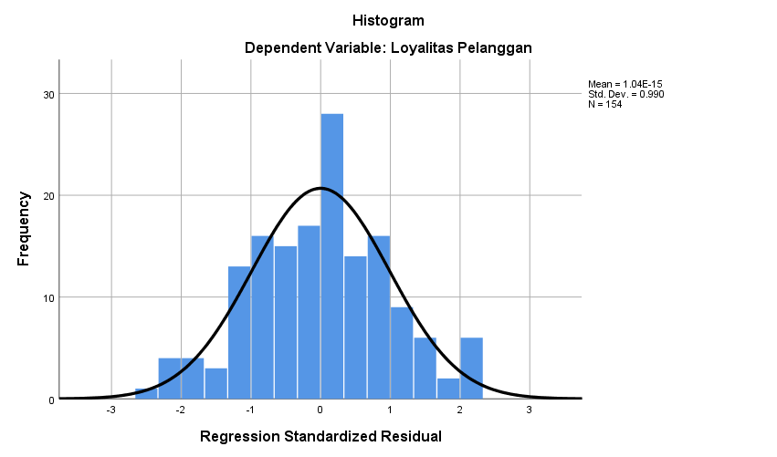

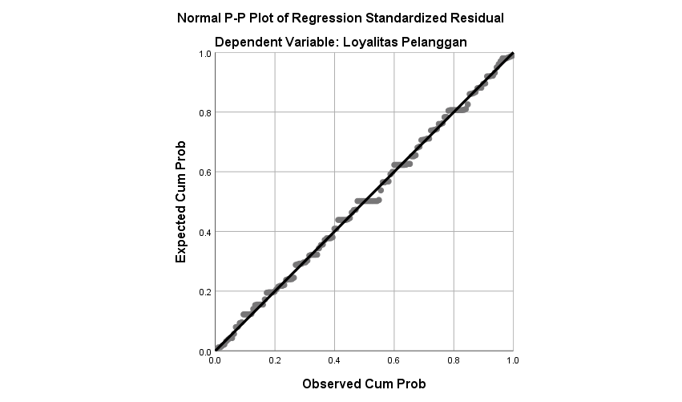

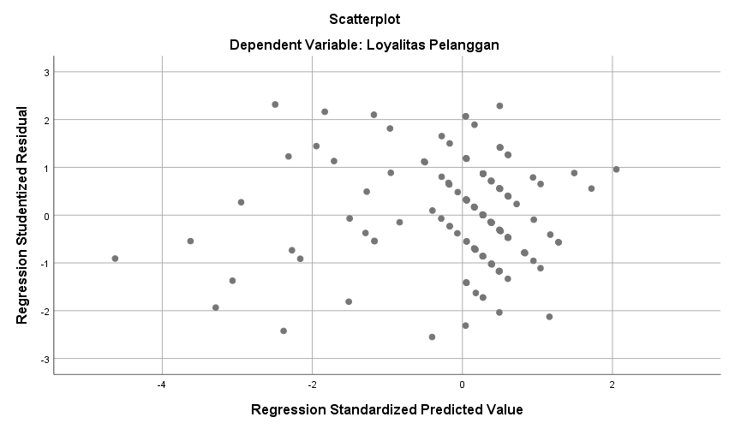

One-Sample Kolmogorov-Smirnov Test
 |  | Unstandardized Residual
N |  | 154
Normal Parameters^{a,b} | Mean | .0000000
Normal Parameters^{a,b} | Std. Deviation | 1.14997740
Most Extreme Differences | Absolute | .047
Most Extreme Differences | Positive | .047
Most Extreme Differences | Negative | -.029
Test Statistic |  | .047
Asymp. Sig. (2-tailed) |  | .200^{c,d}
a. Test distribution is Normal.
b. Calculated from data.
c. Lilliefors Significance Correction.
d. This is a lower bound of the true significance.

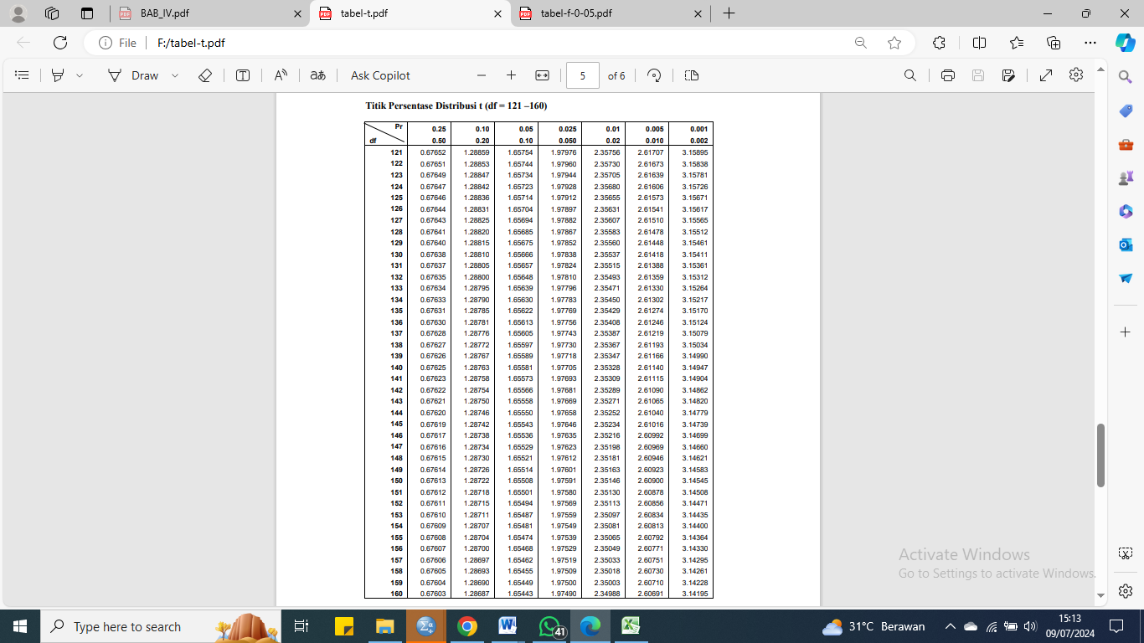
t Tabel

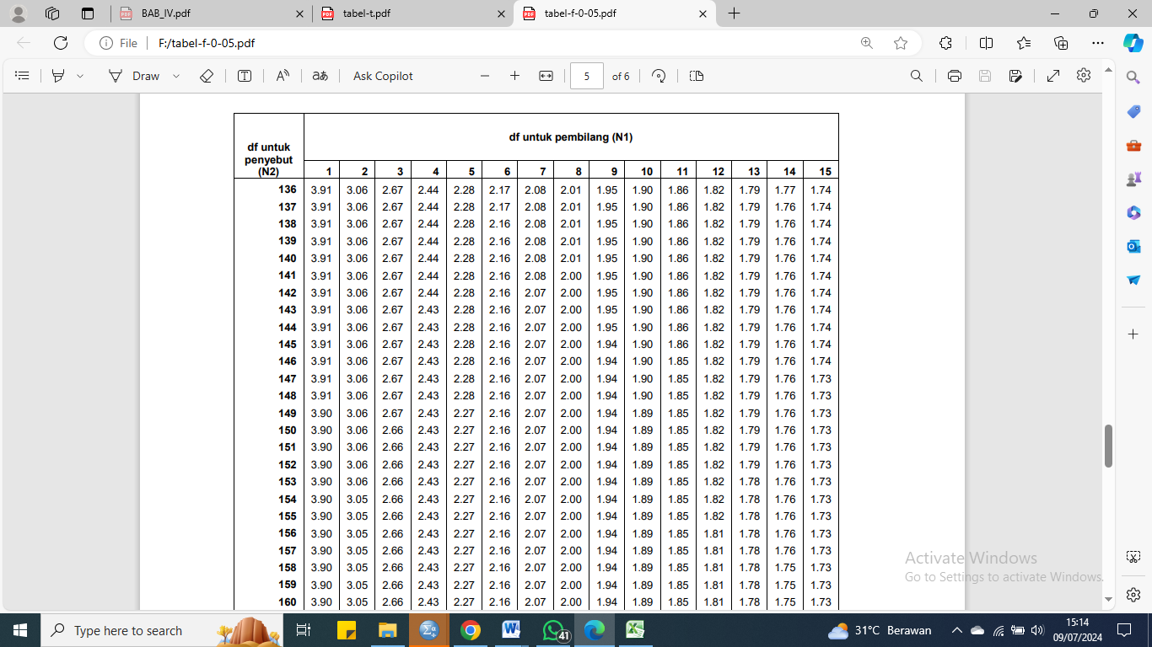
F Tabel

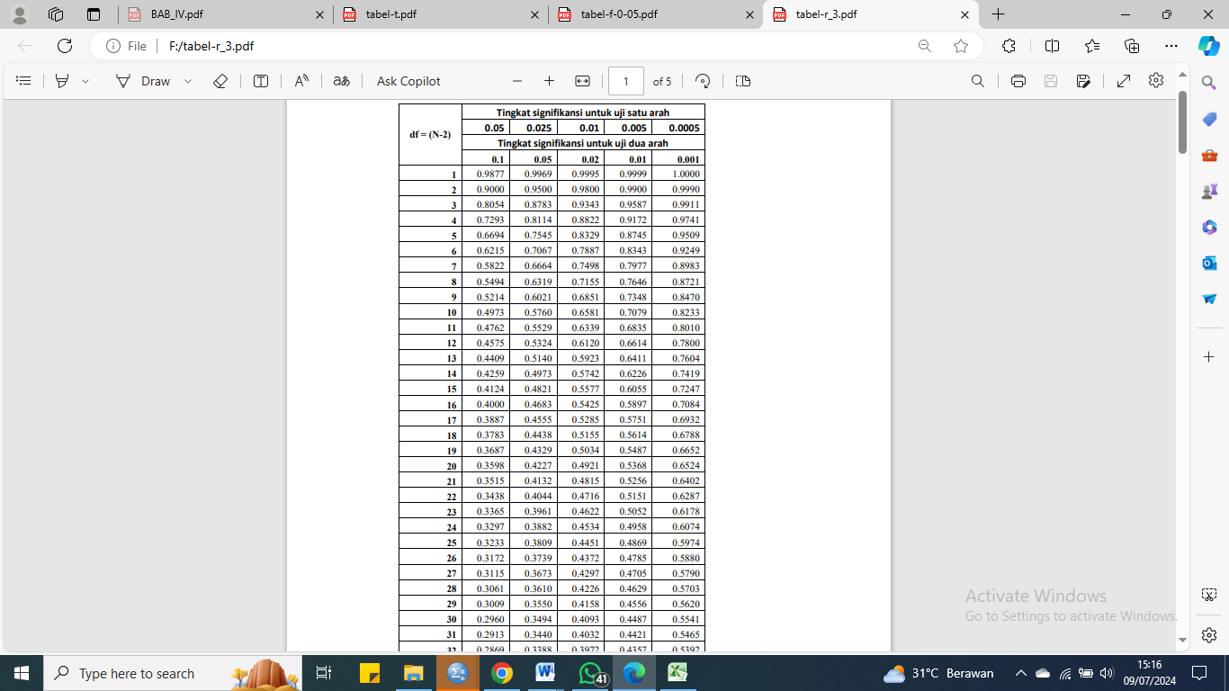
R Tabel

