**Lampiran 01**

# KUESIONER

Kepada Yth, Bapak/Ibu Responden Di

Tempat

Puji syukur kita panjatkan kehadirat Allah SWT karena atas limpahan rahmat, hidayah dan taufik-Nya lah sehingga angket penelitian ini yang berjudul “Pengaruh Lingkungan Kerja Non Fisik Dan Fasilitas Kantor Terhadap Kinerja Pegawai di Kantor Desa Kota Pari Kecamatan Pantai Cermin Kabupaten Serdang Bedagai”. Sehubungan dengan hal tersebut, maka mohon kesediaan Bapak/Ibu untuk mengisi angket ini walaupun disadari bahwa kesibukan selalu menyertai aktivitas, tugas dan pekerjaan Bapak/Ibu. Dalam mengisi angket ini, mohon kesediannya untuk menjawab secara jujur dan objektif, serta tidak merasa ragu karena angket ini hanya untuk kebutuhan penelitian, yangtidak sama sekali dimaksudkan untuk memberi penilaian yang dapat merugikan akademik Bapak/Ibu.

Atas kesediaan dan kerjasama yang baik ini diucapkan banyak terimakasih, semoga Allah SWT meridhoi kita semua, Amin.

Medan, Juli 2024 Peneliti

Ainun 203114039

# IDENTITAS RESPONDEN

Nama : .........................................................................

Jenis Kelamin : .........................................................................

Umur : .........................................................................

Pekerjaan : .........................................................................

# PETUNJUK PENGISIAN

bacalah baik-baik setiap pernyataan dalam angket ini sebelum menjawabnya. Berilah jawaban dengan memberi tanda (√) pada kolom yang tersedia.

SS = Sangat Setuju

S = Setuju

KS = Kurang Setuju TS = Tidak Setuju

STS = Sangat Tidak Setuju

bila ada sesuatu yang kurang jelas mohon ditanyakan pada peneliti.

# DAFTAR PERNYATAAN

**Variabel Lingkungan Kerja Non Fisik (X1)**

|  |  |  |  |  |  |  |
| --- | --- | --- | --- | --- | --- | --- |
| **No** | **Pernyataan** | **Alternatif Jawaban** | | | | |
| **SS** | **S** | **KS** | **TS** | **STS** |
| 1 | Saya diberikan penghargaan berupa pengakuan dari pihak pimpinan sehingga membuat semakin rajin dalam bekerja |  |  |  |  |  |
| 2 | Saya selalu menjalin komunikasi yang baik antar pegawai |  |  |  |  |  |
| 3 | Saya merasa pimpinan sudah memberi pekerjaan dengan bijak dan sesuai kepada pegawai |  |  |  |  |  |
| 4 | Saya selalu menjaga hubungan baik antar sesama pegawai |  |  |  |  |  |

**Variabel Fasilitas Kantor (X2)**

|  |  |  |  |  |  |  |
| --- | --- | --- | --- | --- | --- | --- |
| **No** | **Pernyataan** | **Alternatif Jawaban** | | | | |
| **SS** | **S** | **KS** | **TS** | **STS** |
| 1 | Saya sebagai pegawai diberikan fasilitas sesuai dengan kebutuhan kerja |  |  |  |  |  |
| 2 | Sejauh ini perlengkapan pekerjaan sudah membantu Saya untuk menyelesaikan pekerjaan |  |  |  |  |  |
| 3 | Fasilitas kerja pada Kantor Desa Kota Pari Kecamatan Pantai Cermin Kabupaten Serdang Bedagai mudah digunakan |  |  |  |  |  |
| 4 | Saat ini fasilitas yang terdapat pada Kantor Desa Kota Pari Kecamatan Pantai Cermin Kabupaten Serdang Bedagai telah mempercepat proses pekerjaan dan mendukung kinerja |  |  |  |  |  |

**Variabel Kinerja Pegawai (Y)**

|  |  |  |  |  |  |  |
| --- | --- | --- | --- | --- | --- | --- |
| **No** | **Pernyataan** | **Alternatif Jawaban** | | | | |
| **SS** | **S** | **KS** | **TS** | **STS** |
| 1 | Saya sebagai pegawai Kantor Desa Kota Pari Kecamatan Pantai Cermin Kabupaten Serdang Bedagai memiliki kualitas yang baik  dalam bekerja |  |  |  |  |  |
| 2 | Saya mampu menyelesaikan pekerjaan sesuai  dengan target yang ditentukan |  |  |  |  |  |
| 3 | Sebagai pegawai mampu untuk  menyelesaikan pekerjaan dengan tepat waktu |  |  |  |  |  |
| 4 | Saya selalu diberikan pengawasan pada saat  melaksanakan pekerjaan |  |  |  |  |  |
| 5 | Saya memiliki hubungan yang baik antar pegawai pada Kantor Desa Kota Pari  Kecamatan Pantai Cermin Kabupaten Serdang Bedagai |  |  |  |  |  |

## Lampiran

**Tabulasi Data Responden Variabel Lingkungan Kerja Non Fisik**

|  |  |  |  |  |  |
| --- | --- | --- | --- | --- | --- |
| No | X1.1 | X1.2 | X1.3 | X1.4 | X1.TTL |
| 1 | 4 | 5 | 5 | 5 | 19 |
| 2 | 5 | 4 | 4 | 5 | 18 |
| 3 | 4 | 5 | 5 | 4 | 18 |
| 4 | 5 | 4 | 5 | 5 | 19 |
| 5 | 4 | 5 | 4 | 4 | 17 |
| 6 | 5 | 4 | 5 | 5 | 19 |
| 7 | 4 | 5 | 4 | 4 | 17 |
| 8 | 4 | 4 | 5 | 5 | 18 |
| 9 | 3 | 4 | 4 | 4 | 15 |
| 10 | 4 | 3 | 4 | 4 | 15 |
| 11 | 4 | 4 | 3 | 3 | 14 |
| 12 | 4 | 4 | 4 | 4 | 16 |
| 13 | 5 | 4 | 4 | 4 | 17 |
| 14 | 5 | 5 | 4 | 4 | 18 |
| 15 | 4 | 5 | 5 | 5 | 19 |
| 16 | 5 | 4 | 5 | 5 | 19 |
| 17 | 4 | 5 | 4 | 4 | 17 |
| 18 | 3 | 4 | 5 | 5 | 17 |
| 19 | 4 | 3 | 4 | 4 | 15 |
| 20 | 4 | 4 | 5 | 1 | 14 |
| 21 | 3 | 4 | 4 | 4 | 15 |
| 22 | 2 | 3 | 4 | 4 | 13 |
| 23 | 3 | 2 | 3 | 3 | 11 |
| 24 | 4 | 1 | 4 | 2 | 11 |
| 25 | 4 | 5 | 3 | 3 | 15 |
| 26 | 3 | 5 | 2 | 5 | 15 |
| 27 | 2 | 3 | 4 | 5 | 14 |
| 28 | 3 | 2 | 3 | 3 | 11 |
| 29 | 4 | 3 | 2 | 2 | 11 |
| 30 | 4 | 5 | 1 | 5 | 15 |
| 31 | 3 | 5 | 2 | 5 | 15 |
| 32 | 4 | 5 | 5 | 5 | 19 |
| 33 | 4 | 4 | 4 | 5 | 17 |
| 34 | 5 | 5 | 1 | 4 | 15 |
| 35 | 5 | 4 | 4 | 3 | 16 |

|  |  |  |  |  |  |
| --- | --- | --- | --- | --- | --- |
| 36 | 1 | 5 | 5 | 5 | 16 |
| 37 | 5 | 3 | 3 | 4 | 15 |

**Tabulasi Data Responden Variabel Fasilitas Kantor**

|  |  |  |  |  |  |
| --- | --- | --- | --- | --- | --- |
| No | X2.1 | X2.2 | X2.3 | X2.4 | X2.TTL |
| 1 | 5 | 3 | 4 | 4 | 16 |
| 2 | 5 | 5 | 5 | 3 | 18 |
| 3 | 5 | 5 | 4 | 5 | 19 |
| 4 | 4 | 5 | 5 | 5 | 19 |
| 5 | 5 | 4 | 4 | 5 | 18 |
| 6 | 4 | 5 | 5 | 4 | 18 |
| 7 | 5 | 4 | 5 | 5 | 19 |
| 8 | 4 | 5 | 4 | 4 | 17 |
| 9 | 5 | 4 | 5 | 5 | 19 |
| 10 | 4 | 5 | 4 | 4 | 17 |
| 11 | 4 | 4 | 5 | 5 | 18 |
| 12 | 3 | 4 | 4 | 4 | 15 |
| 13 | 4 | 3 | 4 | 4 | 15 |
| 14 | 4 | 4 | 1 | 5 | 14 |
| 15 | 1 | 5 | 5 | 5 | 16 |
| 16 | 5 | 4 | 4 | 4 | 17 |
| 17 | 5 | 5 | 4 | 4 | 18 |
| 18 | 4 | 5 | 5 | 5 | 19 |
| 19 | 5 | 4 | 5 | 5 | 19 |
| 20 | 4 | 5 | 4 | 4 | 17 |
| 21 | 3 | 4 | 5 | 5 | 17 |
| 22 | 4 | 3 | 4 | 4 | 15 |
| 23 | 4 | 4 | 3 | 3 | 14 |
| 24 | 3 | 4 | 4 | 4 | 15 |
| 25 | 2 | 1 | 5 | 5 | 13 |
| 26 | 1 | 4 | 3 | 3 | 11 |
| 27 | 4 | 3 | 2 | 2 | 11 |
| 28 | 4 | 5 | 3 | 3 | 15 |
| 29 | 3 | 5 | 2 | 5 | 15 |
| 30 | 2 | 3 | 4 | 5 | 14 |
| 31 | 3 | 2 | 5 | 1 | 11 |
| 32 | 4 | 3 | 2 | 2 | 11 |
| 33 | 4 | 5 | 3 | 3 | 15 |

|  |  |  |  |  |  |
| --- | --- | --- | --- | --- | --- |
| 34 | 3 | 5 | 2 | 5 | 15 |
| 35 | 4 | 5 | 5 | 5 | 19 |
| 36 | 4 | 4 | 4 | 5 | 17 |
| 37 | 5 | 3 | 3 | 4 | 15 |

**Tabulasi Data Responden Variabel Kinerja Pegawai**

|  |  |  |  |  |  |  |
| --- | --- | --- | --- | --- | --- | --- |
| No | Y.1 | Y.2 | Y.3 | Y.4 | Y.5 | Y.TTL |
| 1 | 5 | 4 | 4 | 3 | 4 | 20 |
| 2 | 4 | 5 | 5 | 5 | 3 | 22 |
| 3 | 5 | 4 | 4 | 5 | 5 | 23 |
| 4 | 5 | 5 | 5 | 5 | 5 | 25 |
| 5 | 5 | 1 | 5 | 5 | 5 | 21 |
| 6 | 5 | 5 | 5 | 5 | 4 | 24 |
| 7 | 4 | 4 | 4 | 4 | 5 | 21 |
| 8 | 5 | 4 | 4 | 5 | 4 | 22 |
| 9 | 4 | 3 | 3 | 4 | 5 | 19 |
| 10 | 4 | 4 | 4 | 5 | 4 | 21 |
| 11 | 3 | 4 | 4 | 4 | 5 | 20 |
| 12 | 4 | 4 | 4 | 4 | 4 | 20 |
| 13 | 4 | 5 | 5 | 3 | 4 | 21 |
| 14 | 4 | 5 | 5 | 4 | 3 | 21 |
| 15 | 5 | 5 | 1 | 5 | 5 | 21 |
| 16 | 5 | 5 | 5 | 4 | 4 | 23 |
| 17 | 4 | 4 | 4 | 5 | 4 | 21 |
| 18 | 5 | 3 | 3 | 5 | 5 | 21 |
| 19 | 4 | 4 | 4 | 4 | 5 | 21 |
| 20 | 1 | 5 | 5 | 5 | 4 | 20 |
| 21 | 4 | 5 | 1 | 4 | 5 | 19 |
| 22 | 4 | 2 | 2 | 3 | 4 | 15 |
| 23 | 3 | 3 | 3 | 4 | 3 | 16 |
| 24 | 2 | 5 | 5 | 4 | 4 | 20 |
| 25 | 3 | 2 | 2 | 3 | 4 | 14 |
| 26 | 2 | 4 | 3 | 2 | 3 | 14 |
| 27 | 4 | 2 | 2 | 3 | 2 | 13 |
| 28 | 3 | 3 | 5 | 4 | 1 | 16 |
| 29 | 2 | 5 | 5 | 4 | 5 | 21 |
| 30 | 3 | 2 | 2 | 3 | 5 | 15 |
| 31 | 2 | 4 | 5 | 2 | 3 | 16 |
| 32 | 5 | 5 | 4 | 3 | 2 | 19 |

|  |  |  |  |  |  |  |
| --- | --- | --- | --- | --- | --- | --- |
| 33 | 4 | 4 | 3 | 4 | 3 | 18 |
| 34 | 3 | 3 | 4 | 4 | 5 | 19 |
| 35 | 4 | 5 | 5 | 1 | 5 | 20 |
| 36 | 4 | 4 | 3 | 4 | 5 | 20 |
| 37 | 5 | 1 | 4 | 4 | 4 | 18 |

**Tabulasi Data Uji Validitas Variabel Lingkungan Kerja Non Fisik**

|  |  |  |  |  |  |
| --- | --- | --- | --- | --- | --- |
| **No** | **X1.1** | **X1.2** | **X1.3** | **X1.4** | **X1.TTL** |
| 1 | 5 | 5 | 5 | 4 | 19 |
| 2 | 4 | 5 | 4 | 5 | 18 |
| 3 | 5 | 5 | 5 | 4 | 19 |
| 4 | 4 | 5 | 4 | 5 | 18 |
| 5 | 4 | 5 | 4 | 4 | 17 |
| 6 | 3 | 4 | 3 | 3 | 13 |
| 7 | 4 | 5 | 4 | 4 | 17 |
| 8 | 4 | 5 | 4 | 4 | 17 |
| 9 | 4 | 5 | 4 | 4 | 17 |
| 10 | 5 | 5 | 5 | 5 | 20 |
| 11 | 5 | 5 | 5 | 5 | 20 |
| 12 | 4 | 5 | 4 | 4 | 17 |
| 13 | 5 | 5 | 5 | 5 | 20 |
| 14 | 4 | 5 | 4 | 4 | 17 |
| 15 | 3 | 4 | 3 | 3 | 13 |
| 16 | 4 | 5 | 4 | 4 | 17 |
| 17 | 4 | 5 | 4 | 4 | 17 |
| 18 | 3 | 4 | 3 | 3 | 13 |
| 19 | 2 | 3 | 2 | 2 | 9 |
| 20 | 3 | 4 | 3 | 3 | 13 |
| 21 | 5 | 5 | 5 | 5 | 20 |
| 22 | 5 | 5 | 4 | 4 | 18 |
| 23 | 5 | 5 | 5 | 3 | 18 |
| 24 | 4 | 5 | 5 | 4 | 18 |
| 25 | 4 | 5 | 5 | 4 | 18 |
| 26 | 3 | 4 | 4 | 3 | 14 |
| 27 | 4 | 5 | 4 | 4 | 17 |
| 28 | 4 | 5 | 5 | 4 | 18 |
| 29 | 5 | 5 | 5 | 5 | 20 |
| 30 | 4 | 5 | 4 | 4 | 17 |

|  |  |  |  |  |  |
| --- | --- | --- | --- | --- | --- |
| **No** | **X2.1** | **X2.2** | **X2.3** | **X2.4** | **X2.TTL** |
| 1 | 5 | 5 | 4 | 5 | 19 |
| 2 | 4 | 4 | 5 | 4 | 17 |
| 3 | 4 | 5 | 4 | 5 | 18 |
| 4 | 4 | 4 | 5 | 4 | 17 |
| 5 | 5 | 4 | 4 | 4 | 17 |
| 6 | 4 | 3 | 4 | 3 | 14 |
| 7 | 3 | 4 | 3 | 4 | 14 |
| 8 | 4 | 4 | 4 | 4 | 16 |
| 9 | 4 | 4 | 4 | 4 | 16 |
| 10 | 4 | 5 | 4 | 5 | 18 |
| 11 | 5 | 5 | 5 | 5 | 20 |
| 12 | 5 | 4 | 5 | 4 | 18 |
| 13 | 4 | 5 | 4 | 5 | 18 |
| 14 | 5 | 4 | 5 | 4 | 18 |
| 15 | 4 | 3 | 4 | 3 | 14 |
| 16 | 3 | 4 | 3 | 4 | 14 |
| 17 | 4 | 4 | 4 | 4 | 16 |
| 18 | 4 | 3 | 4 | 3 | 14 |
| 19 | 3 | 2 | 3 | 2 | 10 |
| 20 | 2 | 3 | 2 | 3 | 10 |
| 21 | 3 | 4 | 3 | 5 | 15 |
| 22 | 4 | 5 | 5 | 4 | 18 |
| 23 | 3 | 5 | 4 | 3 | 15 |
| 24 | 4 | 4 | 3 | 4 | 15 |
| 25 | 4 | 3 | 5 | 4 | 16 |
| 26 | 3 | 5 | 5 | 3 | 16 |
| 27 | 4 | 5 | 5 | 4 | 18 |
| 28 | 4 | 5 | 4 | 4 | 17 |
| 29 | 5 | 4 | 5 | 5 | 19 |
| 30 | 4 | 5 | 4 | 4 | 17 |

|  |  |  |  |  |  |  |
| --- | --- | --- | --- | --- | --- | --- |
| No | Y.1 | Y.2 | Y.3 | Y.4 | Y.5 | Y.TTL |
| 1 | 4 | 3 | 4 | 4 | 3 | 18 |
| 2 | 3 | 4 | 3 | 3 | 4 | 17 |
| 3 | 4 | 4 | 4 | 4 | 4 | 20 |
| 4 | 4 | 4 | 4 | 4 | 4 | 20 |
| 5 | 4 | 5 | 4 | 4 | 5 | 22 |
| 6 | 5 | 5 | 5 | 5 | 5 | 25 |
| 7 | 5 | 4 | 5 | 5 | 4 | 23 |
| 8 | 4 | 5 | 4 | 4 | 5 | 22 |
| 9 | 5 | 4 | 5 | 5 | 4 | 23 |
| 10 | 4 | 3 | 4 | 4 | 3 | 18 |
| 11 | 3 | 4 | 3 | 3 | 4 | 17 |
| 12 | 4 | 4 | 4 | 4 | 4 | 20 |
| 13 | 4 | 3 | 4 | 4 | 3 | 18 |
| 14 | 3 | 2 | 3 | 3 | 2 | 13 |
| 15 | 2 | 3 | 2 | 2 | 3 | 12 |
| 16 | 3 | 5 | 3 | 3 | 5 | 19 |
| 17 | 5 | 5 | 3 | 5 | 5 | 23 |
| 18 | 3 | 5 | 5 | 3 | 5 | 21 |
| 19 | 5 | 4 | 3 | 4 | 3 | 19 |
| 20 | 4 | 4 | 5 | 4 | 4 | 21 |
| 21 | 5 | 3 | 5 | 4 | 4 | 21 |
| 22 | 5 | 4 | 5 | 3 | 3 | 20 |
| 23 | 5 | 4 | 4 | 4 | 4 | 21 |
| 24 | 4 | 5 | 5 | 4 | 4 | 22 |
| 25 | 5 | 4 | 4 | 5 | 5 | 23 |
| 26 | 4 | 5 | 4 | 4 | 4 | 21 |
| 27 | 5 | 4 | 5 | 5 | 5 | 24 |
| 28 | 4 | 5 | 4 | 4 | 4 | 21 |
| 29 | 5 | 4 | 5 | 5 | 5 | 24 |
| 30 | 4 | 4 | 4 | 4 | 4 | 20 |

**Lampiran**

**Hasil Uji Validitas Dan Reliabilitas**

**Correlations**

|  |  |  |  |  |  |  |
| --- | --- | --- | --- | --- | --- | --- |
| X1 | | | X1 | X1 | X1 | X1 |
| X1 | Pearson Correlation | 1 | .825** | .870** | .750** | .945** |
| Sig. (2-tailed) |  | .000 | .000 | .000 | .000 |
| N | 30 | 30 | 30 | 30 | 30 |
| X1 | Pearson Correlation | .825** | 1 | .792** | .784** | .913** |
| Sig. (2-tailed) | .000 |  | .000 | .000 | .000 |
| N | 30 | 30 | 30 | 30 | 30 |
| X1 | Pearson Correlation | .870** | .792** | 1 | .693** | .922** |
| Sig. (2-tailed) | .000 | .000 |  | .000 | .000 |
| N | 30 | 30 | 30 | 30 | 30 |
| X1 | Pearson Correlation | .750** | .784** | .693** | 1 | .882** |
| Sig. (2-tailed) | .000 | .000 | .000 |  | .000 |
| N | 30 | 30 | 30 | 30 | 30 |
| X1 | Pearson Correlation | .945** | .913** | .922** | .882** | 1 |
| Sig. (2-tailed) | .000 | .000 | .000 | .000 |  |
| N | 30 | 30 | 30 | 30 | 30 |

**. Correlation is significant at the 0.01 level (2-tailed).

|  |  |
| --- | --- |
| **Reliability Statistics** | |
| Cronbach's  Alpha | N of Items |
| .925 | 4 |

|  |  |  |  |  |  |  |
| --- | --- | --- | --- | --- | --- | --- |
| X2 | | | X2 | X2 | X2 | X2 |
| X2 | Pearson Correlation | 1 | .243 | .650** | .484** | .776** |
| Sig. (2-tailed) |  | .196 | .000 | .007 | .000 |
| N | 30 | 30 | 30 | 30 | 30 |
| X2 | Pearson Correlation | .243 | 1 | .346 | .613** | .740** |
| Sig. (2-tailed) | .196 |  | .061 | .000 | .000 |
| N | 30 | 30 | 30 | 30 | 30 |
| X2 | Pearson Correlation | .650** | .346 | 1 | .230 | .739** |
| Sig. (2-tailed) | .000 | .061 |  | .221 | .000 |
| N | 30 | 30 | 30 | 30 | 30 |
| X2 | Pearson Correlation | .484** | .613** | .230 | 1 | .767** |
| Sig. (2-tailed) | .007 | .000 | .221 |  | .000 |
| N | 30 | 30 | 30 | 30 | 30 |
| X2 | Pearson Correlation | .776** | .740** | .739** | .767** | 1 |
| Sig. (2-tailed) | .000 | .000 | .000 | .000 |  |
| N | 30 | 30 | 30 | 30 | 30 |

**. Correlation is significant at the 0.01 level (2-tailed).

|  |  |
| --- | --- |
| **Reliability Statistics** | |
| Cronbach's  Alpha | N of Items |
| .747 | 4 |

|  |  |  |  |  |  |  |  |
| --- | --- | --- | --- | --- | --- | --- | --- |
| Y | | | Y | Y | Y | Y | Y |
| Y | Pearson Correlation | 1 | .147 | .597** | .833** | .253 | .767** |
| Sig. (2-tailed) |  | .440 | .001 | .000 | .177 | .000 |
| N | 30 | 30 | 30 | 30 | 30 | 30 |
| Y | Pearson Correlation | .147 | 1 | .205 | .234 | .757** | .631** |
| Sig. (2-tailed) | .440 |  | .277 | .214 | .000 | .000 |
| N | 30 | 30 | 30 | 30 | 30 | 30 |
| Y | Pearson Correlation | .597** | .205 | 1 | .548** | .306 | .725** |
| Sig. (2-tailed) | .001 | .277 |  | .002 | .100 | .000 |
| N | 30 | 30 | 30 | 30 | 30 | 30 |
| Y | Pearson Correlation | .833** | .234 | .548** | 1 | .448* | .827** |
| Sig. (2-tailed) | .000 | .214 | .002 |  | .013 | .000 |
| N | 30 | 30 | 30 | 30 | 30 | 30 |
| Y | Pearson Correlation | .253 | .757** | .306 | .448* | 1 | .746** |
| Sig. (2-tailed) | .177 | .000 | .100 | .013 |  | .000 |
| N | 30 | 30 | 30 | 30 | 30 | 30 |
| Y | Pearson Correlation | .767** | .631** | .725** | .827** | .746** | 1 |
| Sig. (2-tailed) | .000 | .000 | .000 | .000 | .000 |  |
| N | 30 | 30 | 30 | 30 | 30 | 30 |

**. Correlation is significant at the 0.01 level (2-tailed).

*. Correlation is significant at the 0.05 level (2-tailed).

|  |  |
| --- | --- |
| **Reliability Statistics** | |
| Cronbach's  Alpha | N of Items |
| .791 | 5 |

## Lampiran

## Hasil Statistik Deskriptif Jawaban Responden

**Statistics**

|  |  |  |  |  |  |  |  |  |  |  |  |  |  |  |
| --- | --- | --- | --- | --- | --- | --- | --- | --- | --- | --- | --- | --- | --- | --- |
| Ling kung an Kerja Non  Fisik | | | Ling kung an Kerj a Non  Fisik | Ling kung an Kerj a Non  Fisik | Ling kung an Kerj a Non  Fisik | Fasil itas Kant  or | Fasil itas Kant  or | Fasil itas Kant  or | Fasil itas Kant  or | Kine rja Peg  awai | Kine rja Peg  awai | Kine rja Peg  awai | Kine rja Peg  awai | Kiner ja Pega  wai |
| N | Va lid | 37 | 37 | 37 | 37 | 37 | 37 | 37 | 37 | 37 | 37 | 37 | 37 | 37 |
| Mi  ssi ng | 0 | 0 | 0 | 0 | 0 | 0 | 0 | 0 | 0 | 0 | 0 | 0 | 0 |
| Mean | | 3.86 | 4.03 | 3.84 | 4.08 | 3.84 | 4.08 | 3.92 | 4.14 | 3.84 | 3.84 | 3.81 | 3.92 | 4.05 |
| Std. Error of  Mean | | .156 | .167 | .184 | .166 | .176 | .162 | .179 | .170 | .176 | .196 | .197 | .162 | .169 |
| Media n | | 4.00 | 4.00 | 4.00 | 4.00 | 4.00 | 4.00 | 4.00 | 4.00 | 4.00 | 4.00 | 4.00 | 4.00 | 4.00 |
| Mode | | 4 | 4a | 4 | 5 | 4 | 5 | 4 | 5 | 4 | 4a | 5 | 4 | 5 |
| Std. Deviati on | | .948 | 1.01  3 | 1.11  8 | 1.01  0 | 1.06  8 | .983 | 1.09  0 | 1.03  2 | 1.06  8 | 1.19  1 | 1.19  8 | .983 | 1.02  6 |
| Varian ce | | .898 | 1.02  7 | 1.25  1 | 1.02  1 | 1.14  0 | .965 | 1.18  8 | 1.06  5 | 1.14  0 | 1.41  7 | 1.43  5 | .965 | 1.05  3 |
| Range | | 4 | 4 | 4 | 4 | 4 | 4 | 4 | 4 | 4 | 4 | 4 | 4 | 4 |
| Minim um | | 1 | 1 | 1 | 1 | 1 | 1 | 1 | 1 | 1 | 1 | 1 | 1 | 1 |
| Maxim um | | 5 | 5 | 5 | 5 | 5 | 5 | 5 | 5 | 5 | 5 | 5 | 5 | 5 |
| Sum | | 143 | 149 | 142 | 151 | 142 | 151 | 145 | 153 | 142 | 142 | 141 | 145 | 150 |

a. Multiple modes exist. The smallest value is shown

**Lingkungan Kerja Non Fisik**

|  |  |  |  |  |  |
| --- | --- | --- | --- | --- | --- |
| Frequency | | | Percent | Valid Percent | Cumulative Percent |
| Valid | Sangat Tidak Setuju | 1 | 2.7 | 2.7 | 2.7 |
| Tidak Setuju | 2 | 5.4 | 5.4 | 8.1 |
| Kurang Setuju | 7 | 18.9 | 18.9 | 27.0 |
| Setuju | 18 | 48.6 | 48.6 | 75.7 |
| Sangat Setuju | 9 | 24.3 | 24.3 | 100.0 |
| Total | 37 | 100.0 | 100.0 |  |

**Lingkungan Kerja Non Fisik**

|  |  |  |  |  |  |
| --- | --- | --- | --- | --- | --- |
| Frequency | | | Percent | Valid Percent | Cumulative Percent |
| Valid | Sangat Tidak Setuju | 1 | 2.7 | 2.7 | 2.7 |
| Tidak Setuju | 2 | 5.4 | 5.4 | 8.1 |
| Kurang Setuju | 6 | 16.2 | 16.2 | 24.3 |
| Setuju | 14 | 37.8 | 37.8 | 62.2 |
| Sangat Setuju | 14 | 37.8 | 37.8 | 100.0 |
| Total | 37 | 100.0 | 100.0 |  |

**Lingkungan Kerja Non Fisik**

|  |  |  |  |  |  |
| --- | --- | --- | --- | --- | --- |
| Frequency | | | Percent | Valid Percent | Cumulative Percent |
| Valid | Sangat Tidak Setuju | 2 | 5.4 | 5.4 | 5.4 |
| Tidak Setuju | 3 | 8.1 | 8.1 | 13.5 |
| Kurang Setuju | 5 | 13.5 | 13.5 | 27.0 |
| Setuju | 16 | 43.2 | 43.2 | 70.3 |
| Sangat Setuju | 11 | 29.7 | 29.7 | 100.0 |
| Total | 37 | 100.0 | 100.0 |  |

**Lingkungan Kerja Non Fisik**

|  |  |  |  |  |  |
| --- | --- | --- | --- | --- | --- |
| Frequency | | | Percent | Valid Percent | Cumulative Percent |
| Valid | Sangat Tidak Setuju | 1 | 2.7 | 2.7 | 2.7 |
| Tidak Setuju | 2 | 5.4 | 5.4 | 8.1 |
| Kurang Setuju | 5 | 13.5 | 13.5 | 21.6 |
| Setuju | 14 | 37.8 | 37.8 | 59.5 |
| Sangat Setuju | 15 | 40.5 | 40.5 | 100.0 |
| Total | 37 | 100.0 | 100.0 |  |

**Fasilitas Kantor**

|  |  |  |  |  |  |
| --- | --- | --- | --- | --- | --- |
| Frequency | | | Percent | Valid Percent | Cumulative Percent |
| Valid | Sangat Tidak Setuju | 2 | 5.4 | 5.4 | 5.4 |
| Tidak Setuju | 2 | 5.4 | 5.4 | 10.8 |
| Kurang Setuju | 6 | 16.2 | 16.2 | 27.0 |
| Setuju | 17 | 45.9 | 45.9 | 73.0 |
| Sangat Setuju | 10 | 27.0 | 27.0 | 100.0 |
| Total | 37 | 100.0 | 100.0 |  |

**Fasilitas Kantor**

|  |  |  |  |  |  |
| --- | --- | --- | --- | --- | --- |
| Frequency | | | Percent | Valid Percent | Cumulative Percent |
| Valid | Sangat Tidak Setuju | 1 | 2.7 | 2.7 | 2.7 |
| Tidak Setuju | 1 | 2.7 | 2.7 | 5.4 |
| Kurang Setuju | 7 | 18.9 | 18.9 | 24.3 |
| Setuju | 13 | 35.1 | 35.1 | 59.5 |
| Sangat Setuju | 15 | 40.5 | 40.5 | 100.0 |
| Total | 37 | 100.0 | 100.0 |  |

**Fasilitas Kantor**

|  |  |  |  |  |  |
| --- | --- | --- | --- | --- | --- |
| Frequency | | | Percent | Valid Percent | Cumulative Percent |
| Valid | Sangat Tidak Setuju | 1 | 2.7 | 2.7 | 2.7 |
| Tidak Setuju | 4 | 10.8 | 10.8 | 13.5 |
| Kurang Setuju | 5 | 13.5 | 13.5 | 27.0 |
| Setuju | 14 | 37.8 | 37.8 | 64.9 |
| Sangat Setuju | 13 | 35.1 | 35.1 | 100.0 |
| Total | 37 | 100.0 | 100.0 |  |

**Fasilitas Kantor**

|  |  |  |  |  |  |
| --- | --- | --- | --- | --- | --- |
| Frequency | | | Percent | Valid Percent | Cumulative Percent |
| Valid | Sangat Tidak Setuju | 1 | 2.7 | 2.7 | 2.7 |
| Tidak Setuju | 2 | 5.4 | 5.4 | 8.1 |
| Kurang Setuju | 5 | 13.5 | 13.5 | 21.6 |
| Setuju | 12 | 32.4 | 32.4 | 54.1 |
| Sangat Setuju | 17 | 45.9 | 45.9 | 100.0 |
| Total | 37 | 100.0 | 100.0 |  |

**Kinerja Pegawai**

|  |  |  |  |  |  |
| --- | --- | --- | --- | --- | --- |
| Frequency | | | Percent | Valid Percent | Cumulative Percent |
| Valid | Sangat Tidak Setuju | 1 | 2.7 | 2.7 | 2.7 |
| Tidak Setuju | 4 | 10.8 | 10.8 | 13.5 |
| Kurang Setuju | 6 | 16.2 | 16.2 | 29.7 |
| Setuju | 15 | 40.5 | 40.5 | 70.3 |
| Sangat Setuju | 11 | 29.7 | 29.7 | 100.0 |
| Total | 37 | 100.0 | 100.0 |  |

**Kinerja Pegawai**

|  |  |  |  |  |  |
| --- | --- | --- | --- | --- | --- |
| Frequency | | | Percent | Valid Percent | Cumulative Percent |
| Valid | Sangat Tidak Setuju | 2 | 5.4 | 5.4 | 5.4 |
| Tidak Setuju | 4 | 10.8 | 10.8 | 16.2 |
| Kurang Setuju | 5 | 13.5 | 13.5 | 29.7 |
| Setuju | 13 | 35.1 | 35.1 | 64.9 |
| Sangat Setuju | 13 | 35.1 | 35.1 | 100.0 |
| Total | 37 | 100.0 | 100.0 |  |

**Kinerja Pegawai**

|  |  |  |  |  |  |
| --- | --- | --- | --- | --- | --- |
| Frequency | | | Percent | Valid Percent | Cumulative Percent |
| Valid | Sangat Tidak Setuju | 2 | 5.4 | 5.4 | 5.4 |
| Tidak Setuju | 4 | 10.8 | 10.8 | 16.2 |
| Kurang Setuju | 6 | 16.2 | 16.2 | 32.4 |
| Setuju | 12 | 32.4 | 32.4 | 64.9 |
| Sangat Setuju | 13 | 35.1 | 35.1 | 100.0 |
| Total | 37 | 100.0 | 100.0 |  |

**Kinerja Pegawai**

|  |  |  |  |  |  |
| --- | --- | --- | --- | --- | --- |
| Frequency | | | Percent | Valid Percent | Cumulative Percent |
| Valid | Sangat Tidak Setuju | 1 | 2.7 | 2.7 | 2.7 |
| Tidak Setuju | 2 | 5.4 | 5.4 | 8.1 |
| Kurang Setuju | 7 | 18.9 | 18.9 | 27.0 |
| Setuju | 16 | 43.2 | 43.2 | 70.3 |
| Sangat Setuju | 11 | 29.7 | 29.7 | 100.0 |
| Total | 37 | 100.0 | 100.0 |  |

**Kinerja Pegawai**

|  |  |  |  |  |  |
| --- | --- | --- | --- | --- | --- |
| Frequency | | | Percent | Valid Percent | Cumulative Percent |
| Valid | Sangat Tidak Setuju | 1 | 2.7 | 2.7 | 2.7 |
| Tidak Setuju | 2 | 5.4 | 5.4 | 8.1 |
| Kurang Setuju | 6 | 16.2 | 16.2 | 24.3 |
| Setuju | 13 | 35.1 | 35.1 | 59.5 |
| Sangat Setuju | 15 | 40.5 | 40.5 | 100.0 |
| Total | 37 | 100.0 | 100.0 |  |

## Lampiran

**Hasil Uji Asumsi Klasik Dan Uji Hipotesis**

**ANOVAa**

|  |  |  |  |  |  |  |
| --- | --- | --- | --- | --- | --- | --- |
| Model |  | Sum of Squares | df | Mean Square | F | Sig. |
| 1 | Regression | 199.940 | 2 | 99.970 | 34.951 | .000b |
| Residual | 97.249 | 34 | 2.860 |  |  |
| Total | 297.189 | 36 |  |  |  |

1. Dependent Variable: Kinerja Pegawai
2. Predictors: (Constant), Fasilitas Kantor, Lingkungan Kerja Non Fisik

**Coefficientsa**

|  |  |  |  |  |  |  |  |  |
| --- | --- | --- | --- | --- | --- | --- | --- | --- |
| Unstandardized Coefficients | | | | Standardized Coefficients | t | Sig. | Collinearity Statistics | |
| Model |  | B | Std. Error | Beta | Tolerance | VIF |
| 1 | (Constant) | .520 | 2.322 |  | .224 | .824 |  |  |
| Lingkungan Kerja Non Fisik | .466 | .123 | .388 | 3.794 | .001 | .921 | 1.086 |
| Fasilitas Kantor | .724 | .119 | .622 | 6.079 | .000 | .921 | 1.086 |

a. Dependent Variable: Kinerja Pegawai

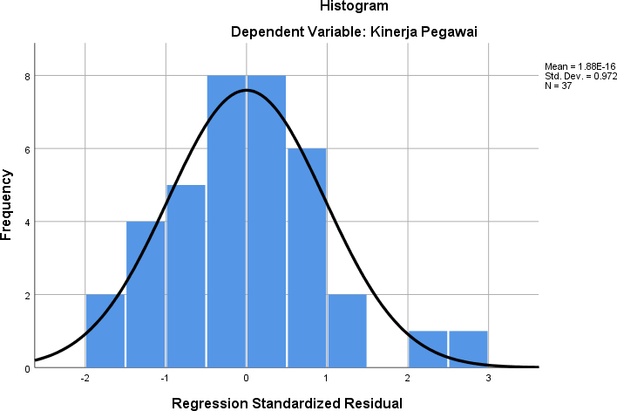

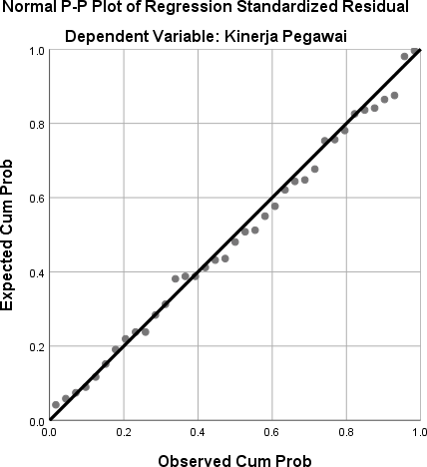

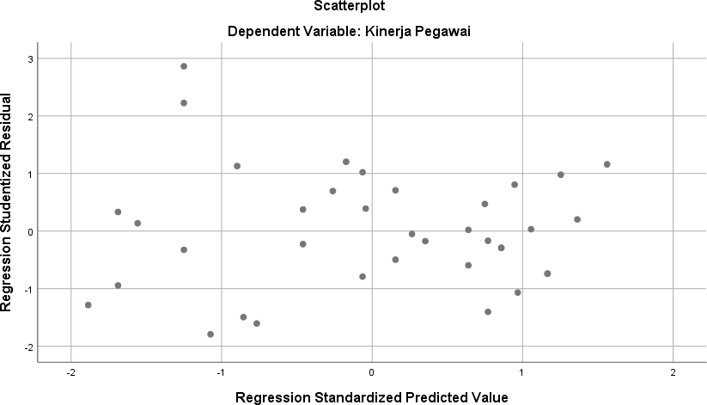

**One-Sample Kolmogorov-Smirnov Test**

Unstandardized Residual

|  |  |  |
| --- | --- | --- |
| N | | 37 |
| Normal Parametersa,b | Mean | .0000000 |
|  | Std. Deviation | 1.64358058 |
| Most Extreme Differences | Absolute | .064 |
|  | Positive | .064 |
|  | Negative | -.053 |
| Test Statistic | | .064 |
| Asymp. Sig. (2-tailed) | | .200c,d |

1. Test distribution is Normal.
2. Calculated from data.
3. Lilliefors Significance Correction.
4. This is a lower bound of the true significance.

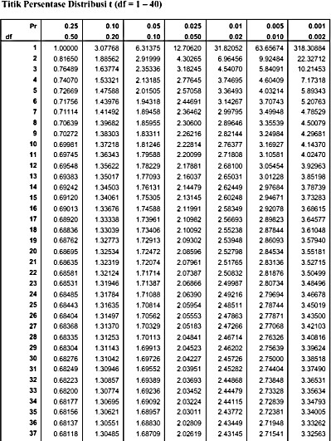

**2.03011**

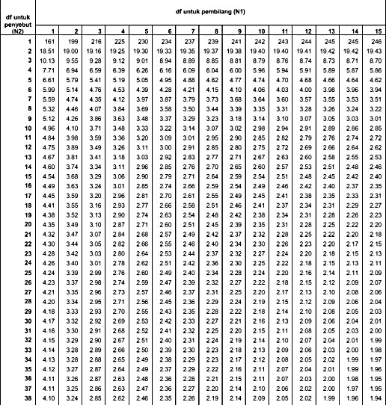

**3.27**

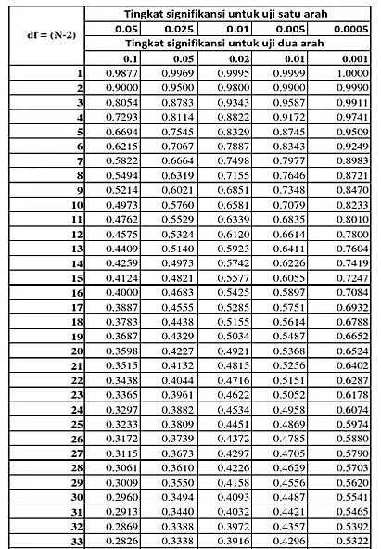

**0.3610**