# ACKNOWLEDEGMENT

بِسْــــــــــــــــــمِ اللهِ الرَّحْمَنِ الرَّحِيْمِ

يَا أَيُّهَا الَّذِينَ آمَنُوا هَلْ أَدُلُّكُمْ عَلَىٰ تِجَارَةٍ تُنْجِيكُمْ مِنْ عَذَابٍ أَلِيمٍ (١٠) تُؤْمِنُونَ بِاللَّهِ

وَرَسُولِهِ وَتُجَاهِدُونَ فِي سَبِيلِ اللَّهِ بِأَمْوَالِكُمْ وَأَنْفُسِكُمْ ۚ ذَٰلِكُمْ خَيْرٌ لَكُمْ إِنْ كُنْتُمْ

تَعْلَمُونَ (١١)

*“Wahai orang-orang yang beriman! Maukah kamu aku tunjukkan suatu perdagangan yang dapat menyelamatkan kamu dari azab yang pedih?. (Yaitu) kamu beriman kepada Allah dan Rasul-Nya dan berjihad di jalan Allah dengan harta dan jiwamu. Itulah yang lebih baik bagi kamu jika kamu mengetahui.”*

*(Q.S. Ash-Shaff 10-11)*

***Assalamu’alaikum Warahmatullahi Wabarakatuh***

Alhamdulillahirabbil'alamin, Praise be to the presence of Allah SWT who has created, bestowed and perfected His blessings in the form of sustenance, health, safety and enthusiasm so that the researcher can complete this thesis with the title "An Analysis of Slang Words in The Basketball Diaries Movie", Researchers compiled it as one of the final requirements for completing Bachelor's Degree (S1) at the Faculty of Letters, Al Washliyah Muslim Nusantara University, Medan.

In preparing this thesis, a lot of effort was made in the process. However, this thesis would not have been completed without the parties who provided sincere support and assistance in all matters so that this thesis could be completed on time. We express our gratitude to all parties.

1. Dr. Firmansyah, M.Si, the rector of Universitas Muslim Nusantara Al Washliyah.
2. Dewi Nurmala, S.S., M.Hum., the dean of Faculty of Letters and also as an examiner.
3. Diana Sopha S.S, M.Hum., the deputy dean of Faculty of Letters.
4. Ayu Melati Ningsih, S.Pd., M.S., the head of English Literature Study Program.
5. Vera Kristiana S.Pd, M.Pd as advisor who has guided, directed, and advised me during the process of preparing this thesis.
6. Prof. Dr. Risnawaty, M.Hum and Dewi Nurmala, S.S, M.Hum, as my examining lecturers who have guided, directed, and advised me during the process of preparing this thesis.
7. All lecturers of the Faculty of Letters Universitas Muslim Nusantara Al Washliyah.
8. The researcher conveys the highest appreciation to her beloved parents who always provide their prayers and support, father Erwin Chandra Nst and mother Novita, as well as brother M. Aditya Chandra Nst who always support and encourage each other with extraordinary sincerity.
9. The researcher's childhood friends Nur Nabila, Affandi Lubis and Fadlan Selian. Thank you for all the support and encouragement that has been given to the researcher.
10. The Researcher’s friends Wais Al Qorni, Almira Devany, Pinka Yani, Dea Deffiar and Muftia Zakia Mawaddah. Friends who are in the English 20' WhatsApp group, the researcher would like to thank you for being willing to fight together in college. *See you on top, guys.*
11. For someone whose name Allah has written in Lauhul Mahfudz is someone whom Allah has destined to have a soul mate with the writer one day. Even though the researcher doesn't know who you are, the researcher also dedicates this thesis to you. Hopefully we can be together in other important moments. Hopefully we meet at the right time according to Allah.
12. And last but not least, thank you to the owner of NPM 206114001, for working hard and fighting so far. Being able to control myself from various pressures outside of circumstances and never giving up no matter how difficult the process of completing this thesis as well and maximally as possible, this is an achievement that you should be proud of.

Finally, there are no best words that the researcher can convey to all parties who have helped complete this thesis, but thank you. Researchers highly expect constructive criticism and suggestions. The researcher describes the good and the bad and the assistance that has been given to the researcher may be rewarded by Allah SWT with abundant rewards and in the end the researcher would like to say thank you.

Medan, 2023 Juny 30th

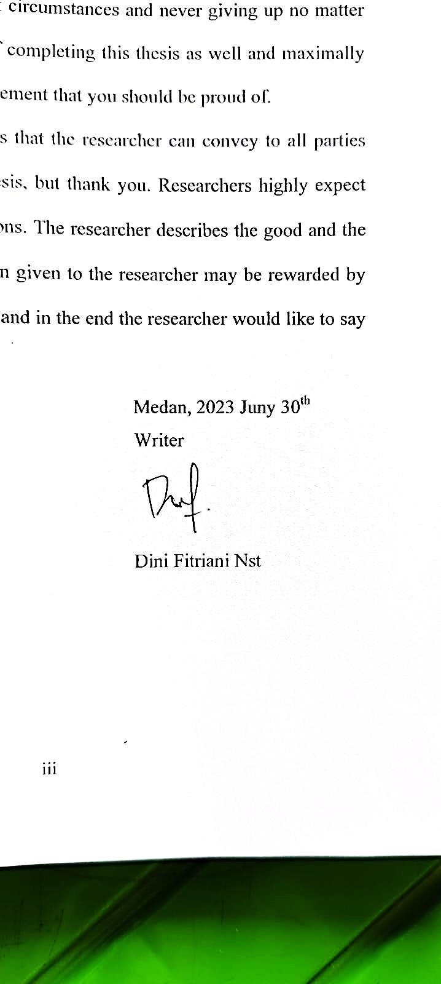Writer

Dini Fitriani Nst