# CHAPTER II

# REVIEW OF LITERATURE

## 2.1 Slang Words

### 2.1.1 Definition of Slang Word

Slang word is the casual that is utilized in a particular organization of human specifically used by young adults of their sports to talk each other. Habibiloyevna (2021), slang isn’t always language or dialect, it could be said as a code that product through converting the present language to the commonplace one. Every language has a vocabulary, pronounciation and grammar, while slang has not. It just has vocabulary which is not profanity and ungrammatical. The form of slang can be entire sentence but usually slang is categorised as a phrase. Slang itself may be defied as deviating faraway from trendy language use. Slang is a form of non-wellknown use of words in a language and every so often the introduction of new words are from any other language. The spreading of slang could be very rapid specifically amongst millenial generation. It’s miles resulting form the influence of media which includes tv, radio, net, and so on.

Budasi & Bhuwana (2020) verifies that slang is easy sufficient to use but very hard to put in writing about. This correlates withthe phenomena wherein most people use slang yet while they are requested to define slang, they might have a tough time in doing so. This phenomenon happens because of the truth that the meaning and form of the slang itself constantly adjustments. The change occurs due to the fast invention of the slang itself. As one technology grows up, the opposite technology who can be within the teenage degree will certainly

invent new slangs both through which means shift or the absolutely invented phrase.

In opinion of Lumendang (2020) Slang is jargon that is applied among individuals who have a place with a similar collecting of human beings and who understand each other well. Slang is pretty informal language. It can outrage individuals in case it's miles utilized by others or outside a gathering of folks who do not have a clue approximately one another well. We typically use slang in speakme rather than composing. Slang permit an man or woman to turn out to be creative within the usage of language. A few organization use slang to speak with each other casually. Additionally, individuals making use of slang can apprehend one of a kind people from their subculture without any problem. Slang isn't something very similar at each time motive it modifications depend upon length. every character at better location have no longer a similar slang they applied. They have got numerous slang.

According to Putu Aristya Dewi (2017:239) slang is considered a completely informal phrase or expression that is typically utilized in our every day conversations. Many people like children, young adults, and adultshas its own kind of slang. Slang is due to the fact it's far easier to understand however can still supply a deep impression to the listener.And according to Chapman (1987) in Dewi (2017:239) saysslang emerged from the unique languages of subcultures and it has little to do with the principle goal of language and it's far the maximum nonlinguistic form of language. Slang is the things that everyone can recognize and nobody can define. The makes use of of slang through the teenagers are nonetheless being counted on for innovation on creating new slang.

According to Dalzell & Victor (2015) Slang is simple enough to apply, but very hard to jot down approximately with the facile convincingness that a subject seemingly so simple might, at the start sight, appear to demand. But the simplest matters are the toughest to outline, certainly the hardest to speak about, for it's far typically in the beginning sight simplest that their simplicity is what strikes one the most forcibly. And slang, in spite of everything, is a peculiar sort of vagabond language, constantly placing on the outskirts of valid speech, however always straying or forcing its way into the maximum respectable business enterprise.

Derived from the definition of slang to several experts above, the author can conclude that the word slang is used in organizations where teenagers talk to each other casually. Slang cannot be used at formal events such as speeches because it uses non-standard or rude words. Along with time, teenagers use slang to make jokes but don’t use it when having conversations with stranger. Slang is used in communities that understand the language. We can easily apply slang in everyday life but not in writing because it will be difficult to give meaning to the slang used. This slang can also make people who use it become creative in their use of language.

### 2.1.2 Types of Slang word

According to Chapman (2007:8) there are two types of slang which are primary and secondary slang.

1. **Primary Slang**

Primary slang is considered the speech of subculture members and is so natural and pure for them that it is as if they would become mute without it. Primary slang can also be interpreted as general words used to express their feelings in everyday communication. A group's primary slang is often adapted to general slang. Most teenage talk and urban street gang talk are examples of mainstream slang such as:

* Baby : to call a girl or women
* Dude : to call a man
* Fuck : to do the sex

1. **Secondary Slang**

Secondary slang is considered to be a word chosen not to indicate one's part in a group but rather to express one's attitude. Secondary slang is more a matter of stylistic choice than actual identification. Secondary slang is also considered a word that is used to express something in a secret manner which only limits people who understand the meaning of the words. Words used by a drug user, street gang member, gambler, criminal, and so on are examples of secondary slang:

* Goddamn : a swear word or angry
* Coke : cocaine

This research focuses on primary slang because in the film "The Basketball Diaries" there is more primary slang than secondary slang.

### 2.1.3 Function of Slang

Allan and Burridge (2006) in (Manurung, et al, 2020) provide an explanation for there are seven features of slang phrasesas follows:

1. To cope with, way the audio system use slang phrase to deal with some other speaker with a purpose to keep their near relationship.
2. To humiliate, the audio systemhave the tendency to express ugly or dislike feeling of the speakers closer tosomeone or something via mocking them.
3. To initiate relax communication, thespeakers who have near dating with different tends to use certain vocabulary inorder to make the communication run more relaxed in an effort to feel extra at ease.
4. To shape intimate ecosystem, slang can be an opportunity way toalleviate the connection most of the strangers that will reduce socialdistance and more comfortable.
5. To specific influence, the speakers often useslang to reflex their affect whether it is a superb or a awful influence aboutsomething in an effort to deliver a clear photo about the positive feeling that they need to explicit,
6. To show anger, the audio system who've near dating regularly useslang words to curse others rather than use everyday phrases when they need to describe anger
7. To expose intimacy, the audio system generally use formal languagewith strangers at some point of communique but favor to use slang with buddies to signifyintimacy or unity in their social courting.

## 2.2 Semantics

### 2.2.1 Defition of Semantic

According to Kreidler (2002: 3-24) semantic is the systematic study of menaing, and linguistic semantic is the study of how languages organize and express meanings. Semantics is one of the grammar; phonology, syntax and morphology are other parts. It is impossible to explore semantics without also dealing with syntax (and vice versa) because the two are closly interrelated: meaning of a word of a sentence is more than the meanings of the words it contains, and the meaning of a word often depends partly on the company it keeps-what words occur in the same sentence. One part of semantic analysis, is concerned with describing the kinds of expressions which usually accompany various verbs-what roles these expressions play with respect to the verb and to each other-the two, what, where and when.

According to Bagha (2011) Semantics is the study of meaning in language. We recognize that language is used to specific meanings which can be understood with the aid of others. but meanings exist in our minds and we will explicit what's in our minds through the spoken andwritten styles of language (in addition to via gestures, motion and so forth.). The sound styles of language are studied at thestage of phonology and the company of phrases and sentences is studied at the extent of morphology and syntax. Theseare in turn prepared in the sort of way that we will deliver meaningful messages or get hold of and apprehend messages. “Howis language organized in an effort to be significant?” this is the question we ask and try to answer at the level ofsemantics. Semantics is that stage of linguistic analysis wherein which means is analyzed. It's far the maximum summary level oflinguistic evaluation, in view that we can not see or observe that means as we will observe and report sounds. Meaning is associatedvery closely to the human capacity to think logically and to understand. So whilst we try to investigate which means, we'retrying to analyze our very own capability to assume and recognize our very own capacity to create which means. Semantics concerns itself with giving a systematic account of the nature of that means.

According to Kearns (2017), said that semantics deals with the literal that means of phrases and the meaning of the manner them are blended, which taken collectively from the middle of which means, or the starting point from which the entire suggest-ing of a selected utterance is constructed.

According to Sopha (2021) state that semantics is the observe of meanings. It is defined as the meaning or courting of meanings of a sign or set of signs and symptoms particularly: connotative meaning .

According to Asrianti (2020) Semantics is the study of meaning. Seen by Breal, in the late 19th century, as an emerging science (French, “semantique‟) opposed to phonetics (“phonetique‟) as a science of sounds: similarly, for Bloomfield in 1930, it was a field covering, as one account of meaningful forms, and the lexicon. Also seen morenarrowly, in a traditional lasting into the 1960s, as the study of meaning in the lexicon alone, including changes in word meaning. Later, in accounts in which the study of distribution was divorced from that of meanings, opposed either to grammar in general; or, within grammar and especially within a generative grammar from the 1960s onwards, to syntax specifically. Of the uses currently at the beginning of the 21st century, many restrict semantics to the study of meaning is abstraction from the contexts in which words and sentences are uttered: in opposition, therefore, to pragmatics. Others include pragmatics as one of its branches. In others its scope is in practice very narrow: thus one handbook of “contemporary semantic theory‟, in the mid-1990s deals almost solely with problems in formal semantics, even the meanings of lexical units being neglected.

Based on the definition of semantic to several experts above, the author can conclude that semantics is one part of semantic analysis is concerned with describing the type of self-actualization that generally accompanies various verbs – what role the self-actualizers play in relation to the verbs and each other – both, what, where, and when. Semantics is the study of meaning in language. Semantics focuses its attention on providing a systematic explanation of the nature of meaning. Semantics is the observation of meaning. Semantics is the study of meaning. Unlike pragmatics, semantics is a subset of grammar, a view of the inner structure of language. Unfortunately, because semantics is the most poorly understood aspect of language, it is perhaps one of the most difficult areas of linguistic study.

### 2.2.2 Branches of Semantic

Lists the subsequent as the principle extensively distinguishable region of interest inside the look at of meaning: lexical semantics, grammatical semantics, logical semantics, and linguistics pragmatics (Curse, 2005:15 in Sankaravelayuthan, 2018).

1. **Lexical Semantics**

Lexical semantics studies the meanings of phrases; the point of interest is on ‘content material’ phrases like *lion, jasmine, selfish and convince*, in preference to form/grammatical words just like *the, of, than, and, so on*. A non-specialist mostlylinks the perception of meaning with phrases instead of some other linguistics units which can be lesser than words (consisting include affixes) or wider than words (consisting of phrases, sentences). We do not forget dictionary because the onewhich deals approximately phrases. The department of semantics which systematically study the meaning words is lexical semantics.

* Lions are powerful carnivorous animals and lead in the hierarchy of wild life.
* Jasmine is a fragrant flower and is often used in various traditional ceremonies.

1. **Grammatical Semantics**

Grammatical semantics research aspects of meaning that have direct relevance to syntax. This has many manifestation. That may best be in brief dealt right here. Syntatics categories are one the problems in the interface of syntax and semantics. As an instance, remember the problem of assigning class to the word black. It could take delivery of the category along with adjectives, noun, and verb as illustrated underneath:

* The car has a shiny and elegant black color. (adjectives)
* The black hat stood out among all the clothes worn. (noun)
* He painted his fence with new black paint. (verb)

You could surely visualize that this overlaps with lexical semantics due to the fact that some grammatical elements (incluisng the and of) are phrases and additionally due some other fact that some amount of grammatical conduct is determined by the lexical items themselves. The subsequent examples will illustrate this:

* She is reading a book in the library. (grammatical)
* She book reading in the library. (ungrammatical)

1. **Logical Semantics**

Logical semantics studies the relation among herbal language and formal logical structures inclusive of the propositional and prdeicate calculi. Such studies generally purpose at modeling herbal language as carefully as viable the use of a tightly controlled, maximally strict logical formalism (cruse, 2000:15). Every so often such studies shed greater mild at the foemalism used than on the language being modeled. But treasured insights have cropped up from this approach. Most of such studies until date are worried with the propositional or sentence level meaning and that they rarely stoop down the level of words.

1. **Semantic Pragmatics**

Semantics is the study of meaning, or extra precisely, the have a look at the relation between linguistic expressions and their meanings. Whenever we’ve a verbal war of words, we disagree about the semantics of some expression we employes in stating our views. Pragmatics is the take a look at of context, or more prcisely, a take a look at of the way context an affect our knowledge of linguistic utterances. Every time we’ve a contextual confrontation, we take ourselves to be in exclusive context and the difference consequences what we take ourselves to have carried out via our repective acts of mentioning our perspectives. Deciding on a shared that means for the expressions we used may be hard, however settling on a shared take on the context is often harder.

For the present reason, pragmatics may be taken to be concerned with aspects of information (inside the widest sense) conveyed through language which are not encoded by using normally well-known convention within the linguistic forms used, however which none the much less stand up certainly out of and rarely on the meanings conventionally encoded inside the linguistic paper work used, taken at the side of the context in which the forms are used.

* “She’s throwing shade at her ex-boyfriend.”

Slang word : “throwing shade”

Pragmatic implicature : Implies that someone is sarcastic or criticizing their ex-girlfrind.

* “That party was lit, man!”

Slang word : “lit”

Pragmatic implicature : Revealing that the party is very exciting or great.

Slang words are a part of semantics where the slang words are included in the branch of semantic pragmatics. Slang words have an interesting role in the branch of semantic pragmatics because they ot only reflect the literal menaing of words, but also involve a rich pragmatic dimension. Often, slang words are used to express emotional, social, or cultural nuances in a conversation. For example, when someone uses the word”savage” to refer to an unexpected or spicy action, it not only describes the event itself but also carries pragmatic implications related to surprise or unexpectedness. Likewise, the word “lit” which may originaly mean bright or shining, but in a slang context, is used to express excitement about something extraordinary. Therefore, the study of slang words in pragmatic semantics opens the door to understanding how word meanings are not only limited to linguistic structure, but also develop in everyday use to convey richer and more complex messages.

## 2.3 Movie

### 2.3.1 Definition of Movie

A movie is a form visible communication which makes use of shifting pictures and sound to inform stories so those who watch can see and listen directly. According to Artawan (2022) movie manner a series of moving photo recorded with sound that tells a tale, proven at cinema or film. By way of the usage of film, the college students are hoping to experience and pleasure to learn English vocabulary, make clear the message, can keep the trainer power, can encourage the coaching and learning using films or films in the lecture room, students can decorate their vocabulary recognation and they could even make their pronounciation and intonation much better. According to Rasyid (2018) Movie is moving described as : a collection of pics projected onto a display screen with enough rapidity as to create the illusion of movement and continuity or a form odf amusement that enacts a story with the aid of a sequence of pix giving the illusion of continuous and sound and suspends our disbelief to offer an enjoyable immersive revel in fot the viewer.

So it can be concluded that film is a visible communication that utilizes a series of moving photos and sounds that will be seen and heard by the audience. The film is created with the help of the movement of the image to make the audience who watch the film can watch it casually nad feel interested.

### 2.3.2 Types of Movie

According to Artawan (2022) movies are grouped into story movie, news movie, documentaries and cartoons:

1. **Story Movie**

Story movieis a form of movie that contains a story this is generally proven in cinema buildings with well-known film stars and is sent as an enjoyment medium. The tale that is raised as the subject of the film may be inside the shape of a fictional story or primarily based on a modified genuine tale, in order that there are interesting factors, both from the storyline and from an inventive angle.

1. **News movie**

A news movie or newsreel is a film about statistics, occasions that surely passed off. because of its newsworthy nature, films provided to the general public must contain news cost. The information criteria are important and interesting.

1. **Documentaries**

Documentary movie are defined by means of Robert Flaherty as “creative remedy of actuality, which isn't the same as information movies that are recordings of fact, sodocumentary movies are the result of private interpretation (the maker of thereality).

1. **Cartoons**

Cartoon movie are made for kid's consumption, and we may be positive we all realize the characters Donald duck (Donald duck), Snow White (Snow White),Mickey Mouse (Mickey Mouse) created by means of American artists.

This research is included in the story movie because “ The Basketball Diaries” is that movie tells the story of the life of a teenager named Jim Carroll, played by Leonardo DiCaprio. This story is based on Jim Carroll’s authobiographical memoir which has the same title. In this film, the audience followa Jim’s journey, who was originally a talented and good basketball athlete at school. However, the story takes a drastic turn when Jim falls into a life of drugs and crime. The movie provides a clear, chronological narrative of the main character’s transformation, from a vibrant life on the basketball court to the struggles and despair of a drug addict.

## 2.4 Synopsis of “The Basketball Diaries” Movie

In the first scene of the film Jim Carroll is being spanked in front of his classmates by his teacher. When the teacher is finished he tells Jim "We can do it again tomorrow if you like Mr. Carroll". After this Jim and his friends Pedro (James Madio), Mickey (Mark Wahlberg), and Neutron (Patrick McGaw) are on the Staten Island ferry. They then sniff Carbona cleaning fluid to get high. After Pedro gets a little too high he accidentally pukes on another man's head. The man chases them as they make their escape to their high school where they play a match of basketball. During the match Pedro steals from the opposing team's locker. After the match their coach Swifty (Bruno Kirby) brings them for burgers as a reward for winning the match. At the restaurant the other team confronts them about the theft and then Jim and his friends assault them.

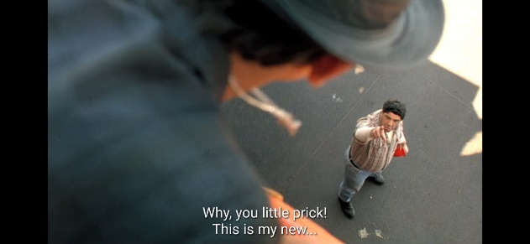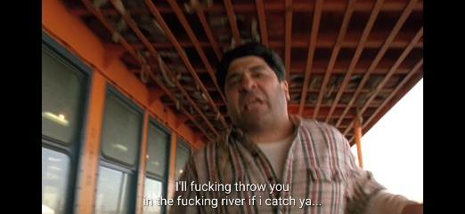

***Figure 2.4.1 Pedro vomits Figure 2.4.2 The man chases***

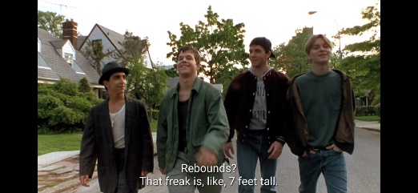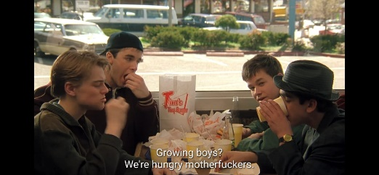

***Figure 2.4.3 Heading to school Figure 2.4.4 Burgers***

Jim then visits his satisfactory buddy Bobby (Michael Imperioli) in sanatorium who's demise from leukemia. Jim then takes Bobby to a strip display. Jim then meets Reggie (Ernie Hudson) and they play some basketball together. After this Jim and his predominant buddies go to a cliff to jump into the river underneath it to prove they may be brave. Jim and Mickey then go to prostitute twins Winkie and Blinkie. this is wherein Jim nervously tries cocaine for the primary time.

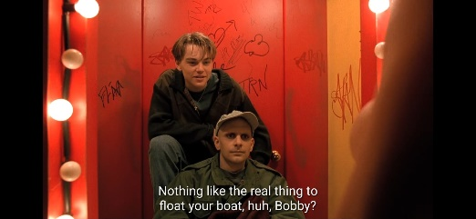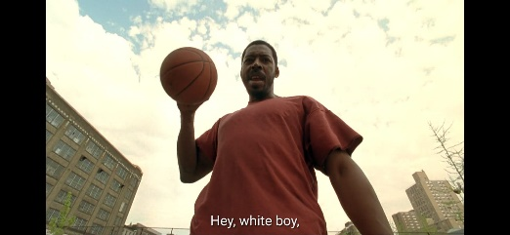

***Figure 2.4.5 Strip display Figure 2.4.6 Reggie***

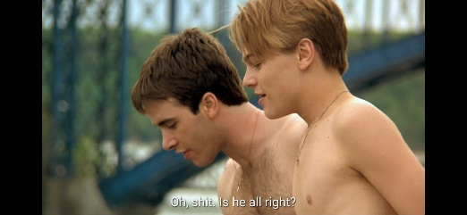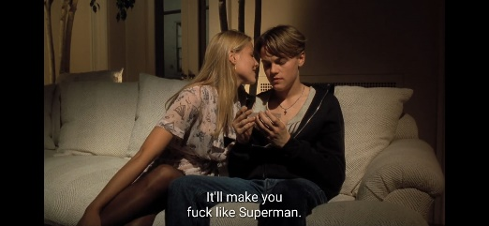

***Figure 2.4.7 Jump to the river Figure 2.4.8 Tries cocaine***

The subsequent scene is at Bobby's funeral. while the funeral is over Jim and his pals go to the basketball court and communicate approximately Bobby's life. Mickey says "that child become in a lot pain, it is better that he died" Jim disagrees with this and that they get into a controversy over it. Jim describes his first time the usage of heroin. inside the film he's seen jogging through a discipline of plant life to describe the gigantic pleasure he felt.

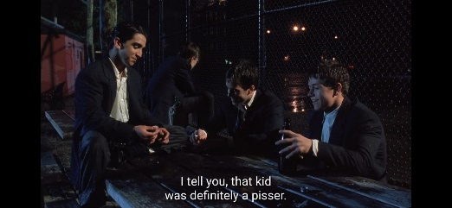

***Figure 2.4.9 Basketball court***

In basketball exercise Swifty takes Jim into the toilet and offers him money in change for sexual favors. Jim refuses. before a basketball game in opposition to Harlem excessive, Jim, Pedro, and Mickey select pills from Pedro's hat, hoping they're uppers; Neutron is there, but he refuses the pills. alas, the drugs are downers, and the boys are stumbling all over themselves at the courtroom. Swifty pulls them out of the game and lectures them in the locker room, telling Jim he will in no way play basketball there once more. Jim and Mickey quit the crew and drop out of faculty. Neutron remains.

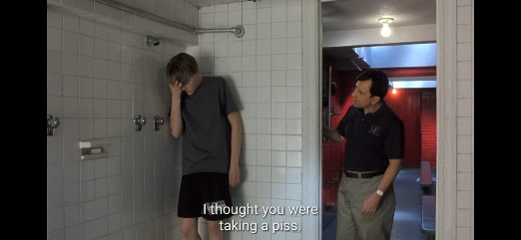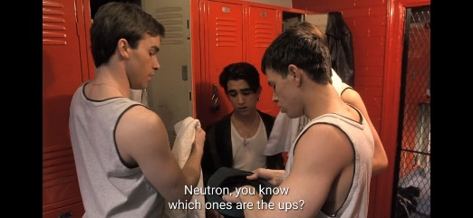

***Figure 2.4.10 Jim and Swifty Figure 2.4.11 Select pills***

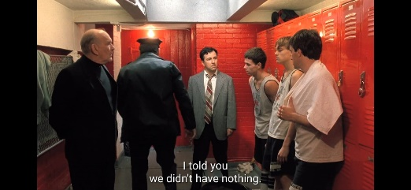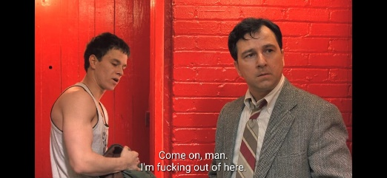

***Figure 2.4.12 Courtroom Figure 2.4.13 Drop out***

Jim's mother then reveals the pills he has been the use of. They get into a controversy. Inside the subsequent scene Pedro tells Jim and Mickey approximately this guy who he is supposed to deliver a vehicle to. They steal the car however once they go the man to supply it to him they recognise they parked it in a "No-car parking zone" and that they see the car being towed away. the man receives mad at them and breaks Mickey's arm. Jim, Mickey and Pedro damage into a shop however they enjoy hassle getting the coins register to open. They listen the police officers coming and Jim and Mickey get away however Pedro is just too past due and gets arrested.

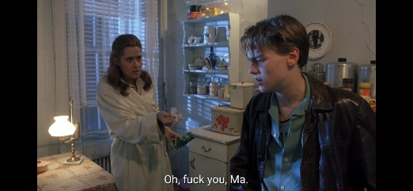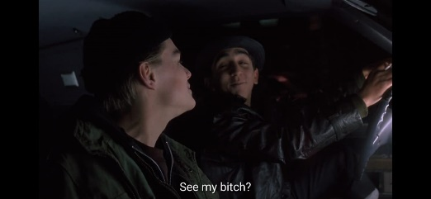

***Figure 2.4.14 Debate Figure 2.415 Steal the car***

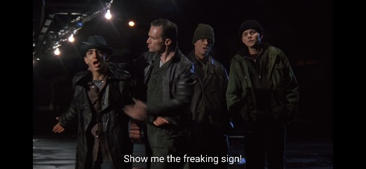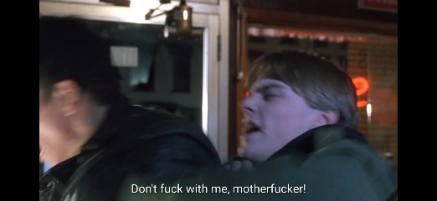

***Figure 2.4.16 Towed away Figure 2.4.17 Shop***

Jim passes out in the snow high off heroin and Reggie comes and takes him up to his rental and forces him to detox. Jim screams in pain from the withdrawal and begs for a few heroin.

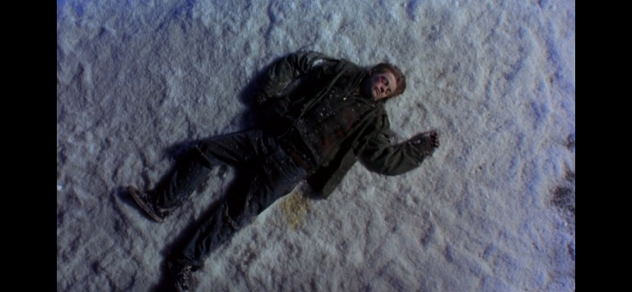

*Figure 2.4.18 High off heroin*

Jim and Mickey buy a few heroin off a drug provider however once they find out that the drug supplier ripped them off Mickey chases him across the city and up onto a roof and pushes him off. Mickey then attempts to break out however is beaten up by way of a gang after which arrested by way of the police. Jim then is going to his mother's condominium and begs to be permit in. She refuses and speak to him via the locked door. Jim tells her that he is in a few problem and needs a few cash and desires to get out of town for a bit. His mom then calls the police. Jim sentenced to 6 months at Riker's Island for assault, robbery, resisting arrest, and ownership of medication.

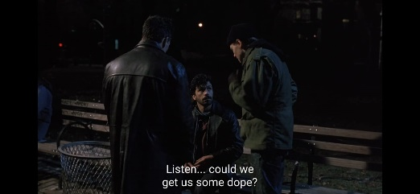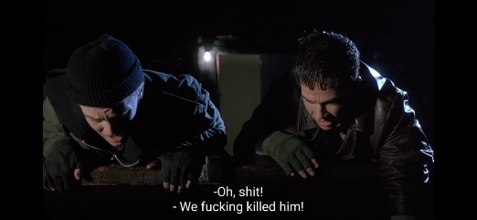

***Figure 2.4.19 Drug provider Figure 2.4.20 Pushes him off***

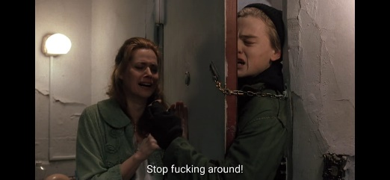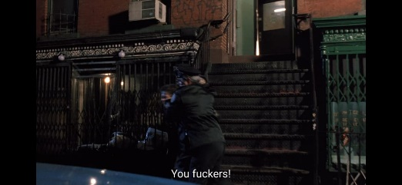

***Figure 2.4.21 Permit in Figure 2.4.22 Calls the police***

Within the very last scene Jim approaches the degree door to give his poetry reading. Pedro stops him and, to celebrate his launch from Riker's, gives him a bag of dope. Jim refuses. The film ends with Jim reciting his work before an audience.

## 2.5 Previous Research

The researcher found three previous research that were relevant to the researcher. Previous research by Jayanthi, Suastiani, and Jayantini (2022) with the research title An Analysis of Slang Words in Song Lyrics Used by Ariana Grande. The method used in the research is descriptive qualitative where this research focuses on the analysis of slang words proposed in Chapman's theory (2007) and the effect of slang words by the theory by Eble (1996). The data used in this study were obtained from the lyrics of several Ariana Grande songs entitled 34 + 35, Positions, Thank U, Next, and Side to Side. The result of this study, the researcher managed to find 21 (78%) data types of primary slang and 6 (22%) data types of secondary slang. The effects of slang words there are 21 (78%) slang words identified as expressing formality and 6 (12%) slang words identified as identifying group members and no slang found to apposed establishing authority.

Research by Achmad, Erdiana, Fadilla, and Bahri (2023) with the title An Analysis of Slang Words in The “Green Book”, A Movie Directed By Peter Farrelly. Using qualitative method, this research focuses on describing the type of slang words, eating, and the reasons for using slang words in the movie Green Book directed by Peter Farrelly. Based on the data collected, there are 118 slang words used in the movie. The researcher states that there are 3 findings in this study, namely the first finding is the type of slang words in which there are 4 types of slang words used by the characters in this movie, namely fresh and creative, imitative, flippant, and clipping. The second finding is the meaning of each slang words used by the characters in the movie. Then the third finding is the reason for using slang words by the characters, where there are seven reasons for its use such as address, to form intimate atmosphere, to initiate relax conversation, to express impression, to show intimacy, to reveal anger, and to express humiliation.

Another research by Tika Thapa (2017) with the title Failure of the American Dream in Scoot Kalvert's The Basketball Diaries. In this study, researchers raised the issue of the adverse impact of the cultural industry on the younger generation of American society in the 1960s, using neo-marxist theory initiated by Theodor Adorno, Max Horkheimer and George Lukacs. This study explores the rise of the cultural industry in America which actually destroyed its society, where many teenagers became drug addicts and various criminal acts to get money. The researcher found that the American Dream is a sagging ideal that fails to fulfill the promises of life, liberty and the pursuit of happiness. After independence, the United States practiced the culture industry to fulfill individual dreams and emerged capitalism and a capitalist society that exploits human moral and ethical values and relations. Therefore, the researcher has gone to the underlying level of such societies in the light of Neo-Marxism which postulates a different speculation of a given society.