**ACKNOWLEDGMENT**

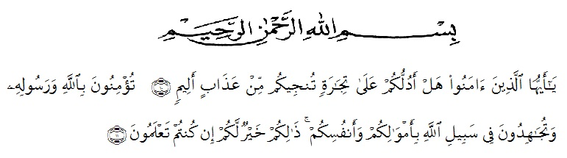

First of all, the writer would like to express his great thankfulness to the Almighty God, who has given mercy, health, and guidance to allow the writer finishing this writing, along with his family and his companions. The writer is aware that without Allah’s permission she will not be able to finish her study. The paper entitled “An Analysis of Authority Values in Sandra Brown’s Novel, *White Hot*is as a requirement for academic at faculty of letters in University of Muslim Nusantara Al-Washliyah Medan.

I would like to thank for the great blessing and guidance. She realizes that the settlement of the requirement is not easy, but the motivation, help, support, and attention given by parents, friends and the others make the writer is able to go through and finish it. Therefore, the writer would like to dedicate her sincere gratitude to all of them.

1. H. Hardy Mulyono, SE, M.AP, the Rector in University of Muslim Nusantara Al-Washliyah Medan.
2. Dr. Hj. Risnawaty, M.Hum, the Dean of Faculty of Letters
3. Dewi Nurmala, SS, M.Hum, the Head of Deparment of Faculty of Letters.
4. Dr. YuliaArfanti, M.Hum and Drs. Ratna Sari Dewi , SS, MS as the writer’s consultants who had educated, supported, directed, and given us countless advice, suggestion, and recommendation in writing this script from beginning until the end. Thanks for their patience and guidance.
5. Vera Kristina,S.Pd, M.Pd, the examiner for her guidance, advices, suggestion and previous time she had given during the complementation of this script and her study
6. For all lecturers who gave their patience and support.
7. Grateful thanks to beloved father, mother, and uncle, Sempurna, SarifahAini, and Abdul Salam, and also to my family who always gives the writer pray, encourage, love, support, motivation and patience tom the writer during finishing this script and writing for writer’s graduation.
8. Thanks for my best friends,AhokLimbong, MarianiUlfa,WirdaFakhraniLubis, and AgustinaLimbong and the other classmates for a lot of support, laugh, sadness, happiness that we shared together. Thank you so much for everybody being part of my life.
9. Finally for the readers, may the grace and love Almighty God be with us all forever, Amin. Medan,

**Rahmawati**

**146224023**