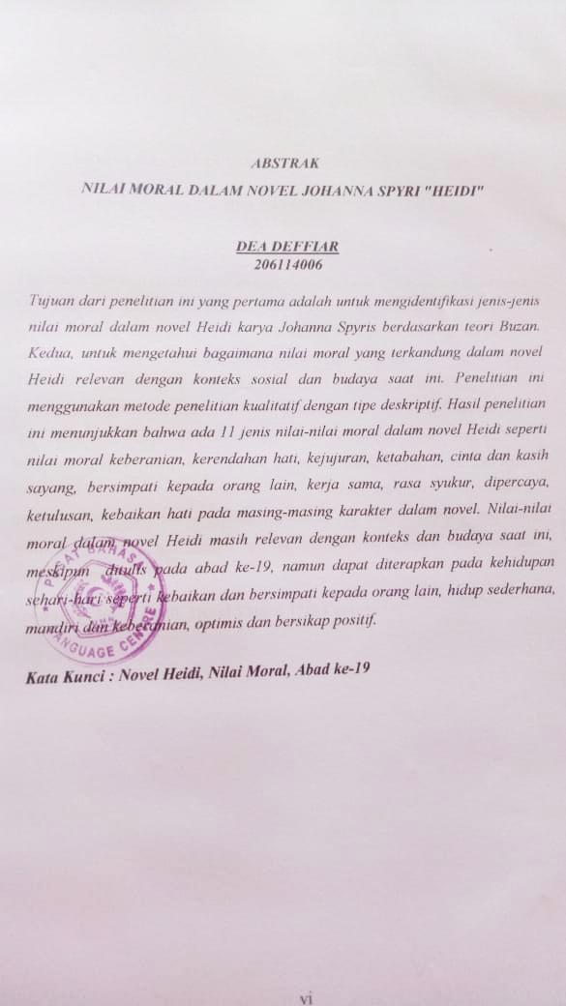

**ABSTRACT**

**MORAL VALUES IN JOHANNA SPYRI NOVEL *"HEIDI"***

**DEA DEFFIAR**

**206114006**

The aim of this first research was to identify the types of moral values in Johanna Spyri Heidi novel based on Buzan theory. Second, to find out how the moral value contained in the novel Heidi is relevant to the current context and cultural context. This research used qualitative research methods with descriptive types. The results of this research show that there are 11 types of moral values in Heidi novel such as the moral value of bravery, humbleness, honesty, steadfastness, love and affection, being sympathetic to others, cooperativeness, thankfulness, trustworthiness, sincerity, kind-hearted on each character in the novel. The moral values in Heidi novel are still relevant to today context, although it were written in the 19th century, but can be applied to everyday life such as kindness and being sympathy to others, the simple life, independent and bravery, optimism and positive attitude.

**Keywords : Novel Heidi, Moral Values, 19th Century**