**ACKNOWLEDGMENT**

بِسْــــــــــــــــــمِ اللهِ الرَّحْمَنِ الرَّحِيْمِ

يَا أَيُّهَا الَّذِينَ آمَنُوا هَلْ أَدُلُّكُمْ عَلَىٰ تِجَارَةٍ تُنْجِيكُمْ مِنْ عَذَابٍ أَلِيمٍ (١٠) تُؤْمِنُونَ بِاللَّهِ وَرَسُولِهِوَتُجَاهِدُونَ فِي سَبِيلِ اللَّهِ بِأَمْوَالِكُمْ وَأَنْفُسِكُمْ ۚ ذَٰلِكُمْ خَيْرٌ لَكُمْ إِنْ كُنْتُمْ تَعْلَمُونَ (١١)

Artinya :

*Wahai orang-orang yang beriman! Maukah kamu aku tunjukan suatu perdagangan yang dapat menyelamatkanmu dari azab yang pedih?*

*(Q.S. Ash-Shaff : 10)*

*(Yaitu) kamu beriman kepada Allah dan Rasul-Nya dan berjihad di jalan Allah dengan harta dan jiwamu. Itulah yang baik bagi kamu jika kamu mengetahui. (Q.S. Ash-Shaff : 11)*

The researcher always gives thanks and thanks to Allah SWT for all the abundance of grace, favors, and gifts that He has given so that the researcher can complete the writing of this thesis well. Shalawat too Greetings are always poured out to the Prophet Muhammad SAW who has brought Islamic teachings to the people always o be people of faith and obey Allah SWT.

The thesis entitled "MORAL VALUES IN JOHANNA SPYRI NOVEL *"HEIDI"* " was prepared in order to fulfill the duties and requirements to obtain a Bachelor of Letters (S.S) degree at the Faculty of Letters, Universitas Muslim Nusantara Al-Washliyah. In the process of working on the thesis, the researcher tried as hard as possible so that this thesis could be completed with good results, but of course, the researcher realized that there were still many shortcomings and weaknesses in terms of content and grammar due to limited knowledge and the researcher experience. Therefore, the researcher expects criticism and Suggestions that could be constructive for the perfection of this thesis and hopefully, this thesis can be useful and useful for the readers. The researcher successful completion of this thesis is certainly not an achievement purely from oneself but with support, assistance, and prayers from the people who gave it to the researcher. Therefore the researcher wholeheartedly thanks :

1. Mr. Dr. H. Firmansyah, M.Si as Rector of UMN Al-Washliyah.
2. Mrs. Dewi Nurmala, S.S.,M.Hum as Dean of English Literature of UMN Al-Washliyah.
3. Mrs. Diana Sopha, S.S., M.Hum as Deputy Dean of English Literature UMN Al-Washliyah.
4. Mrs. Ayu Melati Ningsih, S.Pd., M.S as the Head of the UMN Al-Washiyah English Literature Study Program Department.
5. Mrs. Ratna Sari Dewi, S.S., M.S as Supervisor has patiently guided me, and provided various valuable inputs, which with kindness and sincerity guided the researcher in completing this thesis.
6. Mrs. Prof. Dr. Risnawaty, M.Hum as Examining Lecturer I has provided input and suggestions in preparing this thesis.
7. Mrs. Rezky Khoirina Tarihoran, S.S., M.A as Examining Lecturer II has also provided very meaningful guidance, suggestions, criticism, and encouragement in completing this thesis.
8. All lecturers at the Faculty of Letters, Universitas Muslim Nusantara Al-Washliyah.
9. The researcher especially expresses his thanks and gratitude to the researcher extraordinary parents, namely fatherbeloved Juliono and beloved mother Sri Rama who both always give love continuous and sincere prayer so that this can be completed this thesis well. May Allah SWT continue to provide health and blessings upon you.
10. Dear beloved sister Aqila Amanda Shiha, thank you for always providing the best embrace, support, prayers, and love for the writer in completing this thesis.
11. To close friends at lectures, Muftia Zakia Mawaddah, Pinka Yani , Dini Fitriani Nst, Almira Denany, Wais Al-Qorni, Luthfia Putri Mawaddah, tthank you for being friends who laughed, had fun during lectures and provided lots of suggestions and opinions so that the researcher could complete this thesis well.
12. The researcher was able to complete this thesis well. Everyone I can't mention one by one has Thank you very much for helping me complete this thesis. May Allah reward you abundantly for the good deeds and assistance given to the reseacher in completing this thesis.

Medan, 18 July 2024

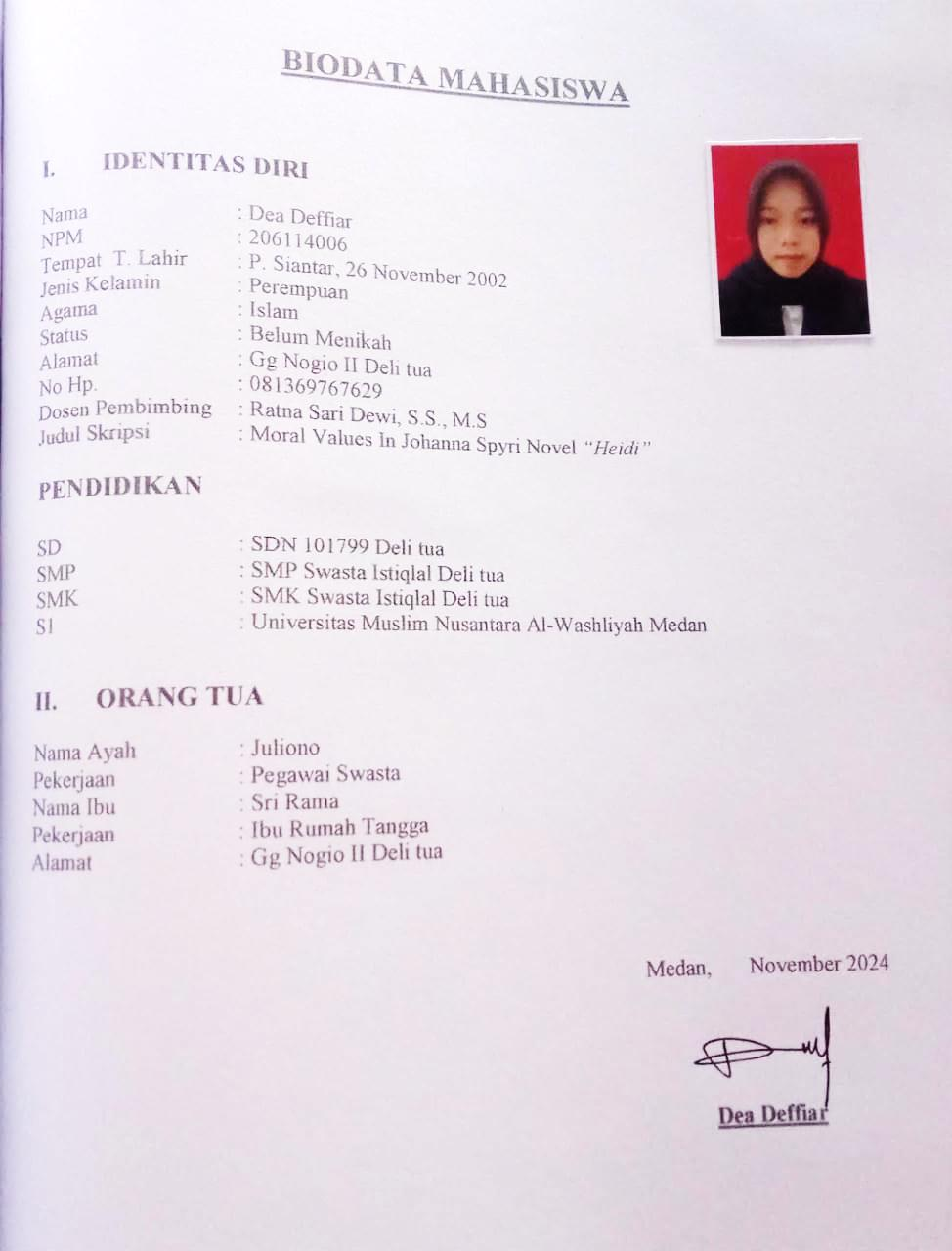Researcher

Dea Deffiar

NPM. 206114006