**A MORPHOLOGICAL ANALYSIS OF WORD FORMATION PROCESS IN MOVIE SCRIPT “THE FLASH”**

**A THESIS**

**Submitted to the English Literature Study Program in Partial Fulfillment of the Requirements for the Degree of Literature**

**By**

**Almira Devany**

**Registration Number : 206114003**

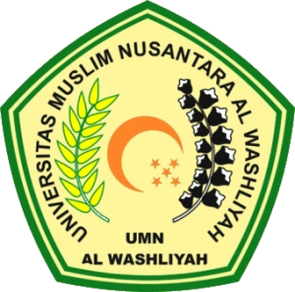

**FACULTY OF LETTERS**

**UNIVERSITAS MUSLIM NUSANTARA AL WASHLIYAH**

**MEDAN**

**2024**