**ACKNOWLEDGEMENT**

**بِسْــــــــــــــــــمِ اللهِ الرَّحْمَنِ الرَّحِيْمِ**

**يٰۤاَيُّهَا الَّذِيۡنَ اٰمَنُوۡا هَلۡ اَدُلُّكُمۡ عَلٰى تِجَارَةٍ تُنۡجِيۡكُمۡ مِّنۡ عَذَابٍ اَلِيۡمٍ‏ ١٠ تُؤۡمِنُوۡنَ بِاللّٰهِ وَرَسُوۡلِهٖ وَتُجَاهِدُوۡنَ فِىۡ سَبِيۡلِ اللّٰهِ بِاَمۡوَالِكُمۡ وَاَنۡفُسِكُمۡ​ؕ ذٰلِكُمۡ خَيۡرٌ لَّـكُمۡ اِنۡ كُنۡتُمۡ تَعۡلَمُوۡنَۙ‏ ﻿﻿ ١١**

Artinya:

“Wahai orang-orang yang beriman! Maukah kamu Aku tunjukkan suatu perdagangan yang dapat menyelamatkan kamu dari azab yang pedih?” (Q.S. Ash-shaff:10)

“(Yaitu) kamu beriman kepada Allah dan Rasul-Nya dan berjihad di jalan Allah dengan harta dan jiwamu. Itulah yang lebih baik bagi kamu jika kamu mengetahui,” (Q.S. Ash-shaff:11)

***Assalammu’alaikum Warahmatullahi Wabarakatuh***

*Alhamdulillah* , First of all the researcher would like to praises and thank to ALLAH SWT who has given the grace and guidance to complete this thesis on time, Sholawat and salam be upon to the greatest Prophet Muhammad SAW.

This thesis entitled “A Morphological Analysis Of Word Formation Process In Movie Script “The Flash”” was prepared to fulfill one of the requirements to obtain a bachelor’s degree in Literature in the English literature study program at the University of Muslim Nusantara Al Washliyah Medan.

For the first, the researcher would like to convey the appreciation to the following amazing people, namely :

1. Dr. H. Firmansyah, M.Si as a Rector of The University of Muslim Nusantara Al-Washliyah Medan.
2. Dewi Nurmala, S.S., M.Hum as Dean of the Faculty of Letters.
3. Diana Sopha, S.S., M.Hum as a Deputy Dean of the Faculty of Letters, who is also as a researcher ‘s supervisor, for sacrificing her precious time to guide me in completing my thesis.
4. Ayu Melati Ningsih, S.Pd., M.S as the Head of English Literature Study Program.
5. Prof. Dr. Risnawaty, M.Hum and Ratna Sari Dewi , S.S., M.S as the examining lecturer who has provided many constructive suggestions and inputs to the researcher.
6. All lecturers in the Faculty of Letters who have taught and inspired me during the study.
7. My beloved family, who have given so much support to me help me in doing this thesis, may Allah always protect and bless them.
8. My beloved grandmother and my late grandfather, Mr. Johandi, who remain the reason I have persevered until this moment to complete this thesis.
9. Puja Restia, someone who always encouraged me to reach this final stage.
10. Someone who has contributed a lot in writing this thesis, both energy, time, and material to me. Has become a home, a companion in everything that accompanies, supports or comforts in sadness, hears complaints, gives encouragement to never give up. may Allah always give blessings in everything we go through.
11. All my friends in a class of English Literature 2020.
12. Everyone I met and spent time together that cannot be mentioned one by one in sharing the insights, spirit, knowledge, experiences, and motivations for me.
13. *Last but not least, I wanna thank me, I wanna thank me for believing in me, I wanna thank me for doing all this hard work, I wanna thank me for having no days off, I wanna thank me for never quitting, I wanna thank me for just being me at all times.*

The researcher realized that this thesis is still far from perfect, but it is expected to be useful for the researcher and the readers. Suggestions and criticism will be accepted for the improvement of this thesis.

Medan, July 4th 2024

The researcher

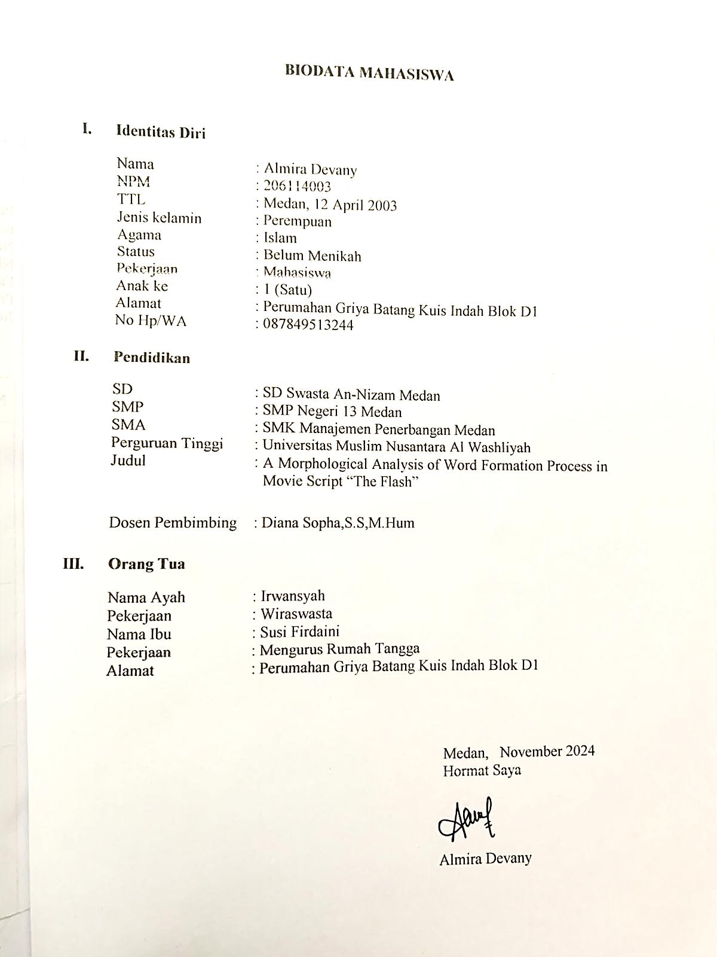

Almira Devany

Reg. No. 206114003