**PERBANDINGAN KADAR PROTEIN PADA KUNING DAN PUTIH TELUR REBUS DARI BEBERAPA JENIS UNGGAS MENGGUNAKAN METODE KJELDAHL DAN SPEKTROFOTOMETRI VISIBLE**

**M. NAUFAL RIFQI**

**NPM. 222114112**

# **ABSTRAK**

Telur adalah jenis lauk pauk protein hewani yang murah, mudah didapat dan penuh nutrisi. Telur menyediakan nutrisi yang lengkap untuk pertumbuhan sel dan sumber protein berkualitas tinggi karena menyediakan semua asam amino essensial yang dibutuhkan manusia. Tujuan Penelitian ini adalah untuk mengetahui dan membandingan kadar protein dari kuning dan putih telur rebus dari ayam kampung, bebek dan puyuh menggunakan metode kjeldahl dan spektrofotometri visible serta menentukan jumlah sampel dalam memenuhi Angka Kecukupan Gizi.

Metode penelitian yang digunakan untuk mengukur kadar protein dari kuning dan putih telur rebus dari ayam kampung, bebek dan puyuh menggunakan metode kjeldahl dan spektrofotometri visible. Metode kjeldahl terdiri dari destruksi, destilsasi dan titrasi, sedangkan metode spektrofotometri visible terdiri dari pembuatan larutan biuret, penetapan panjang gelombang maksimum, pembuatan kurva baku standar dan penentuan kadar protein dalam sampel.

Hasil penelitian didapat kadar protein pada telur rebus dengan metode kjeldahl yaitu 8,92495% (KAk), 12,0165% (PAk), 9,5363% (KBk), 11,6497% (PBk), 11,6147% (KPy) dan 9,4315% (PPy). Dengan metode spektrofotometri visible yaitu 6,5513% (KAk), 10,7764% (PAk), 8,4794% (KBk), 8,64375% (PBk), 13,5671% (KPy) dan 7,5592% (PPy). Terdapat perbedaan nyata kadar protein antara metode kjeldahl dengan spektrofotometri visible, antara putih dengan kuning telur rebus dari masing-masing sampel, antara kuning telur rebus dan antara putih telur rebus dengan hasil SPSS nilai Sig.< 0,05. Dibutuhkan telur rebus sekitar 51-64 (KAk), 21-23 (PAk), 27-31 (KBk), 13-18 (PBk), 149-174 (KPy) dan 112-139 (PPy) butir untuk dapat memenuhi AKG dalam satu hari, sedangkan untuk satu butir penuh telur rebus dibutuhkan 15-17 (Ak), 9-11 (Bk) dan 64-78 (Py) butir.

***Kata kunci* : Telur rebus, unggas, kjeldahl, spektrofotometri visible**

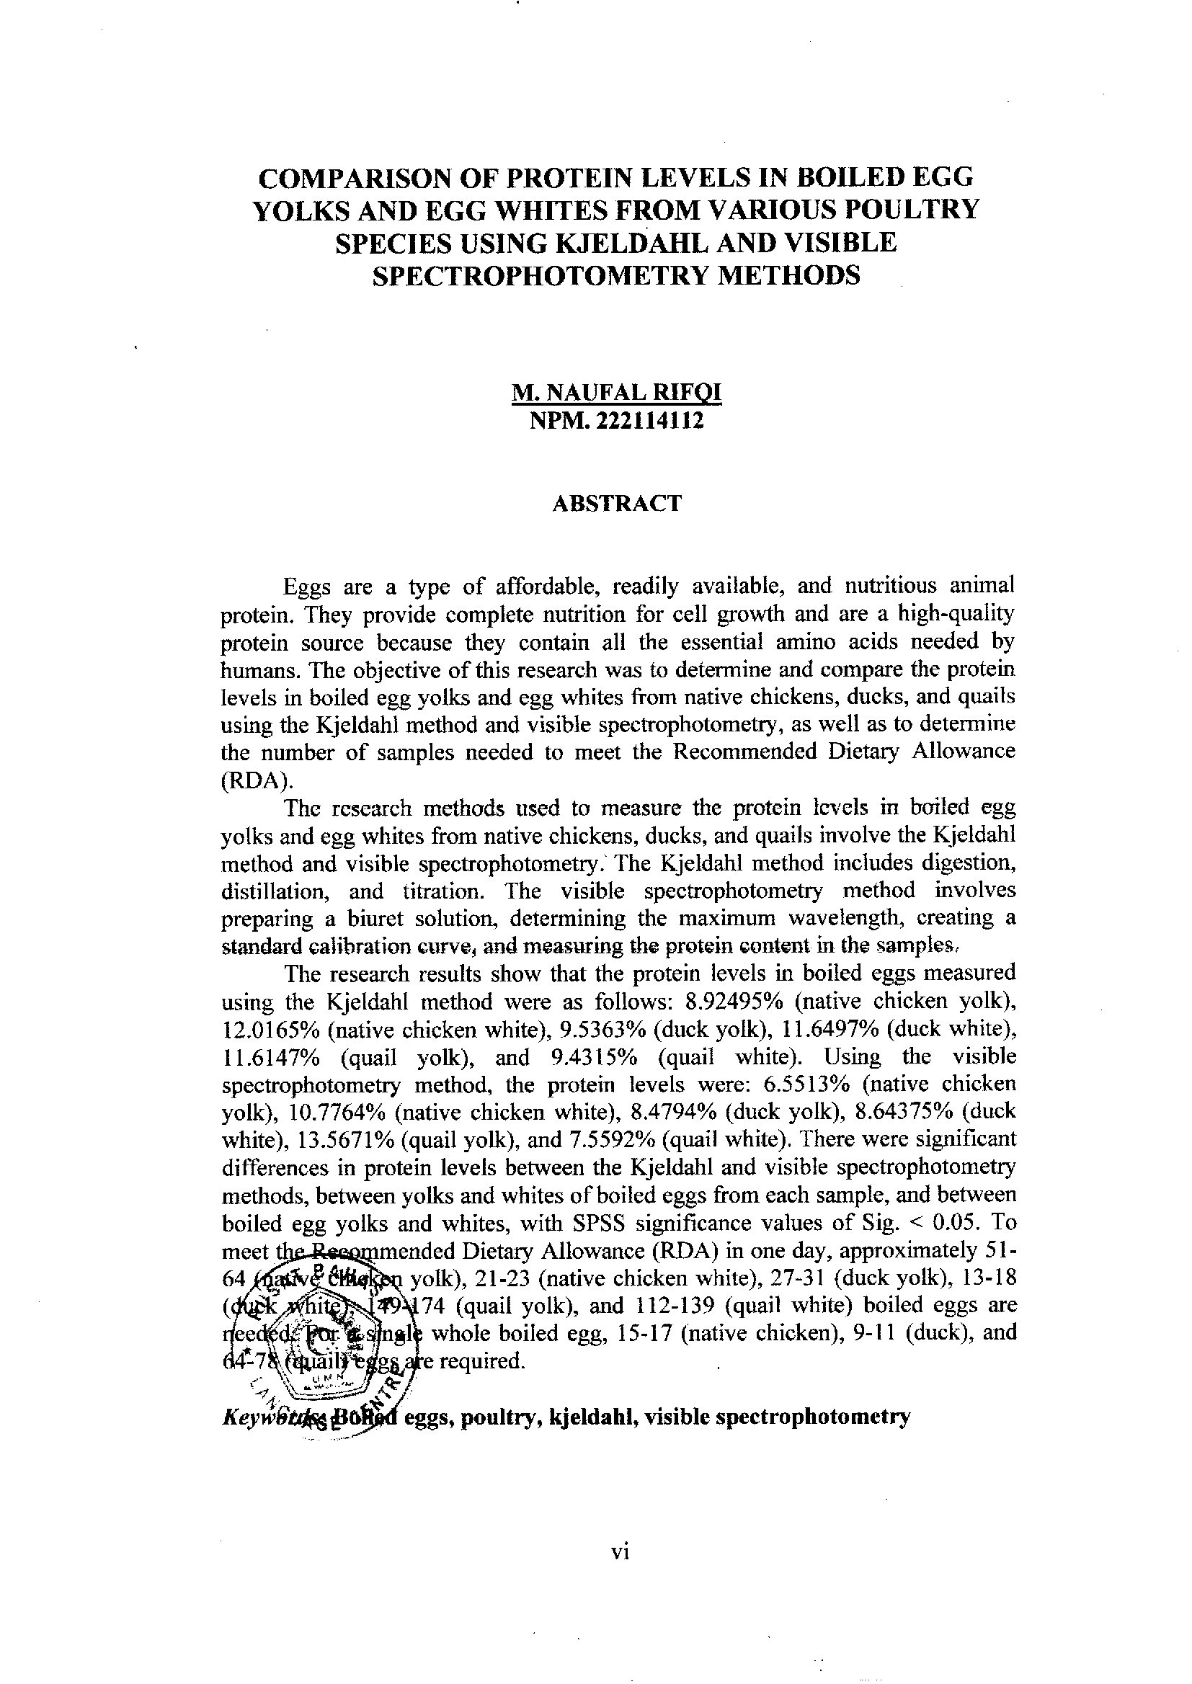

**COMPARISON OF PROTEIN LEVELS IN BOILED EGG**

**YOLKS AND EGG WHITES FROM VARIOUS POULTRY**

**SPECIES USING KJELDAHL AND VISIBLE**

**SPECTROPHOTOMETRY METHODS**

**M. NAUFAL RIFQI**

**NPM. 222114112**

**ABSTRACT**

Eggs are a type of affordable, readily available, and nutritious animal protein. They provide complete nutrition for cell growth and are a high-quality protein source because they contain all the essential amino acids needed by humans. The objective of this research was to determine and compare the protein levels in boiled egg yolks and egg whites from native chickens, ducks, and quails using the Kjeldahl method and visible spectrophotometry, as well as to determine the number of samples needed to meet the Recommended Dietary Allowance (RDA).

The research methods used to measure the protein levels in boiled egg yolks and egg whites from native chickens, ducks, and quails involve the Kjeldahl method and visible spectrophotometry. The Kjeldahl method includes digestion, distillation, and titration. The visible spectrophotometry method involves preparing a biuret solution, determining the maximum wavelength, creating a standard calibration curve, and measuring the protein content in the samples.

The research results show that the protein levels in boiled eggs measured using the Kjeldahl method were as follows: 8.92495% (native chicken yolk), 12.0165% (native chicken white), 9.5363% (duck yolk), 11.6497% (duck white), 11.6147% (quail yolk), and 9.4315% (quail white). Using the visible spectrophotometry method, the protein levels were: 6.5513% (native chicken yolk), 10.7764% (native chicken white), 8.4794% (duck yolk), 8.64375% (duck white), 13.5671% (quail yolk), and 7.5592% (quail white). There were significant differences in protein levels between the Kjeldahl and visible spectrophotometry methods, between yolks and whites of boiled eggs from each sample, and between boiled egg yolks and whites, with SPSS significance values of Sig. < 0.05. To meet the Recommended Dietary Allowance (RDA) in one day, approximately 51-64 (native chicken yolk), 21-23 (native chicken white), 27-31 (duck yolk), 13-18 (duck white), 149-174 (quail yolk), and 112-139 (quail white) boiled eggs are needed. For a single whole boiled egg, 15-17 (native chicken), 9-11 (duck), and 64-78 (quail) eggs are required.