***THE EFFORTS TO IMPROVE STUDENTS’ LEARNING ACHIEVEMENTS BY APPLYING THE COOPERATIVE LEARNING MODEL WITH THE JIGSAW TECHNIQUE IN ECONOMICS SUBJECTS IN GRADE X OF SMA PAB MEDAN***

**PUTRI RAHMA SARI LUBIS**

# NPM : 151364134

***ABSTRACT***

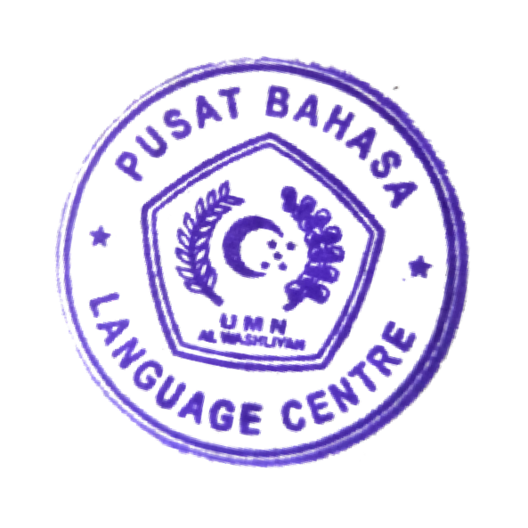*This research was motivated by the lack of learning achievements obtained by students, especially for class X students in the teaching and learning process that was carried out. Many students could understand and comprehend the teaching materials delivered, but not a few students who did not understand what was conveyed by the teacher or did not know what the teacher meant at all. In making a learning plan, all learning objectives on one topic of learning material were to make students who previously did not understand, those who previously did not know and in the end all teachers wanted their students to be able to absorb what was given in the learning and get satisfactory learning achievements. But in reality not all students could get what they wanted. This research was an activity in the classroom which was a Classroom Action Research (CAR), with the sample being students in class X at SMA PAB3 Medan, The research was to use the jigsaw technique cooperative learning model. In cycles I and II after being given action using the jigsaw type cooperative strategy, data was obtained that students who completed learning in cycle I were 15 students or 42.85% while students who did not complete were 20 students or 57.14% with an average score <80. While in cycle II, students who completed learning were 28 students or 80% while students who did not complete were 7 students or 20% with an average score> 80, and this score had reached a score above the Minimum Mastery Criteria.*

*Keywords: cooperative learning model, jigsaw technique, students’ learning*

*achievement*