# DAFTAR PUSTAKA

BPOM RI. (2018). Perubahan atas Peraturan kepala badan pengawas obat dan makanan republic Indonesia nomor HK.03.1.33.12.12.8195 Tahun 2012 tentang penerapan pedoman cara pembuatan obat yang baik. Jakarta: badan pengawas obat dan makanan.

BPOM RI.(2012). Petunjuk Operasional Penerapan Cara Pembuatan Obat yang Baik. Jilid I. Jakarta: Badan Pengawas Obat Dan Makanan.

Dirjen Binfar dan Alkes RI.(2011). Pedoman Pelayanan Perizinan Industri Farmasi.Jakarta: Direktorat Bina Produksi Dan Distribusi Kefarmasian, Direktorat Jenderal Bina Kefarmasian Dan Alat Kesehatan Kementerian Kesehatan RI.

Menkes RI. (2017). Peraturan Menteri Kesehatan Republik Indonesia Nomor 24/menkes/per/XII/2017 tentang kriteria dan tata laksana registrasi obat.Jakarta : Kementerian Kesehatan Republik Indonesia.

Presiden RI. (2009). Peraturan Pemerintah Republik Indonesia Nomor 51 tahun 2009 tentang Pekerjaan Kefarmasian.Jakarta : Lembaran Negara Republik Indonesia.

# LAMPIRAN

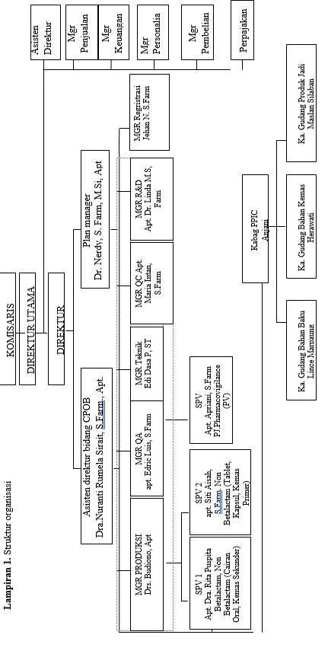**Lampiran 1.** Struktur organisasi

**Lampiran 2.** Sertifikat CPOB cairan obat luar nonbetalaktam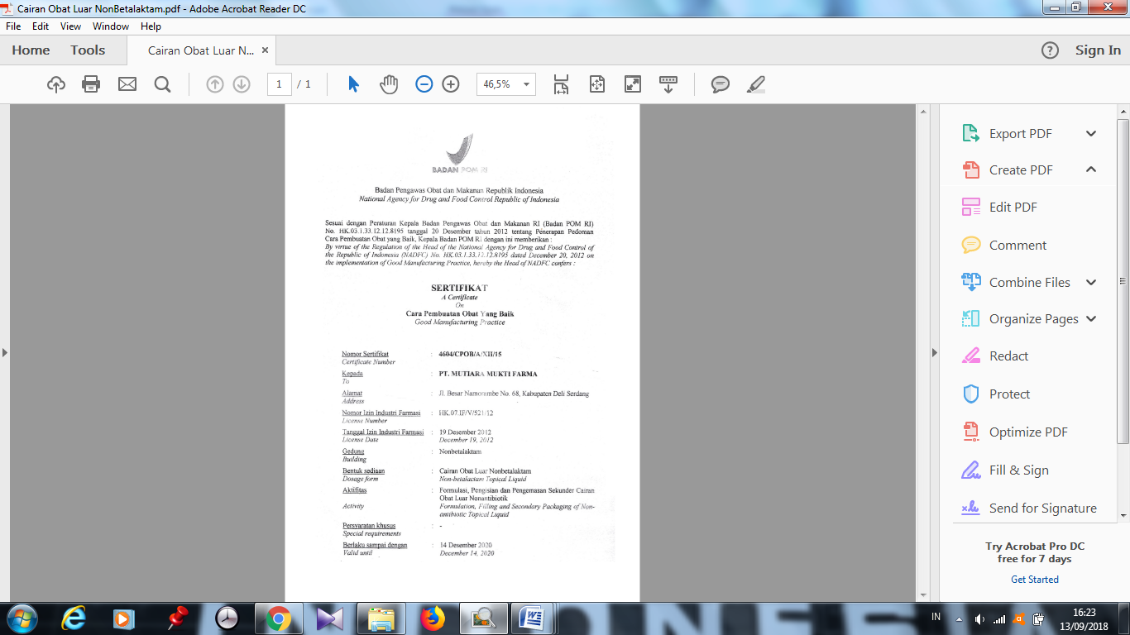

**Lampiran 3.** Sertifikat CPOB cairan oral nonbetalaktam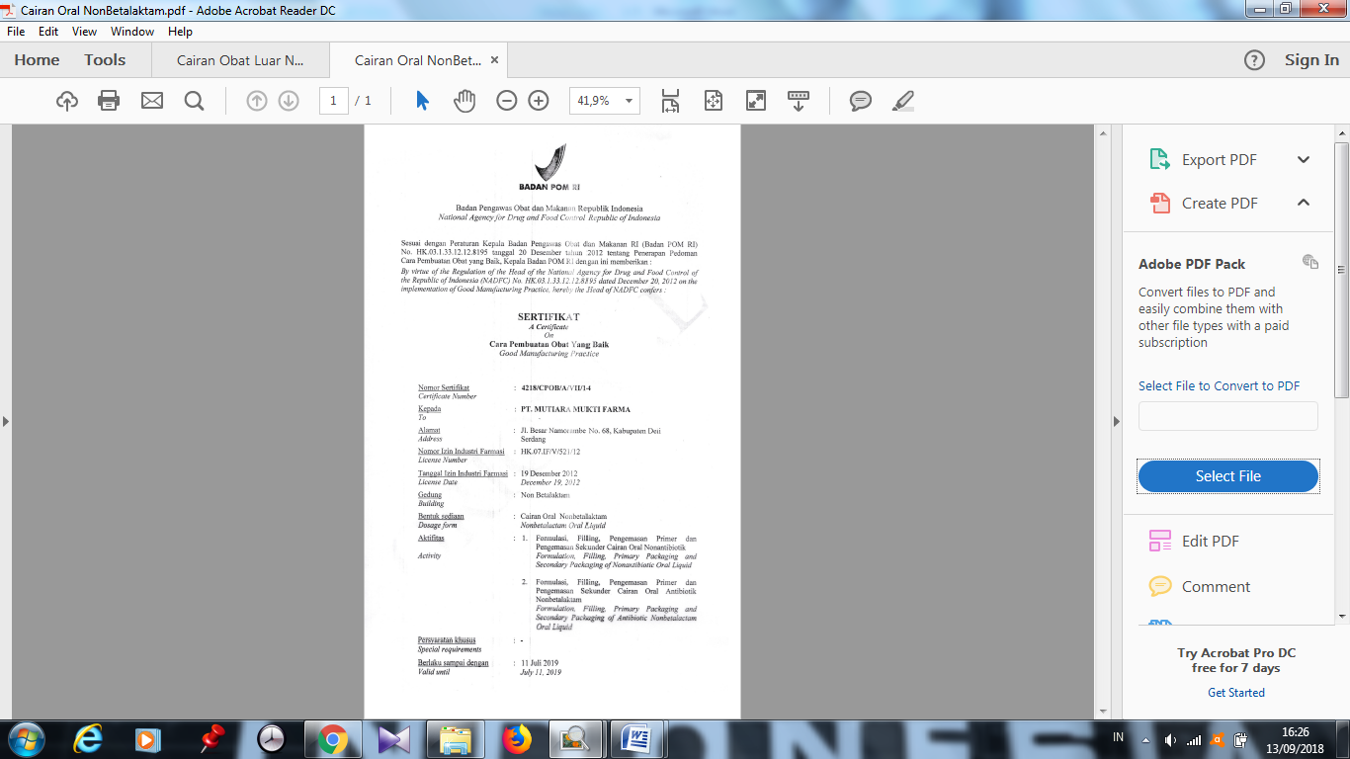

**Lampiran 4.** Sertifikat CPOB kapsul keras nonbetalaktam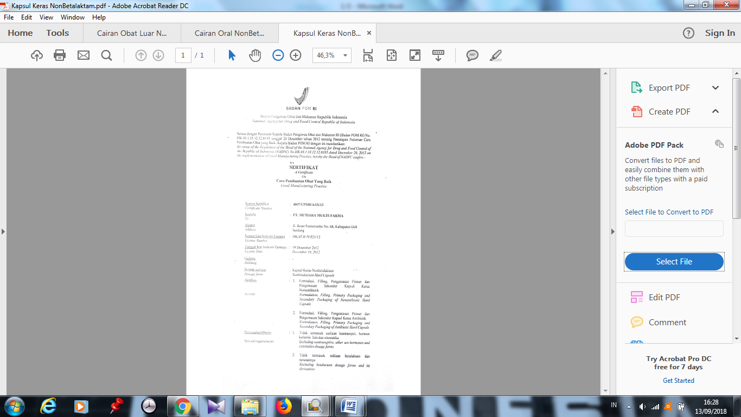

**Lampiran 5.** Sertifikat CPOB semisolid non betalaktam**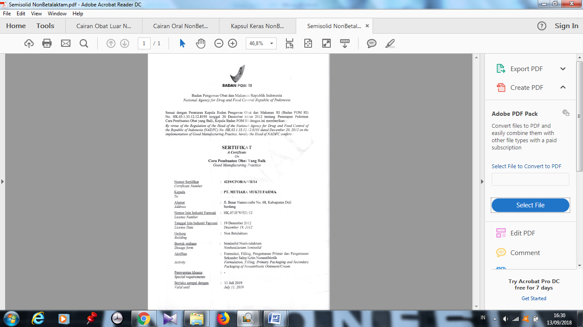****Lampiran 6.** Sertifikat CPOB serbuk obat luar nonbetalaktam

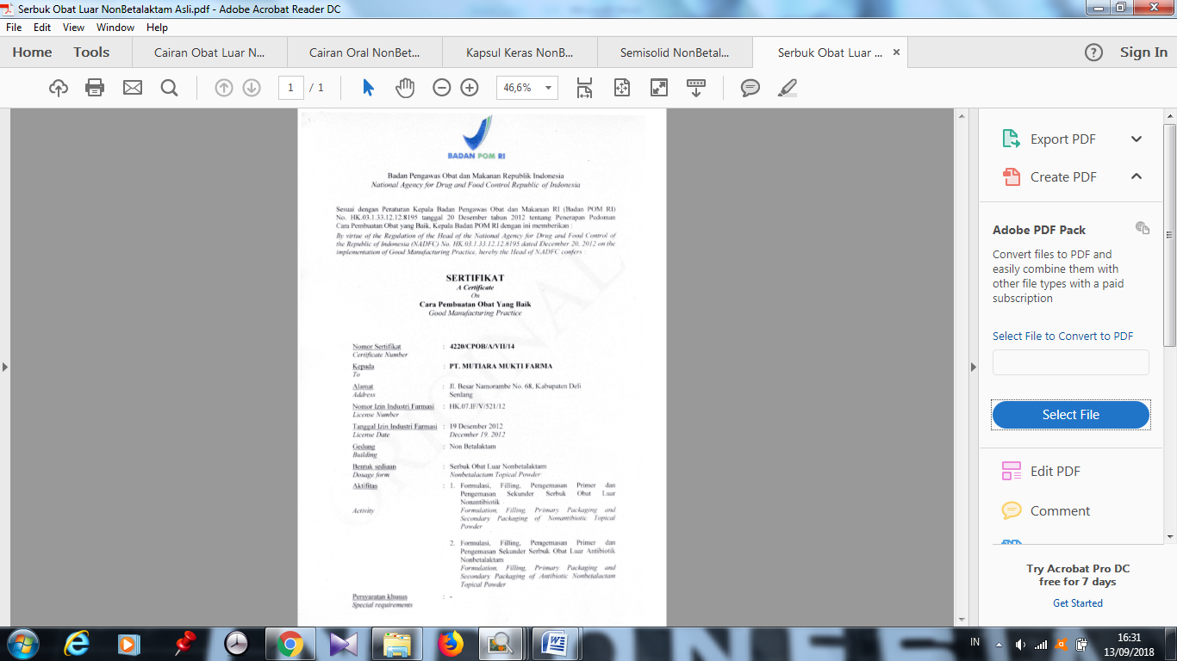

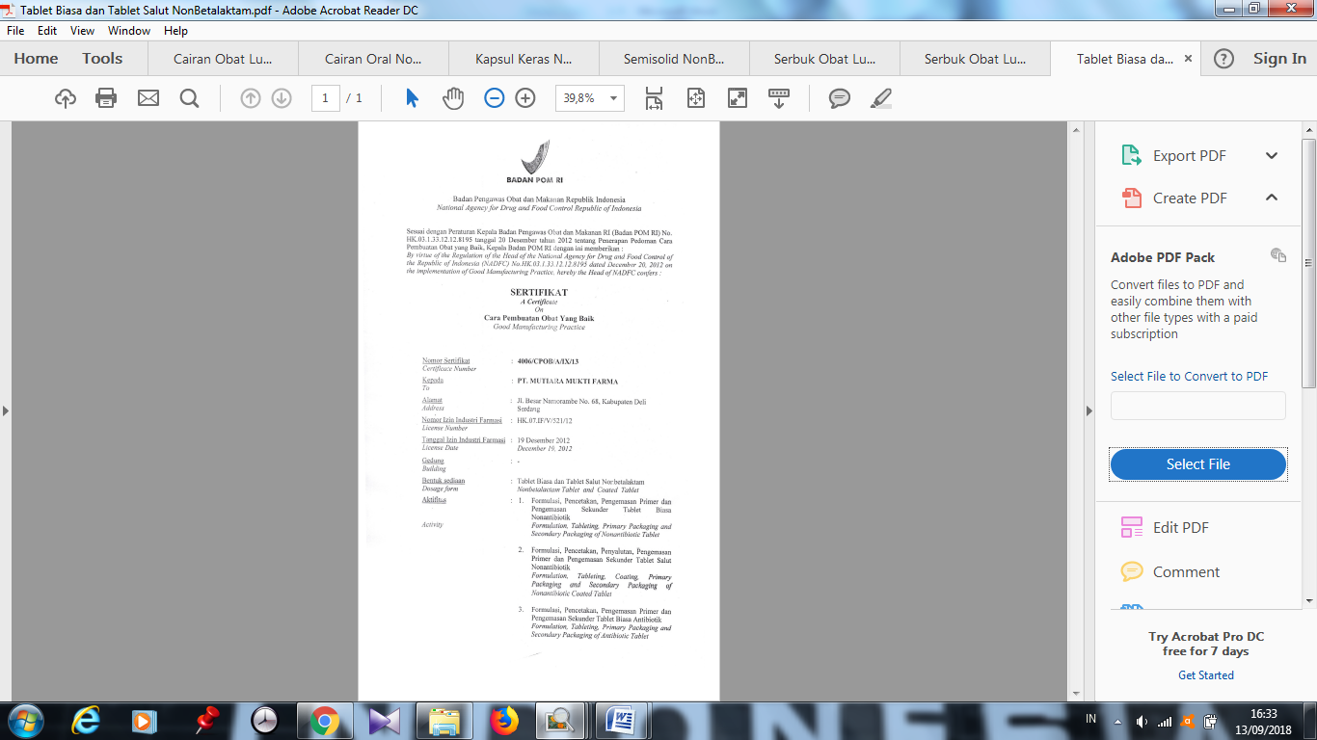**Lampiran 7.** Sertifikat CPOB tablet biasa dan tablet salut nonbetalaktam

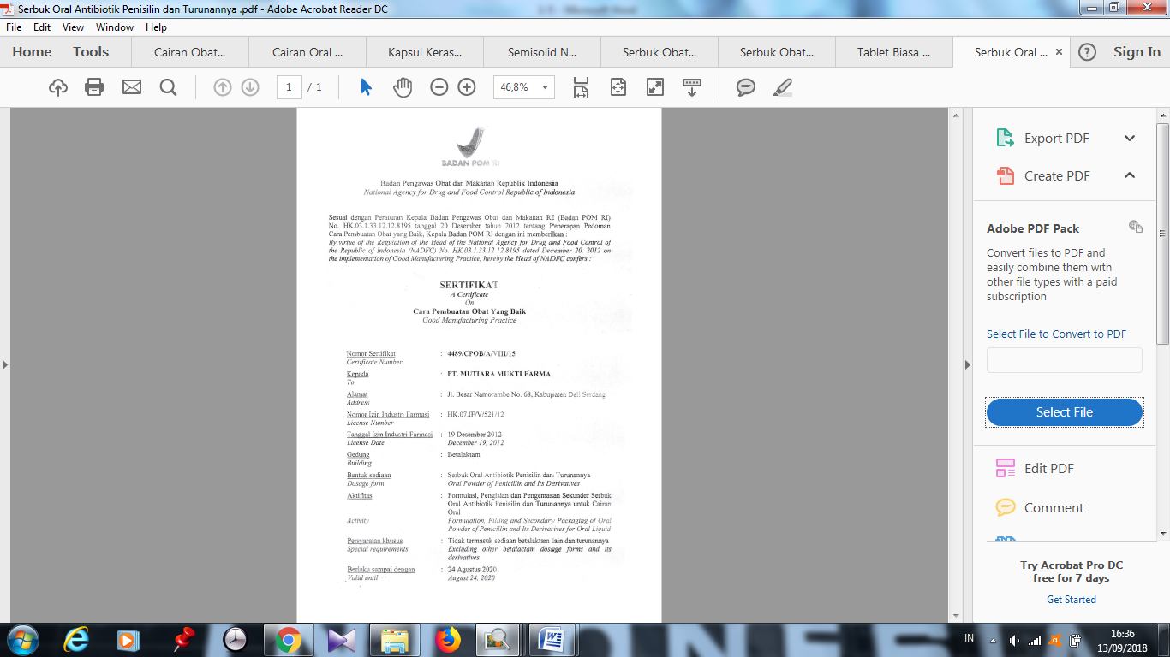**Lampiran 8.** Sertifikat CPOB serbuk oral antibiotik penisilin dan turunannya

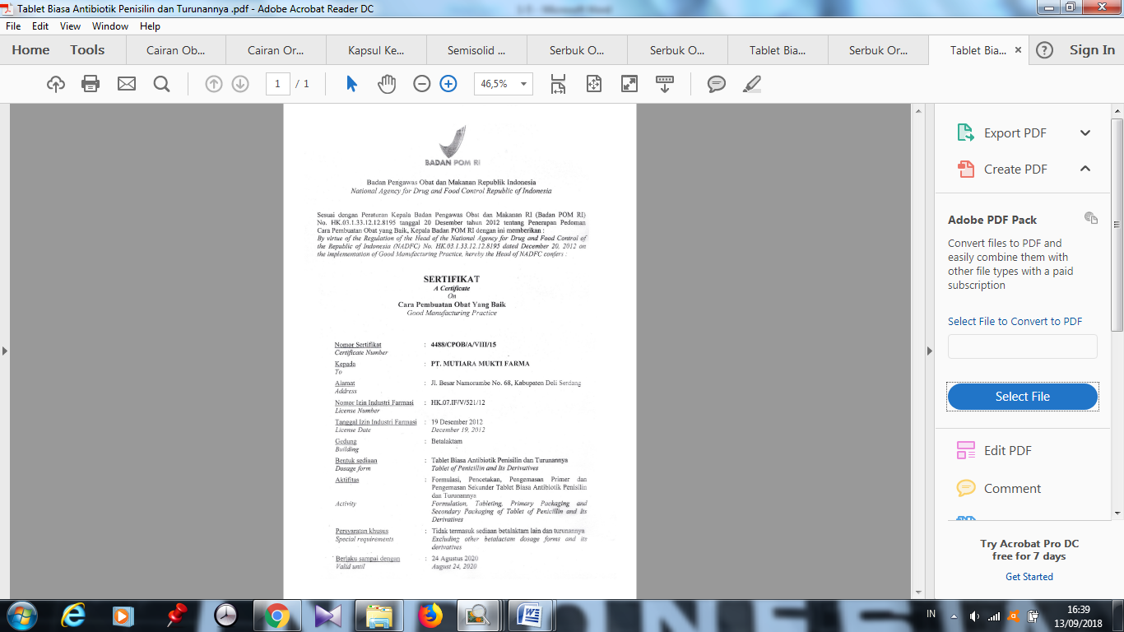**Lampiran 9.** Sertifikat CPOB tablet biasa antibiotik penisilin dan turunannya

**Lampiran 10.** Bagan proses pembuatan sediaan liquida

Penimbangan

Gudang Hasil Jadi



*Finished Pack Analysis*



Karantina



Pengemasan



Karantina



IPC :

* Keseragama volome
* Kadar zat berkhasiat
* Kebocoran wadah



Pengisian ke bawah



Karantina



Pelarutan



Pencampuran



Penyaringan



IPC :

* pH lautan
* Bj
* Kadar zat

Berkhasiat

* Viskositas



**Lampiran 11**. Bagan proses pembuatan kapsul

Penimbangan

Pengeringan dan pencampuran

IPC :

kadar zat berkhasiat

Karantina

IPC :

* Suhu
* Kelembaban maks 50%

Pengisian ke cangkang kapsul

IPC :

* Kadar zat berkhasiat
* Waktu hancur
* Keseragaman bobot
* Disolusi

Karantina

Seleksi

Pengemasan

Karantina

*Finished Pack Analysis*

Gudang hasil jadi

**Lampiran 12.** Bagan proses pembuatan tablet dan kaplet

Penimbangan

Pencampuran

Cetak tidak langsung

*Slugging*

Pengeringan di oven suhu 60oC

Granulasi basah

Granulasi kering

IPC:LOD

Lubrikasi/penambahan bahan pelicin

IPC : Kadar zat

berkhasiat

Karantina

IPC :

* Pemerian
* Diameter
* Friabilitas
* Keseragaman bobot
* Waktu hancur
* Tebal
* Kekerasan
* Kadar zat berkhasiat

Pencetakan

Karantina

Pengemasan

Gudang hasil jadi

Karantina

**Lampiran 13.** Daftar produk obat PT. MUTIFA

**BETALAKTAM**

|  |  |  |
| --- | --- | --- |
| **No.** | **Nama obat** | **Komposisi** |
| 1. | Omemox dry syrup | Amoxicillin |
| 2. | Omemox 500 | Amoxicillin |

**NONBETALAKTAM**

TABLET DAN KAPLET

|  |  |  |
| --- | --- | --- |
| **No.** | **Nama obat** | **Komposisi** |
| 1. | Allopurinol 100 | Allopurinol |
| 2. | Ambroxol tablet | Ambroxol |
| 3. | Amlodipine 5 MF | Amlodipine |
| 4. | Amlodipine 5 Mulia | Amlodipine |
| 5. | Amlodipine 10 MF | Amlodipine |
| 6. | Amlodipine 10 Mulia | Amlodipine |
| 7. | As. Mefenamat blister | Asam mefenamat |
| 8. | As. Mefenamat Strip MF | Asam mefenamat |
| 9. | As. Mefenamat Strip MU | Asam mefenamat |
| 10. | Cetirizine Kap MF | Cetirizine |
| 11. | Cetirizine Kap Mulia | Cetirizine |
| 12. | Cimetidine | Cimetidine |
| 13. | Domperidone Tablet | Domperidone |
| 14. | Gentirizin Kap | Cetirizin |
| 15. | Genvask 5mg | Amlodipine besylate |
| 16. | Genvask 10mg | Amlodipine besylate |
| 17. | Glenistan 500 | Asam mefenamat |
| 18. | Ibuprofen 200 | Ibuprofen |
| 19. | Ibuprofen 400 | Ibuprofen |
| 20. | Loratadine | Loratadin |
| 21. | Methylprednisolone 4 | Methylprednisolone |
| 22. | Methylprednisolone 8 | Methylprednisolone |

|  |  |  |
| --- | --- | --- |
| 23. | Methylprednisolone16 | Methylprednisolone |
| 24. | Metilgen 4 | Methylprednisolone |
| 25. | Metilgen 8 | Methylprednisolone |
| 26. | Metilgen 16 | Methylprednisolone |
| 27. | Metronidazole 500 | Metronidazole |
| 28. | Omecal + D | CaCO3, Vit D |
| 29. | Omecidal | Mebhidrolin |
| 30. | Omecold | Paracetamol, phenylpropanolamin HCI, Chlorpheniramine maleat |
| 31. | Omedeson 200 | Dexamethason |
| 32. | Omedom tablet | Domperidon |
| 33. | Omedrinat | Dimendrinat |
| 34. | Omefulvin 125 mg | Griseofulvin |
| 35. | Omefulvin 500mg | Griseofulvin |
| 36. | Omegavit kapsul | Fero Fumarat 89,5 Mg, Mn- Sulfat 0,2 Mg, Cu Sulfat 0,2 Mg, Vit C 50 Mg, Folic Acid 1 Mg, Vit B 127,5 Mg |
| 37. | Omegdiar tablet | Kaolin, pectin |
| 38. | Omegesic | Metampiron, Vit B1, Vit B6, Vit B 12 |
| 39. | Omegrip tablet | Paracetamol 500 Mg |
| 40. | Omegtamine | Dexamethason, Dexhlorfeniramine maleat |
| 41. | Omegtrim tablet | Trimethoprin, Sulphametoxazole |
| 42. | Omegzole | Ketokonazole |
| 43. | Omekur | Cimetidine |
| 44. | Omellegar kaplet | Loratadin |
| 45. | Omenacort | Triamcinolone |
| 46. | Omeneuron tablet | Vit B1, Vit B6, Vit B12 |
| 47. | Omenizol tab | Metronidazole |
| 48. | Omeproksil kaplet | Cyprofloxacine HCI monohidrat |
| 49. | Omeranin 150 mg | Ranitidin |
| 50. | Omeretik 20 mg | Piroxicam |
| 51. | Omeric 100 mg tab | Allopurinol |
| 52. | Omeric 300 mg tab | Allopurinol |
| 53. | Omeroxol tablet | Ambroxol HCI |
| 54. | Omesivask 5 | Amlodipine |
| 55. | Omesivask 10 | Amlodipine |
| 56. | Omesolvon tablet | Bromheksin HCl |
| 57. | Omestan 500 (blister) | Asam mefenamat |
| 58. | Omestan 500 (strip) | Asam mefenamat |
| 59. | Ometilson 4 | Metilprednisolon |
| 60. | Ometilson 8 | Metilprednisolon |
| 61. | Omezyrteks tablet | Cetirizin HCl |
| 62. | Oraprofen 200 | Ibuprofen |
| 63. | Oraprofen 400 | Ibuprofen |
| 64. | Panvit C | Vit C, Vit B1, Vit B2, Vit B3 (Nikotinamid), Vit B5, Vit B6, Vit B12, |
| 65. | Panviton kaplet | Curcumae, Ekstrak ginseng, Vit V, Vit B1, Vit B12, Nikotinamid, Capantothenat, Mn (II), Cu, Co, Ca, Mg, Zn |
| 66. | Piroxicam | Piroxicam |
| 67. | Ranitidine | Rantidine |
| 68. | Simvastatin MF | Simvastatin |
| 69. | Simvastatin MFS | Simvastatin |
| 70. | Stomach tablet | Aluminium Hidroksida, Magnesium Hidroksida, Simetikon |
| 71. | Tianvas | Simvastatin |
| 72. | Vidabion Cal | Fero Fumarat, Asam Folat, Vitamin B12, Calcium Carbonate, Kolekalsiferol, Asam Ascorbat |
| 73. | Vilergi kaplet | Dexchlorfeniramine Maleat |
| 74. | Vitalamin kaplet | Vit A, Vit B1, Vit B2, Vit B6, Vit B12, Vit C, Vit D, kalsium pantotenat, Nikotinamid, Asam Folat, Fe (II), Fumarat, ZnSO4, CuSO4, MnSO4 |

**PRODUK POT**

|  |  |  |
| --- | --- | --- |
| **No.** | **Nama obat** | **Komposisi** |
| 1. | Chloramphenicol | Chloramphenicol |
| 2. | Prednison isi 100 | Prednison |
| 3. | Vitamin B complek isi 250 | Vit B1, Vit B2,Vit B5, Vit B6, |
| 4. | Vitamin B1 | Vitamin B1 |
| 5. | Vitamin B6 isi 250 | Viamin B6 |

**PRODUK SYRUP**

|  |  |  |
| --- | --- | --- |
| **No.** | **Nama obat** | **Komposisi** |
| 1. | Cetirizine syr | Cetirizine |
| 2. | Cough friend 100ml | CTM, Amonium klorida, Succus liquiritae |
| 3. | Curbion kids emulsion | Betakaroten, curcuma, biotin, lysin HCl, Vit B1, Vit B2, Vit B3, Vit B5, Vit B6, Vit B12 |
| 4. | Curbion syr 60ml | Betakaroten, curcumae, biotin, lysin HCl, Vit B1, Vit B2, Vit B3, Vit B5, Vit B6, Vit B12 |
| 5. | Gentrizin syr | Cetirizine |
| 6. | Muliavit 60ml | Vit A, D3, B1, B6, B2, C |
| 7. | OBH 100 ml | Paracetamol, CTM, Ammonium chlorida, efedrin HCl, Succus Liquiritae |
| 8. | OBH 200 ml kaca | Paracetamol, CTM, Ammonium chlorida, efedrin HCl, Succus Liquiritae |
| 9. | Omecidal syrup | Mebhidrolin |
| 10. | Omecough syr 60ml | Dextromerthofan HBr, paracetamol, guaiafenesin, CTM |
| 11. | Omedom syr 60ml | Domperidon |
| 12. | Omegdiar syrup | Kaolin, pectin |
| 13. | Omegrip syrup | Paracetamol |
| 14. | Omegrip strawberry | Paracetamol |
| 15. | Omegtamine syrup | Deksamethasone, deksklorfeniramin maleat |
| 16. | Omegtrim syrup | Sulfametoxazole, Trimethorprim |
| 17. | Omellegar syr | Loratadine |
| 18. | Omenizol syr | Metronidazole benzoate |
| 19. | Omeroxol syr | Ambroxol HCl |
| 20. | Omestan suspense | Asam mefenamat |
| 21. | Ometridryl 60 ml syr | Difenhidramin HCl, Amonium klorida, Na-sitrat, Dkstrometorphan HBr, Etilalkohol |
| 22. | Omevita syr 60 ml | Vitamin A palmitate, Vit (D3,B1,B2, B6,B12,C),Nia Cinamide, ca.pantothonat |
| 23. | Omevomid syr 60ml | Metoklopropamide |
| 24. | Omezyrteks syrup 60 ml | Cetirizine |
| 25. | Oraprofen 60 ml syr | Ibu profen |
| 26. | Oraprofen forte 60 ml | Ibu profen |
| 27. | Oratifed hijau syr | Triprolide HCl, Pseudoephedrin HCl, Gliserin Guaiakolat |
| 28. | Oratifed kuning syr | Triprolide HCl, Pseudoephedrin HCl, Gliserin Guaiakolat |
| 29. | Oratifed merah syr | Triprolide HCl, Pseudoephedrin HCl, Dextromethorpan HBr, Ethanol |
| 30. | Pacdin cough 60ml | Parasetamol, Gliserin Guaiakolat, kloramfeniramin maleat |
| 31. | Pacdin cough strawberry | Parasetamol, Gliserin Guaiakolat, kloramfeniramin maleat |
| 32. | Pacdin vit cur | Curcuma Extract 95%, AA 10% |
| 33. | Stomach syrup | Aluminium hidroksida, Magnesium hidroksida, simethicone |
| 34. | Tusselix 100ml syr | Glycyrrizae Succus, Efedrin HCl, Klorpheniramin Maleat, Amonium Klorida |

**PRODUK OBAT LUAR**

|  |  |  |
| --- | --- | --- |
| **No.** | **Nama obat** | **Komposisi** |
| 1. | Alkohol 70% 100ml | Alkohol |
| 2. | Alkohol 70% 1000ml | Alkohol |
| 3. | Gentian violet 15ml | Gentian violet |
| 4. | Ichtyol salap | Ichtammolum 0,1 gr |
| 5. | Pacdin biosepta 1L |  |
| 6. | Pacdin biosepta 15 ml |  |
| 7. | Pacdin biosepta 8ml |  |
| 8. | Pacdin biosepta 30ml |  |
| 9. | Pacdin biosepta 60ml |  |
| 10. | Povidone iodine 1L | Povidon iodine |
| 11. | Povidone iodine 15ml | Povidon iodine |
| 12. | Povidone iodine 100ml | Povidon iodine |
| 13. | Povidone iodine 30ml | Povidon iodine |
| 14. | Povidone iodine 60ml | Povidon iodine |
| 15. | Rivanol 100ml | Rivanol |
| 16. | Rivanol 300ml | Rivanol |
| 17. | Rodehond 100ml |  |
| 18. | Rodehond 300ml |  |
| 19. | Salap 2-4 |  |
| 20. | Salicyl menthol talk |  |
| 21. | Salicyl talk 100gr |  |
| 22. | Salicyl talk btl |  |
| 23. | Talcum powder 100 gr |  |
| 24. | Talcum powder 500 gr |  |

**Lampiran 14.** Label identitas produk

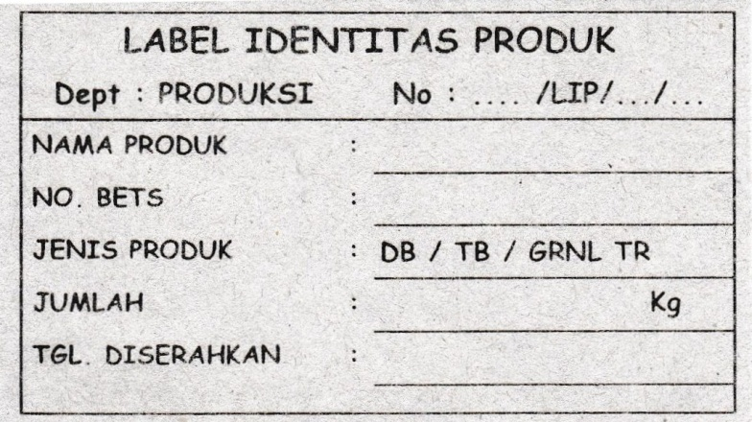

**Lampiran 15.** Label sampel telah diambil

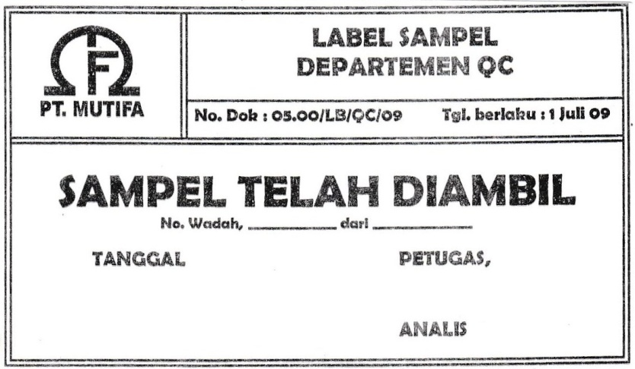

**Lampiran 16.** Label pembersihan mesin/alat

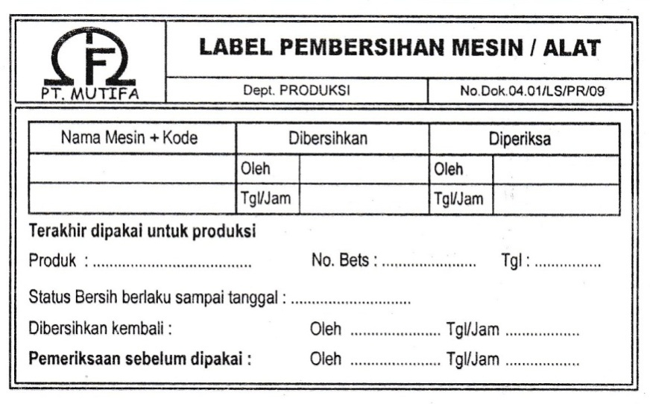

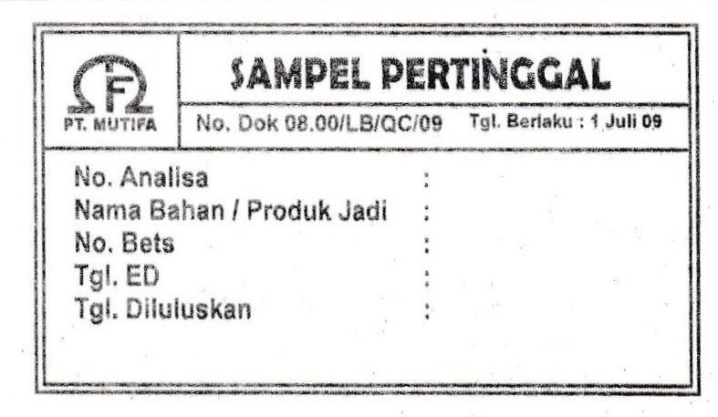**Lampiran 17.** Sampel pertinggal

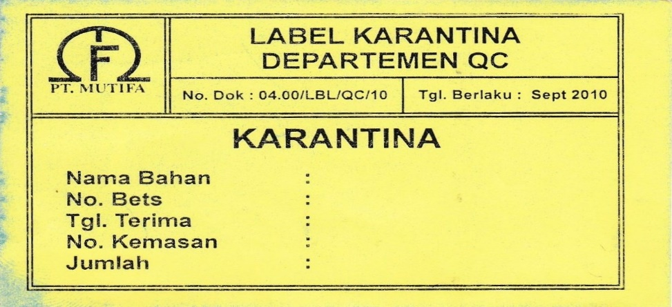**Lampiran 18.** Label karantina

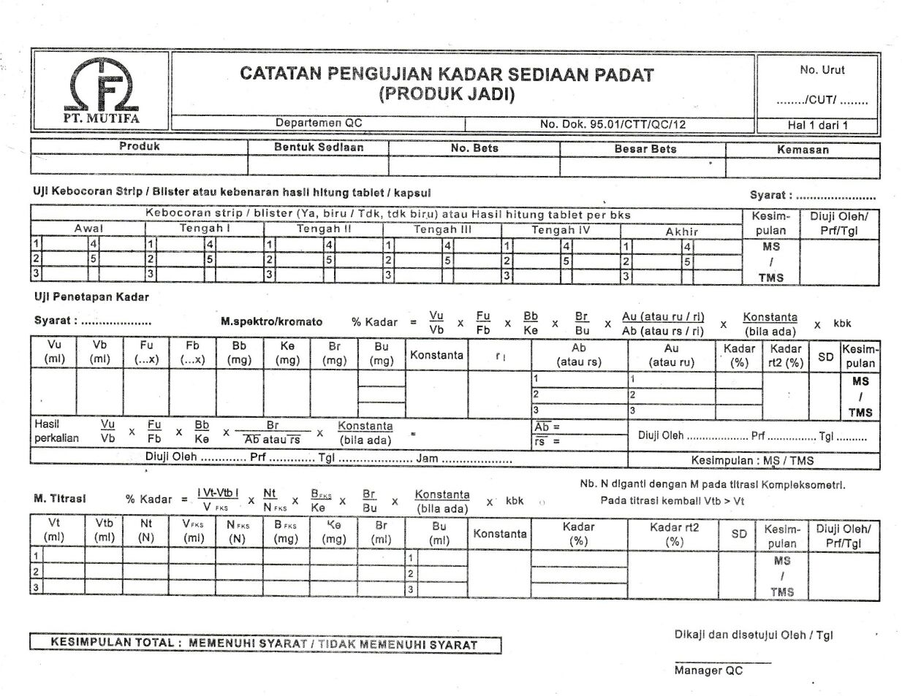**Lampiran 19.** Catatan pengujian kadar sediaan padat

**Lampiran 20.** Catatan pengujian kadar cairan

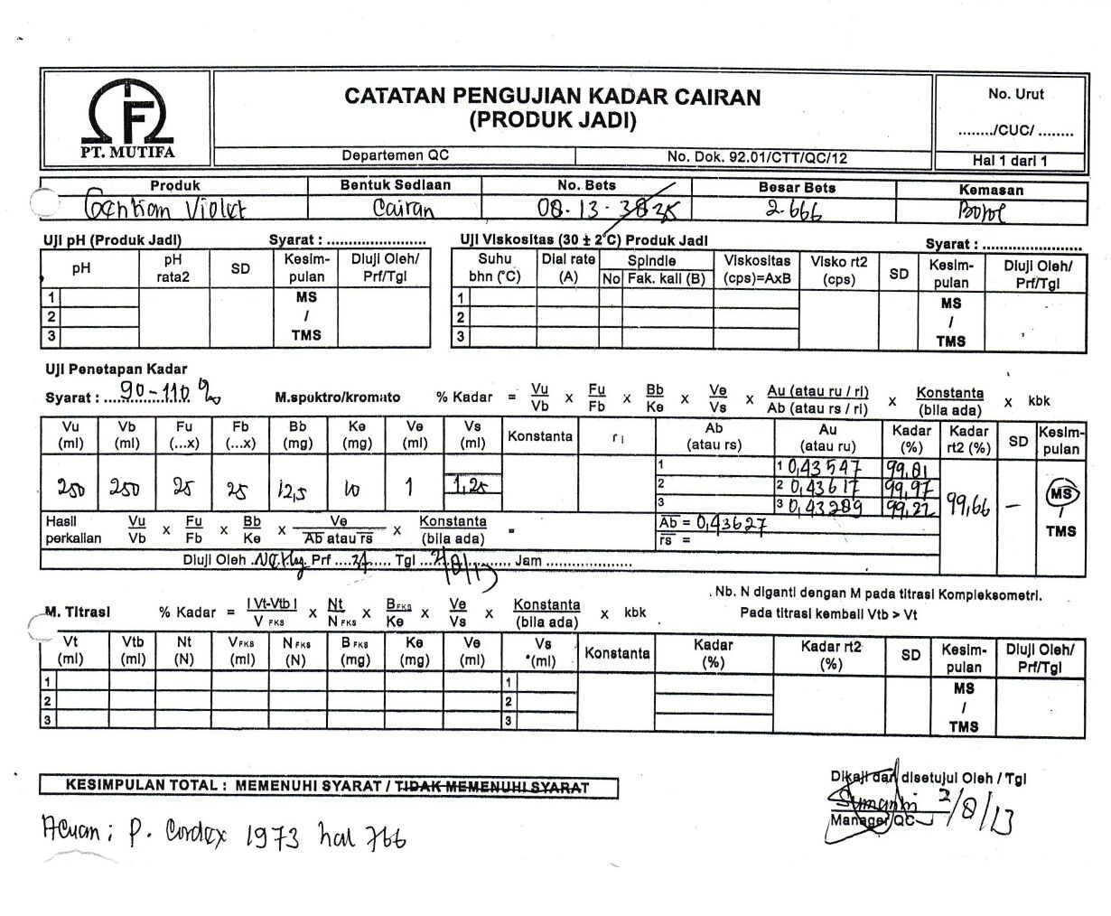

**Lampiran 21.** Label diluluskan

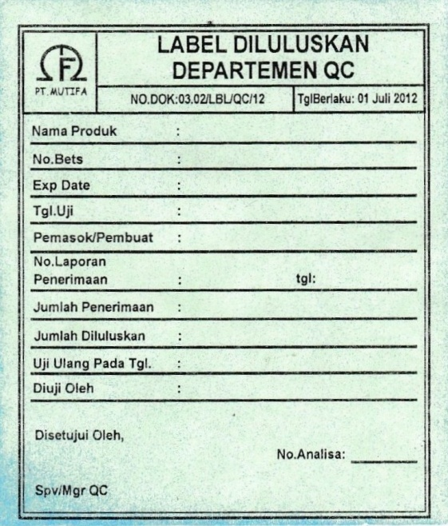

**Lampiran 22.** Label penimbangan

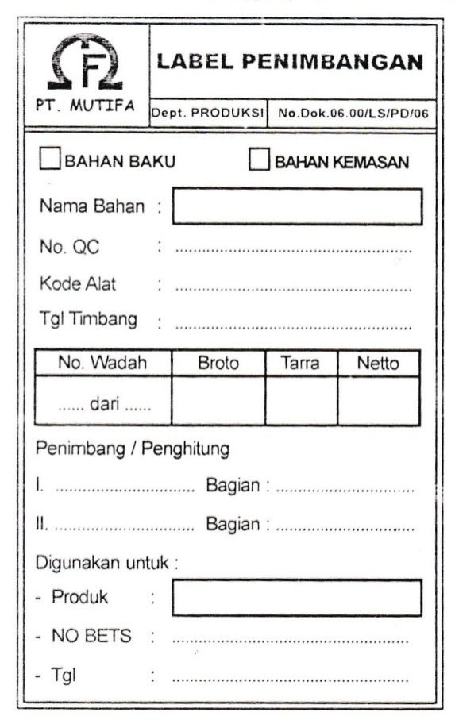

**Lampiran 23.** Bukti permintaan dan penyerahan bahan baku

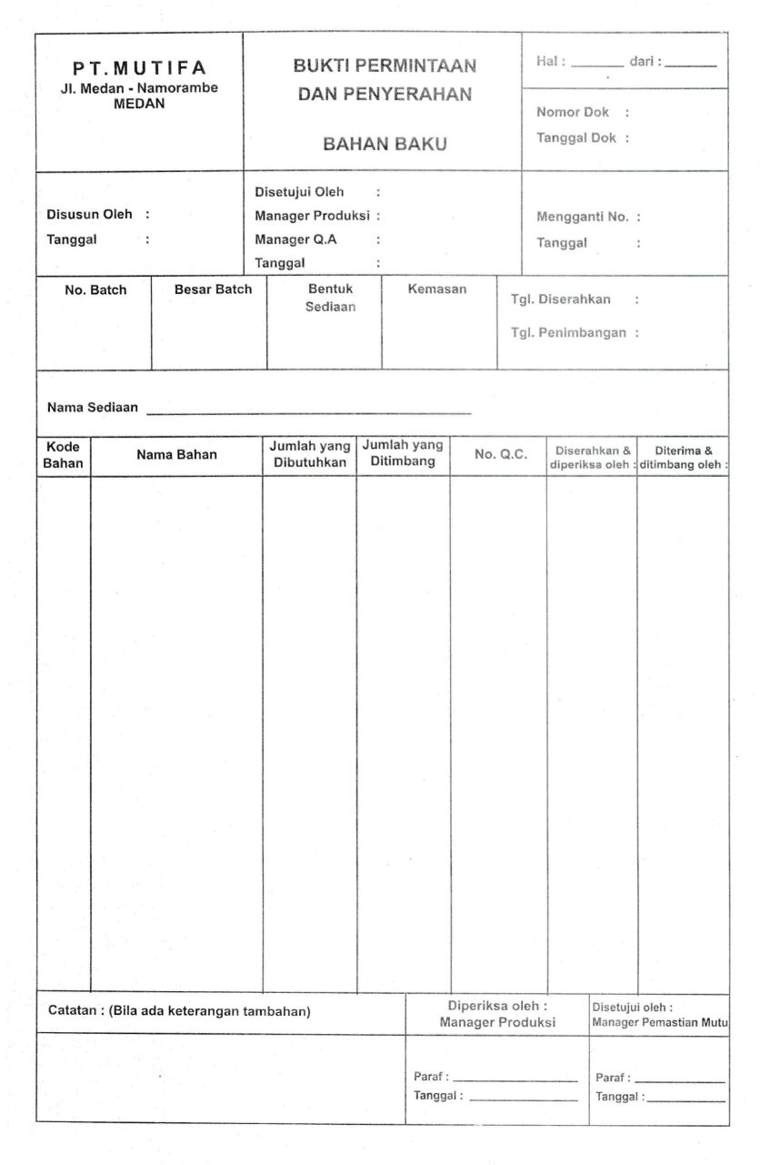

**Lampiran 24.** Kartu persediaan bahan baku

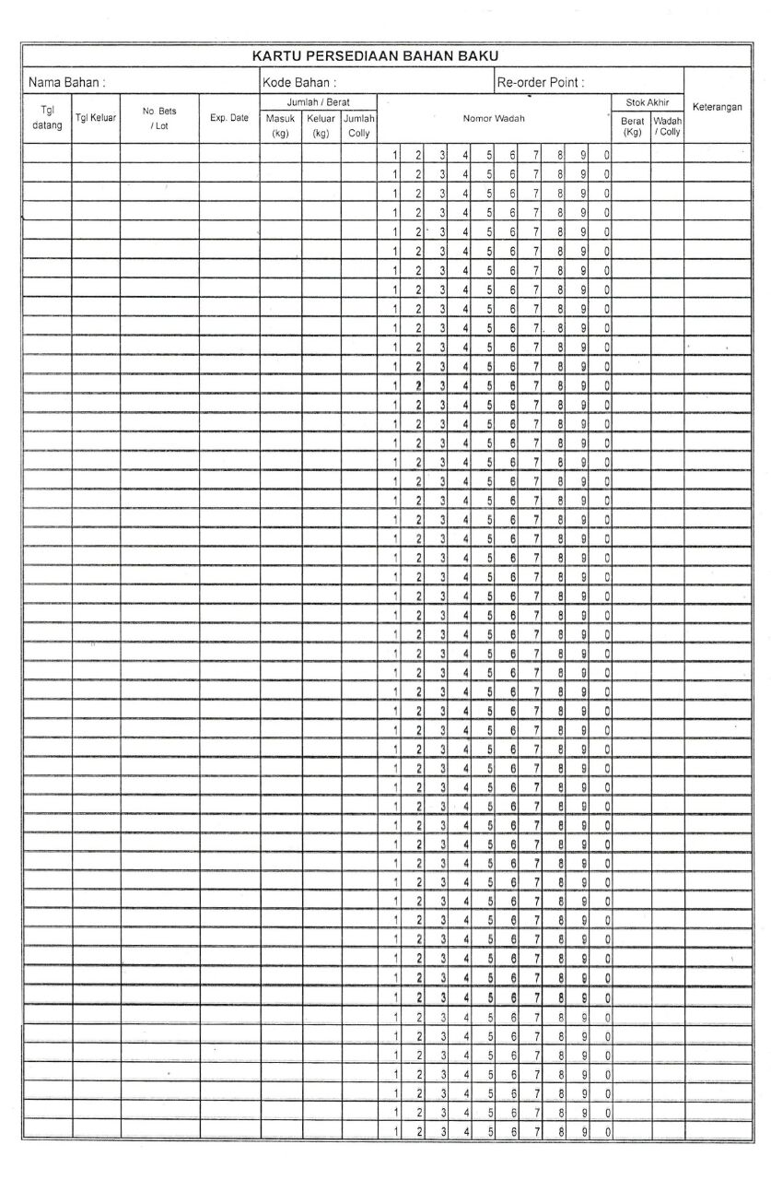

**Lampiran 25.** Kartu persediaan

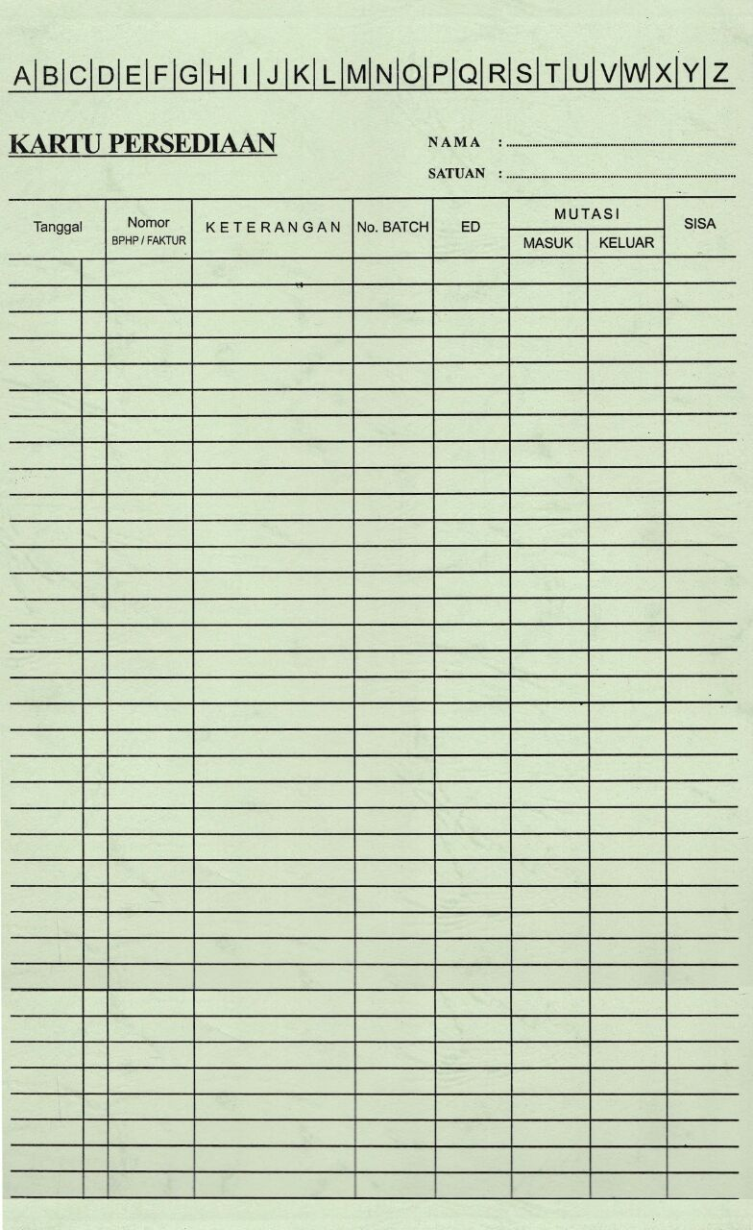

|  |  |  |  |  |  |  |  |  |  |  |  |
| --- | --- | --- | --- | --- | --- | --- | --- | --- | --- | --- | --- |
| **Nama** |  | **: ABC** |  |  |  |  |  |  |  |  |  |
| **Nama** | | **: ABC** |  |  |  |  |  |  |  |  |  |
| **Zat Aktif** | | **: A** |  |  |  |  |  |  |  |  |  |
| **Jumlah** | | **: 47** |  |  |  |  |  |  |  |  |  |
| **Besar Bets** |  | **: 200.000 :Tablet** | |  |  |  |  |  |  |  |  |
| **Periode** |  | **: 2024** |  |  |  |  |  |  |  |  |  |
|  |  |  |  |  |  |  |  |  |  |  |  |
|  |  |  |  |  |  |  |  |  |  |  |  |
| **No.** | **No.Bets** | **Parameter Uji** | | | | | | | | | **Disolusi Rata – rata tidak kurang dari 70% dalam waktu 30 menit** |
| **Variasi Bobot (152 - 168 mg/tab)** | **Ketebalan (3,2 ± 0,2 mm)** | **Kekerasan (3,0 - 10,0 kg)** | **Kerenyahan (≤ 0,80 %)** | **Waktu Hancur (≤ 15 menit)** | **Ruahan** | **Jadi** | **Keseragaman Kandungan** | |
| **Kadar A (92,5 - 107,5%)** | **Kadar A (92,5 - 107,5%)** | **Kadar rata-rata (%)** | **Nilai penerimaan** |
|
|
|
| 1 | 001 | 158 | 3.25 | 5.43 | 0.36 | 2 | 97.28 | 97.88 | 100.07 | 1.7 | 102.15 |
| 2 | 002 | 159 | 3.24 | 6.64 | 0.27 | 2 | 98.54 | 99.22 | 100.03 | 1.8 | 103.06 |
| 3 | 003 | 160 | 3.25 | 5.92 | 0.64 | 2 | 100.68 | 101.17 | 99.98 | 1.7 | 103.15 |
| 4 | 004 | 158 | 3.25 | 5.94 | 0.33 | 2 | 99.19 | 99.59 | 99.88 | 1.53 | 100.98 |
| 5 | 005 | 160 | 3.25 | 7.2 | 0.1 | 2 | 103.95 | 104.02 | 99.95 | 1.77 | 102.24 |
| 6 | 006 | 159 | 3.24 | 6.46 | 0.03 | 2 | 102.23 | 102.40 | 99.64 | 1.80 | 102.97 |
| 7 | 007 | 160 | 3.25 | 6.69 | 0.27 | 2 | 99.98 | 100.16 | 100.1 | 1.53 | 102.97 |
| 8 | 008 | 160 | 3.25 | 6.76 | 0.16 | 2 | 101.37 | 101.60 | 100.23 | 1.10 | 102.88 |
| 9 | 009 | 161 | 3.25 | 6.18 | 0.20 | 2 | 95.22 | 96.10 | 99.97 | 1.70 | 102.73 |
| 10 | 010 | 160 | 3.24 | 6.71 | 0.23 | 2 | 95.63 | 95.74 | 99.77 | 1.05 | 103.33 |
| 11 | 011 | 159 | 3.24 | 5.75 | 0.24 | 4 | 98.18 | 99.20 | 99.96 | 1.70 | 101.75 |
| 12 | 012 | 160 | 3.24 | 6.39 | 0.26 | 4 | 101.18 | 101.80 | 99.96 | 1.68 | 101.41 |
| 13 | 013 | 160 | 3.25 | 6.25 | 0.20 | 4 | 97.07 | 97.87 | 99.96 | 0.70 | 101.83 |
| 14 | 014 | 160 | 3.24 | 5.92 | 0.18 | 4 | 97.23 | 97.28 | 100.16 | 1.12 | 101.07 |
| 15 | 015 | 161 | 3.25 | 6.12 | 0.32 | 2 | 97.17 | 98.16 | 100.07 | 1.46 | 98.95 |
| 16 | 016 | 160 | 3.25 | 6.16 | 0.08 | 2 | 97.5 | 98.16 | 100.06 | 1.46 | 95.54 |
| 17 | 017 | 161 | 3.24 | 6.59 | 0.12 | 2 | 96.29 | 97.10 | 99.84 | 1.41 | 102.03 |
| 18 | 018 | 160 | 3.24 | 6.3 | 0.24 | 2 | 94.32 | 94.93 | 99.94 | 0.24 | 99.72 |
| 19 | 019 | 160 | 3.24 | 6.01 | 0.15 | 2 | 98.04 | 98.26 | 99.64 | 1.17 | 100.23 |
| 20 | 020 | 159 | 3.25 | 6.46 | 0.23 | 2 | 98.21 | 99.02 | 99.75 | 1.10 | 99.72 |
| 21 | 021 | 163 | 3.24 | 6.03 | 0.14 | 2 | 102.18 | 102.38 | 99.87 | 1.48 | 96.03 |
| 22 | 022 | 160 | 3.24 | 6.04 | 0.17 | 2 | 99.93 | 100.11 | 99.91 | 1.70 | 101.86 |
| 23 | 023 | 160 | 3.25 | 5.74 | 0.24 | 2 | 98.42 | 98.35 | 99.96 | 1.72 | 99.89 |
| 24 | 024 | 160 | 3.25 | 5.3 | 0.20 | 2 | 101.67 | 101.51 | 100 | 1.72 | 100.84 |
| 25 | 025 | 159 | 3.25 | 6.18 | 0.12 | 4 | 104.37 | 104.48 | 99.99 | 1.70 | 104.33 |
| 26 | 026 | 160 | 3.25 | 5.73 | 0.26 | 4 | 102.33 | 102.37 | 99.97 | 1.70 | 104.24 |
| 27 | 027 | 160 | 3.24 | 5.62 | 0.33 | 4 | 103.15 | 103.39 | 100.07 | 1.82 | 103.73 |
| 28 | 028 | 160 | 3.24 | 5.97 | 0.30 | 4 | 103.29 | 103.33 | 100.09 | 1.89 | 103.05 |
| 29 | 029 | 160 | 3.24 | 7.08 | 0.26 | 2 | 102.55 | 102.34 | 99.81 | 1.44 | 100.74 |
| 30 | 030 | 160 | 3.24 | 5.25 | 0.27 | 2 | 104.81 | 104.48 | 99.7 | 1.58 | 102.35 |
| 31 | 031 | 160 | 3.24 | 5.62 | 0.19 | 2 | 104.76 | 104.21 | 99.82 | 1.46 | 100.82 |
| 32 | 032 | 160 | 3.25 | 6.08 | 0.17 | 2 | 104.51 | 104.46 | 100.03 | 1.53 | 100.39 |
| 33 | 033 | 160 | 3.24 | 4.82 | 0.17 | 2 | 101.07 | 100.53 | 99.81 | 1.99 | 98.45 |
| 34 | 034 | 160 | 3.25 | 5.87 | 0.22 | 2 | 100.67 | 101.15 | 99.86 | 1.53 | 98.79 |
| 35 | 035 | 161 | 3.25 | 5.86 | 0.16 | 2 | 96.24 | 96.63 | 99.81 | 1.89 | 98.45 |
| 36 | 036 | 160 | 3.25 | 4.85 | 0.16 | 2 | 100.04 | 100.56 | 100.08 | 1.89 | 98.7 |
| 37 | 037 | 160 | 3.25 | 5.75 | 0.16 | 2 | 99.46 | 99.49 | 99.64 | 1.20 | 102.74 |
| 38 | 038 | 160 | 3.26 | 5.31 | 0.14 | 2 | 98.17 | 98.42 | 99.94 | 1.70 | 102.57 |
| 39 | 039 | 160 | 3.25 | 5.76 | 0.14 | 2 | 99.59 | 99.48 | 99.83 | 0.67 | 100.75 |
| 40 | 040 | 161 | 3.25 | 6.46 | 0.13 | 2 | 96.8 | 97.50 | 99.8 | 0.86 | 103.26 |
| 41 | 041 | 160 | 3.25 | 5.92 | 0.24 | 2 | 101.4 | 101.41 | 99.75 | 1.03 | 99.18 |
| 42 | 042 | 161 | 3.25 | 5.82 | 0.25 | 2 | 98.37 | 98.38 | 99.97 | 1.75 | 96.15 |
| 43 | 043 | 161 | 3.25 | 5.25 | 0.23 | 2 | 104.2 | 104.65 | 99.73 | 1.00 | 97.49 |
| 44 | 044 | 161 | 3.25 | 5.78 | 0.36 | 2 | 100 | 100.72 | 99.92 | 1.46 | 99 |
| 45 | 045 | 160 | 3.25 | 5.62 | 0.18 | 2 | 95.33 | 95.76 | 99.48 | 1.70 | 99.98 |
| 46 | 046 | 160 | 3.25 | 6.05 | 0.16 | 2 | 94.8 | 94.74 | 100 | 1.70 | 100.25 |
| 47 | 047 | 161 | 3.25 | 6.7 | 0.16 | 2 | 97.07 | 98.00 | 100 | 1.70 | 98.65 |

Hasil : Cp : 2.44

Cpk : 2.22

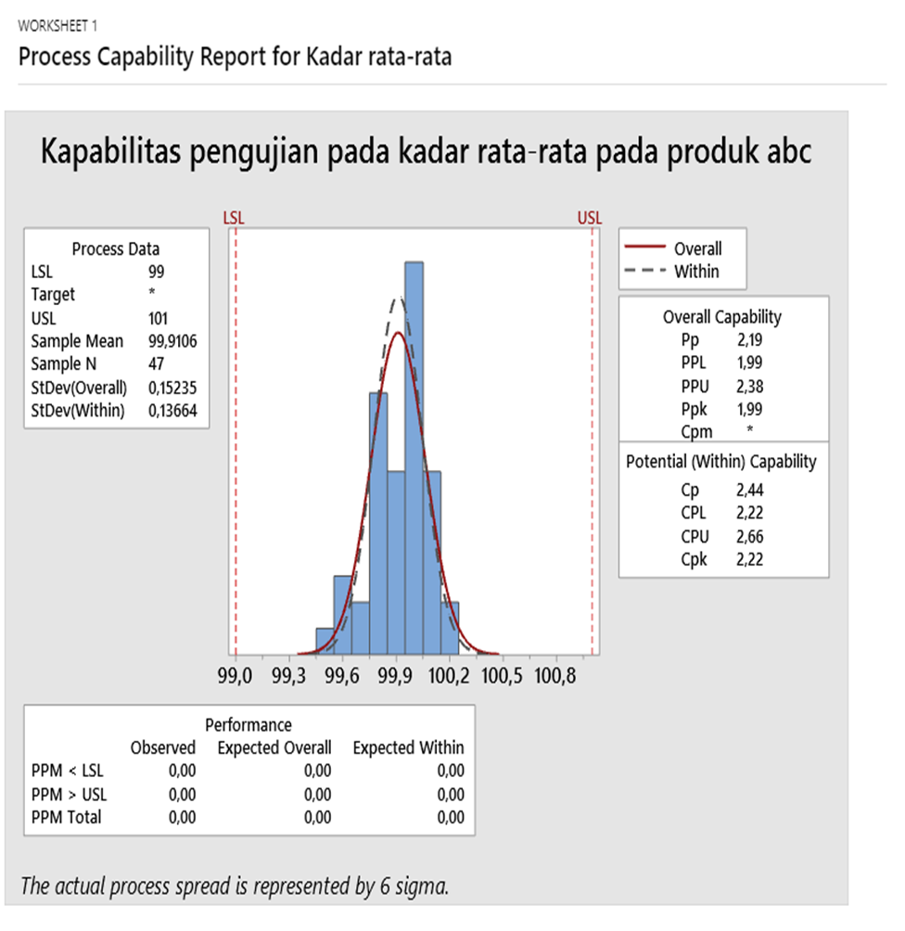

**Kesimpulan :**

CP dan Cpk merupakan parameter (Indeks) yang dapat mengukur variasi proses dan dapat membantu untuk menentukan kinerja dan kapabilitas proses, dapat disimpulkan bahwa Cp dan Cpk pada proses pengujian waktu hancur untuk produk ABC dikatakan Capable (memenuhi spesifikasi). Dikatakan memenuhi spesifikasi karena Nilai Cp (2.44) dan Cpk (2.22) diatas persyaratan yang ditentukan yakni (1.33). Jadi semakin tinggi sigma semakin rendah nilai kerusakan yang terdeteksi.