**Lampiran 1**

**Instrumen Angket Lingkungan Sekolah**

**LEMBAR ANGKET**

**Nama :**

**Kelas :**

**No. Absen :**

**Asal Sekolah :**

**PENGANTAR :**

Angket ini tidak berpengaruh pada hasil belajar anda. Isilah angket ini tanpa ada perasaan khawatir, serta tidak ada jawaban yang benar dan salah. Anda diharapkan menjawab dengan jujur dan teliti sesuai dengan keadaan anda yang sebenarnya pada saat ini. Jawaban anda bersifat pribadi dan dijaga kerahasiaannya. Oleh karena itu, kerjakanlah angket ini secara jujur dan sungguh-sungguh dengan petunjuk pengerjaan dibawah ini.

**PETUNJUK PENGISIAN ANGKET**

1. Tulislah identitas anda pada tempat yang tersedia.
2. Bacalah pernyataan-pernyataan dalam angket ini secara teliti dan cermat.
3. Pilih jawaban yang paling sesuai dengan keadaan anda sebenarnya, dengan cara member tanda (√) pada kolom pilihan.
4. Jawablah sesuai dengan kenyataan yang ada, sehingga kesimpulan yang diambil dari data ini benar.
5. Periksalah kembali nomor pernyataan, jangan sampai ada yang terlewatkan.

**KETERANGAN**

SS : Sangat Sering J : Jarang

S : Sering TP : Tidak Pernah

SELAMAT MENGERJAKAN

|  |  |  |  |  |  |  |  |
| --- | --- | --- | --- | --- | --- | --- | --- |
| **No** | **Pertanyaan** | | | **Alternatif pilhan jawaban** | | | |
| **SS** | **S** | **J** | **TP** |
| 1 | Guru mengajarkan saya untuk berdoa  sebelum dan sesudah belajar dikelas. | | |  |  |  |  |
| 2 | Guru mengajarkan kepada  saling menghormati. | saya | untuk |  |  |  |  |
| 3 | Saya tidak mengikuti  keagamaan. | hari | besar |  |  |  |  |
| 4 | Saya mengucapkan salam ketika bertemu  orang lain dilingkungan sekolah. | | |  |  |  |  |
| 5 | Saya melaksanakan solat dzuhur  berjamaah di sekolah. | | |  |  |  |  |
| 6 | Guru menuntun siswa untuk menghafalkan  surah-surah pendek dalam Al-qur’an. | | |  |  |  |  |
| 7 | Guru selalu memberi contoh untuk selalu  datang tepat waktu kesekolah. | | |  |  |  |  |
| 8 | Saya tidak mengerjakan PR dan terlambat  masuk sekolah. | | |  |  |  |  |
| 9 | Saya berpakaian sopan dan rapi ke sekolah. | | |  |  |  |  |
| 10 | Saya tidak suka membolos ketika  pembelajaran berlangsung. | | |  |  |  |  |
| 11 | Guru mengajarkan untuk membuang  sampah pada tempatnya. | | |  |  |  |  |
| 12 | Saya menjalin hubungan pertemanan  dengan teman sekolah. | | |  |  |  |  |
| 13 | Saya merasa tertekan ketika berada  diantara teman sekolah. | | |  |  |  |  |
| 14 | Saya melakukan kegiatan yang dilakukan secara bersama-sama dengan teman sekolah. | | |  |  |  |  |
| 15 | Jika dalam suatu kegiatan bersama teman  sekolah saya merasa kesepian. | | |  |  |  |  |
| 16 | Saya bertegur sapa dengan baik ketika  bertemu guru di sekolah. | | |  |  |  |  |
| 17 | Saya mengerjakan tugas yang diberikan  oleh guru. | | |  |  |  |  |
| 18 | Saya selalu menaati perintah guru. | | |  |  |  |  |
| 19 | Saya tidak mendengarkan ketika guru  menjelaskan materi. | | |  |  |  |  |
| 20 | Saya dan teman saya menggunjing guru. | | |  |  |  |  |

**Lampiran 2**

**Instrumen Angket Pembentukan Karakter**

**LEMBAR ANGKET**

**Nama :**

**Kelas :**

**No. Absen :**

**Asal Sekolah :**

**PENGANTAR :**

Angket ini tidak berpengaruh pada hasil belajar anda. Isilah angket ini tanpa ada perasaan khawatir, serta tidak ada jawaban yang benar dan salah. Anda diharapkan menjawab dengan jujur dan teliti sesuai dengan keadaan anda yang sebenarnya pada saat ini. Jawaban anda bersifat pribadi dan dijaga kerahasiaannya. Oleh karena itu, kerjakanlah angket ini secara jujur dan sungguh-sungguh dengan petunjuk pengerjaan dibawah ini.

**PETUNJUK PENGISIAN ANGKET**

1. Tulislah identitas anda pada tempat yang tersedia.
2. Bacalah pernyataan-pernyataan dalam angket ini secara teliti dan cermat.
3. Pilih jawaban yang paling sesuai dengan keadaan anda sebenarnya, dengan cara member tanda (√) pada kolom pilihan.
4. Jawablah sesuai dengan kenyataan yang ada, sehingga kesimpulan yang diambil dari data ini benar.
5. Periksalah kembali nomor pernyataan, jangan sampai ada yang terlewatkan.

**KETERANGAN**

SS : Sangat Sering J : Jarang

S : Sering TP : Tidak Pernah

SELAMAT MENGERJAKAN

|  |  |  |  |  |  |
| --- | --- | --- | --- | --- | --- |
| **No** | **Pertanyaan** | **Alternatif pilhan jawaban** | | | |
| **SS** | **S** | **J** | **TP** |
| 1 | Saya berkata jujur apa adanya. |  |  |  |  |
| 2 | Saya tidak pernah terlambat masuk  sekolah. |  |  |  |  |
| 3 | Saya tidak pernah bertengkar dengan  teman saya. |  |  |  |  |
| 4 | Saya tidak suka mengusili teman. |  |  |  |  |
| 5 | Saya senang bergaul dengan siapapun. |  |  |  |  |
| 6 | Saya suka menjahili teman. |  |  |  |  |
| 7 | Saya melerai teman yang ingin berkelahi. |  |  |  |  |
| 8 | Saya pernah membuat kerusuhan. |  |  |  |  |
| 9 | Guru saya mengajarkan untuk bertata krama yang baik dan bersifat jujur dalam  segala hal dilingkungan sekolah. |  |  |  |  |
| 10 | Saya menyontek ketika ulangan. |  |  |  |  |
| 11 | Saya melaporkan teman yang menyontek  ketika ulangan disekolah. |  |  |  |  |
| 12 | Saya memarahi teman ketika dia  mengganggu saya. |  |  |  |  |
| 13 | Saya mengerjakan tugas dengan sabar dan  teliti. |  |  |  |  |
| 14 | Saya memaafkan teman saya ketika dia  melakukan kesalahan. |  |  |  |  |
| 15 | Saya membantu guru yang membutuhkan  pertolongan dengan senang hati. |  |  |  |  |
| 16 | Saya membantu teman yang sedang  kesulitan untuk memahami pembelajaran. |  |  |  |  |
| 17 | Saya mengejek teman ketika tidak bisa  menjawab pertanyaan dari guru. |  |  |  |  |
| 18 | Saya tau menjahili guru itu tidak baik, tapi  saya melakukannya. |  |  |  |  |
| 19 | Saya tahu bahwa saya telah melakukan kesalahan dan saya berani mengakui kesalahan tersebut. |  |  |  |  |
| 20 | Saya mengajak teman berbicara ketika  guru menjelaskan. |  |  |  |  |

**Lampiran 3. Surat Permohonan Izin Penelitian**

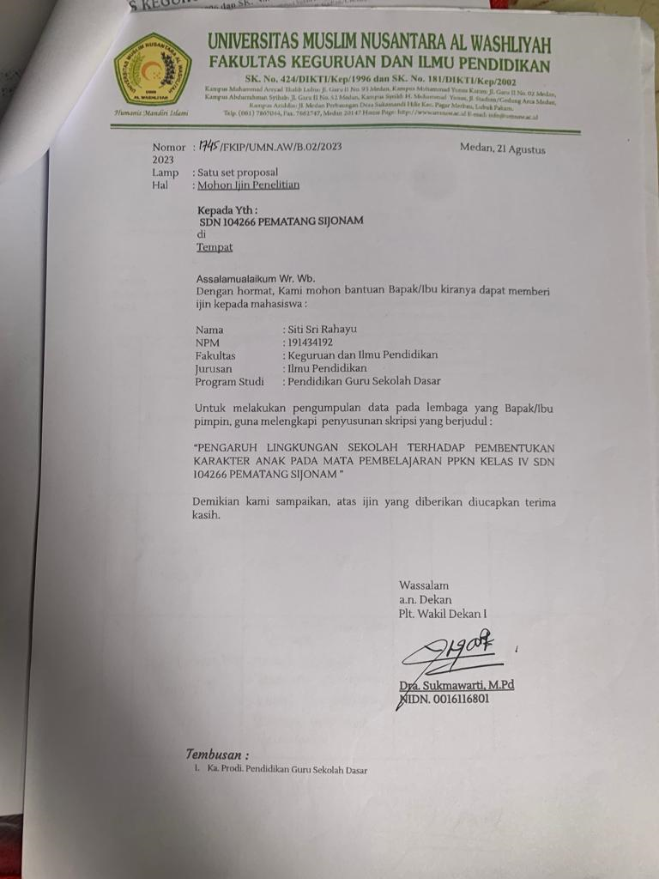

**Lampiran 4. Surat Telah Melaksanakan Penelitian**

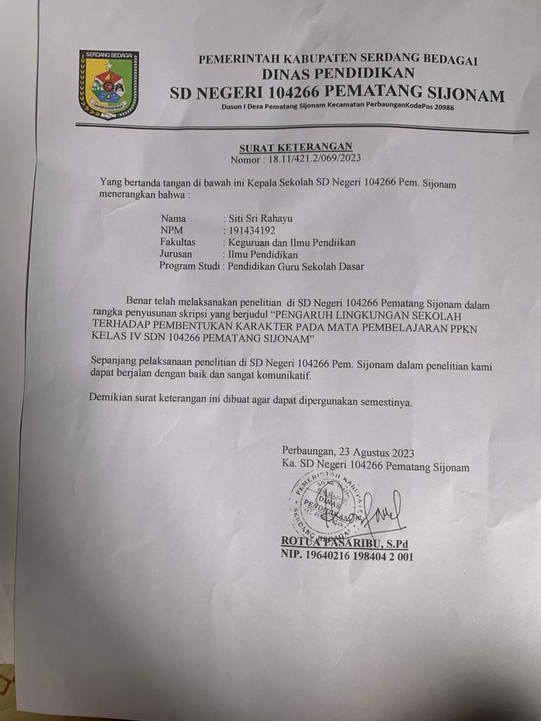

**Lampiran 5. Dokumentasi**

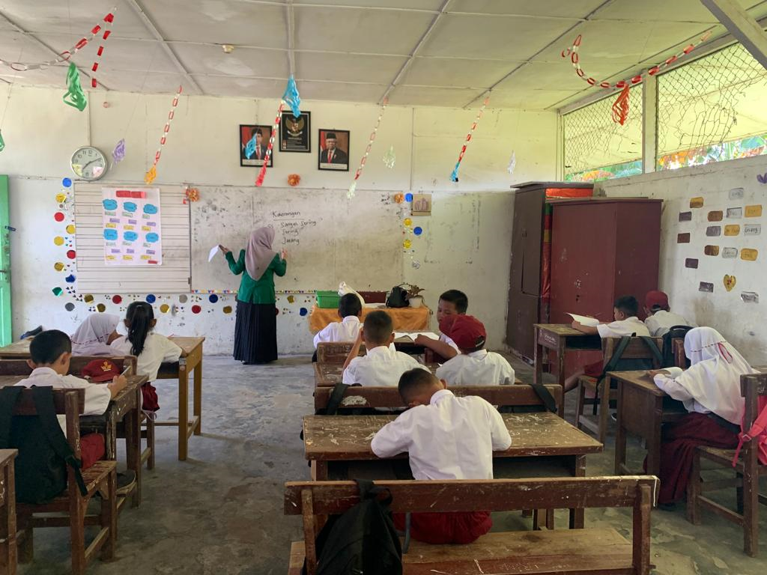

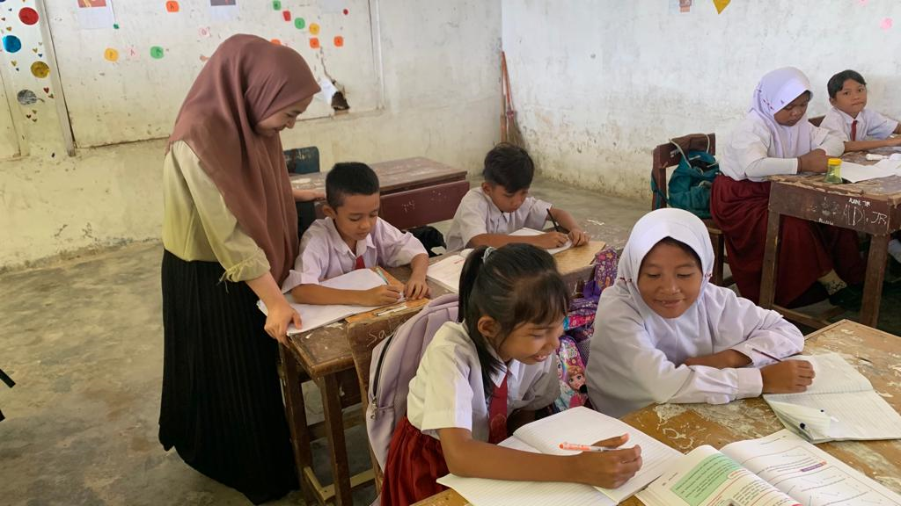

**Lampiran 6 Uji Validitas Angket Lingkungan Sekolah**

|  |  |  |  |
| --- | --- | --- | --- |
| **Case Processing Summary** | | | |
|  | | N | % |
| Cases | Valid | 36 | 100.0 |
| Excludeda | 0 | .0 |
| Total | 36 | 100.0 |
| a. Listwise deletion based on all variables in the procedure. | | | |

|  |  |
| --- | --- |
| **Reliability Statistics** | |
| Cronbach's Alpha | N of Items |
| .766 | 20 |

|  |  |  |  |
| --- | --- | --- | --- |
| **Item Statistics** | | | |
|  | Mean | Std. Deviation | N |
| VAR00001 | 2.89 | .979 | 36 |
| VAR00002 | 3.22 | .760 | 36 |
| VAR00003 | 3.08 | .967 | 36 |
| VAR00004 | 2.64 | .961 | 36 |
| VAR00005 | 3.36 | .798 | 36 |
| VAR00006 | 3.08 | .906 | 36 |
| VAR00007 | 3.00 | .926 | 36 |
| VAR00008 | 2.97 | .941 | 36 |
| VAR00009 | 3.28 | .974 | 36 |
| VAR00010 | 3.22 | .929 | 36 |
| VAR00011 | 2.75 | 1.180 | 36 |
| VAR00012 | 3.11 | .979 | 36 |
| VAR00013 | 3.03 | 1.000 | 36 |
| VAR00014 | 3.19 | .889 | 36 |
| VAR00015 | 2.08 | .937 | 36 |
| VAR00016 | 2.56 | 1.054 | 36 |
| VAR00017 | 2.64 | 1.125 | 36 |
| VAR00018 | 3.28 | .779 | 36 |
| VAR00019 | 2.94 | .715 | 36 |
| VAR00020 | 2.58 | 1.105 | 36 |

|  |  |  |  |  |
| --- | --- | --- | --- | --- |
| **Item-Total Statistics** | | | | |
|  | Scale Mean if Item Deleted | Scale Variance if Item Deleted | Corrected Item-Total Correlation | Cronbach's Alpha if Item Deleted |
| VAR00001 | 56.03 | 67.685 | -.127 | .788 |
| VAR00002 | 55.69 | 69.304 | -.260 | .788 |
| VAR00003 | 55.83 | 57.629 | .547 | .740 |
| VAR00004 | 56.28 | 56.721 | .618 | .735 |
| VAR00005 | 55.56 | 60.368 | .450 | .749 |
| VAR00006 | 55.83 | 61.514 | .299 | .758 |
| VAR00007 | 55.92 | 62.364 | .231 | .763 |
| VAR00008 | 55.94 | 57.883 | .547 | .741 |
| VAR00009 | 55.64 | 60.352 | .350 | .755 |
| VAR00010 | 55.69 | 57.304 | .599 | .737 |
| VAR00011 | 56.17 | 63.914 | .068 | .779 |
| VAR00012 | 55.81 | 59.475 | .408 | .751 |
| VAR00013 | 55.89 | 68.844 | -.196 | .793 |
| VAR00014 | 55.72 | 59.863 | .432 | .750 |
| VAR00015 | 56.83 | 58.200 | .525 | .742 |
| VAR00016 | 56.36 | 56.352 | .577 | .737 |
| VAR00017 | 56.28 | 57.578 | .454 | .746 |
| VAR00018 | 55.64 | 61.609 | .358 | .755 |
| VAR00019 | 55.97 | 63.171 | .256 | .761 |
| VAR00020 | 56.33 | 56.686 | .522 | .740 |

|  |  |  |  |
| --- | --- | --- | --- |
| **Scale Statistics** | | | |
| Mean | Variance | Std. Deviation | N of Items |
| 58.92 | 66.593 | 8.160 | 20 |

**Lampiran 7. Uji Validitas Variabel Pembentukan Karakter**

|  |  |  |  |
| --- | --- | --- | --- |
| **Case Processing Summary** | | | |
|  | | N | % |
| Cases | Valid | 36 | 100.0 |
| Excludeda | 0 | .0 |
| Total | 36 | 100.0 |
| a. Listwise deletion based on all variables in the procedure. | | | |

|  |  |
| --- | --- |
| **Reliability Statistics** | |
| Cronbach's Alpha | N of Items |
| .847 | 20 |

|  |  |  |  |
| --- | --- | --- | --- |
| **Item Statistics** | | | |
|  | Mean | Std. Deviation | N |
| VAR00001 | 3.00 | .926 | 36 |
| VAR00002 | 2.97 | .941 | 36 |
| VAR00003 | 3.08 | .967 | 36 |
| VAR00004 | 2.64 | .961 | 36 |
| VAR00005 | 3.36 | .798 | 36 |
| VAR00006 | 3.22 | .929 | 36 |
| VAR00007 | 3.00 | .926 | 36 |
| VAR00008 | 2.97 | .941 | 36 |
| VAR00009 | 3.28 | .974 | 36 |
| VAR00010 | 3.22 | .929 | 36 |
| VAR00011 | 2.75 | 1.180 | 36 |
| VAR00012 | 3.11 | .979 | 36 |
| VAR00013 | 3.03 | 1.000 | 36 |
| VAR00014 | 3.19 | .889 | 36 |
| VAR00015 | 2.08 | .937 | 36 |
| VAR00016 | 2.56 | 1.054 | 36 |
| VAR00017 | 2.64 | 1.125 | 36 |
| VAR00018 | 3.28 | .779 | 36 |
| VAR00019 | 2.94 | .715 | 36 |
| VAR00020 | 2.58 | 1.105 | 36 |

|  |  |  |  |  |
| --- | --- | --- | --- | --- |
| **Item-Total Statistics** | | | | |
|  | Scale Mean if Item Deleted | Scale Variance if Item Deleted | Corrected Item-Total Correlation | Cronbach's Alpha if Item Deleted |
| VAR00001 | 55.92 | 87.507 | .343 | .844 |
| VAR00002 | 55.94 | 83.025 | .606 | .833 |
| VAR00003 | 55.83 | 82.943 | .592 | .833 |
| VAR00004 | 56.28 | 83.235 | .579 | .834 |
| VAR00005 | 55.56 | 86.254 | .500 | .838 |
| VAR00006 | 55.69 | 81.990 | .681 | .830 |
| VAR00007 | 55.92 | 87.507 | .343 | .844 |
| VAR00008 | 55.94 | 83.025 | .606 | .833 |
| VAR00009 | 55.64 | 86.066 | .403 | .842 |
| VAR00010 | 55.69 | 81.990 | .681 | .830 |
| VAR00011 | 56.17 | 91.400 | .067 | .859 |
| VAR00012 | 55.81 | 85.133 | .455 | .839 |
| VAR00013 | 55.89 | 95.930 | -.134 | .864 |
| VAR00014 | 55.72 | 85.463 | .490 | .838 |
| VAR00015 | 56.83 | 84.543 | .516 | .837 |
| VAR00016 | 56.36 | 82.866 | .538 | .835 |
| VAR00017 | 56.28 | 84.206 | .428 | .841 |
| VAR00018 | 55.64 | 88.580 | .349 | .844 |
| VAR00019 | 55.97 | 91.056 | .201 | .848 |
| VAR00020 | 56.33 | 83.200 | .490 | .838 |

|  |  |  |  |
| --- | --- | --- | --- |
| **Scale Statistics** | | | |
| Mean | Variance | Std. Deviation | N of Items |
| 58.92 | 94.307 | 9.711 | 20 |

**Lampiran 8. Uji Realibilitas SkalaLingkungan Sekolah**

|  |  |  |  |
| --- | --- | --- | --- |
| **Case Processing Summary** | | | |
|  | | N | % |
| Cases | Valid | 36 | 100.0 |
| Excludeda | 0 | .0 |
| Total | 36 | 100.0 |
| a. Listwise deletion based on all variables in the procedure. | | | |

|  |  |
| --- | --- |
| **Reliability Statistics** | |
| Cronbach's Alpha | N of Items |
| .847 | 13 |

|  |  |  |  |
| --- | --- | --- | --- |
| **Item Statistics** | | | |
|  | Mean | Std. Deviation | N |
| VAR00003 | 3.08 | .967 | 36 |
| VAR00004 | 2.64 | .961 | 36 |
| VAR00005 | 3.36 | .798 | 36 |
| VAR00008 | 2.97 | .941 | 36 |
| VAR00009 | 3.28 | .974 | 36 |
| VAR00010 | 3.22 | .929 | 36 |
| VAR00012 | 3.11 | .979 | 36 |
| VAR00014 | 3.19 | .889 | 36 |
| VAR00015 | 2.08 | .937 | 36 |
| VAR00016 | 2.56 | 1.054 | 36 |
| VAR00017 | 2.64 | 1.125 | 36 |
| VAR00018 | 3.28 | .779 | 36 |
| VAR00020 | 2.58 | 1.105 | 36 |

|  |  |  |  |  |
| --- | --- | --- | --- | --- |
| **Item-Total Statistics** | | | | |
|  | Scale Mean if Item Deleted | Scale Variance if Item Deleted | Corrected Item-Total Correlation | Cronbach's Alpha if Item Deleted |
| VAR00003 | 34.92 | 46.707 | .567 | .832 |
| VAR00004 | 35.36 | 46.352 | .601 | .830 |
| VAR00005 | 34.64 | 49.266 | .468 | .839 |
| VAR00008 | 35.03 | 47.113 | .553 | .833 |
| VAR00009 | 34.72 | 49.521 | .341 | .847 |
| VAR00010 | 34.78 | 46.121 | .646 | .827 |
| VAR00012 | 34.89 | 49.244 | .359 | .846 |
| VAR00014 | 34.81 | 48.675 | .458 | .839 |
| VAR00015 | 35.92 | 47.679 | .509 | .836 |
| VAR00016 | 35.44 | 45.968 | .564 | .832 |
| VAR00017 | 35.36 | 46.237 | .499 | .837 |
| VAR00018 | 34.72 | 49.749 | .436 | .841 |
| VAR00020 | 35.42 | 45.964 | .531 | .834 |

|  |  |  |  |
| --- | --- | --- | --- |
| **Scale Statistics** | | | |
| Mean | Variance | Std. Deviation | N of Items |
| 38.00 | 55.143 | 7.426 | 13 |

**Lampiran 9. Uji Realibilitas Skala Pembentukan Karakter**

|  |  |  |  |
| --- | --- | --- | --- |
| **Case Processing Summary** | | | |
|  | | N | % |
| Cases | Valid | 36 | 100.0 |
| Excludeda | 0 | .0 |
| Total | 36 | 100.0 |
| a. Listwise deletion based on all variables in the procedure. | | | |

|  |  |
| --- | --- |
| **Reliability Statistics** | |
| Cronbach's Alpha | N of Items |
| .877 | 17 |

|  |  |  |  |
| --- | --- | --- | --- |
| **Item Statistics** | | | |
|  | Mean | Std. Deviation | N |
| VAR00001 | 3.00 | .926 | 36 |
| VAR00002 | 2.97 | .941 | 36 |
| VAR00003 | 3.08 | .967 | 36 |
| VAR00004 | 2.64 | .961 | 36 |
| VAR00005 | 3.36 | .798 | 36 |
| VAR00006 | 3.22 | .929 | 36 |
| VAR00007 | 3.00 | .926 | 36 |
| VAR00008 | 2.97 | .941 | 36 |
| VAR00009 | 3.28 | .974 | 36 |
| VAR00010 | 3.22 | .929 | 36 |
| VAR00012 | 3.11 | .979 | 36 |
| VAR00014 | 3.19 | .889 | 36 |
| VAR00015 | 2.08 | .937 | 36 |
| VAR00016 | 2.56 | 1.054 | 36 |
| VAR00017 | 2.64 | 1.125 | 36 |
| VAR00018 | 3.28 | .779 | 36 |
| VAR00020 | 2.58 | 1.105 | 36 |

|  |  |  |  |  |
| --- | --- | --- | --- | --- |
| **Item-Total Statistics** | | | | |
|  | Scale Mean if Item Deleted | Scale Variance if Item Deleted | Corrected Item-Total Correlation | Cronbach's Alpha if Item Deleted |
| VAR00001 | 47.19 | 81.933 | .365 | .876 |
| VAR00002 | 47.22 | 77.549 | .632 | .866 |
| VAR00003 | 47.11 | 77.587 | .609 | .867 |
| VAR00004 | 47.56 | 77.625 | .612 | .867 |
| VAR00005 | 46.83 | 81.457 | .473 | .872 |
| VAR00006 | 46.97 | 76.713 | .696 | .863 |
| VAR00007 | 47.19 | 81.933 | .365 | .876 |
| VAR00008 | 47.22 | 77.549 | .632 | .866 |
| VAR00009 | 46.92 | 80.536 | .424 | .874 |
| VAR00010 | 46.97 | 76.713 | .696 | .863 |
| VAR00012 | 47.08 | 80.421 | .428 | .874 |
| VAR00014 | 47.00 | 80.571 | .473 | .872 |
| VAR00015 | 48.11 | 79.816 | .490 | .871 |
| VAR00016 | 47.64 | 77.952 | .529 | .870 |
| VAR00017 | 47.56 | 79.340 | .414 | .875 |
| VAR00018 | 46.92 | 82.936 | .378 | .875 |
| VAR00020 | 47.61 | 78.416 | .473 | .873 |

|  |  |  |  |
| --- | --- | --- | --- |
| **Scale Statistics** | | | |
| Mean | Variance | Std. Deviation | N of Items |
| 50.19 | 88.904 | 9.429 | 17 |

**Lampiran 10. Uji Normalitas**

|  |  |  |  |
| --- | --- | --- | --- |
| **One-Sample Kolmogorov-Smirnov Test** | | | |
|  | | Lingkungan Sekolah | Pembentukan Karakter |
| N | | 36 | 36 |
| Normal Parametersa,b | Mean | 58.92 | 58.92 |
| Std. Deviation | 8.160 | 9.711 |
| Most Extreme Differences | Absolute | .083 | .078 |
| Positive | .075 | .065 |
| Negative | -.083 | -.078 |
| Test Statistic | | .083 | .078 |
| Asymp. Sig. (2-tailed) | | .200c,d | .200c,d |
| a. Test distribution is Normal. | | | |
| b. Calculated from data. | | | |
| c. Lilliefors Significance Correction. | | | |
| d. This is a lower bound of the true significance. | | | |

**Lampiran 11. Uji Linieritas**

|  |  |  |  |  |  |  |
| --- | --- | --- | --- | --- | --- | --- |
| **Case Processing Summary** | | | | | | |
|  | Cases | | | | | |
| Included | | Excluded | | Total | |
| N | Percent | N | Percent | N | Percent |
| Pembentukan Karakter * Lingkungan Sekolah | 36 | 100.0% | 0 | 0.0% | 36 | 100.0% |

|  |  |  |  |
| --- | --- | --- | --- |
| **Report** | | | |
| Pembentukan Karakter | | | |
| Lingkungan Sekolah | Mean | N | Std. Deviation |
| 42 | 37.00 | 1 | . |
| 45 | 42.00 | 2 | 1.414 |
| 49 | 50.00 | 1 | . |
| 50 | 47.50 | 2 | .707 |
| 51 | 51.00 | 1 | . |
| 52 | 49.00 | 1 | . |
| 54 | 54.00 | 1 | . |
| 55 | 53.00 | 1 | . |
| 56 | 57.00 | 4 | 3.162 |
| 57 | 55.67 | 3 | 3.215 |
| 58 | 59.00 | 2 | 1.414 |
| 59 | 58.00 | 1 | . |
| 60 | 60.00 | 2 | 2.828 |
| 62 | 62.75 | 4 | 1.500 |
| 63 | 65.00 | 1 | . |
| 64 | 67.00 | 1 | . |
| 65 | 64.00 | 1 | . |
| 68 | 72.00 | 1 | . |
| 70 | 74.50 | 2 | .707 |
| 71 | 71.00 | 2 | 1.414 |
| 72 | 72.00 | 1 | . |
| 76 | 75.00 | 1 | . |
| Total | 58.92 | 36 | 9.711 |

|  |  |  |  |  |  |  |  |
| --- | --- | --- | --- | --- | --- | --- | --- |
| **ANOVA Table** | | | | | | | |
|  | | | Sum of Squares | df | Mean Square | F | Sig. |
| Pembentukan Karakter * Lingkungan Sekolah | Between Groups | (Combined) | 3228.333 | 21 | 153.730 | 29.720 | .000 |
| Linearity | 3131.804 | 1 | 3131.804 | 605.458 | .000 |
| Deviation from Linearity | 96.529 | 20 | 4.826 | .933 | .567 |
| Within Groups | | 72.417 | 14 | 5.173 |  |  |
| Total | | 3300.750 | 35 |  |  |  |

|  |  |  |  |  |
| --- | --- | --- | --- | --- |
| **Measures of Association** | | | | |
|  | R | R Squared | Eta | Eta Squared |
| Pembentukan Karakter * Lingkungan Sekolah | .974 | .949 | .989 | .978 |

**Lampiran 13. Uji Regresi Linier Sederhana**

|  |  |  |  |
| --- | --- | --- | --- |
| **Variables Entered/Removeda** | | | |
| Model | Variables Entered | Variables Removed | Method |
| 1 | Lingkungan Sekolahb | . | Enter |
| a. Dependent Variable: Pembentukan Karakter | | | |
| b. All requested variables entered. | | | |

|  |  |  |  |  |
| --- | --- | --- | --- | --- |
| **Model Summary** | | | | |
| Model | R | R Square | Adjusted R Square | Std. Error of the Estimate |
| 1 | .974a | .949 | .947 | 2.229 |
| a. Predictors: (Constant), Lingkungan Sekolah | | | | |

|  |  |  |  |  |  |  |
| --- | --- | --- | --- | --- | --- | --- |
| **ANOVAa** | | | | | | |
| Model | | Sum of Squares | df | Mean Square | F | Sig. |
| 1 | Regression | 3131.804 | 1 | 3131.804 | 630.270 | .000b |
| Residual | 168.946 | 34 | 4.969 |  |  |
| Total | 3300.750 | 35 |  |  |  |
| a. Dependent Variable: Pembentukan Karakter | | | | | | |
| b. Predictors: (Constant), Lingkungan Sekolah | | | | | | |

|  |  |  |  |  |  |  |
| --- | --- | --- | --- | --- | --- | --- |
| **‘]’** | | | | | | |
| Model | | Unstandardized Coefficients | | Standardized Coefficients | t | Sig. |
| B | Std. Error | Beta |
| 1 | (Constant) | -9.378 | 2.746 |  | -3.416 | .002 |
| Lingkungan Sekolah | 1.159 | .046 | .974 | 25.105 | .000 |
| a. Dependent Variable: Pembentukan Karakter | | | | | | |

Lampiran 14. Tabulasi Data Skala Lingkungan Sekolah

|  |  |  |  |  |  |  |  |  |  |  |  |  |  |  |  |  |  |  |  |  |  |  |
| --- | --- | --- | --- | --- | --- | --- | --- | --- | --- | --- | --- | --- | --- | --- | --- | --- | --- | --- | --- | --- | --- | --- |
| **No Responden** |  |  |  |  |  |  |  |  |  | **No Item** |  |  |  |  |  |  |  |  |  |  |  |  |
| **Nama** | **1** | **2** | **3** | **4** | **5** | **6** | **7** | **8** | **9** | **10** | **11** | **12** | **13** | **14** | **15** | **16** | **17** | **18** | **19** | **20** |  |
| 1 | CS | 2 | 4 | 2 | 1 | 4 | 3 | 2 | 2 | 3 | 4 | 4 | 2 | 4 | 4 | 1 | 2 | 4 | 4 | 2 | 2 | 56 |
| 2 | GT | 2 | 2 | 1 | 2 | 3 | 3 | 4 | 2 | 3 | 2 | 2 | 2 | 2 | 3 | 2 | 3 | 3 | 4 | 2 | 2 | 49 |
| 3 | TT | 3 | 3 | 4 | 3 | 4 | 2 | 2 | 2 | 4 | 4 | 2 | 1 | 3 | 4 | 2 | 2 | 3 | 4 | 3 | 2 | 57 |
| 4 | AC | 3 | 4 | 4 | 3 | 4 | 2 | 2 | 2 | 4 | 4 | 3 | 1 | 3 | 4 | 2 | 2 | 3 | 4 | 3 | 2 | 59 |
| 5 | E | 3 | 3 | 2 | 2 | 2 | 4 | 4 | 2 | 2 | 2 | 3 | 2 | 4 | 2 | 2 | 3 | 2 | 2 | 2 | 2 | 50 |
| 6 | TY | 4 | 4 | 3 | 3 | 3 | 3 | 3 | 3 | 3 | 3 | 1 | 3 | 3 | 3 | 3 | 3 | 3 | 3 | 3 | 3 | 60 |
| 7 | ET | 2 | 2 | 3 | 3 | 4 | 3 | 4 | 3 | 3 | 4 | 3 | 4 | 4 | 4 | 4 | 3 | 4 | 3 | 4 | 4 | 68 |
| 8 | DG | 2 | 2 | 3 | 3 | 2 | 3 | 3 | 3 | 4 | 4 | 4 | 2 | 4 | 4 | 4 | 3 | 4 | 3 | 3 | 4 | 64 |
| 9 | HH | 1 | 3 | 3 | 3 | 3 | 4 | 4 | 3 | 3 | 3 | 3 | 3 | 2 | 4 | 2 | 3 | 4 | 4 | 3 | 4 | 62 |
| 10 | HA | 3 | 3 | 4 | 3 | 3 | 4 | 3 | 4 | 4 | 3 | 1 | 3 | 3 | 3 | 3 | 3 | 3 | 3 | 3 | 3 | 62 |
| 11 | GF | 3 | 2 | 4 | 3 | 4 | 2 | 2 | 4 | 3 | 3 | 4 | 4 | 4 | 3 | 3 | 3 | 3 | 3 | 3 | 3 | 63 |
| 12 | FE | 1 | 3 | 3 | 1 | 4 | 4 | 4 | 3 | 3 | 3 | 1 | 4 | 4 | 4 | 2 | 2 | 2 | 3 | 3 | 2 | 56 |
| 13 | FG | 2 | 2 | 4 | 3 | 4 | 4 | 2 | 4 | 4 | 4 | 2 | 4 | 4 | 1 | 1 | 2 | 2 | 4 | 3 | 2 | 58 |
| 14 | GH | 3 | 2 | 4 | 3 | 4 | 3 | 4 | 4 | 4 | 4 | 4 | 4 | 2 | 4 | 2 | 4 | 4 | 4 | 3 | 4 | 70 |
| 15 | NH | 4 | 3 | 4 | 4 | 3 | 4 | 3 | 4 | 4 | 3 | 4 | 3 | 4 | 3 | 3 | 4 | 2 | 3 | 1 | 2 | 65 |
| 16 | KA | 4 | 4 | 2 | 2 | 2 | 2 | 2 | 2 | 2 | 2 | 1 | 2 | 2 | 2 | 1 | 2 | 3 | 2 | 3 | 3 | 45 |
| 17 | IA | 3 | 3 | 3 | 3 | 3 | 3 | 2 | 3 | 4 | 4 | 1 | 3 | 3 | 3 | 1 | 1 | 1 | 3 | 3 | 1 | 51 |
| 18 | JH | 4 | 4 | 4 | 3 | 3 | 4 | 2 | 4 | 4 | 4 | 2 | 3 | 2 | 2 | 1 | 1 | 1 | 4 | 3 | 1 | 56 |
| 19 | FG | 4 | 4 | 3 | 2 | 3 | 4 | 2 | 3 | 2 | 2 | 4 | 3 | 4 | 2 | 2 | 3 | 2 | 3 | 3 | 2 | 57 |
| 20 | JA | 3 | 3 | 2 | 1 | 2 | 3 | 1 | 2 | 1 | 3 | 4 | 2 | 1 | 4 | 2 | 2 | 4 | 4 | 4 | 4 | 52 |
| 21 | JB | 4 | 4 | 1 | 2 | 1 | 2 | 3 | 1 | 4 | 1 | 4 | 1 | 2 | 3 | 1 | 1 | 1 | 2 | 3 | 1 | 42 |
| 22 | SF | 2 | 4 | 1 | 1 | 4 | 1 | 2 | 1 | 1 | 2 | 4 | 4 | 4 | 2 | 1 | 2 | 2 | 3 | 2 | 2 | 45 |
| 23 | JO | 2 | 3 | 2 | 1 | 4 | 4 | 3 | 2 | 3 | 2 | 4 | 4 | 4 | 3 | 2 | 2 | 2 | 3 | 3 | 2 | 55 |
| 24 | KA | 2 | 4 | 2 | 4 | 3 | 4 | 4 | 2 | 1 | 3 | 1 | 3 | 3 | 2 | 4 | 4 | 4 | 4 | 4 | 4 | 62 |
| 25 | KL | 1 | 2 | 4 | 4 | 4 | 4 | 4 | 4 | 4 | 4 | 4 | 4 | 3 | 4 | 3 | 4 | 3 | 4 | 3 | 3 | 70 |
| 26 | LMA | 3 | 4 | 3 | 4 | 4 | 3 | 4 | 3 | 4 | 4 | 3 | 4 | 1 | 4 | 3 | 4 | 4 | 4 | 4 | 4 | 71 |
| 27 | NK | 2 | 4 | 4 | 3 | 4 | 3 | 3 | 4 | 4 | 4 | 2 | 4 | 3 | 4 | 3 | 2 | 2 | 3 | 2 | 2 | 62 |
| 28 | KJ | 2 | 4 | 3 | 3 | 4 | 3 | 3 | 3 | 4 | 3 | 3 | 4 | 3 | 3 | 1 | 1 | 1 | 2 | 3 | 1 | 54 |
| 29 | MK | 3 | 3 | 4 | 1 | 3 | 1 | 4 | 4 | 3 | 4 | 2 | 3 | 4 | 4 | 1 | 3 | 2 | 3 | 2 | 2 | 56 |
| 30 | SJK | 4 | 3 | 3 | 4 | 4 | 4 | 4 | 3 | 4 | 4 | 4 | 4 | 1 | 4 | 2 | 4 | 4 | 4 | 4 | 4 | 72 |
| 31 | DF | 4 | 4 | 4 | 4 | 4 | 4 | 3 | 4 | 4 | 4 | 2 | 4 | 4 | 4 | 3 | 4 | 4 | 4 | 4 | 4 | 76 |
| 32 | UK | 4 | 4 | 4 | 2 | 4 | 2 | 4 | 4 | 4 | 4 | 4 | 4 | 4 | 4 | 2 | 1 | 1 | 1 | 2 | 1 | 60 |
| 33 | GH | 4 | 4 | 4 | 3 | 4 | 3 | 2 | 4 | 4 | 4 | 4 | 4 | 2 | 4 | 2 | 4 | 4 | 4 | 3 | 4 | 71 |
| 34 | KHW | 4 | 3 | 4 | 3 | 3 | 4 | 4 | 4 | 4 | 4 | 2 | 3 | 2 | 2 | 1 | 1 | 1 | 4 | 3 | 1 | 57 |
| 35 | ZFA | 4 | 3 | 3 | 2 | 3 | 2 | 2 | 3 | 2 | 1 | 1 | 3 | 4 | 2 | 2 | 3 | 2 | 3 | 3 | 2 | 50 |
| 36 | HH | 3 | 3 | 3 | 3 | 4 | 3 | 4 | 2 | 4 | 3 | 2 | 4 | 3 | 3 | 1 | 1 | 1 | 3 | 4 | 4 | 58 |

Lampiran 15. Tabulasi Data Skala Pembentukan Karakter

|  |  |  |  |  |  |  |  |  |  |  |  |  |  |  |  |  |  |  |  |  |  |  |
| --- | --- | --- | --- | --- | --- | --- | --- | --- | --- | --- | --- | --- | --- | --- | --- | --- | --- | --- | --- | --- | --- | --- |
| **No Responden** |  |  |  |  |  |  |  |  |  | **No Item** |  |  |  |  |  |  |  |  |  |  |  |  |
| **Nama** | **1** | **2** | **3** | **4** | **5** | **6** | **7** | **8** | **9** | **10** | **11** | **12** | **13** | **14** | **15** | **16** | **17** | **18** | **19** | **20** |  |
| 1 | CS | 2 | 2 | 2 | 1 | 4 | 4 | 2 | 2 | 3 | 4 | 4 | 2 | 4 | 4 | 1 | 2 | 4 | 4 | 2 | 2 | 55 |
| 2 | GT | 4 | 2 | 1 | 2 | 3 | 2 | 4 | 2 | 3 | 2 | 2 | 2 | 2 | 3 | 2 | 3 | 3 | 4 | 2 | 2 | 50 |
| 3 | TT | 2 | 2 | 4 | 3 | 4 | 4 | 2 | 2 | 4 | 4 | 2 | 1 | 3 | 4 | 2 | 2 | 3 | 4 | 3 | 2 | 57 |
| 4 | AC | 2 | 2 | 4 | 3 | 4 | 4 | 2 | 2 | 4 | 4 | 3 | 1 | 3 | 4 | 2 | 2 | 3 | 4 | 3 | 2 | 58 |
| 5 | E | 4 | 2 | 2 | 2 | 2 | 2 | 4 | 2 | 2 | 2 | 3 | 2 | 4 | 2 | 2 | 3 | 2 | 2 | 2 | 2 | 48 |
| 6 | TY | 3 | 3 | 3 | 3 | 3 | 3 | 3 | 3 | 3 | 3 | 1 | 3 | 3 | 3 | 3 | 3 | 3 | 3 | 3 | 3 | 58 |
| 7 | ET | 4 | 3 | 3 | 3 | 4 | 4 | 4 | 3 | 3 | 4 | 3 | 4 | 4 | 4 | 4 | 3 | 4 | 3 | 4 | 4 | 72 |
| 8 | DG | 3 | 3 | 3 | 3 | 2 | 4 | 3 | 3 | 4 | 4 | 4 | 2 | 4 | 4 | 4 | 3 | 4 | 3 | 3 | 4 | 67 |
| 9 | HH | 4 | 3 | 3 | 3 | 3 | 3 | 4 | 3 | 3 | 3 | 3 | 3 | 2 | 4 | 2 | 3 | 4 | 4 | 3 | 4 | 64 |
| 10 | HA | 3 | 4 | 4 | 3 | 3 | 3 | 3 | 4 | 4 | 3 | 1 | 3 | 3 | 3 | 3 | 3 | 3 | 3 | 3 | 3 | 62 |
| 11 | GF | 2 | 4 | 4 | 3 | 4 | 3 | 2 | 4 | 3 | 3 | 4 | 4 | 4 | 3 | 3 | 3 | 3 | 3 | 3 | 3 | 65 |
| 12 | FE | 4 | 3 | 3 | 1 | 4 | 3 | 4 | 3 | 3 | 3 | 1 | 4 | 4 | 4 | 2 | 2 | 2 | 3 | 3 | 2 | 58 |
| 13 | FG | 2 | 4 | 4 | 3 | 4 | 4 | 2 | 4 | 4 | 4 | 2 | 4 | 4 | 1 | 1 | 2 | 2 | 4 | 3 | 2 | 60 |
| 14 | GH | 4 | 4 | 4 | 3 | 4 | 4 | 4 | 4 | 4 | 4 | 4 | 4 | 2 | 4 | 2 | 4 | 4 | 4 | 3 | 4 | 74 |
| 15 | NH | 3 | 4 | 4 | 4 | 3 | 3 | 3 | 4 | 4 | 3 | 4 | 3 | 4 | 3 | 3 | 4 | 2 | 3 | 1 | 2 | 64 |
| 16 | KA | 2 | 2 | 2 | 2 | 2 | 2 | 2 | 2 | 2 | 2 | 1 | 2 | 2 | 2 | 1 | 2 | 3 | 2 | 3 | 3 | 41 |
| 17 | IA | 2 | 3 | 3 | 3 | 3 | 4 | 2 | 3 | 4 | 4 | 1 | 3 | 3 | 3 | 1 | 1 | 1 | 3 | 3 | 1 | 51 |
| 18 | JH | 2 | 4 | 4 | 3 | 3 | 4 | 2 | 4 | 4 | 4 | 2 | 3 | 2 | 2 | 1 | 1 | 1 | 4 | 3 | 1 | 54 |
| 19 | FG | 2 | 3 | 3 | 2 | 3 | 2 | 2 | 3 | 2 | 2 | 4 | 3 | 4 | 2 | 2 | 3 | 2 | 3 | 3 | 2 | 52 |
| 20 | JA | 1 | 2 | 2 | 1 | 2 | 3 | 1 | 2 | 1 | 3 | 4 | 2 | 1 | 4 | 2 | 2 | 4 | 4 | 4 | 4 | 49 |
| 21 | JB | 3 | 1 | 1 | 2 | 1 | 1 | 3 | 1 | 4 | 1 | 4 | 1 | 2 | 3 | 1 | 1 | 1 | 2 | 3 | 1 | 37 |
| 22 | SF | 2 | 1 | 1 | 1 | 4 | 2 | 2 | 1 | 1 | 2 | 4 | 4 | 4 | 2 | 1 | 2 | 2 | 3 | 2 | 2 | 43 |
| 23 | JO | 3 | 2 | 2 | 1 | 4 | 2 | 3 | 2 | 3 | 2 | 4 | 4 | 4 | 3 | 2 | 2 | 2 | 3 | 3 | 2 | 53 |
| 24 | KA | 4 | 2 | 2 | 4 | 3 | 3 | 4 | 2 | 1 | 3 | 1 | 3 | 3 | 2 | 4 | 4 | 4 | 4 | 4 | 4 | 61 |
| 25 | KL | 4 | 4 | 4 | 4 | 4 | 4 | 4 | 4 | 4 | 4 | 4 | 4 | 3 | 4 | 3 | 4 | 3 | 4 | 3 | 3 | 75 |
| 26 | LMA | 4 | 3 | 3 | 4 | 4 | 4 | 4 | 3 | 4 | 4 | 3 | 4 | 1 | 4 | 3 | 4 | 4 | 4 | 4 | 4 | 72 |
| 27 | NK | 3 | 4 | 4 | 3 | 4 | 4 | 3 | 4 | 4 | 4 | 2 | 4 | 3 | 4 | 3 | 2 | 2 | 3 | 2 | 2 | 64 |
| 28 | KJ | 3 | 3 | 3 | 3 | 4 | 3 | 3 | 3 | 4 | 3 | 3 | 4 | 3 | 3 | 1 | 1 | 1 | 2 | 3 | 1 | 54 |
| 29 | MK | 4 | 4 | 4 | 1 | 3 | 4 | 4 | 4 | 3 | 4 | 2 | 3 | 4 | 4 | 1 | 3 | 2 | 3 | 2 | 2 | 61 |
| 30 | SJK | 4 | 3 | 3 | 4 | 4 | 4 | 4 | 3 | 4 | 4 | 4 | 4 | 1 | 4 | 2 | 4 | 4 | 4 | 4 | 4 | 72 |
| 31 | DF | 3 | 4 | 4 | 4 | 4 | 4 | 3 | 4 | 4 | 4 | 2 | 4 | 4 | 4 | 3 | 4 | 4 | 4 | 4 | 4 | 75 |
| 32 | UK | 4 | 4 | 4 | 2 | 4 | 4 | 4 | 4 | 4 | 4 | 4 | 4 | 4 | 4 | 2 | 1 | 1 | 1 | 2 | 1 | 62 |
| 33 | GH | 2 | 4 | 4 | 3 | 4 | 4 | 2 | 4 | 4 | 4 | 4 | 4 | 2 | 4 | 2 | 4 | 4 | 4 | 3 | 4 | 70 |
| 34 | KHW | 4 | 4 | 4 | 3 | 3 | 4 | 4 | 4 | 4 | 4 | 2 | 3 | 2 | 2 | 1 | 1 | 1 | 4 | 3 | 1 | 58 |
| 35 | ZFA | 2 | 3 | 3 | 2 | 3 | 1 | 2 | 3 | 2 | 1 | 1 | 3 | 4 | 2 | 2 | 3 | 2 | 3 | 3 | 2 | 47 |
| 36 | HH | 4 | 2 | 3 | 3 | 4 | 3 | 4 | 2 | 4 | 3 | 2 | 4 | 3 | 3 | 1 | 1 | 1 | 3 | 4 | 4 | 58 |