**L A M P I R A N**

**Lampiran 1.** Surat Hasil Identifikasi Tumbuhan

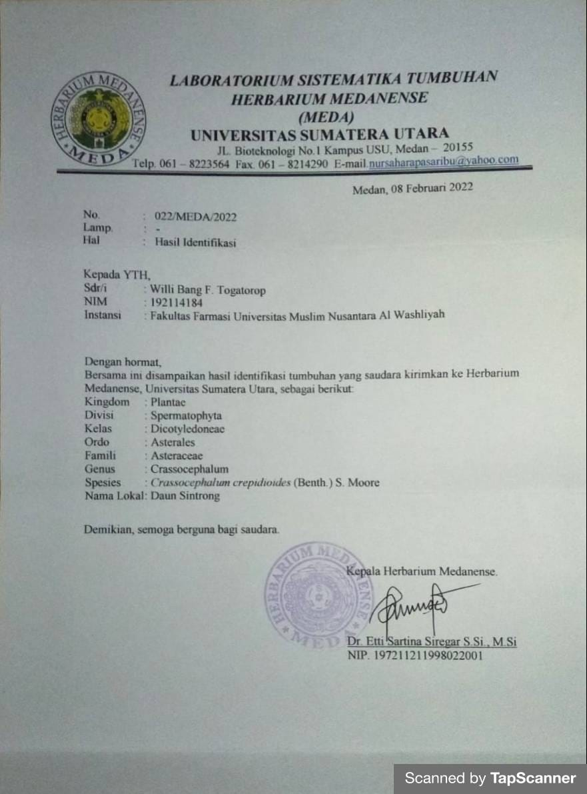

**Lampiran 2.** Tabel Konversi Dosis

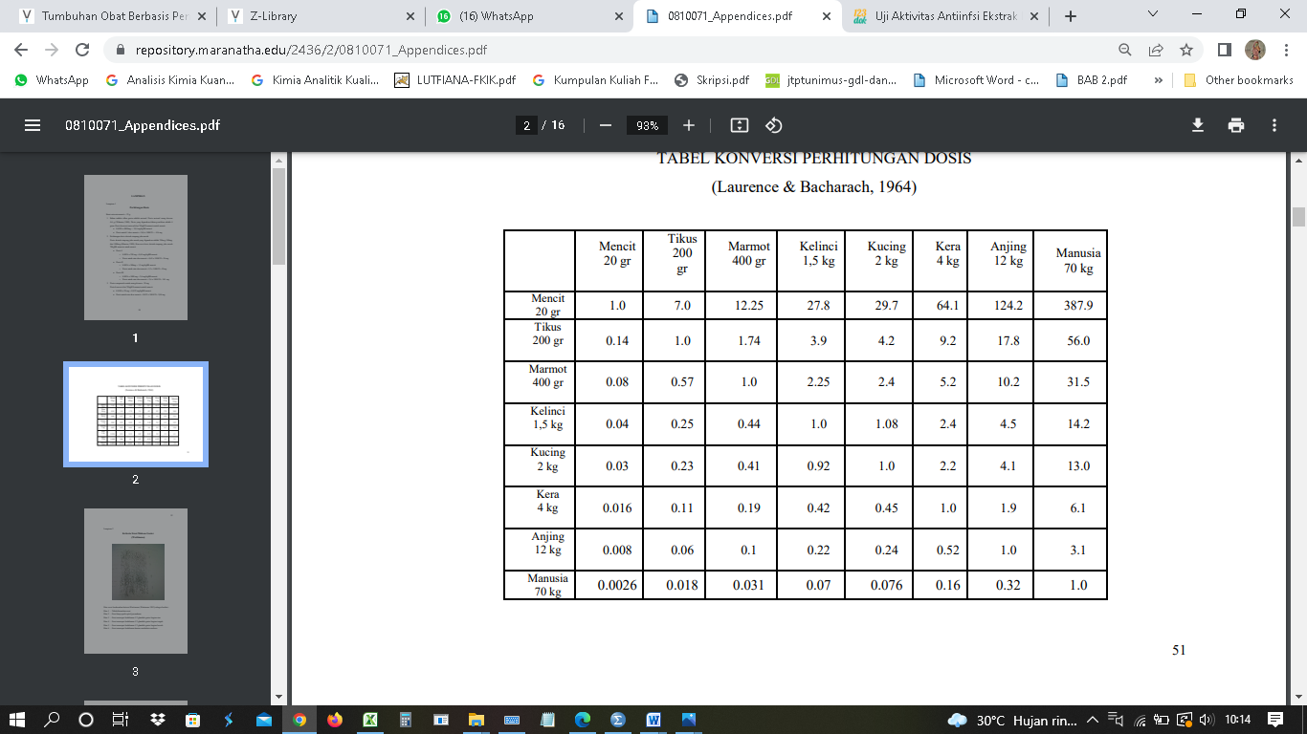

**Keterangan**: Dari atas kebawah

**Lampiran 3.** Makroskopik Daun Sintrong

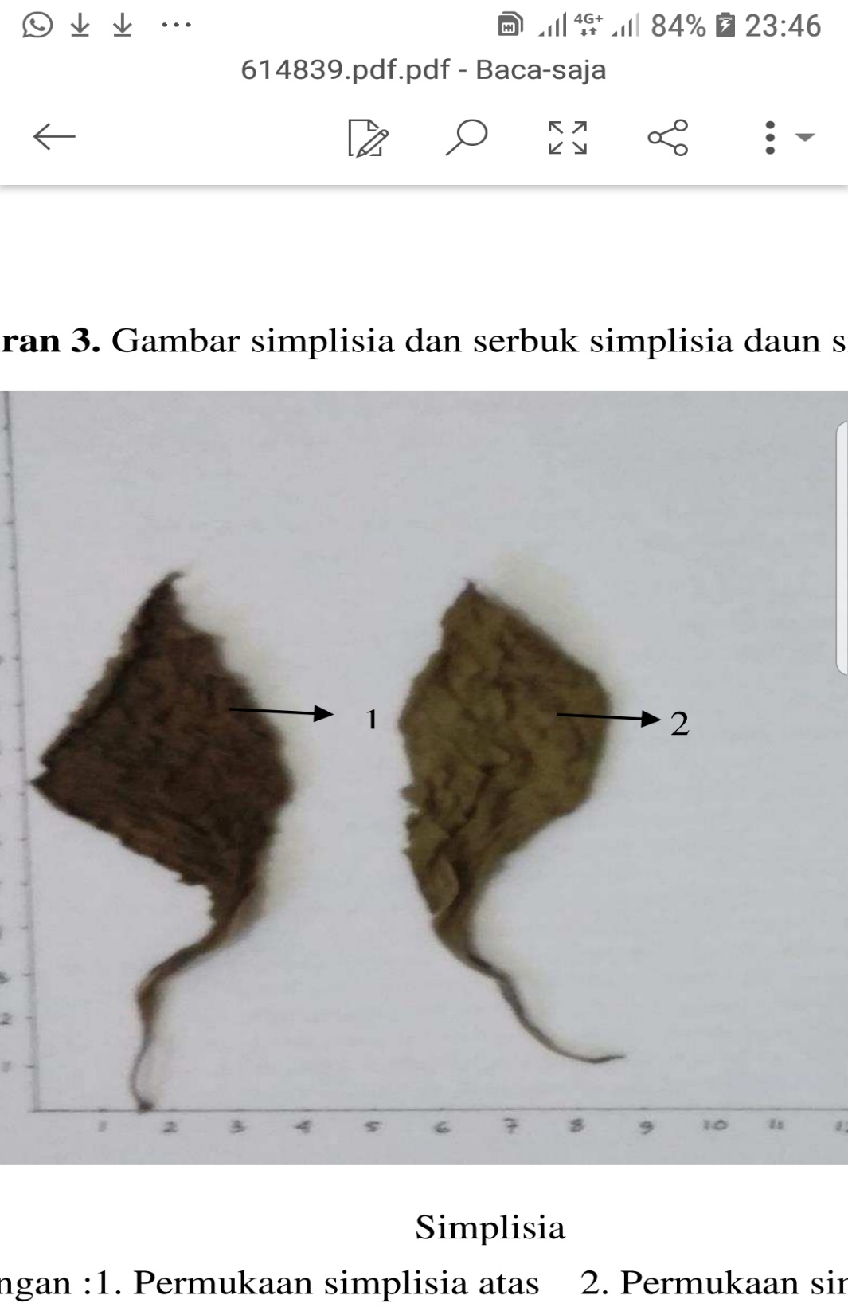

Simplisia Daun Sintrong

Keterangan : 1. Permukaan Simplisia Atas

2. Permukaan Simplisia Bawah

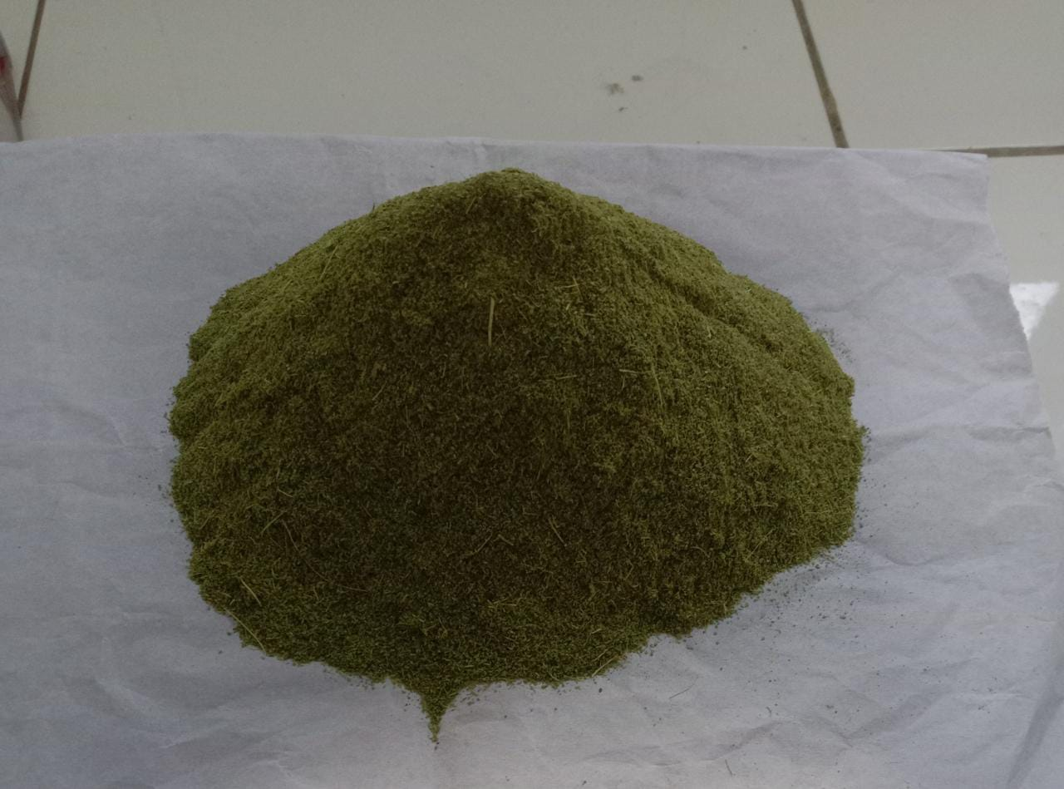

Serbuk Simplisia Daun Sintrong

**Lampiran 4.** Hasil Pemeriksaan Makroskopik Daun Sintrong

|  |  |
| --- | --- |
| Penampang Melintang | 1  2  3 |
| Penampang Membujur | 4 |

Keterangan :

1. Epidermis atas
2. Jaringan palisade
3. Epidermis bawah
4. Stomata (tipe parasitic)

Lampiran 5. Bagan Pembuatan Simplisia, Karakterisasi Dan Skrining Fitokimia Daun Sintrong

Daun Sintrong

Simplisia

Serbuk simplisia

Karakterisasi Simplisia

Skrining fitokimia

Ekstraksi

1. Kadar Air
2. Kadar Abu Total
3. Kadar Abu Tidak Larut Asam
4. Kadar Sari Larut Air
5. Kadar Sari Larut Etanol
6. Alkaloid
7. Flavonoid
8. Tannin
9. Saponin
10. Steroid/triterpenoid

Ekstrak kental etanol 96%

Dicuci, ditiriskan, dan ditimbang berat basah. Lalu dikeringkan dalam lemari pengering

ditimbang berat kering. Lalu dihaluskan

Lampiran 6. Bagan Pembuatan Ekstrak Etanol Daun Sintrong

500 g serbuk simplisia Daun Sintrong

Dimaserasi dengan 3750 ml etanol 96% dalam bejana tertutup

Dibiarkan selama 5 hari terlindung dari cahaya sambil sering diaduk, disaring

Ampas

Maserat I

direndam dengan 1250 ml etanol 96% dibiarkan selama 2 hari

disaring

Maserat II

digabung dituang dan disaring

diuapkan denga rotary evaporator

dipekatkan diatas waterbath

ekstrak kental

Lampiran 7. Bagan Kerja Antiinflamasi

25 ekor tikus

EEDS 50, 100, 200 mg/kg BB

CMC 0,5%

Na. Diklofenak 4,5 mg/kg BB

Hasil

Pada hari pengujian masing-masing hewan ditimbang dan diberi tanda pada ekor dan kakinya

Sebagai volume awal (Vo) yaitu volume kaki sebelum diberi induksi dengan larutan karagenan, kaki yang telah diberi tanda dimasukkan kedalam alat plestimometer lalu pedal ditahan dan dicatat angka pada monitor.

Masing-masing tikus diberi suspense bahan uji secara oral sesuai dengan kelompoknya

Setelah 1 jam, masing-masing telapak kaki tikus disuntik secara intraplantar dengan 0,1 ml larutan karagenan 1%. Setelah 1 jam dilakukan pengukuran dengan alat pletismometer.

Dicatat angka pada monitor plestimometer. Perubahan volume cairan yang terjadi dicatat sebagai volume telapak kaki pada waktu tertentu (Vt)

Lampiran 8. Perhitungan Karakterisasi Simplisia Daun Sintrong

1. Penetapan kadar air

%kadar air = $\frac{V. Akhir-V. Awal}{berat sampel} x 100\%$

|  |  |  |  |
| --- | --- | --- | --- |
| No. | Berat Sampel | Volume awal | Volume akhir |
|  | 5 g | 1,6 ml | 1,8 ml |
|  | 5 g | 1,7 ml | 1,9 ml |
|  | 5 g | 1,7 ml | 1,9 ml |

%kadar air sampel 1 = $\frac{1,8 ml-1,6 ml}{5 g} x 100\%$ = 4 $\%$

%kadar air sampel II = $\frac{1,9 ml-1,7 ml}{5 g} x 100\%$ = 4 $\%$

%kadar air Sampel III = $\frac{1,9 ml-1,8 ml}{5 g} x 100\%$ = 4 $\%$

%rata-rata kadar air = $\frac{4 \%+4 \%+4 \% }{3 }$ = 4 $\%$

1. Penetapan kadar sari larut air

%kadar sari larut air = $\frac{\left((berat cawan+isi\right)-berat cawan)x 5}{berat sampel} x 100\%$

|  |  |  |  |
| --- | --- | --- | --- |
| No. | Berat Sampel | Berat cawan kosong | Berat cawan + isi |
| I. | 5,0278 g | 34,8253 g | 35,1600 g |
| II. | 5,0102 g | 36,5765 g | 36,8987 g |
| III. | 5,0156 g | 36,6021 g | 36,9113 g |

%kadar sari larut air (I) = $\frac{(35,1600 g-34,8253g)x 5}{5,0278 g} x 100\%$ = 33,2 %

%kadar sari larut air (II) = $\frac{( 36,8987g- 36,5765 g)x 5}{5,0102 g} x 100\%$ = 32,1 %

%kadar sari larut air (III) = $\frac{( 36,9113 g- 36,6021g)x 5}{5,0156 g} x 100\%$ = 30,8 %

%rata-rata = $\frac{33,2+32,1+30,8 }{3 }$ = 32,033 %

1. Penetapan kadar sari larut etanol

%kadar sari larut etanol = $\frac{\left((berat cawan+isi\right)-berat cawan)x 5}{berat sampel} x 100\%$

|  |  |  |  |
| --- | --- | --- | --- |
| No. | Berat Sampel | Berat cawan kosong | Berat cawan + isi |
| I. | 5,0052 g | 37,2481g | 37,5618 g |
| II. | 5,0287 g | 35,4983 g | 35,8210 g |
| III. | 5,0207 g | 36,2123 g | 36,5288 g |

%kadar sari larut etanol I = $\frac{(37,5618 g-37,2481 g)x 5}{5,0052 g} x 100\%$ = 31,3 %

%kadar sari larut etanol II = $\frac{(35,8210 g-35,4983 g)x 5}{5,0287 g} x 100\%$ = 32,04 %

%kadar sari larut etanol III = $\frac{(36,5288 g-36,2123 g)x 5}{5,0287g} x 100\%$ = 31,5 %

%rata-rata = $\frac{31,3+32,04+31,5 \% }{3 }$ = 31,6133 %

1. Penetapan kadar abu total

%kadar abu = $\frac{\left((berat cawan+isi\right)-berat cawan)}{berat sampel} x 100\%$

|  |  |  |  |
| --- | --- | --- | --- |
| No. | Berat Sampel | Berat cawan kosong | Berat cawan + isi |
| I | 2 g | 43,78 g | 44,11 g |
| II | 2 g | 36,51g | 36,76 g |
| III | 2 g | 35,63 g | 35,95g |

%kadar abu I = $\frac{(44,11 g-43,78 g)}{2 g} x 100\%$ = 16,5 %

%kadar abu II = $\frac{(36,76 g-36,51 g)}{2 g} x 100\%$ = 12,5 %

%kadar abu III = $\frac{(35,93 g-35,63 g)}{2 g} x 100\%$ = 16 %

%rata-rata = $\frac{16,5 \%+12,5 \%+ 16 \% }{3 }$ = 16 %

1. Penetapan kadar abu tidak larut asam

%kadar abu = $\frac{\left((berat cawan+isi\right)-berat cawan)}{berat sampel} x 100\%$

|  |  |  |  |
| --- | --- | --- | --- |
| No. | Berat Sampel | Berat cawan kosong | Berat cawan + isi |
| I | 2 g | 61,777 g | 61,782 g |
| II | 2 g | 64,414 g | 64,423 g |
| III | 2 g | 73,874 g | 73,876 g |

%kadar abu tidak larut asam I = $\frac{(61,782 g-61,777 g)}{2 g} x 100\%$ = 0,25 %

%kadar abu tidak larut asam II = $\frac{(64,423 g-64,414 g)}{2 g} x 100\%$ = 0,45 %

%kadar abu tidak larut asam III = $\frac{(73,876 g-73,874 g)}{2 g} x 100\%$ = 0,1 %

%rata-rata = $\frac{0,25 \%+0,45 \%+ 0,1 \% }{3 }$ = 0,26 %

Lampiran 9. Penapisan Fitokimia Ekstrak Dan Serbuk Daun Sintrong

| **No.** | **Golongan Senyawa** | **Hasil** | **Keterangan** |
| --- | --- | --- | --- |
|  | Alkaloid | C:\Users\Lydia\AppData\Local\Microsoft\Windows\INetCache\Content.Word\IMG-20221025-WA0036.jpg | (+)  Adanya endapan |
|  | Flavonoid | C:\Users\SascomJy3\Downloads\WhatsApp Image 2022-03-22 at 21.09.39.jpeg | (+)  Terbentuk warna jingga di amyl alcohol |
|  | Tannin | C:\Users\SascomJy3\Downloads\WhatsApp Image 2022-03-22 at 21.09.38.jpeg | (+)  Terbentuk warna biru kehitaman |
|  | Saponin | C:\Users\SascomJy3\Downloads\WhatsApp Image 2022-03-22 at 21.09.38 (2).jpeg  C:\Users\SascomJy3\Downloads\WhatsApp Image 2022-03-22 at 21.09.38 (1).jpeg | (+)  Terbentuk busa lebih dari 1 cm |
|  | Steroid/triterpenoid | C:\Users\Lydia\AppData\Local\Microsoft\Windows\INetCache\Content.Word\IMG-20221025-WA0042.jpg | (+)  Terbentuk warna biru hijau |

Lampiran 10. Perhitungan Dosis

1. Perhitungan bahan suspense Na. diklofenak 0,1%

Suspense Na. diklofenak 0,1% = jumlah Na. diklofenak / volume suspense

= 0,1 g / 100 ml

= 100 mg / 100 ml

= 1 mg/ml

Konversi dosis Na. diklofenak dari manusia (70 kg) ke tikus (200 g) = 0,018

Dosis Na. diklofenak untuk manusia dewasa BB (70 kg) = 50 mg

maka dosis pada tikus Na. diklofenak = dosis terapi manusia x 0,018

= 50 mg x 0,018

= 0,9 mg

Bb tikus misal 200 g (0,2 kg) = Dosis / BB tikus

= 0,9 mg / 0,2 kg

= 4,5 mg/kg BB

**Hewan 1** BB 120 g

Dosis untuk hewan 1 = 4,5 mg/1000g x 120 g

= 0,54 mg

Volume suspense yang diambil = Dosis / konsentrasi

= 0,54 mg / 1 mg/ml

= 0,54 ml

**Hewan 2** BB 124 g

Dosis untuk hewan 2 = 4,5 mg/1000g x 124 g

= 0,558 mg

Volume suspense yang diambil = Dosis / konsentrasi

= 0,558 mg / 1 mg/ml

= 0,558 ml

**Hewan 3** BB 134 g

Dosis untuk hewan 3 = 4,5 mg/1000g x 134 g

= 0,603 mg

Volume suspense yang diambil = Dosis / konsentrasi

= 0,603 mg / 1 mg/ml

= 0,603 ml

**Hewan 4** BB 135 g

Dosis untuk hewan 4 = 4,5 mg/1000g x 135 g

= 0,6075 mg

Volume suspense yang diambil = Dosis / konsentrasi

= 0,6075 mg / 1 mg/ml

= 0,6075 ml

**Hewan 5** BB 132 g

Dosis untuk hewan 1 = 4,5 mg/1000g x 132 g

= 0,594 mg

Volume suspense yang diambil = Dosis / konsentrasi

= 0,594 mg / 1 mg/ml

= 0,594 ml

1. Perhitungan dosis CMC 0,5%

CMC 0,5% = $\frac{jumlah CMC}{Volume}$

= $\frac{0,5 g}{100 ml}$

= $\frac{500 mg}{100 ml}$

= 5 mg/ml

**Hewan 1** BB 157 g

Volume suspense yang diambil = 0,5g/100ml x 157 g

= 0,785 ml

**Hewan 2** BB 127 g

Volume suspense yang diambil = 0,5g/100ml x 127 g

= 0,635 ml

**Hewan 3** BB 126 g

Volume suspense yang diambil = 0,5g/100ml x 126 g

= 0,63 ml

**Hewan 4** BB 120 g

Volume suspense yang diambil = 0,5g/100ml x 120 g

= 0,6 ml

**Hewan 5** BB 138 g

Volume suspense yang diambil = 0,5g/100ml x 160 g

= 0,69 ml

1. Ekstrak etanol daun sintrong (EEDS) 50 mg/kg BB

Konsentrasi suspense EEDS

Konsentrasi EEDS 0,5% = Jumlah EEDS / Volume suspense

= 0,5 g / 100 ml

= 500 mg/ 100 ml

= 5 mg/ml

**Hewan 1** BB 117 g

Dosis EEDS 50 mg/kg = 50 mg/1000 g x 117 g

= 5,85 mg

Volume suspense yang diambil = 5,85 mg / 5 mg/ml

= 1,1`7 ml

**Hewan 2** BB 132 g

Dosis EEDS 50 mg/kg = 50 mg/1000 g x 132 g

= 6,6 mg

Volume suspense yang diambil = 6,6 mg / 5 mg/ml

= 1,32 ml

**Hewan 3** BB 118 g

Dosis EEDS 50 mg/kg = 50 mg/1000 g x 118 g

= 5,9 mg

Volume suspense yang diambil = 5,9 mg / 5 mg/ml

= 1,18 ml

**Hewan 4** BB 132 g

Dosis EEDS 50 mg/kg = 50 mg/1000 g x 132 g

= 6,6 mg

Volume suspense yang diambil = 6,6 mg / 5 mg/ml

= 1,32 ml

**Hewan 5** BB 121 g

Dosis EEDS 50 mg/kg = 50 mg/1000 g x 121 g

= 6,05 mg

Volume suspense yang diambil = 6,05 mg / 5 mg/ml

= 1,21 ml

1. Perhitungan EEDS 100 mg/kg BB

Konsentrasi suspensi EEDS

Konsentrasi EEDS 1% = jumlah EEDS / volume

= 1g / 100ml

= 1000mg / 100ml

= 10 mg/ml

**Hewan 1** BB 159 g

Dosis EEDS 134 mg/kg = 100 mg/1000 g x 134 g

= 13,4 mg

Volume suspense yang diambil = 13,4 mg / 10 mg/ml

= 1,34 ml

**Hewan 2** BB 135 g

Dosis EEDS 100 mg/kg = 100 mg/1000 g x 135 g

= 13,5 mg

Volume suspense yang diambil = 13,5 mg / 10 mg/ml

= 1,35 ml

**Hewan 3** BB 125 g

Dosis EEDS 100 mg/kg = 100 mg/1000 g x 125 g

= 12,5 mg

Volume suspense yang diambil = 12,5 mg / 10 mg/ml

= 1,25 ml

**Hewan 4** BB 127 g

Dosis EEDS 100 mg/kg = 100 mg/1000 g x 127 g

= 12,7 mg

Volume suspense yang diambil = 12,7 mg / 10 mg/ml

= 1,27 ml

**Hewan 5** BB 131 g

Dosis EEDS 100 mg/kg = 100 mg/1000 g x 131 g

= 13,1 mg

Volume suspense yang diambil = 18,5 mg / 10 mg/ml

= 1,31 ml

1. Perhitungan EEDS 200 mg/kg BB

Konsentrasi EEDS 2% = jumlah EEDS / volume

= 2g / 100ml

= 2000mg / 100ml

= 20 mg/ml

**Hewan 1** BB 129 g

Dosis EEDS 200 mg/kg = 200 mg/1000 g x 129 g

= 25,8 mg

Volume suspense yang diambil = 25,8 mg / 20 mg/ml

= 1,29 ml

**Hewan 2** BB 140 g

Dosis EEDS 200 mg/kg = 200 mg/1000 g x 140 g

= 28 mg

Volume suspense yang diambil = 28 mg / 20 mg/ml

= 1,4 ml

**Hewan 3** BB 110 g

Dosis EEDS 200 mg/kg = 200 mg/1000 g x 110 g

= 22 mg

Volume suspense yang diambil = 22 mg / 20 mg/ml

= 1,1 ml

**Hewan 4** BB 132 g

Dosis EEDS 200 mg/kg = 200 mg/1000 g x 132 g

= 26,4 mg

Volume suspense yang diambil = 26,4 mg / 20 mg/ml

= 1,32 ml

**Hewan 5** BB 135 g

Dosis EEDS 200 mg/kg = 200 mg/1000 g x 135 g

= 27 mg

Volume suspense yang diambil = 27 mg / 20 mg/ml

= 1,35 ml

Lampiran 11. Perlakuan Hewan Uji Saat Penelitian

| **No.** | **Gambar** | **Keterangan** |
| --- | --- | --- |
|  | C:\Users\HP\Downloads\WhatsApp Image 2022-04-16 at 23.50.07.jpeg | Kaki hewan sebelum di beri induksi karagenan 1% |
|  | C:\Users\HP\Downloads\WhatsApp Image 2022-04-16 at 23.50.08.jpeg | Kaki hewan setelah diinduksi karagenan terjadi udem |
|  | C:\Users\Lydia\AppData\Local\Microsoft\Windows\INetCache\Content.Word\IMG-20221025-WA0043.jpg | Pengukuran volume udem |
|  | C:\Users\HP\Downloads\WhatsApp Image 2022-04-04 at 12.05.47.jpeg | Pemberian secara oral |

Lampiran 12. Perhitungan Persen Radang Dan Inhibisi Radang

1. Persen radang

% Radang = $\frac{Vt-Vo}{Vo}$ x 100%

Dimana :

Vt = volume radang setelah waktu t

Vo = volume awal kaki tikus

Misal : ekstrak etanol daun sintrong dosis 50 mg/kg BB pada jam ke 1

Diketahui :

Vt = $0,52$

Vo = 0,50

Persen radang = $\frac{0,55- 0,50}{0,50}$ x 100%

= 10%

1. Persen inhibisi radang

Persen inhibisi radang (%IR) = $\frac{a-b}{a}$ x 100%

Dimana :

a = % rata-rata radang kelompok control

b = % rata-rata kelompok perlakuan yang mendapat bahan uji atau obat pembanding

Misalnya : ekstrak etanol daun sintrong 50 mg/kg BB pada jam ke 1

Diketahui a = 82%, b = 10%

Persen inhibisi radang = $\frac{82 - 10}{82}$ x 100%

= 87,80 %

**Lampiran 13.** Hasil Analisis Data Persentase Radang Dengan SPSS

|  |  |  |  |  |  |  |  |
| --- | --- | --- | --- | --- | --- | --- | --- |
| **Multiple Comparisons** | | | | | | | |
| Tukey HSD | | | | | | | |
| Dependent Variable | (I) Kelompok | (J) Kelompok | Mean Difference (I-J) | Std. Error | Sig. | 95% Confidence Interval | |
| Lower Bound | Upper Bound |
| Jam Ke 1 | Kontrol Negatif | Na.Diclofenak | .04460* | .00170 | <,001 | .0395 | .0497 |
| EEDS 50 mg/kg BB | .01560* | .00170 | <,001 | .0105 | .0207 |
| EEDS 100 mg/kg BB | .02960* | .00170 | <,001 | .0245 | .0347 |
| EEDS 200 mg/kg BB | .03980* | .00170 | <,001 | .0347 | .0449 |
| Na.Diclofenak | Kontrol Negatif | -.04460* | .00170 | <,001 | -.0497 | -.0395 |
| EEDS 50 mg/kg BB | -.02900* | .00170 | <,001 | -.0341 | -.0239 |
| EEDS 100 mg/kg BB | -.01500* | .00170 | <,001 | -.0201 | -.0099 |
| EEDS 200 mg/kg BB | -.00480 | .00170 | .070 | -.0099 | .0003 |
| EEDS 50 mg/kg BB | Kontrol Negatif | -.01560* | .00170 | <,001 | -.0207 | -.0105 |
| Na.Diclofenak | .02900* | .00170 | <,001 | .0239 | .0341 |
| EEDS 100 mg/kg BB | .01400* | .00170 | <,001 | .0089 | .0191 |
| EEDS 200 mg/kg BB | .02420* | .00170 | <,001 | .0191 | .0293 |
| EEDS 100 mg/kg BB | Kontrol Negatif | -.02960* | .00170 | <,001 | -.0347 | -.0245 |
| Na.Diclofenak | .01500* | .00170 | <,001 | .0099 | .0201 |
| EEDS 50 mg/kg BB | -.01400* | .00170 | <,001 | -.0191 | -.0089 |
| EEDS 200 mg/kg BB | .01020* | .00170 | <,001 | .0051 | .0153 |
| EEDS 200 mg/kg BB | Kontrol Negatif | -.03980* | .00170 | <,001 | -.0449 | -.0347 |
| Na.Diclofenak | .00480 | .00170 | .070 | -.0003 | .0099 |
| EEDS 50 mg/kg BB | -.02420* | .00170 | <,001 | -.0293 | -.0191 |
| EEDS 100 mg/kg BB | -.01020* | .00170 | <,001 | -.0153 | -.0051 |
| Jam Ke 2 | Kontrol Negatif | Na.Diclofenak | .04460* | .00170 | <,001 | .0395 | .0497 |
| EEDS 50 mg/kg BB | .01560* | .00170 | <,001 | .0105 | .0207 |
| EEDS 100 mg/kg BB | .02960* | .00170 | <,001 | .0245 | .0347 |
| EEDS 200 mg/kg BB | .03980* | .00170 | <,001 | .0347 | .0449 |
| Na.Diclofenak | Kontrol Negatif | -.04460* | .00170 | <,001 | -.0497 | -.0395 |
| EEDS 50 mg/kg BB | -.02900* | .00170 | <,001 | -.0341 | -.0239 |
| EEDS 100 mg/kg BB | -.01500* | .00170 | <,001 | -.0201 | -.0099 |
| EEDS 200 mg/kg BB | -.00480 | .00170 | .070 | -.0099 | .0003 |
| EEDS 50 mg/kg BB | Kontrol Negatif | -.01560* | .00170 | <,001 | -.0207 | -.0105 |
| Na.Diclofenak | .02900* | .00170 | <,001 | .0239 | .0341 |
| EEDS 100 mg/kg BB | .01400* | .00170 | <,001 | .0089 | .0191 |
| EEDS 200 mg/kg BB | .02420* | .00170 | <,001 | .0191 | .0293 |
| EEDS 100 mg/kg BB | Kontrol Negatif | -.02960* | .00170 | <,001 | -.0347 | -.0245 |
| Na.Diclofenak | .01500* | .00170 | <,001 | .0099 | .0201 |
| EEDS 50 mg/kg BB | -.01400* | .00170 | <,001 | -.0191 | -.0089 |
| EEDS 200 mg/kg BB | .01020* | .00170 | <,001 | .0051 | .0153 |
| EEDS 200 mg/kg BB | Kontrol Negatif | -.03980* | .00170 | <,001 | -.0449 | -.0347 |
| Na.Diclofenak | .00480 | .00170 | .070 | -.0003 | .0099 |
| EEDS 50 mg/kg BB | -.02420* | .00170 | <,001 | -.0293 | -.0191 |
| EEDS 100 mg/kg BB | -.01020* | .00170 | <,001 | -.0153 | -.0051 |
| Jam Ke 3 | Kontrol Negatif | Na.Diclofenak | .04460* | .00170 | <,001 | .0395 | .0497 |
| EEDS 50 mg/kg BB | .01560* | .00170 | <,001 | .0105 | .0207 |
| EEDS 100 mg/kg BB | .02960* | .00170 | <,001 | .0245 | .0347 |
| EEDS 200 mg/kg BB | .03980* | .00170 | <,001 | .0347 | .0449 |
| Na.Diclofenak | Kontrol Negatif | -.04460* | .00170 | <,001 | -.0497 | -.0395 |
| EEDS 50 mg/kg BB | -.02900* | .00170 | <,001 | -.0341 | -.0239 |
| EEDS 100 mg/kg BB | -.01500* | .00170 | <,001 | -.0201 | -.0099 |
| EEDS 200 mg/kg BB | -.00480 | .00170 | .070 | -.0099 | .0003 |
| EEDS 50 mg/kg BB | Kontrol Negatif | -.01560* | .00170 | <,001 | -.0207 | -.0105 |
| Na.Diclofenak | .02900* | .00170 | <,001 | .0239 | .0341 |
| EEDS 100 mg/kg BB | .01400* | .00170 | <,001 | .0089 | .0191 |
| EEDS 200 mg/kg BB | .02420* | .00170 | <,001 | .0191 | .0293 |
| EEDS 100 mg/kg BB | Kontrol Negatif | -.02960* | .00170 | <,001 | -.0347 | -.0245 |
| Na.Diclofenak | .01500* | .00170 | <,001 | .0099 | .0201 |
| EEDS 50 mg/kg BB | -.01400* | .00170 | <,001 | -.0191 | -.0089 |
| EEDS 200 mg/kg BB | .01020* | .00170 | <,001 | .0051 | .0153 |
| EEDS 200 mg/kg BB | Kontrol Negatif | -.03980* | .00170 | <,001 | -.0449 | -.0347 |
| Na.Diclofenak | .00480 | .00170 | .070 | -.0003 | .0099 |
| EEDS 50 mg/kg BB | -.02420* | .00170 | <,001 | -.0293 | -.0191 |
| EEDS 100 mg/kg BB | -.01020* | .00170 | <,001 | -.0153 | -.0051 |
| Jam Ke 4 | Kontrol Negatif | Na.Diclofenak | .04420* | .00176 | <,001 | .0389 | .0495 |
| EEDS 50 mg/kg BB | .01520* | .00176 | <,001 | .0099 | .0205 |
| EEDS 100 mg/kg BB | .02920* | .00176 | <,001 | .0239 | .0345 |
| EEDS 200 mg/kg BB | .03940* | .00176 | <,001 | .0341 | .0447 |
| Na.Diclofenak | Kontrol Negatif | -.04420* | .00176 | <,001 | -.0495 | -.0389 |
| EEDS 50 mg/kg BB | -.02900* | .00176 | <,001 | -.0343 | -.0237 |
| EEDS 100 mg/kg BB | -.01500* | .00176 | <,001 | -.0203 | -.0097 |
| EEDS 200 mg/kg BB | -.00480 | .00176 | .086 | -.0101 | .0005 |
| EEDS 50 mg/kg BB | Kontrol Negatif | -.01520* | .00176 | <,001 | -.0205 | -.0099 |
| Na.Diclofenak | .02900* | .00176 | <,001 | .0237 | .0343 |
| EEDS 100 mg/kg BB | .01400* | .00176 | <,001 | .0087 | .0193 |
| EEDS 200 mg/kg BB | .02420* | .00176 | <,001 | .0189 | .0295 |
| EEDS 100 mg/kg BB | Kontrol Negatif | -.02920* | .00176 | <,001 | -.0345 | -.0239 |
| Na.Diclofenak | .01500* | .00176 | <,001 | .0097 | .0203 |
| EEDS 50 mg/kg BB | -.01400* | .00176 | <,001 | -.0193 | -.0087 |
| EEDS 200 mg/kg BB | .01020* | .00176 | <,001 | .0049 | .0155 |
| EEDS 200 mg/kg BB | Kontrol Negatif | -.03940* | .00176 | <,001 | -.0447 | -.0341 |
| Na.Diclofenak | .00480 | .00176 | .086 | -.0005 | .0101 |
| EEDS 50 mg/kg BB | -.02420* | .00176 | <,001 | -.0295 | -.0189 |
| EEDS 100 mg/kg BB | -.01020* | .00176 | <,001 | -.0155 | -.0049 |
| Jam Ke 5 | Kontrol Negatif | Na.Diclofenak | .04420* | .00185 | <,001 | .0387 | .0497 |
| EEDS 50 mg/kg BB | .01520* | .00185 | <,001 | .0097 | .0207 |
| EEDS 100 mg/kg BB | .02920* | .00185 | <,001 | .0237 | .0347 |
| EEDS 200 mg/kg BB | .03960* | .00185 | <,001 | .0341 | .0451 |
| Na.Diclofenak | Kontrol Negatif | -.04420* | .00185 | <,001 | -.0497 | -.0387 |
| EEDS 50 mg/kg BB | -.02900* | .00185 | <,001 | -.0345 | -.0235 |
| EEDS 100 mg/kg BB | -.01500* | .00185 | <,001 | -.0205 | -.0095 |
| EEDS 200 mg/kg BB | -.00460 | .00185 | .133 | -.0101 | .0009 |
| EEDS 50 mg/kg BB | Kontrol Negatif | -.01520* | .00185 | <,001 | -.0207 | -.0097 |
| Na.Diclofenak | .02900* | .00185 | <,001 | .0235 | .0345 |
| EEDS 100 mg/kg BB | .01400* | .00185 | <,001 | .0085 | .0195 |
| EEDS 200 mg/kg BB | .02440* | .00185 | <,001 | .0189 | .0299 |
| EEDS 100 mg/kg BB | Kontrol Negatif | -.02920* | .00185 | <,001 | -.0347 | -.0237 |
| Na.Diclofenak | .01500* | .00185 | <,001 | .0095 | .0205 |
| EEDS 50 mg/kg BB | -.01400* | .00185 | <,001 | -.0195 | -.0085 |
| EEDS 200 mg/kg BB | .01040* | .00185 | <,001 | .0049 | .0159 |
| EEDS 200 mg/kg BB | Kontrol Negatif | -.03960* | .00185 | <,001 | -.0451 | -.0341 |
| Na.Diclofenak | .00460 | .00185 | .133 | -.0009 | .0101 |
| EEDS 50 mg/kg BB | -.02440* | .00185 | <,001 | -.0299 | -.0189 |
| EEDS 100 mg/kg BB | -.01040* | .00185 | <,001 | -.0159 | -.0049 |
| *. The mean difference is significant at the 0.05 level. | | | | | | | |

|  |  |  |  |  |  |
| --- | --- | --- | --- | --- | --- |
| **Jam Ke 1** | | | | | |
| Tukey HSDa | | | | | |
| Kelompok | N | Subset for alpha = 0.05 | | | |
| 1 | 2 | 3 | 4 |
| Na.Diclofenak | 5 | .0204 |  |  |  |
| EEDS 200 mg/kg BB | 5 | .0252 |  |  |  |
| EEDS 100 mg/kg BB | 5 |  | .0354 |  |  |
| EEDS 50 mg/kg BB | 5 |  |  | .0494 |  |
| Kontrol Negatif | 5 |  |  |  | .0650 |
| Sig. |  | .070 | 1.000 | 1.000 | 1.000 |
| Means for groups in homogeneous subsets are displayed. | | | | | |
| a. Uses Harmonic Mean Sample Size = 5,000. | | | | | |

|  |  |  |  |  |  |
| --- | --- | --- | --- | --- | --- |
| **Jam Ke 2** | | | | | |
| Tukey HSDa | | | | | |
| Kelompok | N | Subset for alpha = 0.05 | | | |
| 1 | 2 | 3 | 4 |
| Na.Diclofenak | 5 | .0244 |  |  |  |
| EEDS 200 mg/kg BB | 5 | .0292 |  |  |  |
| EEDS 100 mg/kg BB | 5 |  | .0394 |  |  |
| EEDS 50 mg/kg BB | 5 |  |  | .0534 |  |
| Kontrol Negatif | 5 |  |  |  | .0690 |
| Sig. |  | .070 | 1.000 | 1.000 | 1.000 |
| Means for groups in homogeneous subsets are displayed. | | | | | |
| a. Uses Harmonic Mean Sample Size = 5,000. | | | | | |

|  |  |
| --- | --- |
| Kelompok | N |
| 1 | 2 | 3 |
| Na.Diclofenak | 5 | .0284 |  |  |
| EEDS 200 mg/kg BB | 5 | .0332 |  |  |
| EEDS 100 mg/kg BB | 5 |  | .0434 |  |
| EEDS 50 mg/kg BB | 5 |  | .0474 |  |
| Kontrol Negatif | 5 |  |  | .0730 |
| Sig. |  | .070 | 1.000 | 1.000 |

|  |  |  |  |  |  |
| --- | --- | --- | --- | --- | --- |
| **Jam Ke 4** | | | | | |
| Tukey HSDa | | | | | |
| Kelompok | N | Subset for alpha = 0.05 | | | |
| 1 | 2 | 3 | 4 |
| Na.Diclofenak | 5 | .0324 |  |  |  |
| EEDS 200 mg/kg BB | 5 | .0372 |  |  |  |
| EEDS 100 mg/kg BB | 5 |  | .0474 |  |  |
| EEDS 50 mg/kg BB | 5 |  |  | .0614 |  |
| Kontrol Negatif | 5 |  |  |  | .0766 |
| Sig. |  | .086 | 1.000 | 1.000 | 1.000 |
| Means for groups in homogeneous subsets are displayed. | | | | | |
| a. Uses Harmonic Mean Sample Size = 5,000. | | | | | |

|  |  |  |  |  |  |
| --- | --- | --- | --- | --- | --- |
| **Jam Ke 5** | | | | | |
| Tukey HSDa | | | | | |
| Kelompok | N | Subset for alpha = 0.05 | | | |
| 1 | 2 | 3 |
| Na.Diclofenak | 5 | .0364 |  |  |
| EEDS 200 mg/kg BB | 5 | .0410 |  |  |
| EEDS 100 mg/kg BB | 5 |  | .0514 |  |
| EEDS 50 mg/kg BB | 5 |  | .0554 |  |
| Kontrol Negatif | 5 |  |  | .0806 |
| Sig. |  | .133 | 1.000 | 1.000 |
| Means for groups in homogeneous subsets are displayed. | | | | | |
| a. Uses Harmonic Mean Sample Size = 5,000. | | | | | |

**Lampiran 14.** Hasil Analisis Data Persentase Inhibisi Radang Dengan SPSS

|  |  |  |  |  |  |  |  |
| --- | --- | --- | --- | --- | --- | --- | --- |
| **Multiple Comparisons** | | | | | | | |
| Tukey HSD | | | | | | | |
| Dependent Variable | (I) Kelompok | (J) Kelompok | Mean Difference (I-J) | Std. Error | Sig. | 95% Confidence Interval | |
| Lower Bound | Upper Bound |
| Jam Ke 1 | Na.Diklofenak | EEDS 50 mg/kg BB | .27320* | .01676 | <,001 | .2252 | .3212 |
| EEDS 100 mg/kg BB | .14000* | .01676 | <,001 | .0920 | .1880 |
| EEDS 200 mg/kg BB | .03580 | .01676 | .184 | -.0122 | .0838 |
| EEDS 50 mg/kg BB | Na.Diklofenak | -.27320* | .01676 | <,001 | -.3212 | -.2252 |
| EEDS 100 mg/kg BB | -.13320* | .01676 | <,001 | -.1812 | -.0852 |
| EEDS 200 mg/kg BB | -.23740* | .01676 | <,001 | -.2854 | -.1894 |
| EEDS 100 mg/kg BB | Na.Diklofenak | -.14000* | .01676 | <,001 | -.1880 | -.0920 |
| EEDS 50 mg/kg BB | .13320* | .01676 | <,001 | .0852 | .1812 |
| EEDS 200 mg/kg BB | -.10420* | .01676 | <,001 | -.1522 | -.0562 |
| EEDS 200 mg/kg BB | Na.Diklofenak | -.03580 | .01676 | .184 | -.0838 | .0122 |
| EEDS 50 mg/kg BB | .23740* | .01676 | <,001 | .1894 | .2854 |
| EEDS 100 mg/kg BB | .10420* | .01676 | <,001 | .0562 | .1522 |
| Jam Ke 2 | Na.Diklofenak | EEDS 50 mg/kg BB | .27320* | .07501 | .011 | .0586 | .4878 |
| EEDS 100 mg/kg BB | .14000 | .07501 | .281 | -.0746 | .3546 |
| EEDS 200 mg/kg BB | .14000 | .07501 | .184 | -.0746 | .3546 |
| EEDS 50 mg/kg BB | Na.Diklofenak | -.27320* | .07501 | <,001 | -.4878 | -.0586 |
| EEDS 100 mg/kg BB | -.13320 | .07501 | <,001 | -.3478 | .0814 |
| EEDS 200 mg/kg BB | -.13320 | .07501 | <,001 | -.3478 | .0814 |
| EEDS 100 mg/kg BB | Na.Diklofenak | -.14000 | .07501 | <,001 | -.3546 | .0746 |
| EEDS 50 mg/kg BB | .13320 | .07501 | <,001 | -.0814 | .3478 |
| EEDS 200 mg/kg BB | .00000 | .07501 | <,001 | -.2146 | .2146 |
| EEDS 200 mg/kg BB | Na.Diklofenak | -.14000 | .07501 | .184 | -.3546 | .0746 |
| EEDS 50 mg/kg BB | .13320 | .07501 | <,001 | -.0814 | .3478 |
| EEDS 100 mg/kg BB | .00000 | .07501 | <,001 | -.2146 | .2146 |
| Jam Ke 3 | Na.Diklofenak | EEDS 50 mg/kg BB | .27320* | .01676 | <,001 | .2252 | .3212 |
| EEDS 100 mg/kg BB | .14000* | .01676 | <,001 | .0920 | .1880 |
| EEDS 200 mg/kg BB | .03580 | .01676 | .184 | -.0122 | .0838 |
| EEDS 50 mg/kg BB | Na.Diklofenak | -.27320* | .01676 | <,001 | -.3212 | -.2252 |
| EEDS 100 mg/kg BB | -.13320* | .01676 | <,001 | -.1812 | -.0852 |
| EEDS 200 mg/kg BB | -.23740* | .01676 | <,001 | -.2854 | -.1894 |
| EEDS 100 mg/kg BB | Na.Diklofenak | -.14000* | .01676 | <,001 | -.1880 | -.0920 |
| EEDS 50 mg/kg BB | .13320* | .01676 | <,001 | .0852 | .1812 |
| EEDS 200 mg/kg BB | -.10420* | .01676 | <,001 | -.1522 | -.0562 |
| EEDS 200 mg/kg BB | Na.Diklofenak | -.03580 | .01676 | .184 | -.0838 | .0122 |
| EEDS 50 mg/kg BB | .23740* | .01676 | <,001 | .1894 | .2854 |
| EEDS 100 mg/kg BB | .10420* | .01676 | <,001 | .0562 | .1522 |
| Jam Ke 4 | Na.Diklofenak | EEDS 50 mg/kg BB | .27320* | .01676 | <,001 | .2252 | .3212 |
| EEDS 100 mg/kg BB | .14000* | .01676 | <,001 | .0920 | .1880 |
| EEDS 200 mg/kg BB | .03580 | .01676 | .184 | -.0122 | .0838 |
| EEDS 50 mg/kg BB | Na.Diklofenak | -.27320* | .01676 | <,001 | -.3212 | -.2252 |
| EEDS 100 mg/kg BB | -.13320* | .01676 | <,001 | -.1812 | -.0852 |
| EEDS 200 mg/kg BB | -.23740* | .01676 | <,001 | -.2854 | -.1894 |
| EEDS 100 mg/kg BB | Na.Diklofenak | -.14000* | .01676 | <,001 | -.1880 | -.0920 |
| EEDS 50 mg/kg BB | .13320* | .01676 | <,001 | .0852 | .1812 |
| EEDS 200 mg/kg BB | -.10420* | .01676 | <,001 | -.1522 | -.0562 |
| EEDS 200 mg/kg BB | Na.Diklofenak | -.03580 | .01676 | .184 | -.0838 | .0122 |
| EEDS 50 mg/kg BB | .23740* | .01676 | <,001 | .1894 | .2854 |
| EEDS 100 mg/kg BB | .10420* | .01676 | <,001 | .0562 | .1522 |
| Jam Ke 5 | Na.Diklofenak | EEDS 50 mg/kg BB | .27320* | .01676 | <,001 | .2252 | .3212 |
| EEDS 100 mg/kg BB | .14000* | .01676 | <,001 | .0920 | .1880 |
| EEDS 200 mg/kg BB | .03580 | .01676 | .184 | -.0122 | .0838 |
| EEDS 50 mg/kg BB | Na.Diklofenak | -.27320* | .01676 | <,001 | -.3212 | -.2252 |
| EEDS 100 mg/kg BB | -.13320* | .01676 | <,001 | -.1812 | -.0852 |
| EEDS 200 mg/kg BB | -.23740* | .01676 | <,001 | -.2854 | -.1894 |
| EEDS 100 mg/kg BB | Na.Diklofenak | -.14000* | .01676 | <,001 | -.1880 | -.0920 |
| EEDS 50 mg/kg BB | .13320* | .01676 | <,001 | .0852 | .1812 |
| EEDS 200 mg/kg BB | -.10420* | .01676 | <,001 | -.1522 | -.0562 |
| EEDS 200 mg/kg BB | Na.Diklofenak | -.03580 | .01676 | .184 | -.0838 | .0122 |
| EEDS 50 mg/kg BB | .23740* | .01676 | <,001 | .1894 | .2854 |
| EEDS 100 mg/kg BB | .10420* | .01676 | <,001 | .0562 | .1522 |
| *. The mean difference is significant at the 0.05 level. | | | | | | | |

|  |  |  |  |  |
| --- | --- | --- | --- | --- |
| **Jam Ke 1** | | | | |
| Tukey HSDa | | | | |
| Kelompok | N | Subset for alpha = 0.05 | | |
| 1 | 2 | 3 |
| EEDS 50 mg/kg BB | 5 | .5704 |  |  |
| EEDS 100 mg/kg BB | 5 |  | .7036 |  |
| EEDS 200 mg/kg BB | 5 |  |  | .8078 |
| Na.Diklofenak | 5 |  |  | .8436 |
| Sig. |  | 1.000 | 1.000 | .184 |
| Means for groups in homogeneous subsets are displayed. | | | | |
| a. Uses Harmonic Mean Sample Size = 5.000. | | | | |

|  |  |  |  |
| --- | --- | --- | --- |
| **Jam Ke 2** | | | |
| Tukey HSDa | | | |
| Kelompok | N | Subset for alpha = 0.05 | |
| 1 | 2 |
| EEDS 50 mg/kg BB | 5 | .5904 |  |
| EEDS 100 mg/kg BB | 5 | .7236 | .7236 |
| EEDS 200 mg/kg BB | 5 | .7236 | .7236 |
| Na.Diklofenak | 5 |  | .8636 |
| Sig. |  | .320 | .281 |
| Means for groups in homogeneous subsets are displayed. | | | |
| a. Uses Harmonic Mean Sample Size = 5.000. | | | |

|  |  |  |  |  |
| --- | --- | --- | --- | --- |
| **Jam Ke 3** | | | | |
| Tukey HSDa | | | | |
| Kelompok | N | Subset for alpha = 0.05 | | |
| 1 | 2 | 3 |
| EEDS 50 mg/kg BB | 5 | .6104 |  |  |
| EEDS 100 mg/kg BB | 5 |  | .7436 |  |
| EEDS 200 mg/kg BB | 5 |  |  | .8478 |
| Na.Diklofenak | 5 |  |  | .8836 |
| Sig. |  | 1.000 | 1.000 | .184 |
| Means for groups in homogeneous subsets are displayed. | | | | |
| a. Uses Harmonic Mean Sample Size = 5.000. | | | | |

|  |  |  |  |  |
| --- | --- | --- | --- | --- |
| **Jam Ke 4** | | | | |
| Tukey HSDa | | | | |
| Kelompok | N | Subset for alpha = 0.05 | | |
| 1 | 2 | 3 |
| EEDS 50 mg/kg BB | 5 | .6304 |  |  |
| EEDS 100 mg/kg BB | 5 |  | .7636 |  |
| EEDS 200 mg/kg BB | 5 |  |  | .8678 |
| Na.Diklofenak | 5 |  |  | .9036 |
| Sig. |  | 1.000 | 1.000 | .184 |
| Means for groups in homogeneous subsets are displayed. | | | | |
| a. Uses Harmonic Mean Sample Size = 5.000. | | | | |

|  |  |  |  |  |
| --- | --- | --- | --- | --- |
| **Jam Ke 5** | | | | |
| Tukey HSDa | | | | |
| Kelompok | N | Subset for alpha = 0.05 | | |
| 1 | 2 | 3 |
| EEDS 50 mg/kg BB | 5 | .6504 |  |  |
| EEDS 100 mg/kg BB | 5 |  | .7836 |  |
| EEDS 200 mg/kg BB | 5 |  |  | .8878 |
| Na.Diklofenak | 5 |  |  | .9236 |
| Sig. |  | 1.000 | 1.000 | .184 |
| Means for groups in homogeneous subsets are displayed. | | | | |
| a. Uses Harmonic Mean Sample Size = 5.000. | | | | |