**Lampiran 1.** Sertifikat Rhodamin B

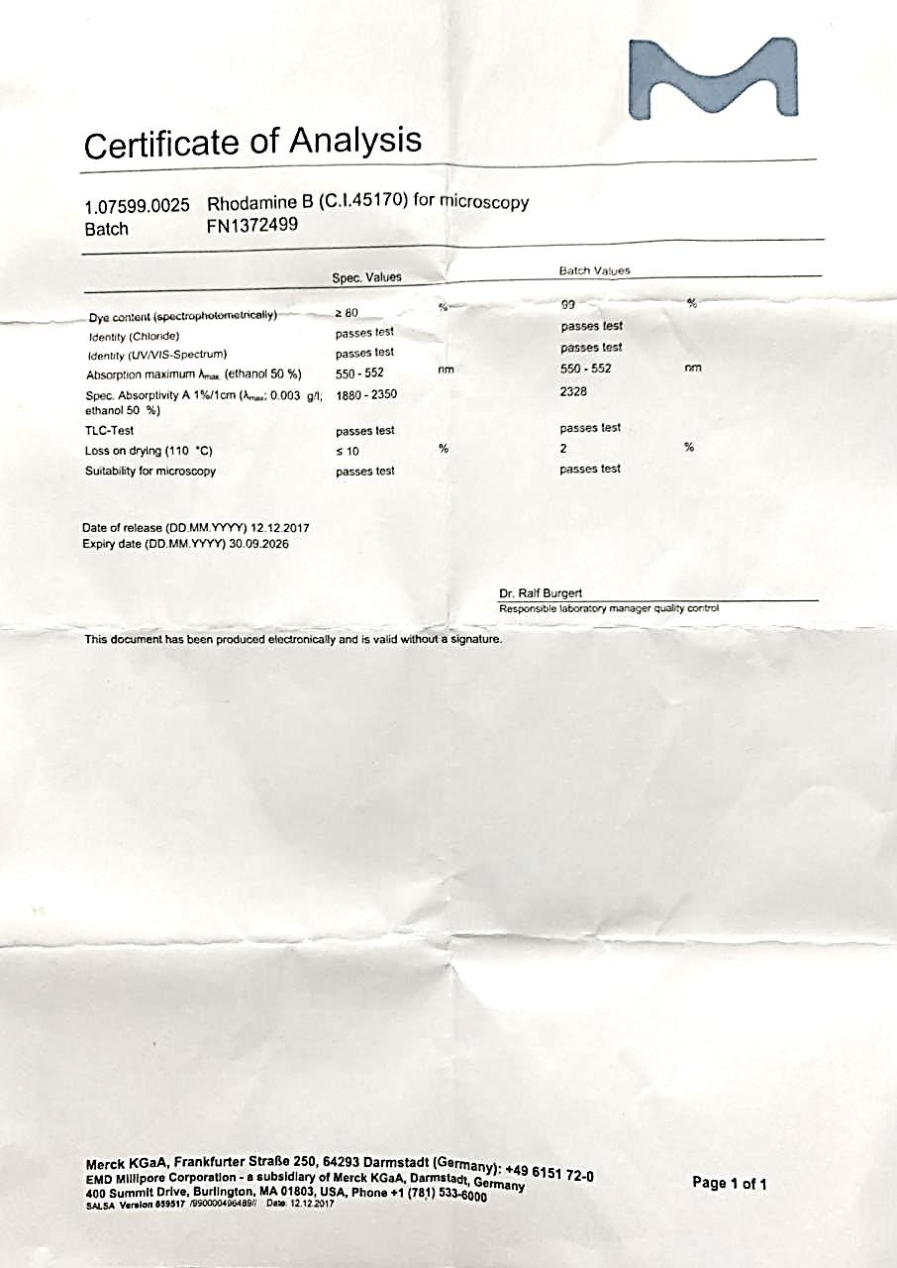

**Lampiran 2.** Bagan Alir Penelitian

Sampel Bedak tabur Perona Wajah

Nilai Rf

Analisis Kualitatif

Kromatografi Lapis Tipis

Kadar Rhodamin B pada Sampel

Analisis Kuantitatif

Kromatografi Cair Kinerja Tinggi

Kandungan Rhodamin B

**Lampiran 3.** Bagan Alir Analisis Uji Kualitatif dengan Kromatografi Lapis Tipis

Rhodamin B

* Ditimbang 500 mg masing- Masing sampel

Larutan Sampel

Sampel Bedak tabur dan Perona Wajah

Plat teraktivasi

Eluen Jenuh

Nilai Rf

Noda pada Plat KLT

* Dimasukkan kedalam labu Ukur 5 ml
* Ditambahkan Metanol Sampai tanda batas
* Ditimbang 50 mg Rhodamin B
* Dimasukkan kedalam labu Ukur 50 ml
* Ditambahkan Metanol Sampai tanda batas

Larutan Baku Pembanding

* + Disiapkan plat Silika Gel GF254 berukuran 20 x 20 cm
  + Ditandai batas atas 2 cm dan bawah 2 cm
  + Diaktivasi plat dengan cara di oven pada suhu 105ºC selama 30 menit
  + Disiapkan Etil Asetat : N-butanol : ammonia 25% (20:55:25)
  + Dimasukkan dalam bejana (Chamber)
  + Ditutup rapat
  + Dibiarkan hingga terelusi sempurna
  + Larutan ditotolkan menggunakan Pipa kapiler 1 mm pada plat
  + Dimasukkan dalam chamber, tutup rapat
  + Ditunggu hingga plat KLT terelusi

Diamati dan ditandai noda yang tampak

Nilai Rf Rhodamin B dan nilai Rf sampel sama, maka sampel positif mengandung rhodamin B

Hasil

**Lampiran 4.** Bagan Alir Analisis Uji Kuantitatif dengan Kromatografi Cair Kinerja Tinggi

1. Penentuan Waktu Retensi
   * Ditimbang 50 mg

LIB I

Rhodamin B

* + Dimasukkan kedalam labu ukur 50 ml
  + Ditambahkan Metanol sampai tanda batas, disaring
  + Dipipet 5 ml dari LIB I
  + Dimasukkan kedalam labu ukur 50 ml
  + Ditambahkan Metanol sampai tanda batas, disaring

LIB II

* + Dipipet sebanyak 0,6 ml dari LIB II
  + Dimasukkan kedalam labu ukur 10 ml

Larutan Uji

Waktu Retensi

Injeksikan kedalam Sistem KCKT

* + Ditambahkan Metanol sampai tanda batas, disaring
  + Kondisikan alat KCKT dengan diatur panjang gelombang: 554 nm,laju alir 1 mL/menit dan volume injeksi 20 µL
  + Ditunggu sampai terbentuk atau terbaca puncak dari sampel

1. Pembuatan Kurva Kalibrasi
   * Ditimbang 50 mg

Rhodamin B

* + Dimasukkan kedalam labu ukur 50 ml
  + Ditambahkan Metanol sampai tanda batas, disaring
  + Dipipet sebanyak 5 ml



- Dipipet 0,2 ml, 0,4 ml, 0,6 ml, 0,8 ml, 1 ml, 2 ml,

* Dimasukkan kedalam labu ukur 10 ml
* Ditambahkan Metanol sampai tanda batas, disaring

- Kondisikan alat KCKT dengan diatur panjang gelombang: 554 nm,laju alir 1 mL/menit dan volume injeksi 20 µL

12 ppm

10 ppm

8 ppm

6 ppm

4 ppm

2 ppm

C = 100 ppm (LIB II)

C = 1000 ppm (LIB I)

Luas Area

Injeksikan kedalam Sistem KCKT

Persamaan Regresi

* + Dimasukkan kedalam labu ukur 50 ml
  + Ditambahkan Metanol sampai tanda batas, disaring
  + Ditunggu sampai terbentuk atau terbaca puncak dari sampel
  + Diukur Luas Area
  + Dihitung nilai a,b dan r

1. Penetapan Kadar Sampel
   * Ditimbang 500 mg masing-masing sampel

Sampel Bedak Tabur dan Perona Wajah

Larutan Sampel

Luas Area

Injeksikan kedalam Sistem KCKT

* + Dimasukkan kedalam labu ukur 25 ml
  + Ditambahkan Metanol sampai tanda batas
  + Disaring, diambil filtratnya
  + Kondisikan alat KCKT dengan diatur fase gerak Asetonitril:Metanol:Air (47:47:6),

panjang gelombang: 554 nm,laju alir 1 mL/menit dan voleme injeksi 20 µL

* + Ditunggu sampai terbentuk atau terbaca puncak dari sampel
  + Dihitung hasil dengan mensubstitusikan luas area sampel pada persamaan regresi

Konsentrasi Rhodamin B

* + Dihitung hasil dengan rumus kadar

Kadar Rhodamin B dalam Sampel

**Lampiran 5.** Gambar Sampel Bedak Tabur dan Perona Wajjah



**Lampiran 6**. Alat – alat yang Digunakan

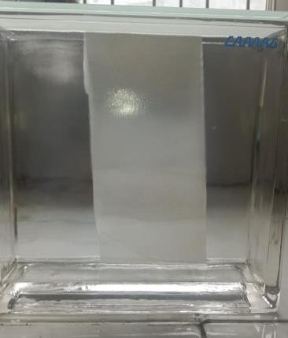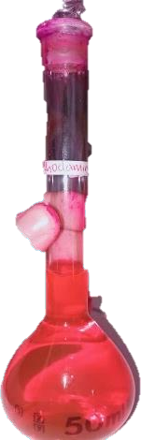

Chamber KLT Labu Ukur

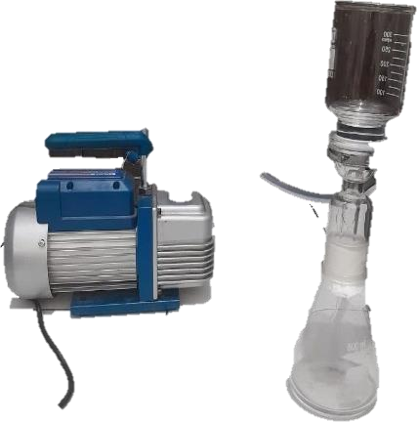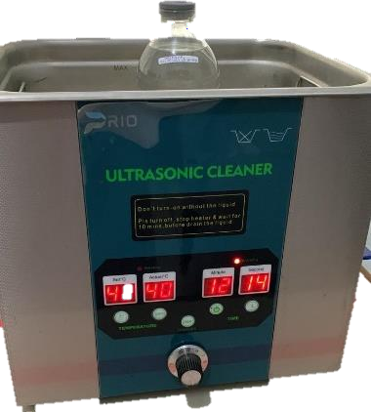

Alat Filtrasi dan Pompa Vacum Ultrasonic Cleaner

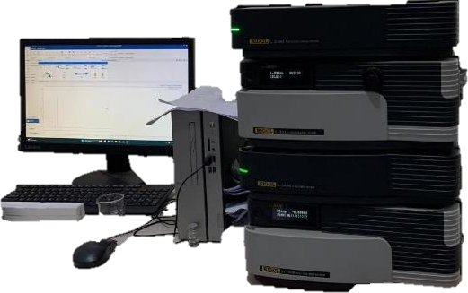

Alat KCKT

**Lampiran 7.** Gambar Analisis Uji Kualitatif dengan Kromatografi Lapis Tipis

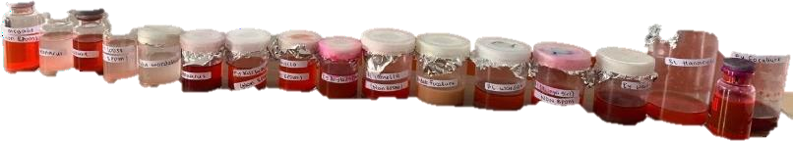

Sampel Bedak Tabur dan Perona Wajah

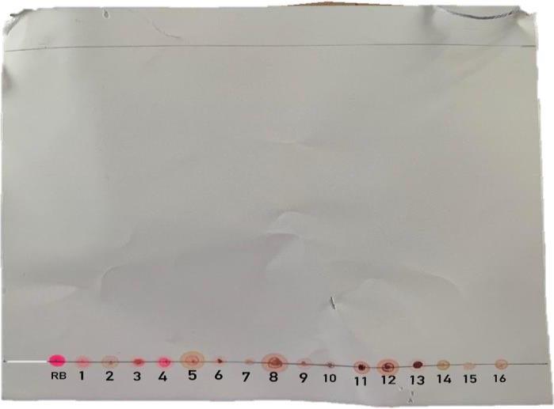

Plat KLT Uji Kualitatif Sampel

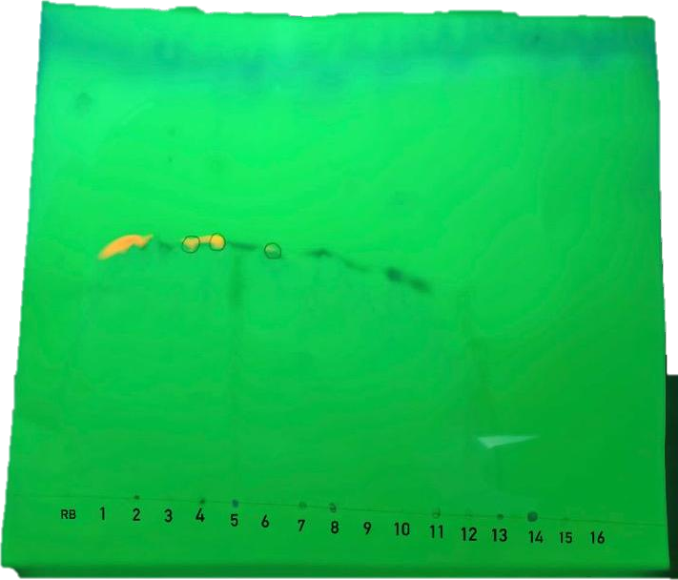

Hasil UV 254 nm Sampel

**Lampiran 8.** Gambar Sampel Perona Wajah

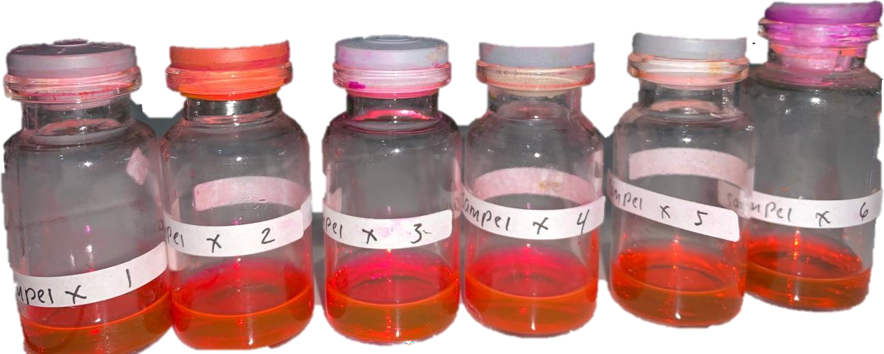

Sampel X

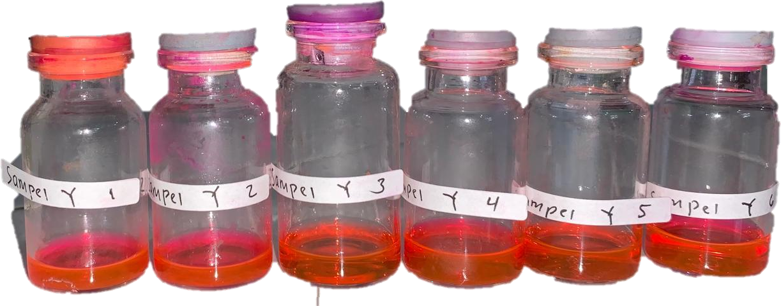

Sampel Y

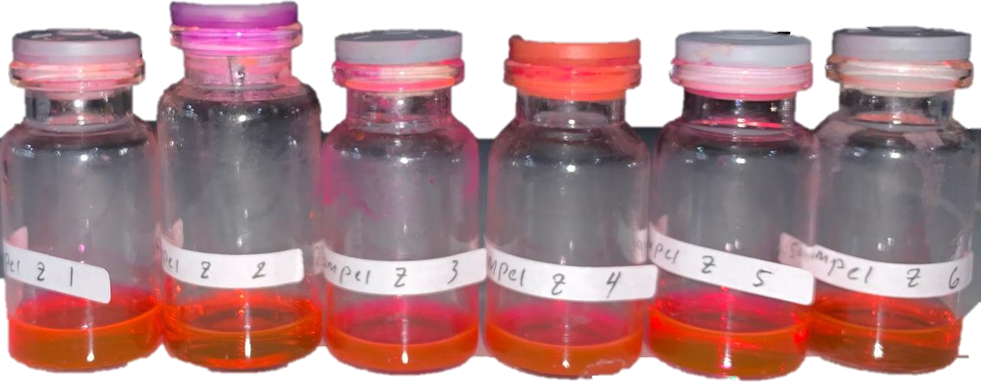

Sampel Z

**Lampiran 9.** Perhitungan Nilai Rf hasil analisis Kromatografi Lapis Tipis Rf = 𝐽𝑎𝑟𝑎𝑘 𝑦𝑎𝑛𝑔 𝑑𝑖 𝑡𝑒𝑚𝑝𝑢ℎ 𝑘𝑜𝑚𝑝𝑜𝑛𝑒𝑛

𝐽𝑎𝑟𝑎𝑘 𝑦𝑎𝑛𝑔 𝑑𝑖 𝑡𝑒𝑚𝑝𝑢ℎ 𝑝𝑒𝑙𝑎𝑟𝑢𝑡

Baku Rhodamin B → Rf = 7,8 = 0, 4875

16

1. Sampel X → Rf = 7,8 = 0, 4875

16

1. Sampel Y → Rf = 7,6 = 0, 475

16

1. Sampel Z → Rf = 7,7 = 0, 4812

16

**Lampiran 10.** Perhitungan Persamaan Regresi dan Koefisien Korelasi

|  |  |  |  |  |
| --- | --- | --- | --- | --- |
| X | Y | XY | X² | Y² |
| 2 | 453,83 | 907,66 | 4 | 205961,6689 |
| 4 | 1028,54 | 4114,16 | 16 | 1057894,532 |
| 6 | 1365,09 | 8190,54 | 36 | 1863470,708 |
| 8 | 1859,69 | 14877,52 | 64 | 3458446,896 |
| 10 | 2358,34 | 23583,4 | 100 | 5561767,556 |
| 12 | 2792,17 | 33506,04 | 144 | 7796213,309 |
| ∑X= 42 | ∑Y= 9857,66 | ∑XY= 85179,32 | ∑X²= 364 | ∑Y²= 19943754,67 |
| 𝑋̅= 7 | 𝑌̅= 1642,9432 |  |  |  |

a = (∑XY)−(∑X)(∑Y)/n (∑X2)−(∑𝑋)2/n

= (85179,32)−(42)(9857,66)/6

(364)−(42)2/6

= 85179,32−69003,62

364−294

= 16175,7

70

= 231,081

b = 𝑌̅ ̵ a𝑋̅

= 1642,9432 ̵ 231,081 (7)

= 25,3762

r = (∑XY)−(∑X)(∑Y)/n

√{(∑X2)−(∑𝑋)2/n}{(∑𝑌2)−(∑𝑌)2/n}

= (85179,32)−(42)(9857,66)/6

√{(364)−(42)2/6}{(19943754,67)−(9857,66)²/6}

= 85179,32−69003,62

√{364−294}{(19943754,67)−(16195576,78)}

= 16175,7

√(70)(3748177,89)

= 16175,7

16197,91506

= 0,9986

**Lampiran 11.** Perhitungan Kadar Rhodamin B dalam Sampel Diketahui : Y ax + b

Dimana : Y = Luas Area

a = Intersept

b = Slope

X = Konsentrasi Rhodamin B (mcg/ml)

* Sampel X1 (Y) = 1555, 317

Y = Ax + b

= 231,0814286 X + 25,3762

X = 1555,317 − 25,3762

231,081

= 6,62079 𝑚𝑐𝑔 𝑚𝑙

⁄

Kadar = 𝐾𝑜𝑛𝑠𝑒𝑛𝑡𝑟𝑎𝑠𝑖 𝑥 𝑉𝑜𝑙𝑢𝑚𝑒 𝑆𝑎𝑚𝑝𝑒𝑙 𝑥 𝐹𝑎𝑘𝑡𝑜𝑟 𝑃𝑒𝑛𝑔𝑒𝑛𝑐𝑒𝑟𝑎𝑛

𝐵𝑒𝑟𝑎𝑡 𝑆𝑎𝑚𝑝𝑒𝑙

6,62079 𝑚𝑐𝑔 𝑚𝑙 𝑥 5 𝑚𝑙 𝑥 1

⁄

=

0,5 𝑔

= 66,2079 𝑚𝑐𝑔 𝑔

⁄

* Sampel X2 ( Y) = 1567, 082

Y = Ax + b

= 231,081 X + 25,3762

X = 1567,082 − 25,3762

231,081

= 6,67171 𝑚𝑐𝑔 𝑚𝑙

⁄

Kadar = 𝐾𝑜𝑛𝑠𝑒𝑛𝑡𝑟𝑎𝑠𝑖 𝑥 𝑉𝑜𝑙𝑢𝑚𝑒 𝑆𝑎𝑚𝑝𝑒𝑙 𝑥 𝐹𝑎𝑘𝑡𝑜𝑟 𝑃𝑒𝑛𝑔𝑒𝑛𝑐𝑒𝑟𝑎𝑛

𝐵𝑒𝑟𝑎𝑡 𝑆𝑎𝑚𝑝𝑒𝑙

6,67171 𝑚𝑐𝑔 𝑚𝑙 𝑥 5 𝑚𝑙 𝑥 1

⁄

=

0,5 𝑔

= 66,7171 𝑚𝑐𝑔 𝑔

⁄

* Sampel X3 ( Y) = 1560,939

Y = Ax + b

= 231,081 X + 25,3762

X = 1560,939 − 25,3762

231,081

= 6,64512 𝑚𝑐𝑔 𝑚𝑙

⁄

Kadar = 𝐾𝑜𝑛𝑠𝑒𝑛𝑡𝑟𝑎𝑠𝑖 𝑥 𝑉𝑜𝑙𝑢𝑚𝑒 𝑆𝑎𝑚𝑝𝑒𝑙 𝑥 𝐹𝑎𝑘𝑡𝑜𝑟 𝑃𝑒𝑛𝑔𝑒𝑛𝑐𝑒𝑟𝑎𝑛

𝐵𝑒𝑟𝑎𝑡 𝑆𝑎𝑚𝑝𝑒𝑙

6,64512 𝑚𝑐𝑔 𝑚𝑙 𝑥 5 𝑚𝑙 𝑥 1

⁄

=

0,5 𝑔

= 66,4512 𝑚𝑐𝑔 𝑔

⁄

* Sampel X4 ( Y) = 1566,527

Y = Ax + b

= 231,081 X + 25,3762

X = 1566,527 − 25,3762

231,081

= 6,6693 𝑚𝑐𝑔 𝑚𝑙

⁄

Kadar = 𝐾𝑜𝑛𝑠𝑒𝑛𝑡𝑟𝑎𝑠𝑖 𝑥 𝑉𝑜𝑙𝑢𝑚𝑒 𝑆𝑎𝑚𝑝𝑒𝑙 𝑥 𝐹𝑎𝑘𝑡𝑜𝑟 𝑃𝑒𝑛𝑔𝑒𝑛𝑐𝑒𝑟𝑎𝑛

𝐵𝑒𝑟𝑎𝑡 𝑆𝑎𝑚𝑝𝑒𝑙

6,6693 𝑚𝑐𝑔 𝑚𝑙 𝑥 5 𝑚𝑙 𝑥 1

⁄

=

0,5 𝑔

= 66,693 𝑚𝑐𝑔 𝑔

⁄

* Sampel X5 ( Y)= 1563,199

Y = Ax + b

= 231,081 X + 25,3762

X = 1563,199 − 25,3762

231,081

= 6,6549 𝑚𝑐𝑔 𝑚𝑙

⁄

Kadar = 𝐾𝑜𝑛𝑠𝑒𝑛𝑡𝑟𝑎𝑠𝑖 𝑥 𝑉𝑜𝑙𝑢𝑚𝑒 𝑆𝑎𝑚𝑝𝑒𝑙 𝑥 𝐹𝑎𝑘𝑡𝑜𝑟 𝑃𝑒𝑛𝑔𝑒𝑛𝑐𝑒𝑟𝑎𝑛

𝐵𝑒𝑟𝑎𝑡 𝑆𝑎𝑚𝑝𝑒𝑙

6,6549 𝑚𝑐𝑔 𝑚𝑙 𝑥 5 𝑚𝑙 𝑥 1

⁄

=

0,5 𝑔

= 66,549 𝑚𝑐𝑔 𝑔

⁄

* Sampel X6 ( Y ) = 1565,232

Y = Ax + b

= 231,0814286 X + 25,3762

X = 1565,232 − 25,3762

231,081

= 6,6637 𝑚𝑐𝑔 𝑚𝑙

⁄

Kadar = 𝐾𝑜𝑛𝑠𝑒𝑛𝑡𝑟𝑎𝑠𝑖 𝑥 𝑉𝑜𝑙𝑢𝑚𝑒 𝑆𝑎𝑚𝑝𝑒𝑙 𝑥 𝐹𝑎𝑘𝑡𝑜𝑟 𝑃𝑒𝑛𝑔𝑒𝑛𝑐𝑒𝑟𝑎𝑛

𝐵𝑒𝑟𝑎𝑡 𝑆𝑎𝑚𝑝𝑒𝑙

6,6637 𝑚𝑐𝑔 𝑚𝑙 𝑥 5 𝑚𝑙 𝑥 1

⁄

=

0,5 𝑔

= 66,637 𝑚𝑐𝑔 𝑔

⁄

* Sampel Y1 ( Y) = 43,958 Y = Ax + b

= 231,081 X + 25,3762

X = 43,958 − 25,3762

231,081

= 0,08042 𝑚𝑐𝑔 𝑚𝑙

⁄

Kadar = 𝐾𝑜𝑛𝑠𝑒𝑛𝑡𝑟𝑎𝑠𝑖 𝑥 𝑉𝑜𝑙𝑢𝑚𝑒 𝑆𝑎𝑚𝑝𝑒𝑙 𝑥 𝐹𝑎𝑘𝑡𝑜𝑟 𝑃𝑒𝑛𝑔𝑒𝑛𝑐𝑒𝑟𝑎𝑛

𝐵𝑒𝑟𝑎𝑡 𝑆𝑎𝑚𝑝𝑒𝑙

0,08042

=

𝑚𝑐𝑔

⁄𝑚𝑙 𝑥 5 𝑚𝑙 𝑥 1

0,5 𝑔

= 0,8042 𝑚𝑐𝑔 𝑔

⁄

* Sampel Y2 ( Y ) = 45,102 Y = Ax + b

= 231,081 X + 25,3762

X = 45,102 − 25,3762

231,081

= 0,08537 𝑚𝑐𝑔 𝑚𝑙

⁄

Kadar = 𝐾𝑜𝑛𝑠𝑒𝑛𝑡𝑟𝑎𝑠𝑖 𝑥 𝑉𝑜𝑙𝑢𝑚𝑒 𝑆𝑎𝑚𝑝𝑒𝑙 𝑥 𝐹𝑎𝑘𝑡𝑜𝑟 𝑃𝑒𝑛𝑔𝑒𝑛𝑐𝑒𝑟𝑎𝑛

𝐵𝑒𝑟𝑎𝑡 𝑆𝑎𝑚𝑝𝑒𝑙

0,08537

=

𝑚𝑐𝑔

⁄𝑚𝑙 𝑥 5 𝑚𝑙 𝑥 1

0,5 𝑔

= 0,8537 𝑚𝑐𝑔 𝑔

⁄

* Sampel Y3 ( Y ) = 44,693 Y = Ax + b

= 231,081 X + 25,3762

X = 44,693 − 25,3762

231,081

= 0,0836 𝑚𝑐𝑔 𝑚𝑙

⁄

Kadar = 𝐾𝑜𝑛𝑠𝑒𝑛𝑡𝑟𝑎𝑠𝑖 𝑥 𝑉𝑜𝑙𝑢𝑚𝑒 𝑆𝑎𝑚𝑝𝑒𝑙 𝑥 𝐹𝑎𝑘𝑡𝑜𝑟 𝑃𝑒𝑛𝑔𝑒𝑛𝑐𝑒𝑟𝑎𝑛

𝐵𝑒𝑟𝑎𝑡 𝑆𝑎𝑚𝑝𝑒𝑙

0,0836

=

𝑚𝑐𝑔

⁄𝑚𝑙 𝑥 5 𝑚𝑙 𝑥 1

0,5 𝑔

= 0,836 𝑚𝑐𝑔 𝑔

⁄

* Sampel Y4 ( Y ) = 44,523 Y = Ax + b

= 231,081 X + 25,3762

X = 44,523 − 25,3762

231,081

= 0,08286 𝑚𝑐𝑔 𝑚𝑙

⁄

Kadar = 𝐾𝑜𝑛𝑠𝑒𝑛𝑡𝑟𝑎𝑠𝑖 𝑥 𝑉𝑜𝑙𝑢𝑚𝑒 𝑆𝑎𝑚𝑝𝑒𝑙 𝑥 𝐹𝑎𝑘𝑡𝑜𝑟 𝑃𝑒𝑛𝑔𝑒𝑛𝑐𝑒𝑟𝑎𝑛

𝐵𝑒𝑟𝑎𝑡 𝑆𝑎𝑚𝑝𝑒𝑙

0,08286

=

𝑚𝑐𝑔

⁄𝑚𝑙 𝑥 5 𝑚𝑙 𝑥 1

0,5 𝑔

= 0,8286 𝑚𝑐𝑔 𝑔

⁄

* Sampel Y5 ( Y ) = 43,999 Y = Ax + b

= 231,081 X + 25,3762

X = 43,999 − 25,3762

231,081

= 0,0806 𝑚𝑐𝑔 𝑚𝑙

⁄

Kadar = 𝐾𝑜𝑛𝑠𝑒𝑛𝑡𝑟𝑎𝑠𝑖 𝑥 𝑉𝑜𝑙𝑢𝑚𝑒 𝑆𝑎𝑚𝑝𝑒𝑙 𝑥 𝐹𝑎𝑘𝑡𝑜𝑟 𝑃𝑒𝑛𝑔𝑒𝑛𝑐𝑒𝑟𝑎𝑛

𝐵𝑒𝑟𝑎𝑡 𝑆𝑎𝑚𝑝𝑒𝑙

0,0806

=

𝑚𝑐𝑔

⁄𝑚𝑙 𝑥 5 𝑚𝑙 𝑥 1

0,5 𝑔

= 0,8060 𝑚𝑐𝑔 𝑔

⁄

* Sampel Y6 ( Y ) = 44,464 Y = Ax + b

= 231,081 X + 25,3762

X = 44,464 − 25,3762

231,081

= 0,08261 𝑚𝑐𝑔 𝑚𝑙

⁄

Kadar = 𝐾𝑜𝑛𝑠𝑒𝑛𝑡𝑟𝑎𝑠𝑖 𝑥 𝑉𝑜𝑙𝑢𝑚𝑒 𝑆𝑎𝑚𝑝𝑒𝑙 𝑥 𝐹𝑎𝑘𝑡𝑜𝑟 𝑃𝑒𝑛𝑔𝑒𝑛𝑐𝑒𝑟𝑎𝑛

𝐵𝑒𝑟𝑎𝑡 𝑆𝑎𝑚𝑝𝑒𝑙

0,08261

=

𝑚𝑐𝑔

⁄𝑚𝑙 𝑥 5 𝑚𝑙 𝑥 1

0,5 𝑔

= 0,8261 𝑚𝑐𝑔 𝑔

⁄

* Sampel Z1 ( Y ) = 510,917 Y = Ax + b

= 231,081 X + 25,3762

X = 510,917 − 25,3762

231,081

= 2,1014 𝑚𝑐𝑔 𝑚𝑙

⁄

Kadar = 𝐾𝑜𝑛𝑠𝑒𝑛𝑡𝑟𝑎𝑠𝑖 𝑥 𝑉𝑜𝑙𝑢𝑚𝑒 𝑆𝑎𝑚𝑝𝑒𝑙 𝑥 𝐹𝑎𝑘𝑡𝑜𝑟 𝑃𝑒𝑛𝑔𝑒𝑛𝑐𝑒𝑟𝑎𝑛

𝐵𝑒𝑟𝑎𝑡 𝑆𝑎𝑚𝑝𝑒𝑙

2,1014

=

𝑚𝑐𝑔

⁄𝑚𝑙 𝑥 5 𝑚𝑙 𝑥 1

0,5 𝑔

= 21,0141 𝑚𝑐𝑔 𝑔

⁄

* Sampel Z2 ( Y ) = 510,619 Y = Ax + b

= 231,081 X + 25,3762

X = 510,619 − 25,3762

231,081

= 2,09989 𝑚𝑐𝑔 𝑚𝑙

⁄

Kadar = 𝐾𝑜𝑛𝑠𝑒𝑛𝑡𝑟𝑎𝑠𝑖 𝑥 𝑉𝑜𝑙𝑢𝑚𝑒 𝑆𝑎𝑚𝑝𝑒𝑙 𝑥 𝐹𝑎𝑘𝑡𝑜𝑟 𝑃𝑒𝑛𝑔𝑒𝑛𝑐𝑒𝑟𝑎𝑛

𝐵𝑒𝑟𝑎𝑡 𝑆𝑎𝑚𝑝𝑒𝑙

2,09989

=

𝑚𝑐𝑔

⁄𝑚𝑙 𝑥 5 𝑚𝑙 𝑥 1

0,5 𝑔

= 20,9989 𝑚𝑐𝑔 𝑔

⁄

* Sampel Z3 ( Y ) = 512,603 Y = Ax + b

= 231,081 X + 25,3762

X = 512,603 − 25,3762

231,081

= 2,10847 𝑚𝑐𝑔 𝑚𝑙

⁄

Kadar = 𝐾𝑜𝑛𝑠𝑒𝑛𝑡𝑟𝑎𝑠𝑖 𝑥 𝑉𝑜𝑙𝑢𝑚𝑒 𝑆𝑎𝑚𝑝𝑒𝑙 𝑥 𝐹𝑎𝑘𝑡𝑜𝑟 𝑃𝑒𝑛𝑔𝑒𝑛𝑐𝑒𝑟𝑎𝑛

𝐵𝑒𝑟𝑎𝑡 𝑆𝑎𝑚𝑝𝑒𝑙

2,10847

=

𝑚𝑐𝑔

⁄𝑚𝑙 𝑥 5 𝑚𝑙 𝑥 1

0,5 𝑔

= 21,0847 𝑚𝑐𝑔 𝑔

⁄

* Sampel Z4 ( Y ) = 508,603 Y = Ax + b

= 231,081 X + 25,3762

X = 508,603 − 25,3762

231,081

= 2,09116 𝑚𝑐𝑔 𝑚𝑙

⁄

Kadar = 𝐾𝑜𝑛𝑠𝑒𝑛𝑡𝑟𝑎𝑠𝑖 𝑥 𝑉𝑜𝑙𝑢𝑚𝑒 𝑆𝑎𝑚𝑝𝑒𝑙 𝑥 𝐹𝑎𝑘𝑡𝑜𝑟 𝑃𝑒𝑛𝑔𝑒𝑛𝑐𝑒𝑟𝑎𝑛

𝐵𝑒𝑟𝑎𝑡 𝑆𝑎𝑚𝑝𝑒𝑙

2,09116

=

𝑚𝑐𝑔

⁄𝑚𝑙 𝑥 5 𝑚𝑙 𝑥 1

0,5 𝑔

= 20,9116 𝑚𝑐𝑔 𝑔

⁄

* Sampel Z5 ( Y ) = 512,299 Y = Ax + b

= 231,081 X + 25,3762

X = 512,299 − 25,3762

231,081

= 2,10716 𝑚𝑐𝑔 𝑚𝑙

⁄

Kadar = 𝐾𝑜𝑛𝑠𝑒𝑛𝑡𝑟𝑎𝑠𝑖 𝑥 𝑉𝑜𝑙𝑢𝑚𝑒 𝑆𝑎𝑚𝑝𝑒𝑙 𝑥 𝐹𝑎𝑘𝑡𝑜𝑟 𝑃𝑒𝑛𝑔𝑒𝑛𝑐𝑒𝑟𝑎𝑛

𝐵𝑒𝑟𝑎𝑡 𝑆𝑎𝑚𝑝𝑒𝑙

2,10716

=

𝑚𝑐𝑔

⁄𝑚𝑙 𝑥 5 𝑚𝑙 𝑥 1

0,5 𝑔

= 21,0716 𝑚𝑐𝑔 𝑔

⁄

* Sampel Z6 ( Y )= 512,744 Y = Ax + b

= 231,081 X + 25,3762

X = 512,744 − 25,3762

231,081

= 2,10908 𝑚𝑐𝑔 𝑚𝑙

⁄

Kadar = 𝐾𝑜𝑛𝑠𝑒𝑛𝑡𝑟𝑎𝑠𝑖 𝑥 𝑉𝑜𝑙𝑢𝑚𝑒 𝑆𝑎𝑚𝑝𝑒𝑙 𝑥 𝐹𝑎𝑘𝑡𝑜𝑟 𝑃𝑒𝑛𝑔𝑒𝑛𝑐𝑒𝑟𝑎𝑛

𝐵𝑒𝑟𝑎𝑡 𝑆𝑎𝑚𝑝𝑒𝑙

2,10908

=

𝑚𝑐𝑔

⁄𝑚𝑙 𝑥 5 𝑚𝑙 𝑥 1

0,5 𝑔

= 21,0908 𝑚𝑐𝑔 𝑔

⁄

**Lampiran 12.** Perhitungan Data Statistik Untuk Menentukan Rentang Kadar Sampel X

|  |  |  |  |
| --- | --- | --- | --- |
| No. | Kadar | 𝑋 - 𝑋̅ | (𝑋 - 𝑋̅)² |
| 1. | 66,2079 | - 0, 3346 | 0,11196 |
| 2. | 66,7171 | 0, 1745 | 0,03045 |
| 3. | 66,4512 | - 0, 0913 | 0,00834 |
| 4. | 66,693 | 0, 1504 | 0,02264 |
| 5. | 66,549 | 0, 0064 | 0,00004 |
| 6. | 66,637 | 0, 0944 | 0,00892 |
|  | ∑𝑋 = 399,2556 |  | ∑(𝑋 - 𝑋̅)²= 0,18237 |
| 𝑋̅ = 66,5426 |  |

SD = √∑(𝑋 − 𝑋̅)² = √0,18237 = √0,18237 = √0,036474 = 0,1909

𝑛−1 6−1 5

RSD = 𝑆𝐷 x 100% = 0,1909

x 100% = 0,2870%

𝑋̅

66,5426

Dasar penolakan data adalah apabila ttabel ≤ thitung dengan tingkat kepercayaan 99% maka 𝛼 = 0,01, n = 6, dk = 5, t.tabel = t(∝, dk) = 4,0321

2

Dasar Penolakan t.tabel = 4,0321

t.hitung (n) = | 𝑋 − 𝑋̅ |

𝑆𝐷⁄√𝑛

t.hitung 1 = | 0,3346 | =

0,1909⁄√6

| | = 4,2952 ( Data Ditolak )

0,0779

0,3346

Karena ttabel ≤ thitung, maka data ditolak

|  |  |  |  |
| --- | --- | --- | --- |
| No. | Kadar | 𝑋 - 𝑋̅ | (𝑋 - 𝑋̅)² |
| 1. | 66,7171 | 0,1075 | 0,0115 |
| 2. | 66,4512 | - 0,1582 | 0,0250 |
| 3. | 66,693 | 0,0835 | 0,0069 |
| 4. | 66,549 | - 0,0604 | 0,0036 |
| 5. | 66,637 | 0,0275 | 0,0007 |
|  | ∑𝑋 = 333,0476 |  | ∑(𝑋 - 𝑋̅)²= 0,0480 |
| 𝑋̅ = 66,6095 |  |

SD = √∑(𝑋 − 𝑋̅)² = √0,0480 = √0,0480 = √0,0120 = 0,1095

𝑛−1 5−1 4

RSD = 𝑆𝐷 x 100% = 0,1095

x 100% = 0,1644%

𝑋̅

66,6095

Dasar penolakan data adalah apabila t.tabel ≤ t.hitung dengan tingkat kepercayaan 99% maka 𝛼 = 0,01, n = 5, dk = 4, t.tabel = t(∝, dk) = 4,6041

2

Dasar Penolakan t.tabel = 4,6041

t.hitung (n) = | 𝑋 − 𝑋̅ |

𝑆𝐷⁄√𝑛

t.hitung 1 = | 0,1075 | =

0,1095⁄√5

| | = 2,1958

0,0489

0,1075

t.hitung 2 = | 0,1582 | =

0,1095⁄√5

t.hitung 3 = | 0,0835 | =

0,1095⁄√5

t.hitung 4 = | 0,0604 | =

0,1095⁄√5

t.hitung 5 = | 0,0275 | =

0,1095⁄√5

| |= 3,2297

0,0489

0,1582

| | = 1,7056

0,0835

0,0489

| | = 1,2336

0,0604

0,0489

| | = 0,5619

0,0275

0,0489

Data diterima karena ttabel ≥ thitung

𝜇 = 𝑋̅ ± (t

) x 𝑆𝐷

tabe

√𝑛

= 66,6095 ± (4,6041) x 0,1095

√5

= 66,6095 ± (4,6041) x 0,0489

= 66,6095 ± 0,2255 mcg/g

66,3839 mcg/g ≤ 𝑋 ≤ 66,8351 mcg/g

**Lampiran 13.** Lanjutan Perhitungan Data Statistik Untuk Menentukan Rentang Kadar Sampel Y

|  |  |  |  |
| --- | --- | --- | --- |
| No | Kadar | 𝑋 - 𝑋̅ | (𝑋 - 𝑋̅)² |
| 1. | 0,8042 | - 0, 0215 | 0,0004653 |
| 2. | 0,8537 | 0, 0279 | 0,0007803 |
| 3. | 0,8360 | 0, 0102 | 0,0001047 |
| 4. | 0,8286 | 0, 0028 | 0,0000082 |
| 5. | 0,8060 | - 0, 0197 | 0,0003919 |
| 6. | 0,8261 | 0, 0003 | 0,0000001 |
|  | ∑𝑋 = 4,9549 |  | ∑(𝑋 - 𝑋̅)²= 0,0017507 |
| 𝑋̅ = 0,8258 |  |

SD = √∑(𝑋 − 𝑋̅)² = √0,0017507 = √0,0017507 = √0,0003501 = 0,0187

𝑛−1 6−1 5

RSD = 𝑆𝐷 x 100% = 0,0187 x 100% = 2,2570%

𝑋̅

0,8258

Dasar penolakan data adalah apabila t.tabel ≤ t.hitung dengan tingkat kepercayaan 99% maka 𝛼 = 0,01, n = 6, dk = 5, t.tabel = t(∝, dk) = 4,0321

2

Dasar Penolakan t.tabel = 4,0321

t.hitung (n) = | 𝑋 − 𝑋̅ |

𝑆𝐷⁄√𝑛

t.hitung 1 = 0,0215 0,0215

| | = | | = 2,8238

0,0187⁄√6 0,0076

t.hitung 2 = 0,0279 0,0279

| | = | | = 3,6565

0,0187⁄√6 0,0076

t.hitung 3 = 0,0102 0,0102

| | = | | = 1,3397

0,0187⁄√6 0,0076

t.hitung 4 = 0,0028 0,0028

| | = | | = 0,3767

0,0187⁄√6 0,0076

t.hitung 5 = 0,0197 0,0197

| | = | | = 2,5916

0,0187⁄√6 0,0076

t.hitung 6 = 0,0003 0,0003

| | = | | = 0,0424

0,0187⁄√6 0,0076

Data diterima karena ttabel ≥ thitung

𝜇 = 𝑋̅ ± (t.tabel) x 𝑆𝐷

√𝑛

= 0,8258 ± (4,0321) x 0,0187

√6

= 0,8258 ± (4,0321) x 0,0076

= 0,8258 ± 0,0308 mcg/g

0,79501 mcg/g ≤ 𝑋 ≤ 0,8566 mcg/g

**Lampiran 14.** Lanjutan Perhitungan Data Statistik Untuk Menentukan Rentang Kadar Sampel Z

|  |  |  |  |
| --- | --- | --- | --- |
| No. | Kadar | 𝑋 - 𝑋̅ | (𝑋 - 𝑋̅)² |
| 1. | 21,0141 | - 0, 0145 | 0,0002 |
| 2. | 20,9989 | - 0, 0297 | 0,0008 |
| 3. | 21,0847 | 0, 0561 | 0,0031 |
| 4. | 20,9116 | - 0, 1169 | 0,0136 |
| 5. | 21,0716 | 0, 0429 | 0,0018 |
| 6. | 21,0908 | 0, 0622 | 0,0038 |
|  | ∑𝑋 = 126,1719 |  | ∑(𝑋 - 𝑋̅)²= 0,0236 |
| 𝑋̅ = 21,0286 |  |

SD = √∑(𝑋 − 𝑋̅)² = √0,0236 = √0,0236 = √0,0047 = 0,0687

𝑛−1 6−1 5

RSD = 𝑆𝐷 x 100% = 0,0687

x 100% = 0,3270%

𝑋̅

21,0286

Dasar penolakan data adalah apabila t.tabel ≤ t.hitung dengan tingkat kepercayaan 99% maka 𝛼 = 0,01, n = 6, dk = 5, t.tabel = t(∝, dk) = 4,0321

2

Dasar Penolakan t.tabel = 4,0321

t.hitung (n) = | 𝑋 − 𝑋̅ |

𝑆𝐷⁄√𝑛

t.hitung 1 = 0,0145 0,0145

| | = | | = 0,5171

0,0687⁄√6 0,0280

t.hitung 2 = 0,0297 0,0297

| | = | | = 1,0597

0,0687⁄√6 0,0280

t.hitung 3 = 0,0561 0,0561

| | = | | = 1,9984

0,0687⁄√6 0,0280

| | = | | = 4,1672 ( Data Ditolak )

t.hitung 4 = 0,1169 0,1169

0,0687⁄√6 0,0280

Karena ttabel ≤ thitung, maka data ditolak

|  |  |  |  |
| --- | --- | --- | --- |
| No. | Kadar | 𝑋 - 𝑋̅ | (𝑋 - 𝑋̅)² |
| 1. | 21,0141 | - 0,0379 | 0,0014 |
| 2. | 20,9989 | - 0,0531 | 0,0028 |
| 3. | 21,0847 | 0,0327 | 0,0010 |
| 4. | 21,0716 | 0,0195 | 0,0003 |
| 5. | 21,0908 | 0,0388 | 0,0015 |
|  | ∑𝑋 = 105,2602 |  | ∑(𝑋 - 𝑋̅)²= 0,0072 |
| 𝑋̅ = 21,0520 |  |

SD = √∑(𝑋 − 𝑋̅)² = √0,007220799 = √0,007220799 = √0,001805199 = 0,042487643

𝑛−1 5−1 4

RSD = 𝑆𝐷 x 100% = 0,042487643 x 100% = 0,201821846 %

𝑋̅

21,05205382

Dasar penolakan data adalah apabila t.tabel ≤ t.hitung dengan tingkat kepercayaan 99% maka 𝛼 = 0,01, n = 5, dk = 4, t.tabel = t(∝, dk) = 4,6041

2

Dasar Penolakan t.tabel = 4,6041

t.hitung (n) = | 𝑋 − 𝑋̅ |

𝑆𝐷⁄√𝑛

t.hitung 1 = 0,0379 0,0379

| | = | | = 1,9955

0,0424⁄√5 0,0190

t.hitung 2 = 0,0531 0,0531

| | = | | = 2,7972

0,0424⁄√5 0,0190

t.hitung 3 = 0,0327 0,0327

| | = | | = 1,7213

0,0424⁄√5 0,0190

t.hitung 4 = 0,0195 0,0195

| | = | |

= 1,0289

0,0424⁄√5 0,0190

t.hitung 5 = 0,0388 0,0388

| | = | | = 2,0424

0,0424⁄√5 0,0190

Data diterima karena ttabel ≥ thitung

𝜇 = 𝑋̅ ± (t.tabel) x 𝑆𝐷

√𝑛

= 21,0520 ± (4,6041) x 0,0424

√5

= 21,0520 ± (4,6041) x 0,0190

= 21,0520 ± 0,0874 mcg/g

20,9645 mcg/g ≤ 𝑋 ≤ 21,1395 mcg/g

**Lampiran 15.** Tabel Distribusi T

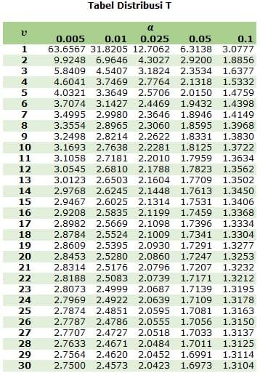

**Lampiran 16**. Kromatogram Sampel X

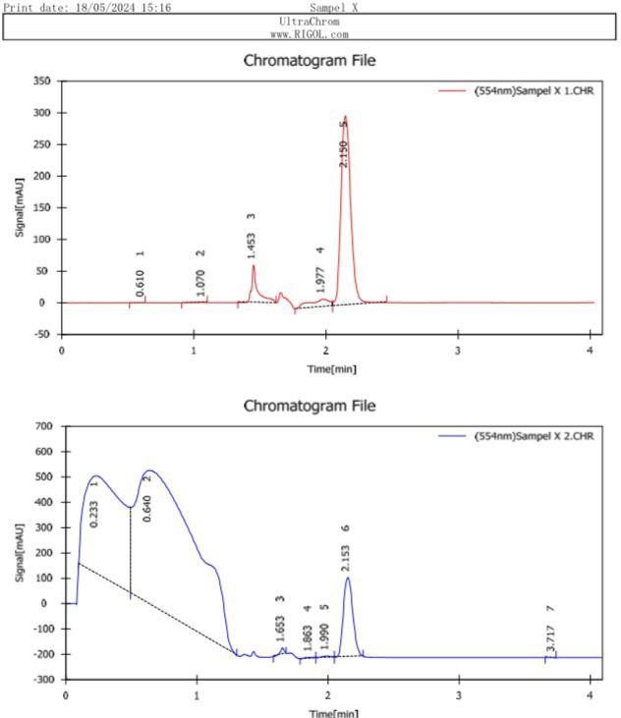

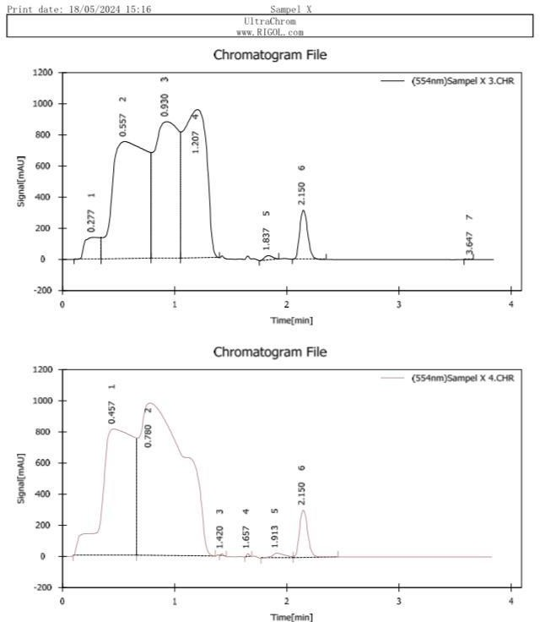

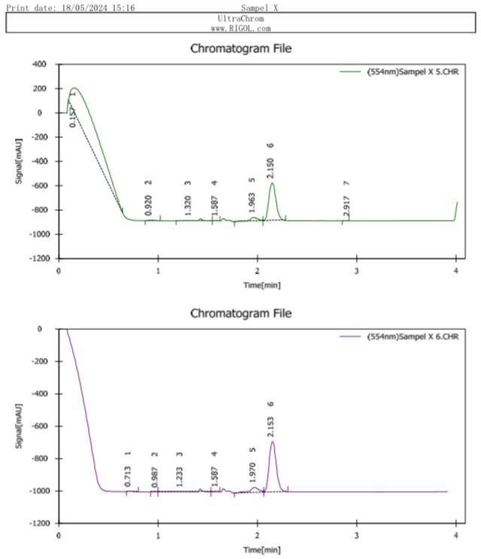

|  |  |  |  |  |  |  |  |
| --- | --- | --- | --- | --- | --- | --- | --- |
|  | Reten. Time [min] | Area [mAU.s] | Area [%] | Height [mAU] | Theoretical Plates [th.pl] | Resolution | Symmetry  / Tailing |
| 1 | 2.150 | 1555.317 | 82.655 | 299.008 | 4017.426 | 0.683 | 1.219 |
| 2 | 2.153 | 1567.082 | 5.746 | 314.077 | 4101.680 | 1.189 | 1.166 |
| 3 | 2.150 | 1560.939 | 3.437 | 316.573 | 4239.323 | 2.222 | 1.171 |
| 4 | 2.150 | 1566.527 | 3.478 | 304.700 | 4064.374 | 1.347 | 1.181 |
| 5 | 2.150 | 1563.199 | 22.111 | 311.709 | 4110.855 | 1.322 | 1.176 |
| 6 | 2.153 | 1565.232 | 83.706 | 311.990 | 4165.210 | 1.313 | 1.170 |

**Lampiran 17**. Kromatogram Sampel Y

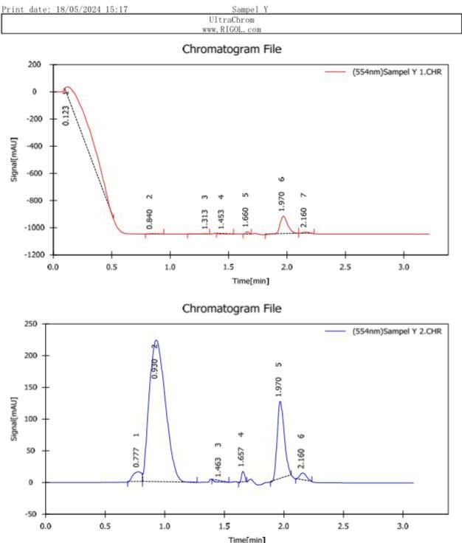

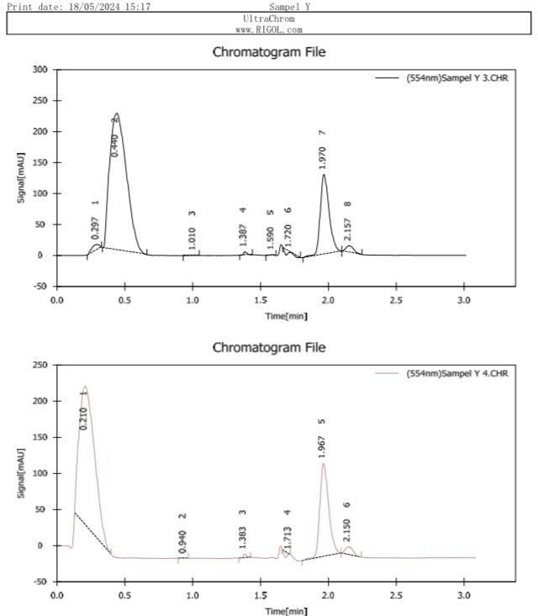

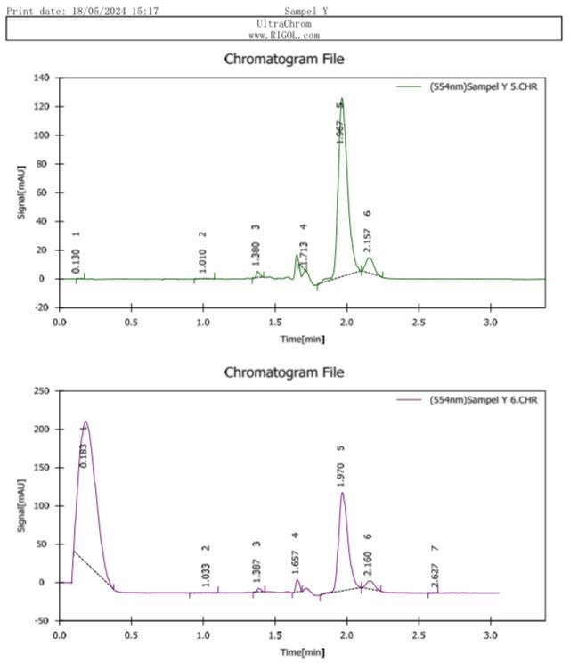

|  |  |  |  |  |  |  |  |
| --- | --- | --- | --- | --- | --- | --- | --- |
|  | Reten. Time [min] | Area [mAU.s] | Area [%] | Height [mAU] | Theoretical Plates [th.pl] | Resolution | Symmetry  / Tailing |
| 1 | 2.160 | 43.958 | 1.173 | 11.018 | 6164.664 | 1.680 | 0.830 |
| 2 | 2.160 | 45.102 | 1.612 | 11.144 | 6234.855 | 1.713 | 0.783 |
| 3 | 2.157 | 44.693 | 1.716 | 11.030 | 6095.162 | 1.636 | 0.777 |
| 4 | 2.150 | 44.523 | 2.038 | 10.901 | 6139.175 | 1.608 | 0.799 |
| 5 | 2.157 | 43.999 | 6.974 | 11.002 | 6341.507 | 1.695 | 0.757 |
| 6 | 2.160 | 44.464 | 2.064 | 11.071 | 6183.292 | 1.668 | 0.775 |

**Lampiran 18**. Kromatogram Sampel Z

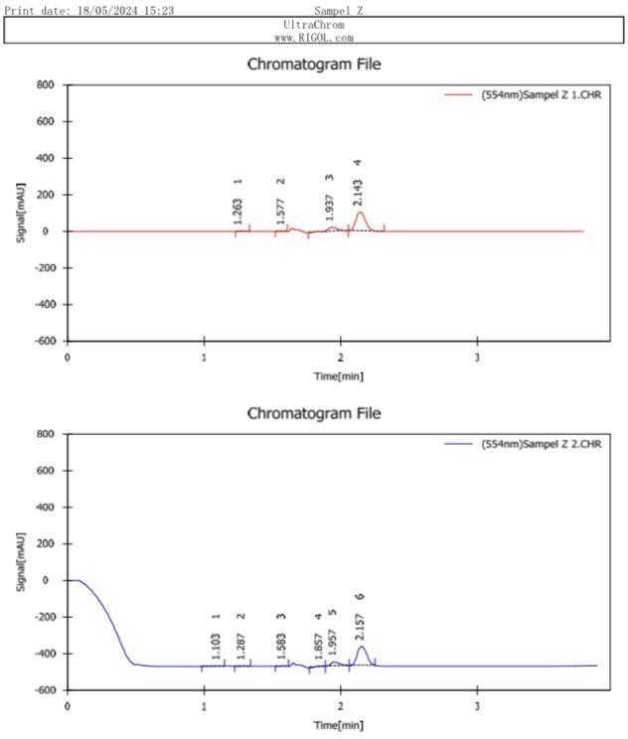

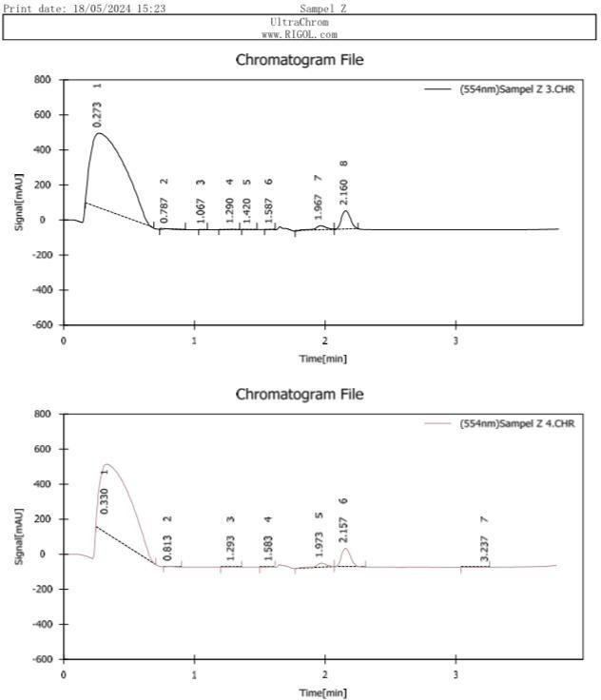

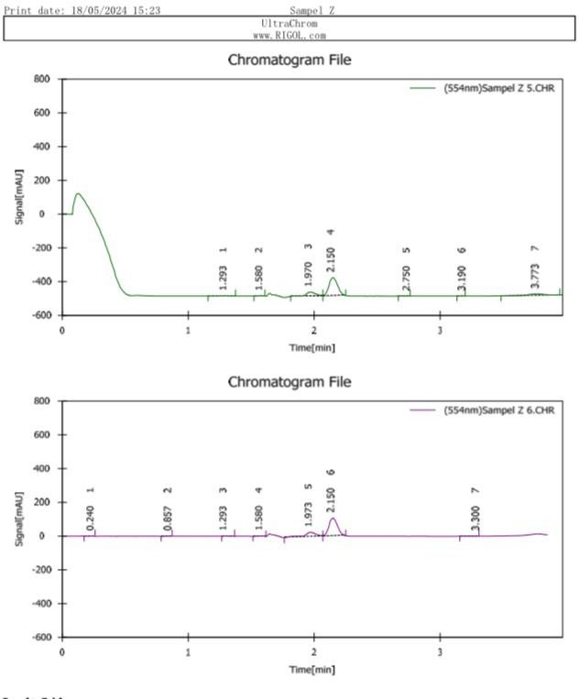

|  |  |  |  |  |  |  |  |
| --- | --- | --- | --- | --- | --- | --- | --- |
|  | Reten. Time [min] | Area [mAU.s] | Area [%] | Height [mAU] | Theoretical Plates [th.pl] | Resolution | Symmetry  / Tailing |
| 1 | 2.143 | 510.971 | 75.827 | 104.117 | 4228.272 | 1.526 | 1.198 |
| 2 | 2.157 | 510.619 | 74.940 | 105.084 | 4187.360 | 1.470 | 1.126 |
| 3 | 2.160 | 512.602 | 5.861 | 106.027 | 4338.731 | 1.391 | 1.150 |
| 4 | 2.157 | 508.603 | 6.784 | 105.447 | 4430.257 | 1.387 | 1.185 |
| 5 | 2.150 | 512.299 | 71.089 | 106.897 | 4356.371 | 1.387 | 1.181 |
| 6 | 2.150 | 512.744 | 72.489 | 106.474 | 4400.958 | 1.289 | 1.175 |