# CHAPTER II

# REVIEW OF LITERATURE

## 2.1 Theoretical Framework

### 2.1.1 Vocabulary

#### 2.1.1.1 The Definition of Vocabulary

Vocabulary is a component of language to improve all English skills. Without vocabulary, students will have difficulty when they express their ideas and students cannot improve their ability to communicate in English.

Susanto (2017:185) said that vocabulary is crucial to be mastered by the learner in order to understand the language. Vocabulary is a principal and vital thing in language teaching and language learners.Alqahtani (2015:25) said that vocabulary is the total number of words that are needed to communicate ideas and express the speakers’ meaning. That is the reason why it is important to learn vocabulary.

Rohmatillah (2014:72) explained that vocabulary is a list of words as a basic component of language proficiency which has a form or expression and contains of aspects, they are meaning, used of word, form pronunciation and spelling. Having a good vocabulary will help students to master language skills. It is almost impossible to learn on words.

Based on the explaination above, researcher can conclude that vocabulary is words that must be known and used to express ideas or thoughts to communicate.

we can express our ideas, thoughts, and experiences. If we already know vocabulary as language, without vocabulary it is impossible to communicate without mastering vocabulary as a language.

#### 2.1.1.2 The Importance of Vocabulary

Alqahtani (2015) said that the most important part of learning foreign languages ​​is vocabulary learning because there are new words that must be emphasized both in books and in class. Learning vocabulary is very important for students so that students can master the target language what they are learning. Students will improve their language skills if they learn more words and expressions. Students can also be trained to use the language both orally and in writing.

Munir (2016:15) states that vocabulary is important in learning English because by having many vocabularies someone can be easier to learn English . It is different when someone has a limited vocabulary, they could not learn English better. Learn English easily by understanding vocabulary. By having a lot vocabulary, we can improve our language. Understanding vocabulary is a skill to acquire many words.

From the statements above, vocabulary is the center of language in learning a foreign language. Learning vocabulary is necessary as a basis for starting English skills. without sufficient vocabulary, students are unable to communicate to express their ideas orally or in writing.

#### 2.1.1.3 Types of Vocabulary

According to Thornbury (in “Nisfulaila” : 2022) there are eight types of vocabularies.

1. Nouns

Nouns reference to an object such as: a book, pencil, and table.

1. Pronouns

Pronouns reference the personal, possesive, reflexive, reciprocal, demonstrative, relative, interrogative, and indefinite such as: I, She, and them.

1. Verbs

Verbs are predictions and actions such as: praying, talking, and writing.

1. Adjective

An adjective is a word or phrase naming an attribute. Used to modify or describe it. Such as: old, young, and new.

1. Adverb

The adverb is a word that modifies the meaning of a verb, an adjective, or another verb. Such as: cheerfully.

1. Preposition

A preposition is a word that is used to define a relation to the things or person in what stands concerning something else. Such as: for.

1. Conjuction

Conjuction is a word that uses to connect sentences or to coordinate words in the same clause. Such as: and, but, if.

1. Determine

A determine is a modifying word and it points out without describing it likes the way an adjective. Such as: a and the.

#### 2.1.1.4 Teaching Vocabulary

Teaching vocabulary is giving new words that students do not know yet. in preparing the material to be taught to students, we must first know the students, because if we already know who the students are, we can choose a material that is appropriate to the student's level such as beginner, intermediate, or advanced. Second, we must have many techniques for teaching vocabulary.

Teaching vocabulary can help students learn what words mean, and understand how to use them. Students are always related to vocabulary in learning English because vocabulary is the starting point for learning English. This is necessary so that teachers and students are not bored and easy in the teaching and learning process.

Syarifudin et al., 2014:2 said that in the process of learning English in Junior High school, vocabulary mastery is very important for the students. It is because in their early years, vocabulary connected experiences that the students have and play a vital role in the development of their language.

It means that vocabulary is an important element in learning English and the students can achieve their goals in learning English skills. Teachers are required to use media that can improve vocabulary acquisition.

#### 2.1.1.5 The Problem in Learning Vocabulary

Destry (2022:8) said thatlearning foreign language vocabulary is not easy for a student because building vocabulary takes a long time. There are many problems students face when they learn vocabulary. English have a very rich and extensive vocabulary, and there are many words for students to memorize**.**A language has more than 450,000 words even more and also one word has a lot of meaning. Students might get some difficulties in learning vocabulary. Some of the problems faced by students in mastering vocabulary. First, they lack vocabulary so they cannot understand the meaning of what they read and hear. Second, they have difficulty in pronouncing words. Third, they have difficulty remembering vocabulary. The last, the lack of use of media used by teachers.

### 2.1.2 Media

The use of media is one way to support the process of teaching and learning English. Media is a source of information for recipients of information, for example, media such as cellphones, computers, videos, films, and others. The use of media is very influential during the learning process because students feel happy and not bored in the learning process. According to Miftah (2013: 98) states that learning media is something (can be a tool, material, or situation) that is used as an intermediary for communication in learning activities. It can be concluded that media is a learning aid and increases students’ motivation in learning English.

#### 2.1.2.1 Types of Media

This type of learning media is needed so that students are enthusiastic about learning. Arsyad (2015) stated that there are six categories of teaching media such as human media, printed media, audio media, visual media, audio-visual media, and multimedia. Those six categories of media can be used in teaching and learning process especially in a scope of English teaching and learning process.

Types of media for teaching decided into:

1. Human media is the oldest media used to send and communicate messages or information.
2. Printed media is a means of conveying information in printed form on paper. For example: magazines, newspapers, electronic mail, etc.
3. Audio media is media that can be heard. For example: radio, records, and record players can stimulate our thinking in learning English.
4. Visual media is media that can be seen with the sense of sight. For example: whiteboards, flashcards, picture cards, slides, films, etc.
5. Audio-visual media is media capable of displaying sound and images. For example: television, YouTube, videos, and films.
6. Multimedia is a combination of several elements such as audio, text, and images that are controlled by a computer. For example: music, game application, animation, ect.

The use of media in the classroom can help teachers in transferring knowledge and increasing student motivation. Teachers must be able to develop learning materials to help students learn more effectively and fun.

### 2.1.3 Lingodeer Application

#### 2.1.3.1 Definition of Lingodeer

According toSaragih et al., 2022:359 Lingodeer is an interactive and foreign language learning application. Fees (2021:2) states that lingodeer is a more recent language learning application, mainly for beginning language students. The technique in the lingodeer application very helps beginners in learning a language because the learning is from the basic. Lingodeer is very simple and easy to use. Nisfulaila (2022:24) states that lingodeer is an the application that is easy to use and can do in every where when there is a signal. In use, lingodeer reinforcement of basic vocabulary, supported with interesting features provided such as animation and audio by native speakers who help users like students for level correction accuracy in pronouncing vocabulary, and again to confirm the user gets the iterations needed before proceeding.

The lingodeer application is important for students to learn languages ​​to increase students’ learning motivation. Using the lingodeer application to learn English can be positive thing feedback from students and teachers. Besides, students can develop their vocabulary by using lingodeer application.

Based on the statement above, the lingodeer application can be a fun new way to learn English and lingodeer can be the media that is helpful for students in improving their vocabulary.



**Figure 2.1 Lingodeer Application**

#### 2.1.3.2 The Purpose of Using Lingodeer

Nisfulaila (2022:20) said that mastering vocabulary is important for beginners in learning a language, especially for foreign language learners. If students lack vocabulary, they will find difficulty in understanding what they read and hear.because for a beginner to understand the sentence is not easy.

The purpose of lingodeer isthe user can understand a language and they can use it. The user will know if lingodeer focuses on mastering vocabulary. Lingodeer can be a medium for students to improve their vocabulary and teachers use lingodeer in teaching to help students master vocabulary. The use of lingodeercan help students master vocabulary through game so students do not get bored easily in learning vocabulary, and one particular game can played for this purpose is Lingodeer.

#### 2.1.3.3 The Procedure of Learning English through Lingodeer

The lingodeer application can help student understand vocabulary in English. The use of the lingodeer application in learning is good media to make students feel involved in the learning process. Naibaho (2022) states that there are several steps to use the Lingodeer application. The steps are as follows:

1. Students can download the Lingodeer application on student’s smartphone in the play store.

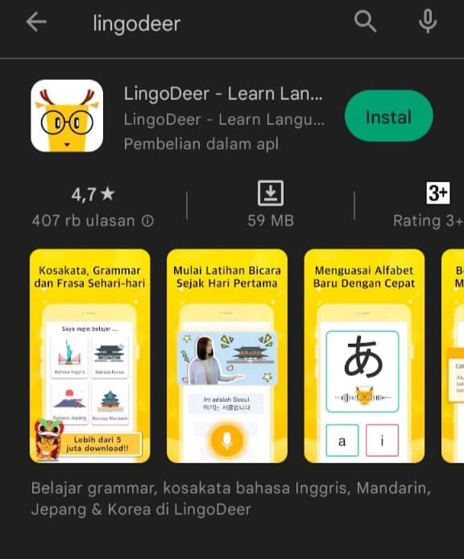

**Figure 2.2 Lingodeer Application in Playstore**

1. Then open the lingodeer application and select the language users want to learn.

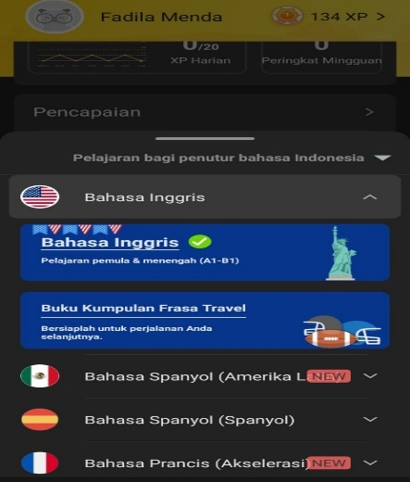

**Figure 2.3 The choices of the Language**

1. After choose the language that the user wants to learn, what choice is there beginners or users know the basics of the language that wants to learn.

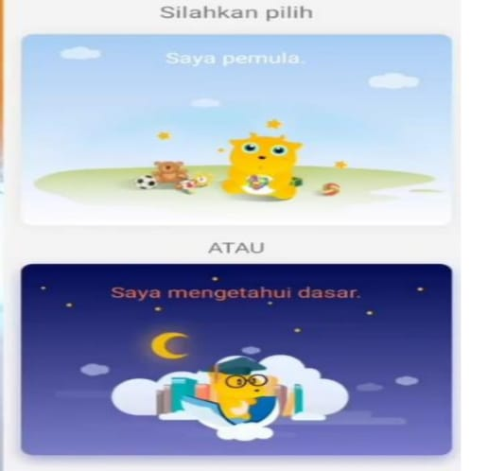

**Figure 2.4 The Choices Level**

1. And then, the users can start learning in the section.

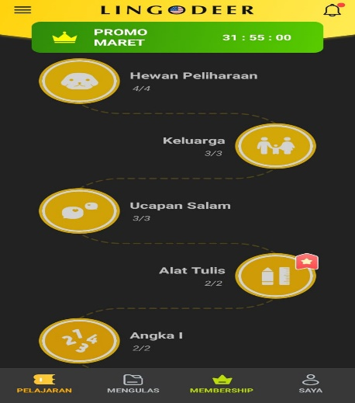

**Figure 2.5 Lesson Section**

1. The users can check the lesson that you learn in the review section.

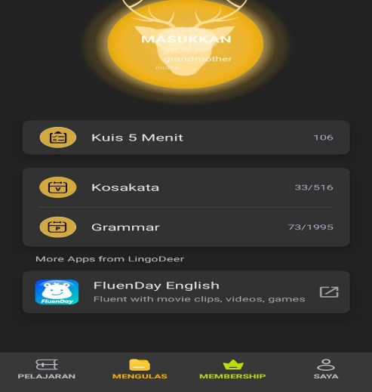

**Figure 2.6 Review Section**

1. The users can check the progress of learning in the lingodeer application.

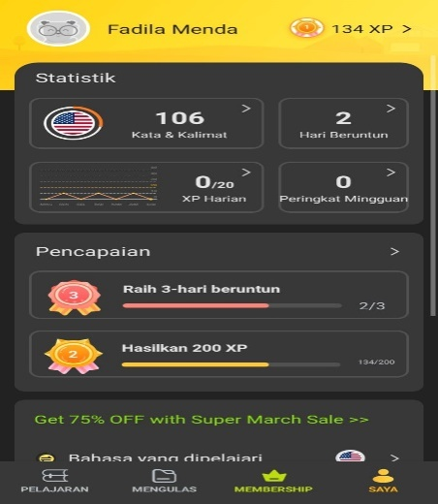

**Figure 2.7 My Section in Lingodeer Application**

#### 2.1.3.4 The Features of Lingodeer

According to the lingodeer website (2017), there are several features in the lingodeer application such as:

1. Lingodeer provides an offline mode.
2. Each language program contains approximately 2000 vocabulary words and phrases that are most often used in everyday life.
3. All audio on Lingodeer is recorded by native speakers with fast or slow sound that makes it easy for Lingodeer users.
4. There is a detailed grammar explanation for the user to easily understand to given sentence structure.
5. The various types of exercises in Lingodeer will make learning more interesting, fun, and not boring.
6. Using flashcards which helps users to memorize new vocabulary and knowledge.

#### 2.1.3.5 Advantages and Disadvantages

According to Vare J. (2023) states that the Lingodeer also has advantages and disadvantages, as follows:

1. **Advantages**
2. Well-structured lesson.
3. Native audio in all course.
4. Excellent grammar explanations.
5. Offline learning.
6. Fantastic review system.
7. Lingodeer is a game-based platform for learning foreign languages.
8. Free travel pharase book.
9. **Disadvantages**
10. Not all course include all the features.
11. No video material or authentic content.
12. No content for advanced learners
13. Little speaking practice for non Asian languages
14. It has to pass previous “test out” quizzes to access later lessons.
15. Each app needs a separate premium subscription.

## 2.2 Conceptual Framework

Vocabulary is an important element to learn a language. When students want to learn English, they should have enough vocabulary. Vocabulary is a set of words in English that are used to express our ideas, feeling, and information to others. Most students find it is difficult to understand and memorize English vocabulary. Besides, English words have different ways when it is written and it is pronounced. It makes them bored and not interested to learn.

In learning vocabulary, the teacher must create an interesting learning atmosphere so that students do not get bored easily and one way is to use the media. Using media in the teaching process can help students learn a language more effectively, but it should able be fun and interesting.

Lingodeer application is a medium that can be used to learn vocabulary. lingodeer can be installed on a smartphone and downloaded on Google Play Store. The features of this application are based on educational games that can increase students’ vocabulary in an interesting way. Lingodeer application can also be an alternative for the student to learn English vocabulary anywhere and anytime. The students can learn not only at school but also at home by using the lingodeer application.

## 2.3 Previous Research

There are some previous research related about mobile application and vocabulary. It means that vocabulary is important in learning English besides grammar.

The research with entitled *The Effectiveness of Lingodeer Application Toward Students’ Vocabulary Mastery* by Nursaqian Nisfulaila (2022). This research was quasi-experimental. The researcher used quasi-experimental research with one group pre-test and post-test. The subject of this research of the seventh grade students of MTs GUPPI Banjit. The result that there were found the effectiveness of lingodeer application towards students’ vocabulary mastery in MTs GUPPI Banjit. Furthermore, the result of the average score of the post-test in the experimental class and control class was different before and after the treatment. The average score of the experimental class and control class was slightly different. The experimental class which got the treatment showed a higher average score than the average score of the control class learning with the lecturing method.

Next is the research with entitled *The Effect of Hello English Application on The Students’ Vocabulary Mastery at The Eighth Grade of Junior High School*by Rita Seroja Br Ginting (2019) found that the use of educational games from Android-Hello English improved the students’ competence in learning vocabulary. The game greatly encourages the students to give actively participation during classroom activities. Furthermore, the use of android-based educational games is one joyful alternative teaching to support the creative young learners’ teachers. Based on the finding and discussion obtained in that study, the Hello English application is effective on the students' vocabulary mastery which is shown by the analysis of the data that t0 was higher than the ttable in the significance level of 5% (8.984 > 1.669). Furthermore, it was found that the effect of Hello English on the students’ vocabulary mastery.

Next is the research with entitled *The Effects of Using Duolingo towards Student’s Vocabulary Mastery*by Hermariyanti Kusumadewi and Kusumadewi (2018) found that found that the use of educational game applications can improve students' vocabulary mastery. In this research, the researcher used Duolingo which is also a language learning application-based game. Furthermore, the researcher used an experimental research design and divided the sample into two groups; experimental and control group. 30 students are in the experimental group and 30 students are in the control group. The results of this research revealed the students were more motivated in learning; more skillful because their interest in learning increased; easy to understand the material; given the opportunity to all students to get a fair turn in practicing the material; eliminate boredom in learning; encourage the idea of new ideas; and facilitate students in remembering and also practice the material in daily life day and then the English learning process by using the Duolingo application has a positive effect compared to conventional student approaches.

Based on the explaination above, the researcher would like apply the lingodeer application that may help students to develop their vocabulary and also would like to investigate the effect of using lingodeer application on students’ vocabulary of the seventh grade at MTs Darul Ilmi Batang Kuis.

## 2.4 Hypothesis

The hypothesis is formulated as follows:

**Ha** : There is a significant effect of using lingodeer application on students’ vocabulary.

**Ho :** There is no significant effect of using lingodeer application on students’ vocabulary.