**ACKNOWLEDGEMENT**

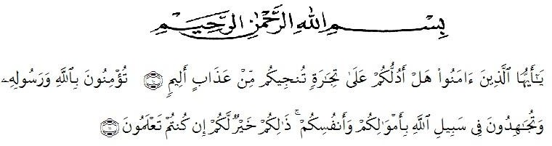

Meaning: “O you who believe! Shall I show you a commerce that will save you from a painful doom?” (10). (Namely) you should believe in Allah and His messenger, and should strive for the cause of Allah with your wealth and your lives. That is better for you, if ye did but know (11)”.

The meanings: “*Hai orang-orang yang beriman, sukakahakutunjukkansuatuperniagaan yang dapatmenyelamatkan mu dariazab yang pedih?” (10). (yaitu) kamuberimankepada Allah danRasul-Nyadanberjihad di jalan Allah denganhartadanjiwa mu. Itulah yang lebihbaikbagimu, jikakamumengetahuinya” (11).*

*Alhamdulillahirabbil’alamiin*. First of all, the writer thanks to the Almighty God, Allah SWT, for the blessing which has been given to the writer so that she finally finished and completed this thesis entitled “The Effect of Cartoon Movie on Students’ Speaking Ability”. As the fulfillment of the requirements for the degree of Bachelor of Education at Faculty of Teachers’ Training and Education, English Education Department of the University of Muslim Nusantara Al Washliyah Medan. Secondly, peace and salutation to our prophet Muhammad SAW who has guided us from the darkness into the bright life.

This thesis could not have been accomplished without the guidance, suggestions, and comments from several people so that in this opportunity the writer would like to express her deep gratitude to the following people:

1. **Rini Fadhillah Putri, S.Pd., M.Hum,** the Adviser who has given guidance, advice, correction, suggestion, and also motivation that always supporting the writer in finishing the script.
2. Her beloved parents, Mr. **M.Khairudin Yani** and Mrs. **Roslinawati** for their affection, care and support that follow her in every step of her life, especially during the process of wrriting her thesis.
3. Her beloved boyfriend, **Muhammad Zulfahri Isnaindi,** as the mood oh the writer-encouragement for the patient, support, affection, attention and jokes that can make her smiles every day even when the writer is in bad situation.
4. **Zulfitri, S.S, M.A, M.Pd** the head of English Language Education Department of Muslim Nusantara Al Washliyah University.
5. All the examiners in her thesis exam, Mr. **Yugi Diraga Prawiyata., M.Hum** and Mrs. **Prof. Risnawaty, S.Pd., M.Hum**, for help, guidance and guide.
6. **Yuyun Isnari, Amelia, Fadilah Menda Prawiyata,** as a writer’s friend who always provides support the author’s unforgettable moments and the extraordinary great friendship.
7. Her sisters, **Tia, Fitria, Menda** who have provided support so that the writer can complete her thesis.
8. Girls and Boys “81” who always make the writer smile and laugh.
9. All of her friends who can not be mentioned one by one for their prayers, help and support.
10. All of the lecturers of the English Education Department of Muslim Nusantara Al Washliyah University Medan.
11. All of the Academic Administration Staffs of Muslim Nusantara Al Washliyah University Medan.
12. All of the Librarians Staffs of Muslim Nusantara Al Washliyah University Medan.

The writer also thanks to anyone whom cannot be mention one by one, it does not mean the writer forget about you, but the writer’s greatest is dedicated to all of you.

Finally, the writer realized that this script far from being perfect. Therefore, the writer hopes constructive critics and suggestion will be highly appreciated much.

Medan, July 2023

The Researcher,

Putri Fadillah