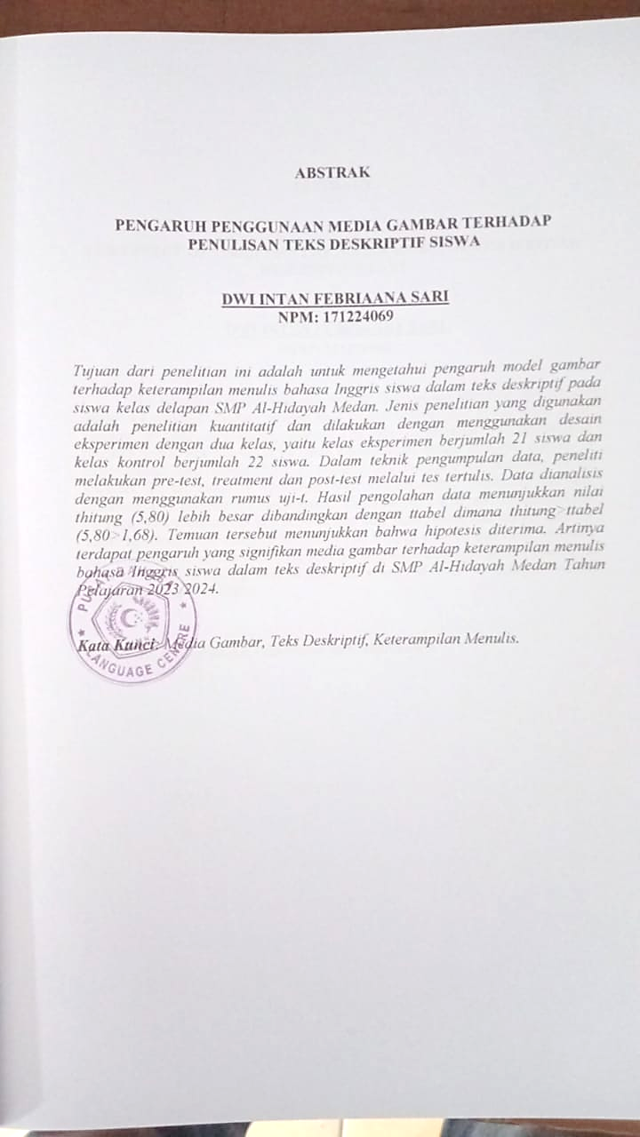

**ABSTRACT**

**THE EFFECT OF USING PICTURE MEDIA ON STUDENT’S WRITING DESCRIPTIVE TEXT**

**DWI INTAN FEBRIANA SARI**

**NPM: 171224069**

The objective of this research was to find out the effect of that picture model on students’ English writing skill in descriptive texts at the eight grade students of SMP Al-Hidayah Medan. The type of research was quantitative research and it was conducted by using experimental design with two classes, in experimental class consisted of 21 students and control class consisted of 22 students. In technique of collecting data, the researcher conducted pre-test, treatment and post-test by writing test. The data were analyzed by using t-test formula. The result of the data showed that ttest (5,80) value was higher than the ttable in which ttest>ttable (5,80>1,68). The finding showed that the hypothesis was accepted. It means that there was a significant effect of picture media on students’ English writing skill in descriptive texts at SMP Al-Hidayah Medan Academic Year 2023/2024..

***Keywords****: Picture Media, Descriptive text, writing skill.*