**CHAPTER IV**

**RESEARCH RESULT AND DISCUSSION**

**4.1 The Result and Data Analysis**

As said in this chapter, the researcher used podcast technology media to gather data on English listening skill, and the researcher subsequently used the test results. Pre-test and post-test were administered for both, experimental and control group. A pre-test gave before treatment to the experimental and control class. The post-test gave after treatment was carried out. A test was administered to collect the data. The experimental and control group were tenth grade of Madrasah Aliyah Swasta Al-Washliyah Gedung Johor Medan

**4.1.1 The Data of Score Pre Test and Post Test**

The both test in experimental and control group were same. But for the experimental class, students were taught by using podcast technology media. While, the control group were taught by only audio method. To be clearer, the researcher has explained the result below.

**Table 4.1 The Score of Pre-Test in Experimentala Class**

|  |  |
| --- | --- |
| **Experimental Class** | **Pre-Test** |
| **Maximum** | 70 |
| **Minimum** | 50 |
| **Mean** | 60.74 |
| **Median** | 61.00 |
| **Mode** | 60 |
| **Standart Deviation** | 5.623 |

41

**Table 4.2 The Score of Post-Test in Experimental Class**

|  |  |
| --- | --- |
| **Experimental Class** | **Post-Test** |
| **Maximum** | 90 |
| **Minimum** | 84 |
| **Mean** | 87.28 |
| **Median** | 87.00 |
| **Mode** | 85 |
| **Standart Deviation** | 1.944 |

After collecting the data and scoring the experimental class answer of pre- test and post-test. It can be shown that the highest scored in pre-test was 70 and the lowest scored was 50, and the highest scored in post-test was 90 and the lowest was 84.

**Table 4.3 The Score of Pre-Test in Control Group**

|  |  |
| --- | --- |
| **Control Group** | **Pre-Test** |
| **Maximum** | 75 |
| **Minimum** | 54 |
| **Mean** | 64.81 |
| **Median** | 65.00 |
| **Mode** | 70 |
| **Standart Deviation** | 4.568 |

**Table 4.4 The Score of Post-Test in Control Group**

|  |  |
| --- | --- |
| **Control Group** | **Post-Test** |
| **Maximum** | 80 |
| **Minimum** | 68 |
| **Mean** | 76.16 |
| **Median** | 78.00 |
| **Modus** | 78 |
| **Standar Deviasi** | 3.192 |

After collecting the data and scoring the control group answer of pre-test and post-test. It can show that the highest score in pre-test was 75 and the lowest scored was 54, and the highest scored in post-test was 80 and the lowest was 68.

It can be concluded that there are differences in the result of pre-test and post-test scores for each class.

**Table 4.5 Test of Normality**

|  |  |  |  |  |  |  |  |
| --- | --- | --- | --- | --- | --- | --- | --- |
| **R E S U L**  **T** | **class** | **Kolmogorov-Smirnov Shapiro wilk** | | | | | |
| **statistic** | **Df** | **sig** | **statistic** | **df** | **sig** |
| **Pre Experimental** | .091 | 43 | 200 | .965 | 43 | .217 |
| **Post Experimental** | .091 | 43 | 200 | .965 | 43 | .217 |
| **Pre Control** | .100 | 43 | 200 | .970 | 43 | .322 |
| **Post Control** | .109 | 43 | . 200 | .970 | 43 | .310 |

Based on table above, it can be shown that the test of normality in each class has been proven to be normal.

**Table 4.6 Frequency**

|  |  |  |  |  |  |  |
| --- | --- | --- | --- | --- | --- | --- |
| **Class** | **Valid** | | **Missing** | | **Total** | |
| **N** | **Percent** | **N** | **Percent** | **N** | **Percent** |
| **Pre Experiment Class** | 43 | 100.0% | 0 | 0.0% | 43 | 100.0% |
| **Post Experiment Class** | 43 | 100.0% | 0 | 0.0% | 43 | 100.0% |
| **Pre Control Group** | 43 | 100.0% | 0 | 0.0% | 43 | 100.0% |
| **Post Control Group** | 43 | 100.0% | 0 | 0.0% | 43 | 100.0% |

Researcher have carried out several data checks, one of which is validating students data. Based on the table frequency above it can be known that the

number of students in each class has been proven to be valid.

**Table 4.7 T-Test**

|  |  |  |  |  |  |  |  |  |  |
| --- | --- | --- | --- | --- | --- | --- | --- | --- | --- |
|  | **Levene's** | **T-Test of equality of means** | | | | | | | |
|  | **Test for** |
|  | **Equality of** |
|  | **Variances** |
|  |  |  |  |  |  |  |  | **95%** | |
| **R** |  |  |  |  |  |  |  | **Confidence** | |
| **E** |  |  |  |  |  |  |  | **Interval of the** | |
| **S** |  |  |  |  |  |  |  | **Difference** | |
| **U** |  | **F** | **t** | **Dif** | **Sig (2** | **Mean** | **Std.** | **lower** | **upper** |
| **L** |  | **tailed** | **diff** | **error** |
| **T** |  | **)** |  | **diff** |
|  | **Equal** | 10.443 | 19.507 | 84 | 000 | 11.116 | .570 | 9.983 | 12.250 |
|  | **variances** |
|  | **assumed** |
|  | **Equal** |  | 19.507 | 69.382 | 000 | 11.116 | .570 | 9.980 | 12.253 |
|  | **variances** |  |
|  | **not assumed** |  |

Based on the table above, obtained sig value (2 tailed) as big as 0,000 <

0,05. So it can be conclude that there is average difference in student learning outcomes between the podcast technology media and those that only use audio. To be clearer, the researcher have explained it in the statistical table below.

**Table 4.8 Group Statistic**

|  |  |  |  |  |  |
| --- | --- | --- | --- | --- | --- |
| **RESULT STUDY** | **Class** | **N** | **Mean** | **Std. Deviation** | **Std. Error**  **Mean** |
| **Post Experiment** | 43 | 87.28 | 1.944 | .294 |
| **Post Control** | 43 | 76.16 | 3.192 | .487 |

Based on the table above, there is mean difference between post experiment and then post control. Which is in post experiment the mean is 87.28. while, in post control the mean is 76.16. it shown that in post experiment they got higher score.

To test the hypothesis, the formula of T-Test and the distribution table of teritical value were applied. Because of Tobserve was higher than Ttable. It can be conclude that the null hypothesis was reject and the alternative hypothesis was accepted. Therefore, the students who taught by using podcast technology media got higher score than students who were taught without podcast technology media. In short, there is significant affect of using podcast technology media for students, especially in english listening skill . Here the diagram below.

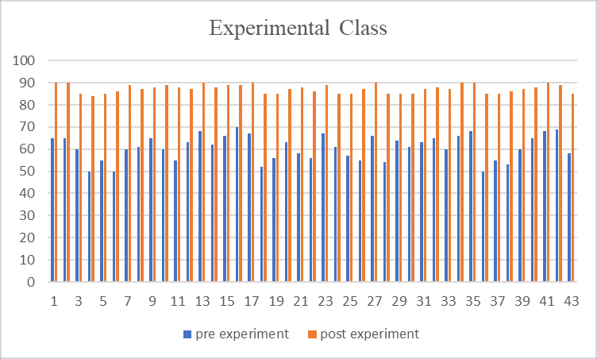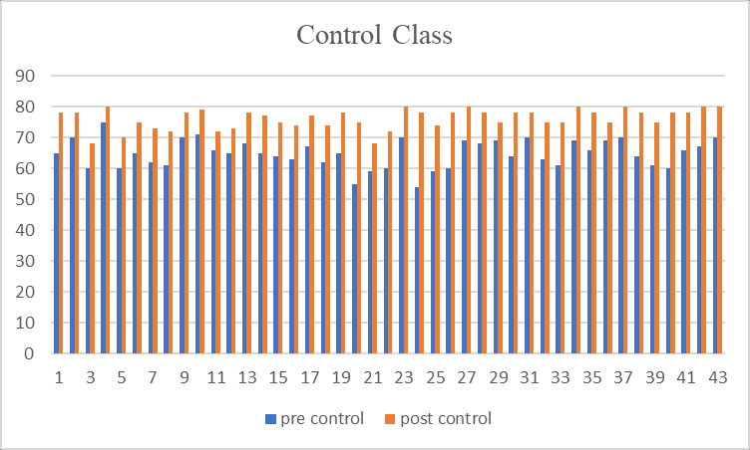

**Criteria of Students’ Test Score**

|  |  |
| --- | --- |
| **Criteria** | **Score** |
| Exellent | 5 (90-100) |
| Great | 4 (76-89) |
| Good | 3 (66-75) |
| Enough | 2 (40-65) |

Poor 1 (00-39)

**4.2 Discussion**

Based on calculating and explanation above,it was conclude that by using podcast technology media on students listening skill of Madrasah Aliyah Swasta Al-Washliyah Gedung Johor medan and the hypothesis was accepted. Therefore, students who taught by using podcast technology media got higher score than students who taught without using podcast technology media.

It can be seen the mean score of experimental class was 87 which is great until excellent, while the mean score of control group was 76 which is good great.