**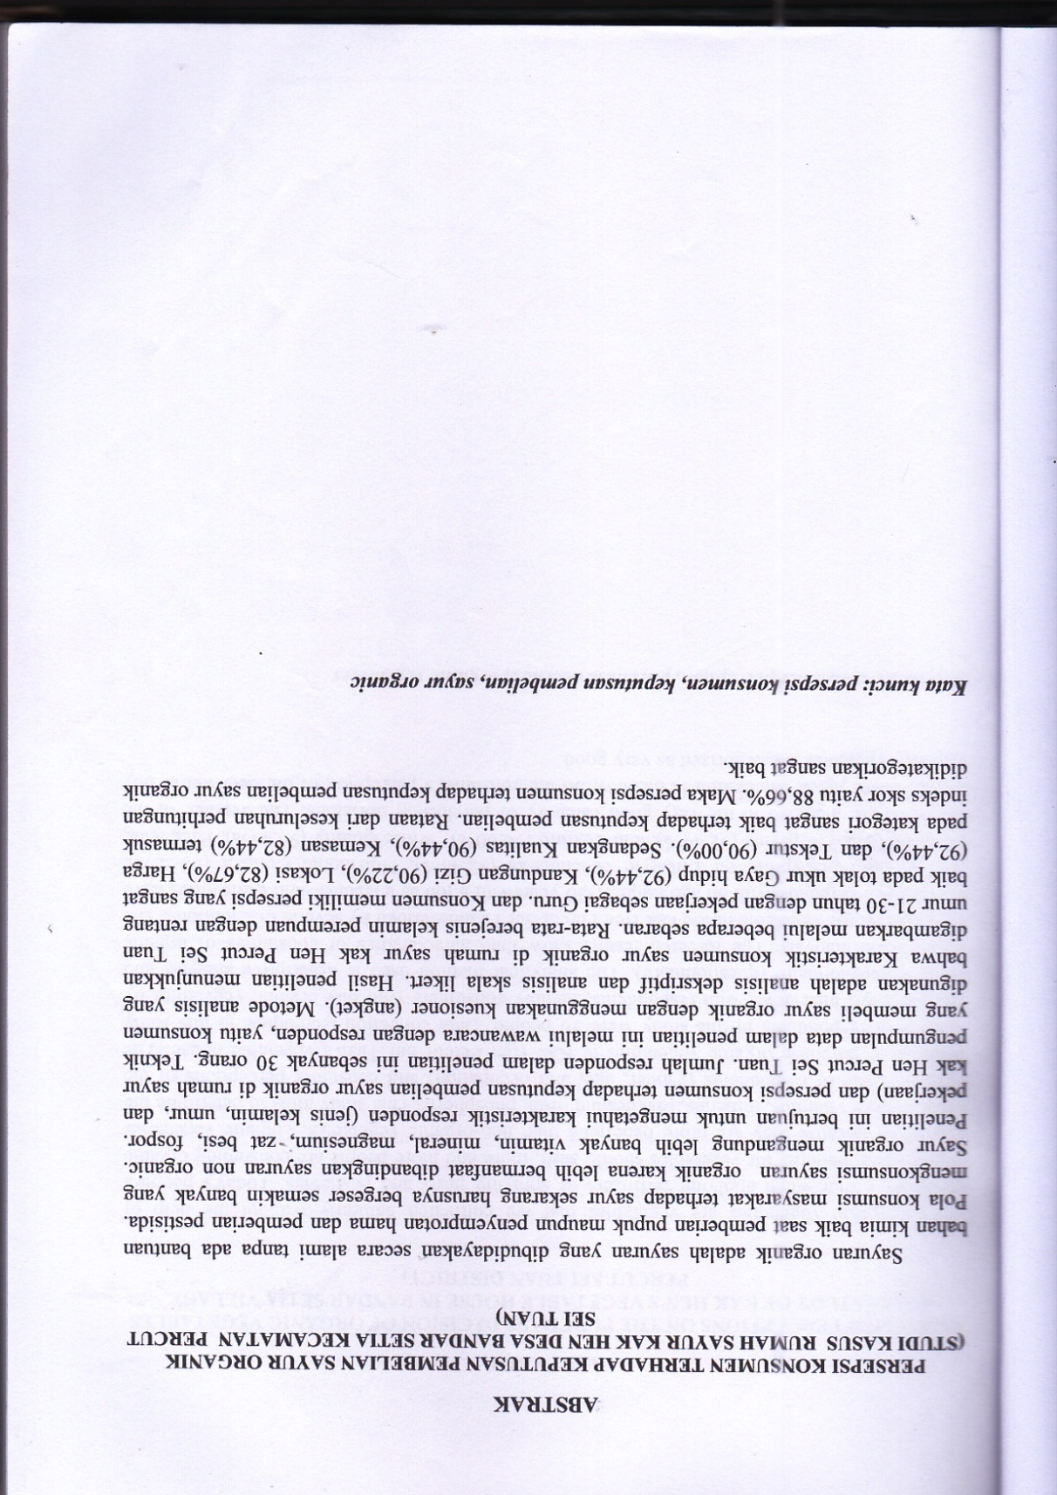**

# C:\Users\OPERATOR\Pictures\2025-02-25\2025-02-25 13-45-45_0008.jpg