**ACKNOWLEDGEMENTS**

Assalamua’alaikum Wr....Wb.....

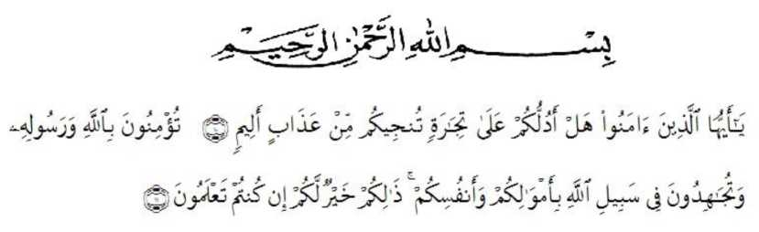

Artinya : *“Hai orang-orang yang beriman, sukakah kamu aku tunjukkan suatu perniagaan yang dapat menyelamatkan mu dari adzab yang pedih. (10). Engkau beriman kepada Allah dan Rasulnya dan berjihad di jalan Allah dengan harta dan jiwamu. Itulah yang lebih baik bagimu jika kamu mengetahuinya. (11) (as-shaffayat 10-11)”.*

Alhamdullillahirrabil’aalamiin, first of all, the researcher would like to praise and thanks a lot God, Allah SWT, the Almighty and most beneficial the his mercy and blessing that have been given to the researcher so that he finally accomplished this thesis. Shalawat and salam to our prophet Muhammad SAW with his followers.

This thesis could have been completed also because of the guidance, encouragement, suggestion and comments from some people. The researcher, therefore, would like to extend his sincere and special thanks to :

1. Dr. Firmansyah, M.Si. The rector of University Muslim Nusantara Al-Washliyah Medan.
2. Dr. Abdul Mujib, S.Pd., M.Pmat. The Dekan of the faculty of Teachers Training and Education of Muslim Nusantara Al-Washliyah University.
3. Zulfitri, S.S., M.A. the Head of English Education Department who had provided her time, knowledge, guiding, and suggestion for her.
4. Nazriani Lubis, S.Pd., M.Hum. as the first cosultant who had contributed her time, knowledge, guiding, suggestion and comments to help her write the draft of this thesis.
5. Zulfitri, S.S., M.A and Prof. Dr. Risnawaty, M.Hum. The reviewers who had contributed their time, knowledge, guiding, suggestion and comments to help her write the draft this thesis.
6. All lecturers at the English Department of FKIP UMN Al Washliyah Medan for their valuable discussion to enrich her knowledge.
7. The writer’s beloved parents, Irwanto and Sri Rahayu Ningsih, for all help, attention, support, hardwork, material support and pray Which gave her spirit to finished this thesis.
8. The writer’s beloved sister, Febby Fitria and Kanaya Adinta who always support and motivate the researcher.
9. The writer’s beloved best Friend, Tri Aura Septia and M.Ridwan Ramadhan who always support and motivate the researcher
10. All of her friends in University of Muslim Nusantara Al-Washliyah Medan, especially class H and Executive class 2019.

Finaly, this thesis is presented to the English Education Study Program of Language and Art Education Department of the Faculty of Teacher Training and Education of University Muslim Nusantara Al-Washliyah Medan.

Medan, 2024

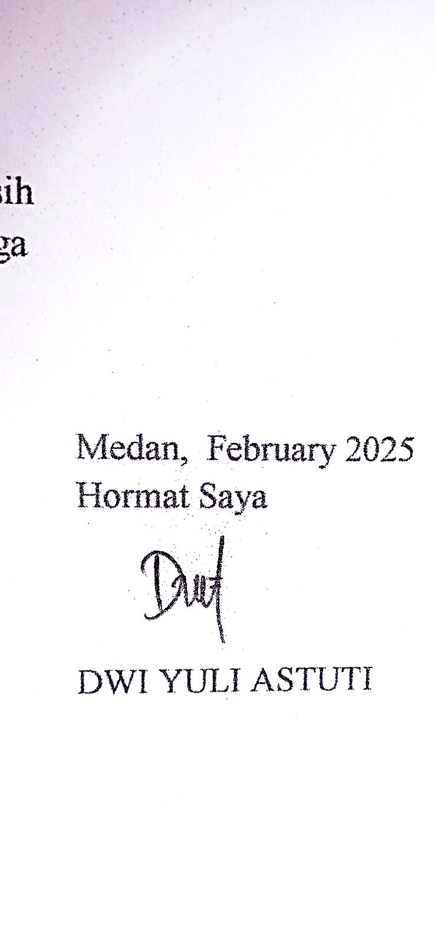 The Researcher,

**DWI YULI ASTUTI**

**No. Reg. 191224047**

**LIST OF CONTENTS**

**ACKNOWLEDGEMENTS i**

**LIST OF CONTENTS iii**

**LIST OF PICTURES v**

**LIST OF TABLES vi**

**LIST OF APPENDICES vii**

**CHAPTER I INTRODUCTION 1**

* 1. Background of the Problem 1
  2. The Identification of the Problem 3
  3. The Limitation of the Problem 3
  4. The Formulation of the Problem 4
  5. The Objective of the Research 4
  6. The Significance of the Research 4
  7. Basic Assumption 5

**CHAPTER II REVIEW OF LITERATURE 6**

2.1 English as Foreign Language in ELT Context 6

2.2 Teaching and Learning English in EFL Context 8

2.3 EFL Students Language Attitude 9

2.4 Characteristic of Language Attitude 11

2.5 Relevant Studies 13

2.6 Conceptual Framework 15

**CHAPTER III METHOD OF RESEARCH 18**

3.1 Research Design 18

3.2 Location and Time of Research 18

3.3 Participants of The Research 19

3.4 The Instrument of Collecting Data 20

3.5 Technique of Collecting Data 21

3.6 Technique of Analyzing Data 22

**CHAPTER IV FINDING AND DISCUSSION 23**

4.1 Result 23

4.1.1 Thematizing and Coding 24

4.1.2 Language Loyalty 25

4.1.3 Language Pride 30

4.1.4 Awareness of the norms 36

4.2 Discussion 41

**CHAPTER V CONCLUSIONS AND SUGGESTIONS 43**

5.1 Conclusion 43

5.2 Suggestions 46

**REFERENCES 47**

**LIST OF TABLE**

Figure 2.1 Conceptual Framework 16

**LIST OF TABLE**

Table 4.1 Thematizing and Coding 24

Table 4.2 Coding Translation 25

**LIST OF APENDIX**

APPENDIXES 1 Question for interview 49

APPENDIXES 2 STATEMENT 51

APPENDIX 3 Interview With User 52

APPENDIX 4 Documentation 59