DAFTAR PUSTAKA

Adhisa, S. (2020). Kajian Penerapan Model Pembelajararan Kooperatif Tipe True or False Pada Kompetensi Dasar Kelainan Dan Penyakit Kulit. E-Jurnal, 82-90.
Afifi, R. E. (2018). UJI ANTI BAKTERI EKSTRAK DAUN BELIMBING WULUH (Averrhoa bilimbi L) TERHADAP ZONA HAMBAT BAKTERI JERAWAT Propionibacterium acnes SECARA IN VITRO. Jurnal Pendidikan dan Biologi, 10-18.
Agoes, G. (2009). Seri Farmasi Industri 1:Pengembangan Sediaan Farmasi Steril. Bandung : :ITB.
Angin, Y. Y. (2019). Pemanfataan kandungan metabolit sekunder yanag dihasilkan tanaman. Jurnal Ilmu Pertanian, 39-47.
Angriani, L. (2019). The Potential of Extract Butterfly Pea Flower (Clitoria ternatea L.) as a Local Natural Dye for Various Food Industry. Canrea Journal; Food Technology, Nutritions, and Culinary Journal, 32-37.
Ansel. (2008). Pengantar bentuk sediaan farmasi. Jakarta: Universitas Indonesia Press.
Apriana, R. R. (2017). Formulasi Dan Uji Stabilitas Gel Antijerawat Yang Mengandung Kuersetin Serta Uji Efektivitas Terhadap Staphylococcus epidermidis. Jurnal Pharmascience, 187-201.
Ardana, M., Aeyni, V., & Ibrahim, A. (2015). FORMULASI DAN OPTIMASI BASIS GEL HPMC (HIDROXY PROPYL METHYL CELLULOSE) DENGAN BERBAGAI VARIASI KONSENTRASI. J. Trop. Pharm. Chem., 3(2), 101–108.
Ariyani, S. B., Pertiwi, Y. K., & Asmawit. (2018). Pengaruh Penambahan Pengawet dan Uji Aktivitas Antibakteri Escherichia coli pada Sediaan Gel Lidah Buaya. JURNAL TEKNOLOGI PROSES DAN INOVASI INDUSTRI, 3(1), 1–5.
Athaillah, S. (2020). Uji Aktivitas Antibakteri Staphylococcus epidermis Menggunakan Ekstrak Etanol Dari Simplisia Kering Bawang Putih (Allium sativum L.). Jurnal Education and development, 375-380.
Azizah, S. (2022). PEMANFAATAN ESSENTIAL OILS SEBAGAI AROMATERAPI DALAM PERAWATAN KULIT. MEDFARM: Jurnal Farmasi Dan Kesehatan, 11(1), 62–77.
Badaring, D. S. (2020). Uji Ekstrak Daun Maja (Aegle marmelos. Indonesian Journal of Fundamental Sciences, 16-26.
Bani, K. d. (2021). Topical Drug Delivery Therapeutics, Drug Absorption and Penetration Enhancement Techniques. Journal of Drug Delivery and Therapeutics, 105-110.
Bilal, M. L. (2022). Formulation Of Anti-Acne Extract Aloe Vera (Aloe vera (L.) Burm.f.) In Hibiting The Activity Of Propionibacterium acnes. International Journal of Science and Environment, 241.
Borges, M. d. (2004). Delivery Metodhs for Introducing Endhopitic Bacteria. Journal Internasional : Biocontrol.
Budiasih. (2017). KAJIAN POTENSI FARMAKOLOGIS BUNGA TELANG (Clitoria ternatea). Prosiding Seminar Nasional Kimia, 201-206.
Cahyaningrum, P. W. (2022). Skrining Fitokimia Ekstrak Etanol Daun Jelatang Ayam (Laportea Interrupta (L.) Chew). Widya Kesehatan, 15-22.
Chaerunisaa, A. Y., Abdassah, M., Levita, J., Febriana, E., & Hafni, U. (2021). Piroxicam Percutaneous Permeation from Gels Through Membrane Models of Shed Snakeskin and Cellulose. Indonesian Journal of Pharmaceutical Science and Technology, 8(2), 66–75.
Chrismanuel, A., Pramono, Y. B., & Setyani, B. E. (2012). EFEK PEMANFAATAN KARAGINAN SEBAGAI EDIBLE COATING TERHADAP pH, TOTAL MIKROBA DAN H2S PADA BAKSO SELAMA PENYIMPANAN 16 JAM. Animal Agriculture Journal, 1(2), 286–292.
Dewi, C., Awaliyah, N. H., Saleh, A., & Hasnawati. (2018). Evaluasi Formula Emulgel Lendir Bekicot(Achatina fulica)Dan Uji Aktivitas Antibakteri Terhadap BakteriStaphylococcus epidermidispenyebab jerawat. Jurnal Mandala Pharmacon Indonesia, 4(2), 122–134.
Depkes RI. (1989). Materia Medika Indonesia Jilid V. Jakarta: Departemen Kesehatan Republik Indonesia.
Detha, A. (2019). KARAKTERISTIK BAKTERI ASAM LAKTAT YANG DIISOLASI DARI SUSU KUDA SUMBA. JURNAL KAJIAN VETERINER, 7(1), 85–92.
Djohari, M., Putri, W. Y., & Pratiwi, E. (2019). ISOLASI DAN UJI AKTIVITAS DAYA HAMBATEKSTRAK ETANOL BIJI PINANG (Areca catechu L.)TERHADAP BAKTERI PADA LIDAH. JURNAL RISET KEFARMASIAN INDONESIA , 1(3), 177–188.
Didimus, T. (2015). Konsep-Konsep Dasar Bakteriologi. Malang: Universitas Negeri Malang.
Ditjen POM. (1995). Farmakope Indonesia Edisi IV. Jakarta: Departemen Kesehatan Republik Indonesia.
Ditjen POM. (1979). armakope Indonesia Edisi III. Jakarta: Departemen Kesehatan RI.
Dusturia, N. S. (2016). EFEKTIVITAS ANTIBAKTERI BUNGA KENANGA ( Cananga odorata ) DENGAN METODE KONVENSIONAL TERHADAP PERTUMBUHAN Staphylococcus aureus. Bioshell, 324-332.
Eka Putri, L. K. (2022). FORMULASI DAN UJI AKTIVITAS ANTIBAKTERI SEDIAAN GEL DARI EKSTRAK GAMBIR TERPURIFIKASI TERHADAP BAKTERI Propionibacterium acnes. Syntax Literate: Jurnal Ilmiah Indonesia, -.
Fachrurrazi, S., & Maryani. (2017). SISTEM PENDUKUNG KEPUTUSAN PEMILIHAN KOSMETIK PRODUK LATULIPE YANG SESUAI DENGAN JENIS KULIT WAJAH PEREMPUAN INDONESIA MENGGUNAKAN METODE PROMETHEE. SISFO: Jurnal Ilmiah Sistem Informasi, 1(2), 97–126.
Febriani, A. M. (2020). Formulasi dan Uji Iritasi Sediaan Gel Kombinasi Ekstrak Etanol Rimpang Kencur (Kaempferia galanga L.) dan Ekstrak Etanol Herba Pegagan (Centella asiatica (L.) Urban). Sainstech Farma, 45-54.
Fitri, L., & Yasmin, Y. (2011). ISOLASI DAN PENGAMATAN MORFOLOGI KOLONI BAKTERI KITINOLITIK. Jurnal Ilmiah Pendidikan Biologi, Biologi Edukasi, 3(2), 20–25.
Fitria, A. N., & Zulaikha. (2018). Aklimatisasi pH dan Pola Pertumbuhan Bacillus cereus S1 pada Medium MSM Modifikasi. JURNAL SAINS DAN SENI ITS, 7(2), 39–41.
FORMULASI GEL KOMBINASI EKSTRAK ETANOL KULIT PISANG AMBON (Musa paradisiaca var. sapientum) DAN MADU TRIGONA DENGAN BASIS NA-CMC GEL . (2021). PHARMASIPHA : Pharmaceutical Journal of Islamic Pharmacy , 32-40.
Gress Ni made, R., N., et al. (2019). Flavonoid and Anthocyanin Analysis of
Sappan Wood Extract (Caesalpinia sappan L.) and Antibacterial Activity
Against Vibrio cholerae. Jurnal Ilmu dan Teknologi Pangan. Hal: 222.
Gunawan, D. &. (2010). Ilmu Obat Alam (Farmakognosi ) jilid 1. Jakarta : Penebar Swadaya.
Handarni, D. P. (2020). Skrining Kualitatif Fitokimia Senyawa Antibakteri pada Ekstrak Daun Jambu Biji (Psidiium guajava L.). Jurnal Keteknikan Pertanian Tropis dan Biosistem, 182-188.
Harborne., J. (1987). Metode Fitokimia Cara Modern Menganalisis Tumbuhan. Bandung: ITB.
Hawari, H. P. (2022). Morfologi dan kandungan flavonoid total bunga telang (Clitoria Ternatea L.) di berbagai ketinggian. Jurnal Kultivasi, 88-96.
Helmiyati, A. F., & Nurrahman. (2010). PENGARUH KONSENTRASI TAWAS TERHADAP PERTUMBUHAN BAK TERI GRAM POSITIF DAN NEGATIF. Jurnal Pangan Dan Gizi, 1(1), 1–6.
Holderman, M. V., Queljoe, E. D., & Rondonuwu, S. B. (2017). IDENTIFIKASI BAKTERI PADA PEGANGAN ESKALATOR DI SALAH SATU PUSAT PERBELANJAAN DI KOTA MANADO. Jurnal Ilmiah Sains, 17(1), 13–18.
Irianto, K. (2006). Mikrobilologi Menguak Dunia Mikroorganisme Jilid 1. Bandung : Yrama Widya.
Izzulhaq et al, I. A. (2022). FORMULASI DAN UJI AKTIVITAS MASKER GEL PEEL-OFF EKSTRAK BUNGA. Jurnal Ilmu Kedokteran dan Kesehatan, 1287-1299.
Kalangi, S. J. R. (2013). HISTOFISIOLOGI KULIT. JBM: Jurnal Biomedik, 5(3), 12–20.
Kementerian Kesehatan RI . (2013). Penggunaan Antibiotik. Jakarta: Bakti Husada.
Khoyrill Muttiin, M. L. (2021). FORMULASI DAN AKTIVITAS ANTIBAKTERI SEDIAAN GEL EKSTRAK. Jurnal Farmasi, Sains, dan Kesehatan, 1-10.
Kusuma Wardani, A. F. (2020). Uji Aktivitas Antibakteri Penyebab Jerawat Staphylococcus epidermidis Menggunakan Ekstrak Daun Ashitaba (Angelica keiskei). Jurnal Ilmu Kefarmasian, 14-19.
Kusuma, I. &. (2021). Potensi Antibakteri Ekstrak Etanol Daun Kemangi (Ocimum x africanum Lour.) terhadap Staphylococcus epidermidis. Sainstech Farma, 87-90.
Kusuma, I. N. (2021). Potensi Antibakteri Ekstrak Etanol Daun Kemangi (Ocimum x africanum Lour.) terhadap Staphylococcus epidermidis. Sainstech Farma, 87-90.
Lestari, I. F. (2021). FORMULASI GEL KOMBINASI EKSTRAK ETANOL KULIT PISANG AMBON (Musa paradisiaca var. sapientum) DAN MADU TRIGONA DENGAN BASIS NA-CMC GEL . PHARMASIPHA : Pharmaceutical Journal of Islamic Pharmacy, 32-40.
Lau, S. H. A. (2019). FORMULASI DAN EVALUASI KESTABILAN FISIK SEDIAAN GEL TOPIKAL EKSTRAK ETANOL DAUN CIPLUKAN (Physalis angulata L.) DENGAN VARIASI KONSENTRASI KARBOPOL 940 SERTA PENGUJIAN HEDONIKNYA. JFS: Jurnal Farmasi Sandi Karsa, 5(2), 120–126.
Marjoni, R. ( 2016). Dasar-dasar fitokimia untuk diploma III farmasi. Makasar: Trans Info Media (TIM).
Megawati, Roosevelt, A., & Akhir, L. A. (2019). FORMULASI DAN UJI STABILITAS FISIK SEDIAAN GEL EKSTRAK KULIT BUAH RAMBUTAN (Nephelium lappaceum L.) SEBAGAI OBAT SARIAWAN MENGGUNAKAN VARIASI KONSENTRASI BASIS CARBOPOL. Jurnal Farmasi Sandi Karsa, 5(1), 5–10.
Muharni, Fitrya, & Farida, S. (2017). Uji Aktivitas Antibakteri Ekstrak Etanol Tanaman Obat Suku Musi di Kabupaten Musi Banyuasin, Sumatera Selatan. Jurnal Kefarmasian Indonesia, 7(2), 127–135.
Murlistyarini, S., Prawitasari, S., & Setyowatie, L. (2018). Intisari ilmu kesehatan kulit dan kelamin. Malang: UB Press.
Mursyid, A. M. (2017). EVALUASI STABILITAS FISIK DAN PROFIL DIFUSI SEDIAAN GEL (MINYAK ZAITUN). Jurnal Fitofarmaka Indonesia, 4(1), 205–211.
Najihudin, A., Frisma, F., Ghizali, D., & Hanifa, S. (2019). CHARACTERISTICS AND FORMULATION OF ANTIACNE GEL FROM ETHANOL EXTRACT OF GREEN GRASS JELLY (Premna oblongata Miq). Jurnal Ilmiah Farmako Bahari, 10(2), 183–196.
Novanti, R., & Zulaikha, E. (2018). Pola Pertumbuhan Bakteri Ureolitik pada Medium Calcium Carbonat Precipitation (CCP). JURNAL SAINS DAN SENI ITS, 7(2), 34–35.
Novaryatiin, S., Handayani, R., & Chairunnisa, R. (2018). Uji Daya Hambat Ekstrak Etanol Umbi Hati Tanah (Angiotepris Sp.) terhadap Bakteri Staphylococcus aureus. Jurnal Surya Medika (JSM), 3(2), 23–31.
Palimbong, &. A. (2020). Potensi Ekstrak Bunga Telang (Clitoria ternatea Linn) sebagai Pewarna pada Produk. Jurnal Sains dan Kesehatan, 228-235.
Pertiwi, F. R. (2022). Uji Aktivitas Antibakteri Ekstrak Etanol Bunga Telang (Clitoria ternatea L.) Terhadap Bakteri Staphylococcus epidermidis. Jurnal Ilmiah BIOSAINTROPIS, 57-68.
Pratimasari, D., Sugihartini, N., & Yuwono, T. (2015). EVALUASI SIFAT FISIK DAN UJI IRITASI SEDIAAN SALEP MINYAK ATSIRI BUNGA CENGKEH DALAM BASIS LARUT AIR. Jurnal Ilmiah Farmasi, 11(1), 9–15.
Purwanto, S. (2015). UJI AKTIVITAS ANTIBAKTERI FRAKSI AKTIF EKSTRAK DAUN SENGGANI (Melastoma malabathricum L) TERHADAP Escherichia coli. Jurnal Keperawatan Sriwijaya, 2(2), 84–92.
Purwaniati, A. R. (2020). ANALISIS KADAR ANTOSIANIN TOTAL PADA SEDIAAN BUNGA TELANG (Clitoria ternatea) DENGAN METODE pH DIFERENSIAL MENGGUNAKAN SPEKTROFOTOMETRI VISIBLE. Jurnal Farmagazine, 18-23.
Puspita, W. P. (2020). Formulasi dan Stabilitas Fisik Gel Semprot Ekstrak Daun Buas-buas (Premna serratifolia L.). Jurnal Farmasi Indonesia., 1-3.
Putri, W. d. (2022). Optimization of cardamom fruit ethanol extract gel with combination of HPMC and Sodium Alginate as the gelling agent using Simplex Lattice Design . Jurnal Ilmiah Farmasi (Scientific Journal of Pharmacy) Special Edition, 107-120.
Rahayu, T. F. (2016). OPTIMASI FORMULASI GEL EKSTRAK DAUN TEMBAKAU (Nicotiana tabacum) DENGAN VARIASI KADAR KARBOPOL940 DAN TEA MENGGUNAKAN METODE Simplex Lattice Design (SLD). Jurnal Ilmiah Farmasi, 16-24.
Rahmah, A. H. (2022). UJI STABILITAS FISIK SEDIAAN GEL EKSTRAK ETANOL DAUN KIRINYUH (Chromolaena odorata L) DENGAN VARIASI HPMC DAN KARBOPOL. Prosiding Seminar Nasional Lingkungan Lahan Basah, 243-249.
Rahmah, W. N., Sartika, F., & Madureni, Y. E. S. (2023). IDENTIFIKASI BAKTERI PADA NUTRIENT AGAR PLATE DI LABORATORIUM MIKROBIOLOGI UNIVERSITAS MUHAMMADIYAH PALANGKA RAYA. Borneo Journal Of Medical Laboratory Technology, 5(2), 338–343.
Ramadhan, V. D. (2021). Studi Literatur Review Sediaan Gel Antiacne Herbal terhadap Bakteri Propionibacterium Acnes. Prosiding Farmasi, 635-641.
Rambe, R. P. (2022). Formulation And Evaluation Of Hand Sanitizer Gel From Clove Flower Extract (Eugenia Aromatica L.). International Journal of Science, 484-491.
Rankin, I. D. (2005). Manual of Antimicrobial Susceptibility Testing, American Society for Microbiology. . Test methods: Disc Diffusion Testing.
Rina, H. (2012). Mekanisme Pertahanan Bakteri Patogen Terhadap Antibiotik. Jakarta: Universitas Indraprasta.
Rosalina, A. I., Sagita, E., & Iskandarsyah. (2023). Penghantaran Obat melalui Kulit: Teknologi Vesikel Liposome dan Analognya. Jurnal Kodekteran Meditek, 29(1), 109–119.
Ruela, A. P. (2016). Evaluation of skin absorption of drugs from topical and transdermal formulations. Brazilian Journal of Pharmaceutical Sciences, 527-544.
Saini, V. K. (2013). Transdermal Drug Delivery Systems: Approaches and Advancements in Drug Absorption through Skin. International Journal of Pharmaceutical Sciences Review and Research, 47-56.
Sayuti, N. A. (2015). Formulasi dan Uji Stabilitas Fisik Sediaan Gel Ekstrak Daun Ketepeng Cina (Cassia alata L.). Jurnal Kefarmasian Indonesia, 5(2), 74–82.
Senja, R. Y., & Amelia, R. (2018). FORMULASI DAN UJI STABILITAS GEL EKSTRAK ETANOL DAUN KEMANGI (Ocimum sanctum L.) DENGAN PEMBENTUK GEL CARBOPOL 940 KONSENTRASI 0.5% & 0.75% dan HPMC. Medimuh, 1(1), 45–54.
Setiawati, M. R., Suryatman, P., Herdiyantoro, D., & ilmiyati, Z. (2014). KARAKTERISTIK PERTUMBUHAN DAN WAKTU GENERASI ISOLAT Azotobacter sp. DAN BAKTERI ENDOFITIK ASAL EKOSISTEM LAHAN SAWAH. Jur. Agroekotek, 6(1), 12–20.
Shiba kamila, et al. Uji Efektifitas In vivo dan In vitro Anti -Aging Pada Sediaan kosmetik. Hal: 37.
Shu, M. (2013). FORMULASI SEDIAAN GEL HAND SANITIZER DENGAN BAHAN AKTIF TRIKLOSAN 0,5% DAN 1%. Calyptra: Jurnal Ilmiah Mahasiswa Universitas Surabaya, 2(1), 1–14.
Siahaan, E. S. (2022). Uji Aktivitas Antibakteri dan Skrining Fitokimia Ekstrak Metanol Buah Hitam (H. monticola.) Asal Kabupaten Teluk Wondama. Jurnal Natural, 72-84.
Sifatullah, N. d. (2021). Jerawat (Acne vulgaris): Review Penyakit Infeksi Pada Kulit. journal.uin-alauddin, 19-23.
Silaban, L. (2009). Skrining Fitokimia dan Uji Aktivitas Antibakteri dari Kulit Buah Sentul (Sandaricum koetjae) Terhadap Beberapa Bakteri Secara in Vitro. Medan: Universitas Sumatera Utara.
Silviana, H. d. (2020). Aktivitas Ekstrak Etanol Daun Cabai Rawit Spesie Capsicum frustencens dan Capsicum anum pada Staphylococus aerus. STIKES Mandala, 4.
Singh, V. K. (2022). Pharmacognostical Screening of Blue Flowered Variety of Clitoria ternatea Linn. - A Phytocentric Overview. International Journal of Research and Review, 168-181.
Stanier, R. (1982). Dunia Mikroba. (P. A. Widia, Penerj.) Jakarta: Bharata Karya Aksra.
Sukarno, N. M., Wirawan, P. W., & Adhy, S. (2015). PERANCANGAN DAN IMPLEMENTASI JARINGAN SARAF TIRUAN BACKPROPAGATION UNTUK MENDIAGNOSA PENYAKIT KULIT. JURNAL MASYARAKAT INFORMATIKA, 5(10), 9–18.
Surahmaida, S. &. (2019). Studi Fitokimia Ekstrak Daun Kemangi Dan Daun Kumis Kucing Menggunakan Pelarut Metanol. Indonesian Chemistry and Application Journal, 1-6.
Surya, A., Nadira, F., Marliza, H., & Zaiyar. (2021). POTENSIEKSTRAK ETANOL DAUN KACAPIRING (Gardenia augusta) DALAMMENGHAMBATPERTUMBUHAN Staphylococcus epidermidis. Jurnal Katalisator, 6(2), 261–269.
Surya arifin & Priyanti. (2016). Suku Fabaceae di Kampus Universitas Islam Negeri (UIN) Syarif Hidayahtullah, Jakarta, Bagian 1: Tumbuhan Polong Berperawakan Pohon. Al Kauniyah Jurnal Biologi, Hal: 45.
Trisia, A., Philriya, R., & Toemon, A. N. (2018). Uji Aktivitas Antibakteri Ekstrak Etanol Daun Kalanduyung (Guazuma ulmifolia Lam.) terhadap Pertumbuhan Staphylococcus aureus dengan Metode Difusi Cakram (Kirby-Bauer): Antibacterial Activity Test of Ethanol Extract from Kalanduyung Leaf (Guazuma ulmifolia Lam.) on Staphylococcus aureus Growth with Difussion Method (Kirby-Bauer). Anterior Jurnal, 17(2), 136–143.
Tutik, Feladita, N., Junova, H., & Anatasia, I. (2021). FORMULASI SEDIAAN GEL MOISTURIZER ANTI-AGING EKSTRAK KULIT BAWANG MERAH (Alliium cepa L.) SEBAGAI ANTIOKSIDAN. JURNAL FARMASI MALAHAYATI, 4(1), 93–106.
Wahidah, N. R. (2017). Analisis Senyawa Metabolit Primer Pada Jamur Merang (Volvariela volvaceae) Di Daerah Perkebunan Kelapa Sawit Lalundu. Jurnal Akademika Kimia, 43-47.
Wardani, A. K., Fitriana, Y., & Malfadinata, S. (2020). Uji Aktivitas Antibakteri Penyebab Jerawat Staphylococcus epidermidis Menggunakan Ekstrak Daun Ashitaba (Angelica keiskei). LUMBUNG FARMASI ; Jurnal Ilmu Kefarmasian, 1(1), 14–19.

Widowati, R. R. (2022). Senyawa Fitokimia dan Aktivitas Antibakteri Ekstrak Etanol Buah Lerak (Sapindus rarak) terhadap Tiga Bakteri Penyebab Infeksi Nosokomial. Jurnal Penelitian Kesehatan Suara Forikes, 694-654.
Zaini, A. N., & Gozali, D. (2016). PENGARUH SUHU TERHADAP STABILITAS OBAT SEDIAAN SUSPENSI. Farmaka, 4(4), 1–14.

Lampiran 1. Hasil Determinasi Tumbuhan

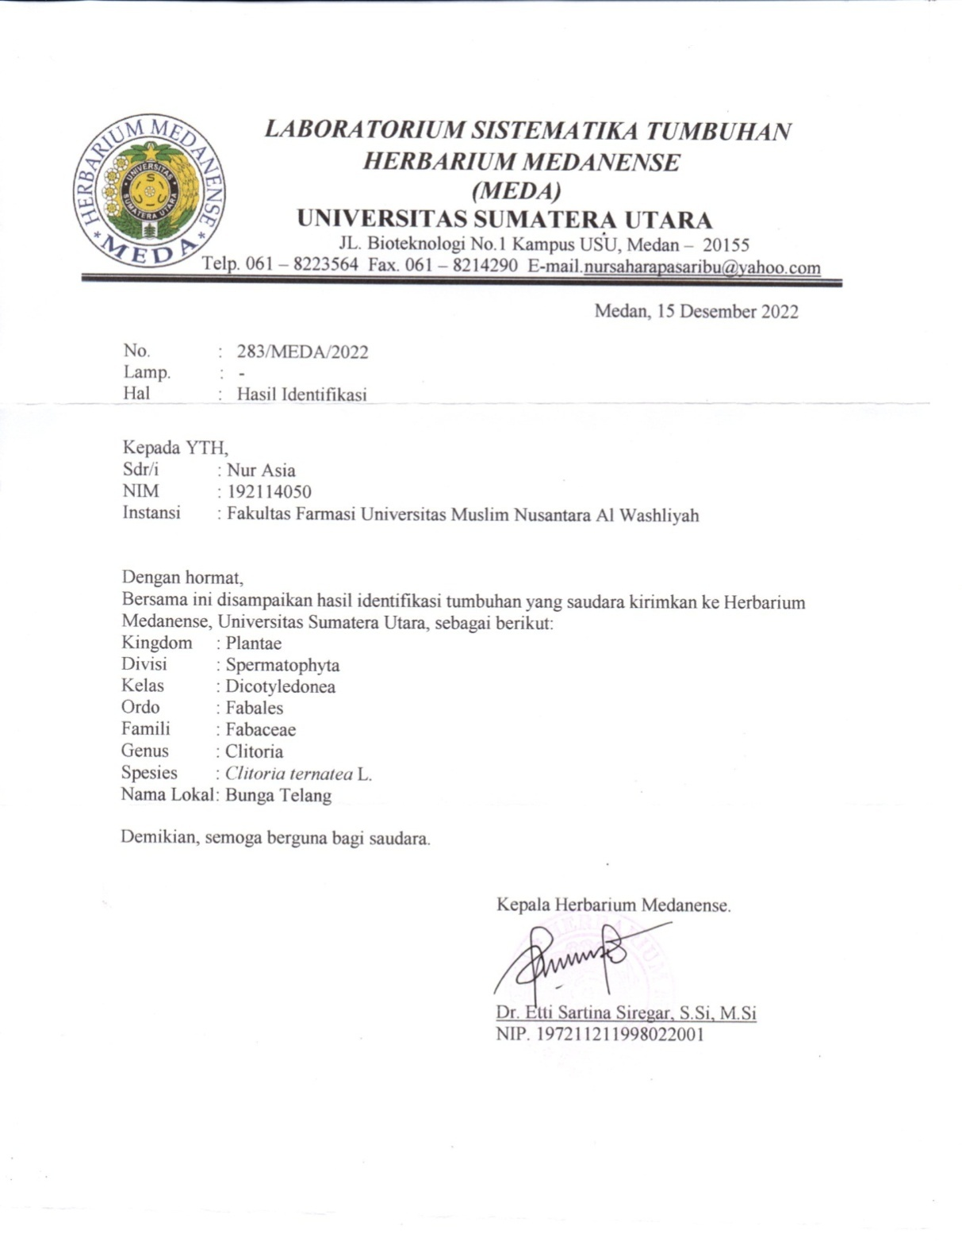

Lampiran 2. Bagan Alir Pembuatan Perasan Bunga Telang (Clitoria ternatea)

Bunga Telang

Penggilingan ataupun proses penggerusan sampel

Menjadi bentuk yang lebih halus

Di saring dan di peras dengan kain bersih

Cairan yang merupakan sari-sari tumbuhan

Lampiran 3. Bagan Alir Skrinig Fitokimia Perasan Bunga Telang (Clitoria ternatea)
Skrining Fitokimia

Perasan Sari Bunga Telang Segar

- Pemeriksaan Alkaloid
- Pemeriksaan Flavonoid
- Pemeriksaan Saponin
- Pemeriksaan Tanin
- Pemeriksaan Steroid/ Triterpenoid
- Pemeriksaan Glikosida

Lampira 4. Bagan Alir Pembuatan Gel Persan Bunga Telang (Clitoria ternatea)
Dipanaskan

Lumpang dan Alu

Digerus homogen

Carbopol & Air Corpus
(M1)

Diaduk homogen

Sampel + Propilenglikol + Metil paraben + Propil paraben + Air Corpus
(M2)

Digerus homogen

M1 + M2

TEA & Oleunm rosae

Digerus homogen

Lampiran 5. Bagan Alir Uji Daya Hambat Gel Perasan Bunga Telang (Clitoria ternatea) terhadap Bakteri Staphylococcus epidermidis
Biakan Bakteri Murni
Diambil dengan jarum ose
Ditanam pada media Nutrient Agar Miring
Diinkubasi pada suhu 35-37 ˚C selama 18-14 jam

Stok Kultur Bakteri

Diambil dengan jarum ose steril
Disuspensikan dalam 10 ml NaCl 0,9 % steril
Dihomogenkan sampai kekeruhan sama dengan Standart Mc Farland

Suspensi Bakteri
Dituang media MHA kedalam cawan petri sebanay 15-20 ml
Dipipet 1ml suspensi bakteri lalu di swab dengan cottun swab steril

Media Padat
Diletakkan cakram yang telah di rendam dengan berbagai konsentrasi gel (1%,3%,& 5%)

Inkubasi suhu 37⁰C Selama 18-24 jam
Diukur diameter zona hambat daerah bening disekitar cakram dengan menggunakan jangka sorong

Diameter Zona Hambat

Lampiran 6. Hasil Uji Skrining Fitokimia Perasan Bunga Telang
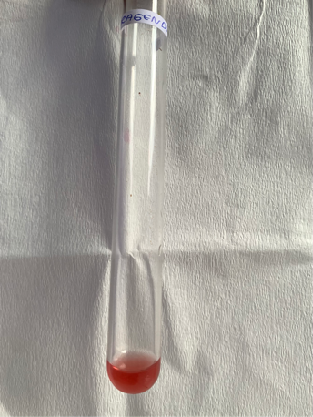
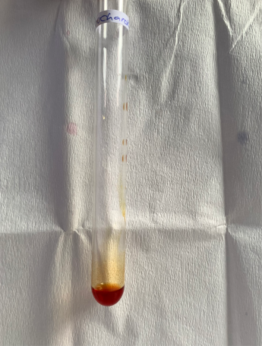
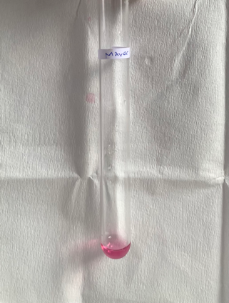

Alkaloid

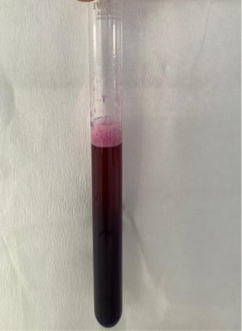
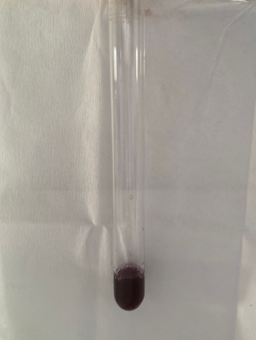
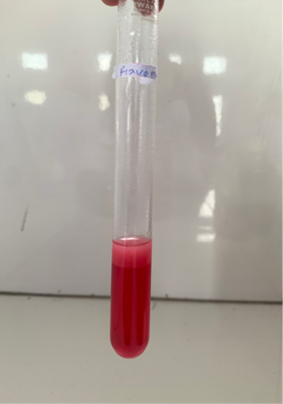

Tanin
Saponin
Flavonoid

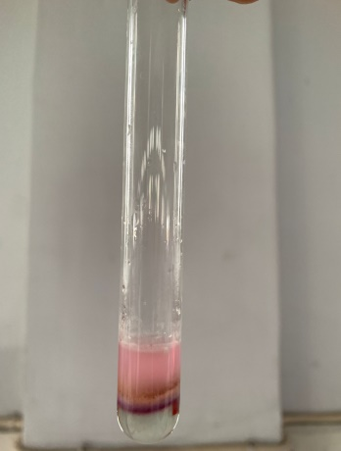
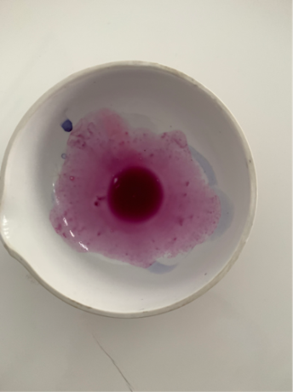

Glikosida
Steroid/Triterpenoid

Lampiran 7. Hasil Perasan Bunga Telang
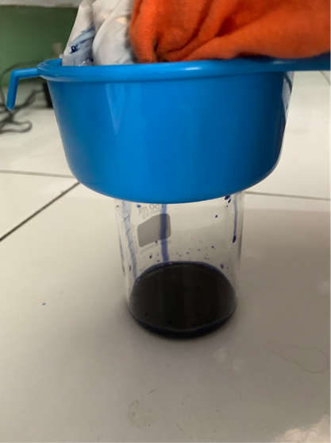
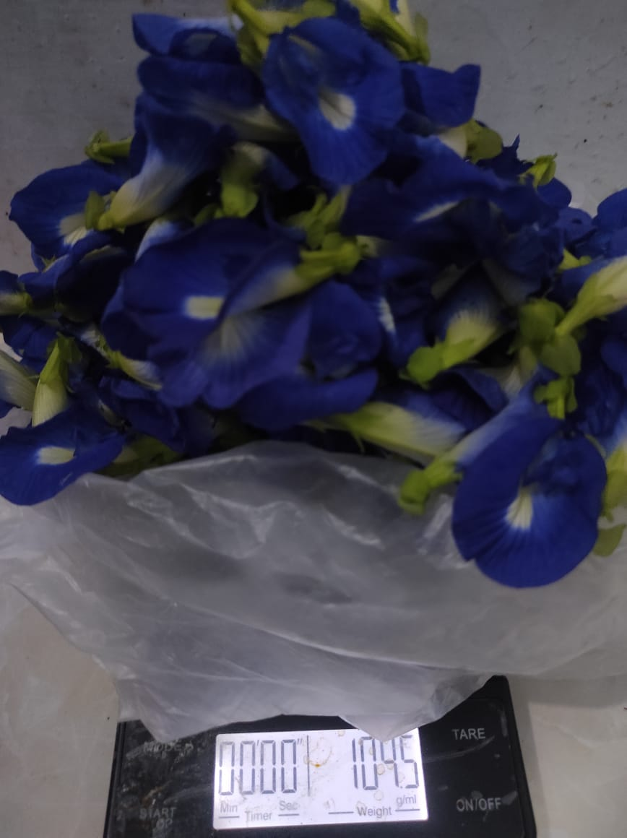

Perasan Bunga Telang
Bunga Telang Segar

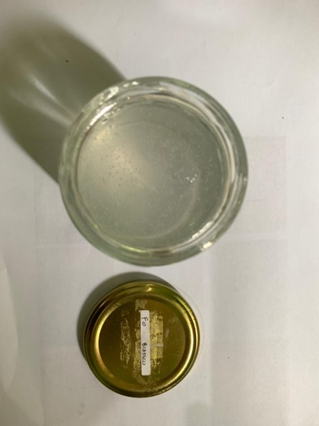
Lampiran 8. Hasil Pembuatan Gel Bunga Telang
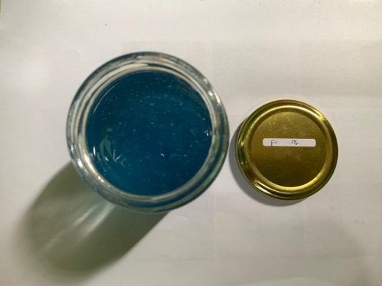

Formula Blanko
Formula Konsentrasi 1%

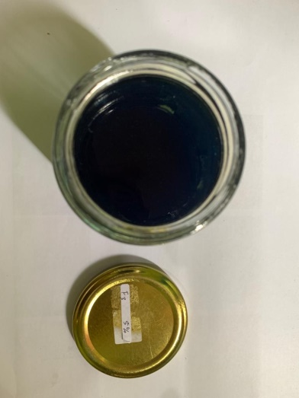
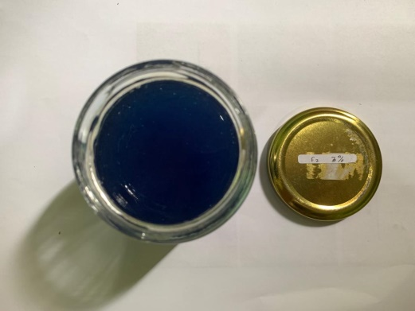

Formula Konsentrasi 3%
Formula Konsentrasi 5%

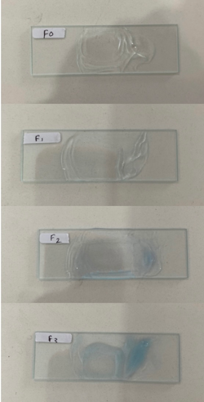
Lampiran 10. Hasil Karakteristik Mutu Fisik Sediaan
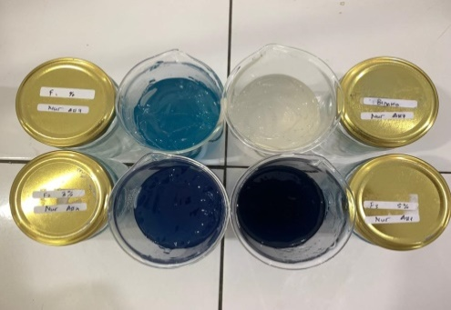

Organoleptis
Homogenitas

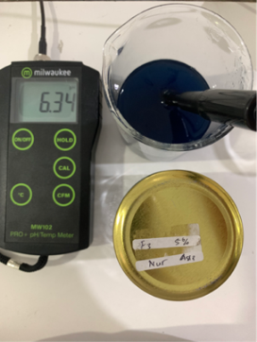
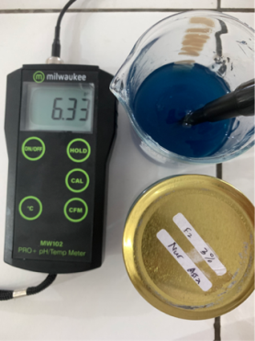
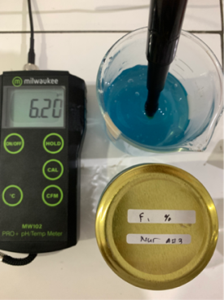
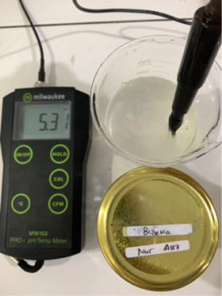

pH F1
pH F2
pH F3
pH F0

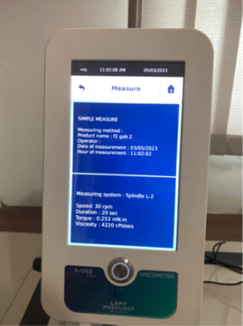
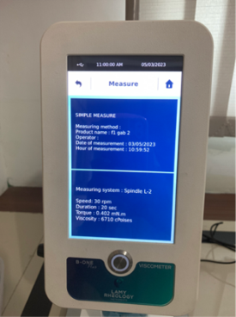
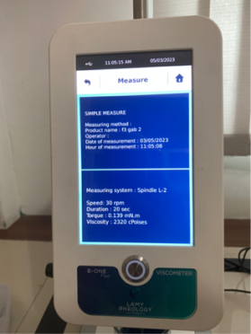
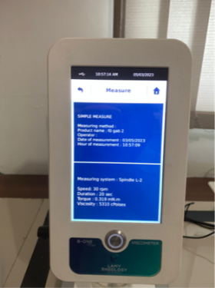

Viskositas F2
Viskositas F0
Viskositas F3
Viskositas F1

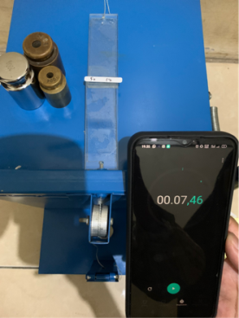
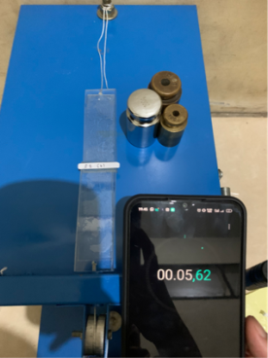
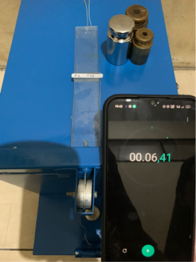
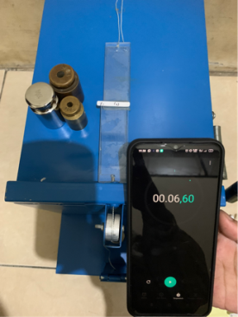

Daya lekat F1
Daya lekat F2
Daya lekat F3
Daya lekat F0

Lampiran 10. (Lanjutan…)
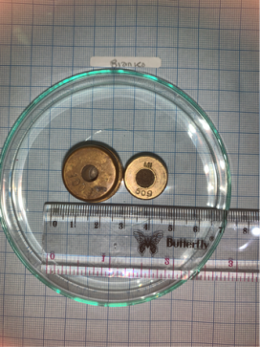
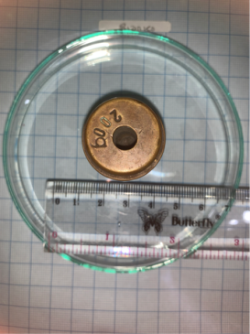
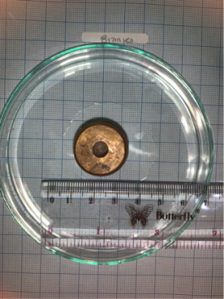
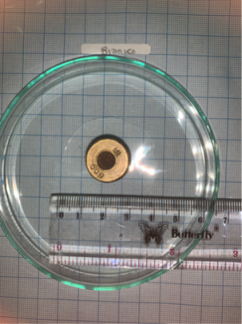

Daya sebar F0
Daya sebar F0
Daya sebar F0
Daya sebar F0
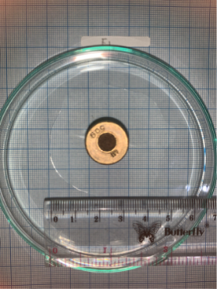
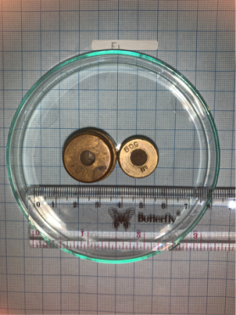
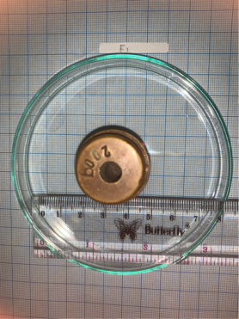
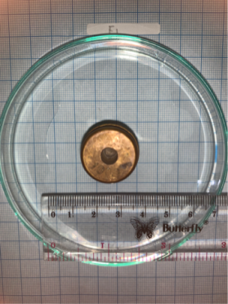

Daya sebar F1
Daya sebar F1
Daya sebar F1
Daya sebar F1
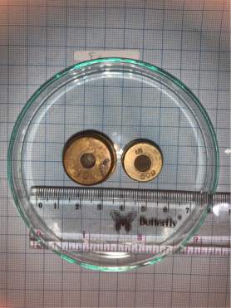
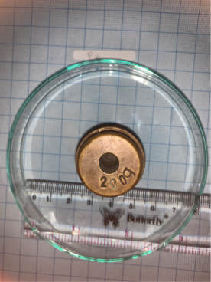
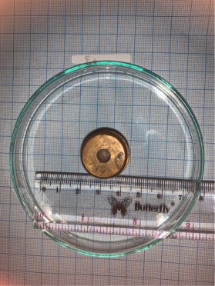
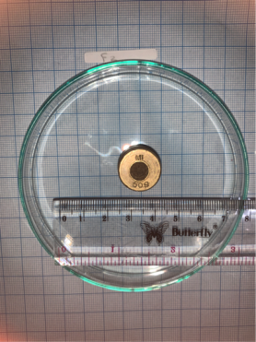

Daya sebar F2
Daya sebar F1
Daya sebar F2
Daya sebar F2
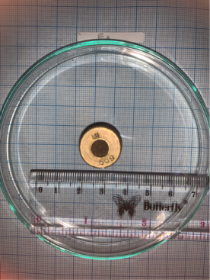
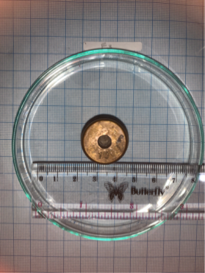
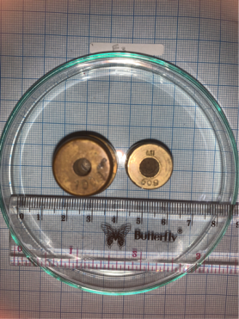
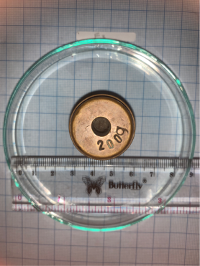

Daya sebar F3
Daya sebar F3
Daya sebar F3
Daya sebar F3

Lampiran 11. Stabilitas (Cycling test)
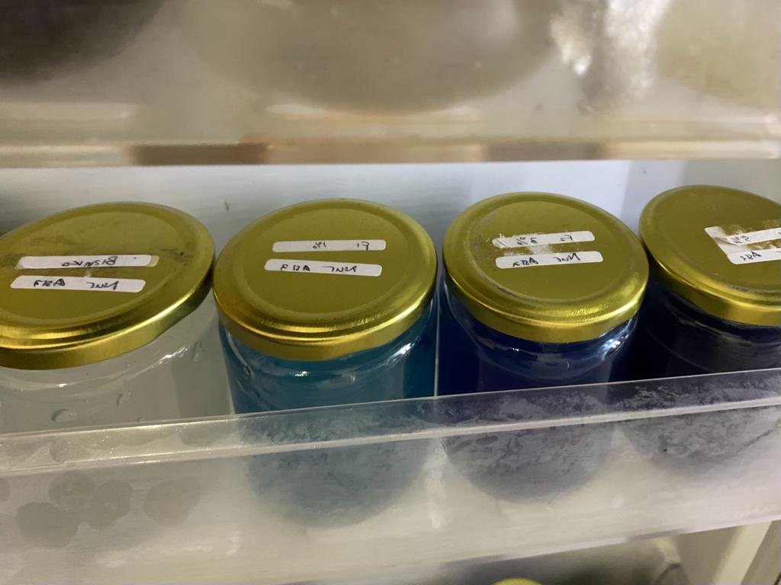

Penyimpanan pada suhu 4 ˚C selama 24 jam

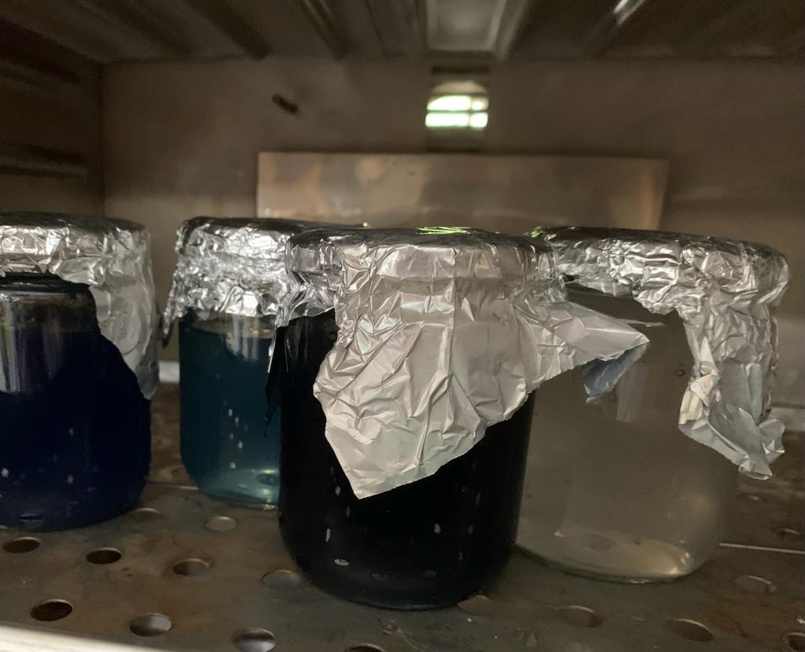

Penyimpanan pada suhu 40 ˚C selama 24 jam

Lampiran 12. Hasil Uji Daya Hambat Gel Perasan Bunga Telang (Clitoria ternatea) terhadap Bakteri Staphylococcus epidermidis

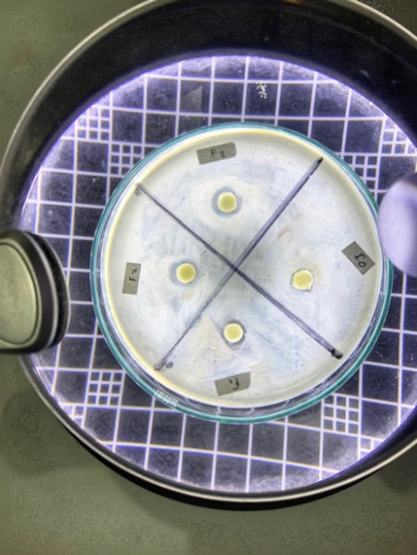
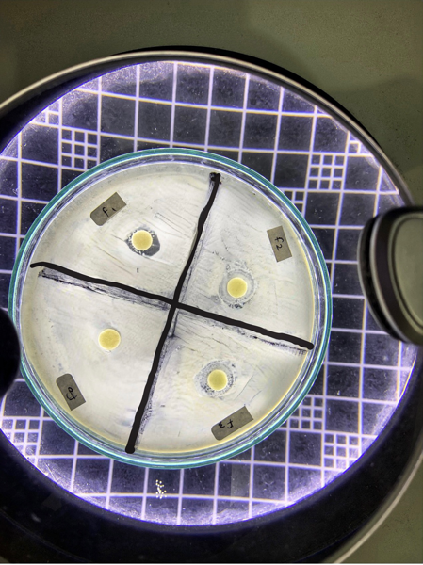
Pengulangan 2
Pengulangan 1

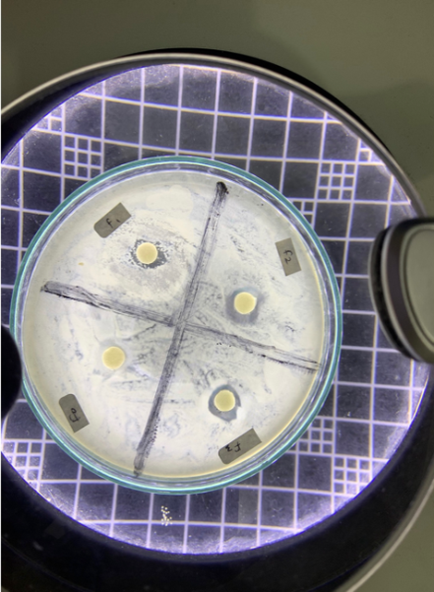

Pengulangan 3

Lampiran 13. Hasil Uji Daya Hambat Kontrol Positif dan Negatif
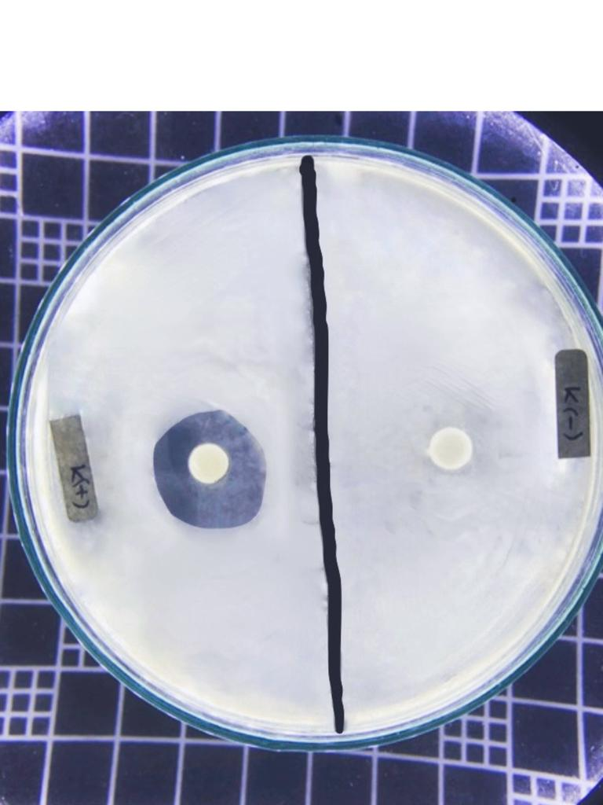
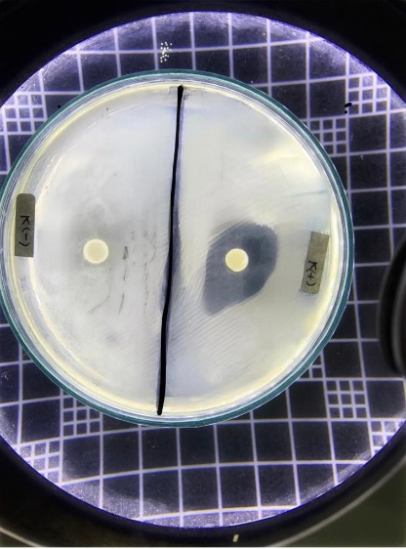

Pengulangan 2
Pengulangan 1

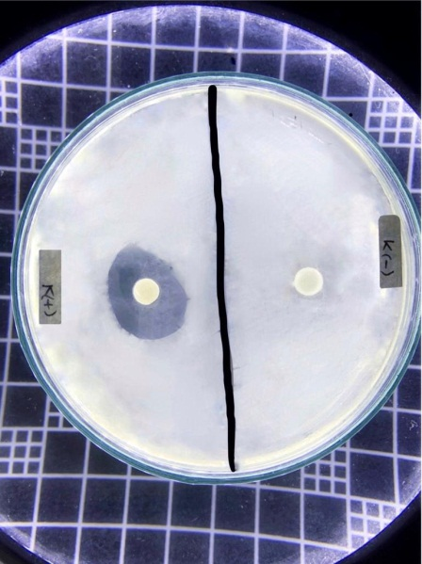

Pengulangan 3

Lampiran 14. Hasil Uji Identifikasi Bakteri Staphylococcus epidermidis

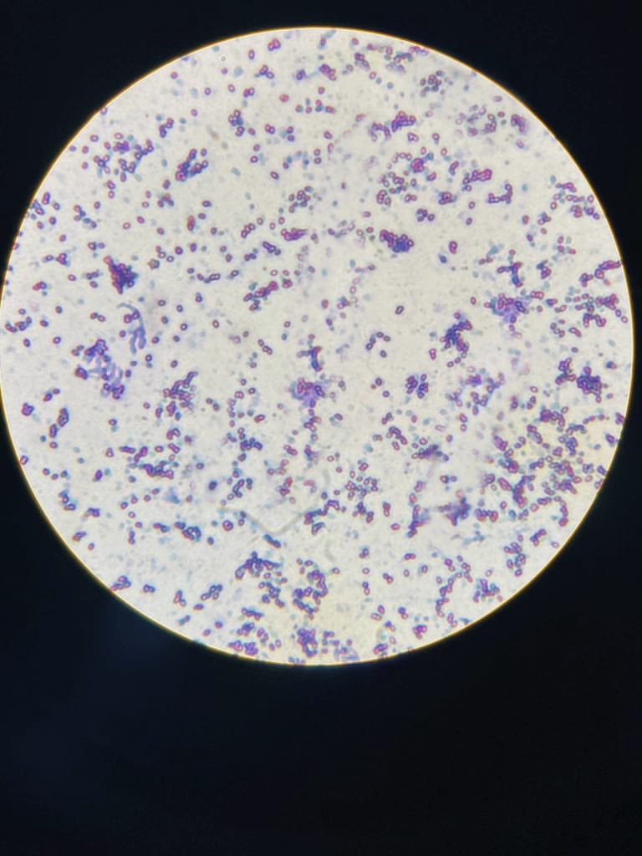
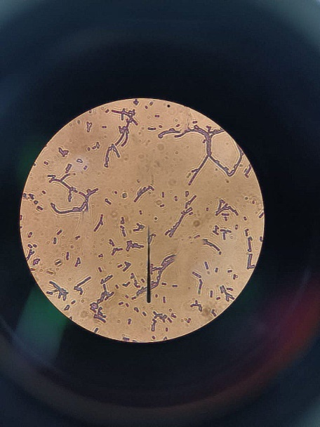

Pembesaran 100
Pembesaran 40

Lampiran 14. Hasil Pengolahan data Statistik pH
Uji Normalitas Data pH
Tests of Normality
 | formula | Kolmogorov-Smirnovª |  |  | Shapiro-Wilk
 |  | Statistic | Df | Sig. | Statistic | df | Sig.
pH | F0 | .164 | 21 | .146 | .932 | 21 | .150
 | F1 | .199 | 21 | .030 | .913 | 21 | .064
 | F2 | .261 | 21 | .001 | .804 | 21 | .001
 | F3 | .227 | 21 | .006 | .899 | 21 | .033
a. Lilliefors Significance Correction

Uji Homigenitas Data pH
Levene's Test of Equality of Error Variances^{a,b}
 |  | Levene Statistic | df1 | df2 | Sig.
pH | Based on Mean | 2.835 | 27 | 56 | .000
 | Based on Median | .542 | 27 | 56 | .958
 | Based on Median and with adjusted df | .542 | 27 | 13.053 | .913
 | Based on trimmed mean | 2.570 | 27 | 56 | .001
Tests the null hypothesis that the error variance of the dependent variable is equal across groups.
a. Dependent variable: Ph
b. Design: Intercept + formula + siklus + formula * siklus

Uji Friedman
Related-Samples Friedman's Two-Way Analysis of Variance by Ranks Summary
Total N | 84
Test Statistic | 104.222
Degree Of Freedom | 2
Asymptotic Sig.(2-sided test) | .000

Uji Post-Hoc
Pairwise Comparisons
Sample 1-Sample 2 | Test Statistic | Std. Error | Std. Test Statistic | Sig. | Adj. Sig.ª
formula-siklus | -.929 | .154 | -6.018 | .000 | .000
formula-Ph | -.607 | .154 | -3.935 | .000 | .000
siklus-pH | -1.536 | .154 | -9.953 | .000 | .000
Each row tests the null hypothesis that the Sample 1 and Sample 2 distributions are the same.
Asymptotic significances (2-sided tests) are displayed. The significance level is .05.
a. Significance values have been adjusted by the Bonferroni correction for multiple tests.

Lampiran 15. Hasil Pengolahan data Statistik Viskositas

Uji Normalitas Data
Tests of Normality
 | formula | Kolmogorov-Smirnovª |  |  | Shapiro-Wilk
 |  | Statistic | Df | Sig. | Statistic | df | Sig.
viskositas | F0 | .145 | 21 | .200* | .910 | 21 | .056
 | F1 | .271 | 21 | .000 | .879 | 21 | .014
 | F2 | .123 | 21 | .200* | .946 | 21 | .291
 | F3 | .119 | 21 | .200* | .952 | 21 | .377
*. This is a lower bound of the true significance.
a. Lilliefors Significance Correction

Uji Homigenitas
Levene's Test of Equality of Error Variances^{a,b}
 |  | Levene Statistic | df1 | df2 | Sig.
Viskositas | Based on Mean | 3.610 | 27 | 56 | .000
 | Based on Median | .784 | 27 | 56 | .751
 | Based on Median and with adjusted df | .784 | 27 | 18.450 | .723
 | Based on trimmed mean | 3.281 | 27 | 56 | .000
Tests the null hypothesis that the error variance of the dependent variable is equal across groups.
a. Dependent variable: viskositas
b. Design: Intercept + formula + siklus + formula * siklus

Uji Friedman
Related-Samples Friedman's Two-Way Analysis of Variance by Ranks Summary
Total N | 84
Test Statistic | 138.667
Degree Of Freedom | 2
Asymptotic Sig.(2-sided test) | .000

Uji Post-Hoc
Pairwise Comparisons
Sample 1-Sample 2 | Test Statistic | Std. Error | Std. Test Statistic | Sig. | Adj. Sig.ª
formula-siklus | -1.286 | .154 | -8.332 | .000 | .000
formula-viskositas | -.429 | .154 | -2.777 | .005 | .016
siklus-viskositas | -1.714 | .154 | -11.110 | .000 | .000
Each row tests the null hypothesis that the Sample 1 and Sample 2 distributions are the same.
Asymptotic significances (2-sided tests) are displayed. The significance level is .05.
a. Significance values have been adjusted by the Bonferroni correction for multiple tests.

Lampiran 16. Hasil Pengolahan data Statistik Daya lekat

Uji Normalitas Data
Tests of Normality
 | formula | Kolmogorov-Smirnovª |  |  | Shapiro-Wilk
 |  | Statistic | Df | Sig. | Statistic | df | Sig.
daya_lekat | F0 | .220 | 21 | .009 | .847 | 21 | .004
 | F1 | .159 | 21 | .180 | .927 | 21 | .119
 | F2 | .180 | 21 | .073 | .893 | 21 | .025
 | F3 | .235 | 21 | .004 | .838 | 21 | .003
a. Lilliefors Significance Correction

Uji Homigenitas
Levene's Test of Equality of Error Variances^{a,b}
 |  | Levene Statistic | df1 | df2 | Sig.
daya_lekat | Based on Mean | 6.401 | 27 | 56 | .000
 | Based on Median | 1.135 | 27 | 56 | .337
 | Based on Median and with adjusted df | 1.135 | 27 | 3.675 | .519
 | Based on trimmed mean | 5.727 | 27 | 56 | .000
Tests the null hypothesis that the error variance of the dependent variable is equal across groups.
a. Dependent variable: daya_lekat
b. Design: Intercept + formula + siklus + formula * siklus

Uji Friedman
Related-Samples Friedman's Two-Way Analysis of Variance by Ranks Summary
Total N | 84
Test Statistic | 112.321
Degree Of Freedom | 2
Asymptotic Sig.(2-sided test) | .000

Uji Post-Hoc
Pairwise Comparisons
Sample 1-Sample 2 | Test Statistic | Std. Error | Std. Test Statistic | Sig. | Adj. Sig.ª
formula-siklus | -1.024 | .154 | -6.635 | .000 | .000
formula-daya_lekat | -.560 | .154 | -3.626 | .000 | .001
siklus-daya_lekat | -1.583 | .154 | -10.261 | .000 | .000
Each row tests the null hypothesis that the Sample 1 and Sample 2 distributions are the same.
Asymptotic significances (2-sided tests) are displayed. The significance level is .05.
a. Significance values have been adjusted by the Bonferroni correction for multiple tests.

Lampiran 17. Hasil Pengolahan data Statistik Daya sebar

Uji Normalitas Data
Tests of Normality
 | formula | Kolmogorov-Smirnovª |  |  | Shapiro-Wilk
 |  | Statistic | df | Sig. | Statistic | df | Sig.
daya_sebar | F0 | .164 | 28 | .053 | .938 | 28 | .101
 | F1 | .130 | 28 | .200* | .938 | 28 | .096
 | F2 | .131 | 28 | .200* | .937 | 28 | .092
 | F3 | .143 | 28 | .147 | .940 | 28 | .108
*. This is a lower bound of the true significance.
a. Lilliefors Significance Correction

Uji Homogenitas Data
Levene's Test of Equality of Error Variances^{a,b}
 |  | Levene Statistic | df1 | df2 | Sig.
daya_sebar | Based on Mean | .120 | 27 | 84 | 1.000
 | Based on Median | .116 | 27 | 84 | 1.000
 | Based on Median and with adjusted df | .116 | 27 | 57.951 | 1.000
 | Based on trimmed mean | .120 | 27 | 84 | 1.000
Tests the null hypothesis that the error variance of the dependent variable is equal across groups.
a. Dependent variable: daya_sebar
b. Design: Intercept + formula + siklus + formula * siklus

Uji Anova
Tests of Between-Subjects Effects
Dependent Variable: daya_sebar
Source | Type III Sum of Squares | df | Mean Square | F | Sig.
Corrected Model | 8.860ª | 27 | .328 | 3.002 | .000
Intercept | 4576.007 | 1 | 4576.007 | 41860.562 | .000
Formula | 7.795 | 3 | 2.598 | 23.770 | .000
Siklus | .823 | 6 | .137 | 1.255 | .287
formula * siklus | .242 | 18 | .013 | .123 | 1.000
Error | 9.182 | 84 | .109
Total | 4594.050 | 112
Corrected Total | 18.043 | 111
a. R Squared = .491 (Adjusted R Squared = .327)

Uji Lancutan (Duncan
daya_sebar
Duncan^{a,b}
Formula | N | Subset
 |  | 1 | 2 | 3
F0 | 28 | 6.082
F1 | 28 | 6.236
F2 | 28 |  | 6.468
F3 | 28 |  |  | 6.782
Sig. |  | .086 | 1.000 | 1.000
Means for groups in homogeneous subsets are displayed.
Based on observed means.
The error term is Mean Square(Error) = .109.
a. Uses Harmonic Mean Sample Size = 28.000.
b. Alpha = ,05.

Lampiran 18. Hasil Pengolahan data Statistik Daya Hambat Bakteri

Uji Normalitas Data
Tests of Normality
 | Formula | Kolmogorov-Smirnovª |  |  | Shapiro-Wilk
 |  | Statistic | df | Sig. | Statistic | Df | Sig.
daya_hambat | F1 | .253 | 3 | . | .964 | 3 | .637
 | F2 | .227 | 3 | . | .983 | 3 | .747
 | F3 | .362 | 3 | . | .803 | 3 | .122
 | kontrol + | .351 | 3 | . | .828 | 3 | .183
a. Lilliefors Significance Correction

Uji Homogenitas Data
Test of Homogeneity of Variances
 |  | Levene Statistic | df1 | df2 | Sig.
daya_hambat | Based on Mean | 3.274 | 3 | 8 | .080
 | Based on Median | .384 | 3 | 8 | .768
 | Based on Median and with adjusted df | .384 | 3 | 4.653 | .770
 | Based on trimmed mean | 2.821 | 3 | 8 | .107

Uji Anova
ANOVA
daya_hambat
 | Sum of Squares | df | Mean Square | F | Sig.
Between Groups | 313.943 | 3 | 104.648 | 194.392 | .000
Within Groups | 4.307 | 8 | .538
Total | 318.249 | 11

Uji Post-Hoc
daya_hambat
Duncanª
Formula | N | Subset for alpha = 0.05
 |  | 1 | 2 | 3
F1 | 3 | 7.567
F2 | 3 |  | 9.200
F3 | 3 |  | 10.200
kontrol + | 3 |  |  | 20.600
Sig. |  | 1.000 | .134 | 1.000
Means for groups in homogeneous subsets are displayed.
a. Uses Harmonic Mean Sample Size = 3.000.

Lampiran 19. Hasil Perhitungan Rendemen Perasan Bunga telang (Clitoria ternatea L.)

Diketahui :
Berat Bunga telang Segar : 100 g
Berat Perasan Bunga telang : 25 g
% Rendemen = Berat Perasan Bunga telang
X 100% Berat Bunga telang Segar

= 25 / 100 gram x 100%
= 25%

Lampiran 20. Hasil Perhitungan Suspensi Clindamicin
Clindamicin = 2 mcg/ml
2 mcg/ml x 10ml = 2 mg
Ditimbang = 2 mg
X 4858 mg = 32,38 mg = 0,03238 g
300 mg

