ABSTRAK

ANALISIS KEMAMPUAN PEMECAHAN MASALAH SISWA DALAM MENYELESAIKAN SOAL MATEMATIKA BENTUK HOTS MENGGUNAKAN MODEL PROBLEM BASED
LEARNING DI KELAS VIII MTs
SWASTA CITRA AMANAH

DHEA AYUNDA

Penelitian ini bertujuan untuk mengetahui dan mendeskripsikan kemampuan pemecahan masalah siswa dalam menyelesaikan soal matematika bentuk HOTS menggunakan model Problem Based Learning di kelas VIII MTs Swasta Citra Amanah. Jenis penelitian ini adalah penelitian kualitatif. Penelitian ini dilaksanakan di sekolah MTs Swasta Citra Amanah. Subjek dari penelitian ini adalah siswa kelas VIII-1. Instrumen yang digunakan dalam penelitian ini adalah lembar observasi, tes kemampuan pemecahan masalah dan wawancara. Hasil penelitian dapat disimpulkan bahwa proses pembelajaran dengan model Problem Based Learning pada materi pola bilangan terlaksana dengan baik. Kemampuan pemecahan masalah siswa kelas VIII-1 sebanyak 2 siswa termasuk kriteria baik sekali, 9 siswa kriteria baik, 5 siswa kriteria cukup dan 5 siswa kriteria kurang dan 1 siswa kriteria kurang sekali.

Kata Kunci: Kemampuan Pemecahan Masalah, Problem Based Learning

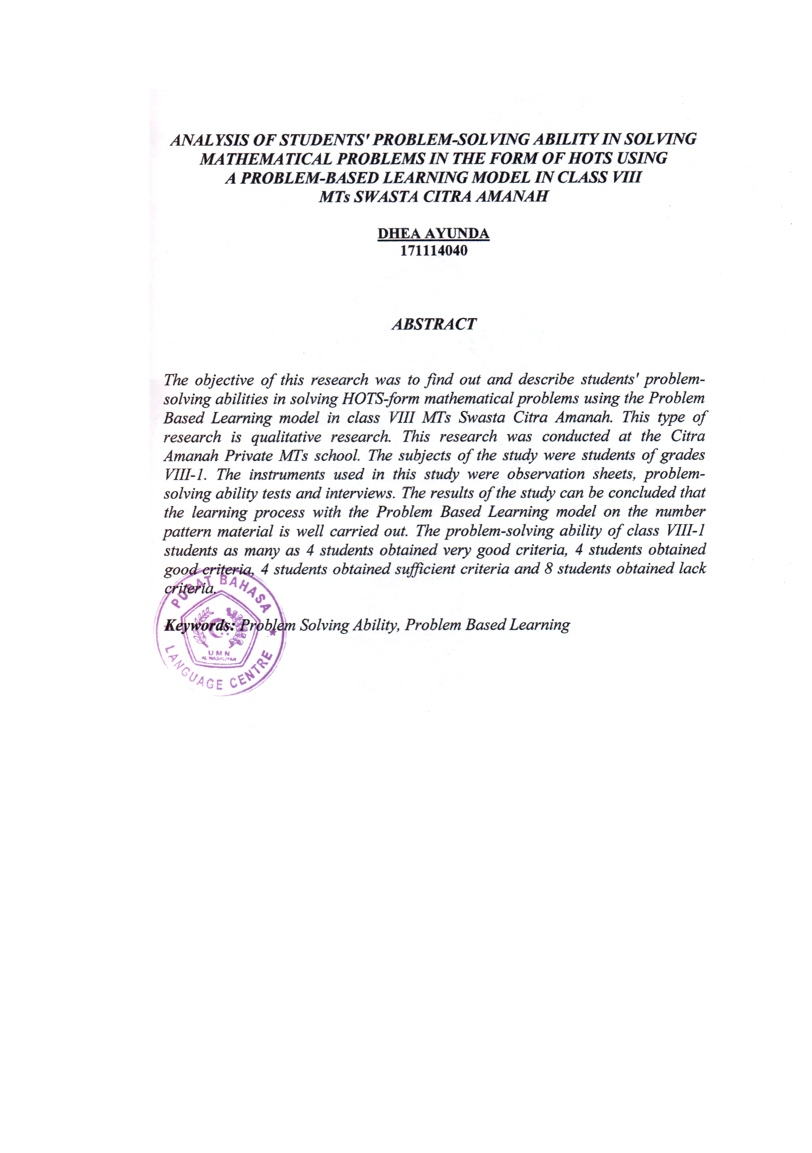
ABSTRACT

ANALYSIS OF STUDENTS' PROBLEM SOLVING ABILITY IN SOLVING HOTS MATHEMATICS PROBLEMS USING THE
PROBLEM BASED MODEL LEARNING IN CLASS VIII
MTs PRIVATE IMAGE AMANAH

DHEA AYUNDA

This study aims to determine and describe students' problem-solving skills in solving HOTS math questions using the Problem Based Learning model in class VIII MTs Citra Amanah Private. This type of research is qualitative research. This research was conducted at Citra Amanah Private MTs school. The subjects of this study were students of class VIII-1. The instruments used in this study were observation sheets, problem solving ability tests and interviews. The results of the study can be concluded that the learning process with the Problem Based Learning model on number pattern material is carried out well. There are 2 students with very good criteria for solving problems in class VIII-1, 9 students with good criteria, 5 students with sufficient criteria and 5 students with poor criteria and 1 student with very poor criteria.

Keywords: Problem Solving Ability, Problem Based Learning

